

Cross-Layer Dataset Design and Exploratory Analysis of ESP32-Based ESP-WIFI-MESH Network

A Thesis Proposal Presented to
The Faculty of the College of Computer Studies
De La Salle University

In Partial Fulfillment
of the Requirements for the Degree of
Bachelor of Science in Computer Science

by
Calpoporo, Jose Angelo C.
Carlos, Miguel Sebastian C.
Ong, Kyle Edward M.
Reinante, Christian Victor G.

Mr. Gregory G. Cu
Faculty Adviser
October 24, 2026
Abstract
Wireless Mesh Networks (WMNs) are widely used in Internet of Things (IoT) systems due to their decentralized, multi-hop communication capabilities. The ESP32 microcontroller, with built-in Wi-Fi support and ESP-WIFI-MESH functionality, enables low-cost deployment of infrastructure-less mesh networks. However, most existing intrusion detection research relies on simulation-based datasets that do not accurately capture the cross-layer interactions and hardware-level behaviors observed in real ESP32 mesh deployments.
This study addresses this gap by designing and generating a hardware-derived cross-layer dataset from an ESP32-based ESP-WIFI-MESH testbed deployed in a controlled indoor environment. A network of 8 nodes is configured to collect telemetry under normal operation and controlled routing-based attack scenarios, including blackhole and wormhole attacks. Metrics are gathered across the Physical (PHY), Medium Access Control (MAC), and Network layers, including RSSI values, retransmission counts, hop transitions, forwarding ratios, and parent-switching events.
Rather than implementing a real-time intrusion detection system, the study focuses on documenting cross-layer behavioral patterns and applying exploratory data analysis and unsupervised clustering to examine separability between normal and attack conditions. The resulting dataset provides a structured foundation for future research on ESP32-based wireless mesh security.

TABLE OF CONTENTS
1. Introduction
1.1. Overview
1.2. Problem Statement
1.3. Research Objectives
1.3.1. General Objective
1.3.2. Specific Objectives
1.4. Project Scope and Limitation
1.4.1. Limitations of the Study
1.5. Significance of the Study
1.6. Resources
1.6.1. Hardware
1.6.2. Software
2. Review of Related References
2.1. Wireless Mesh Networks (WMNs)
2.2. Security Challenges and Common Attacks in WMNs
2.3. Infrastructure-less and Decentralized Network Environments
2.4. Intrusion Detection Systems (IDS) for WMNs
2.5. Machine Learning and Anomaly Detection in IDS
2.6. Cross Layer
2.7. ESP32 Technical Literature
2.8. Existing Wireless Network Datasets
2.9. Dataset Design and Feature Engineering
2.10. Exploratory Data Analysis and Clustering in Network Telemetry
3. Theoretical Framework
3.1. Wireless Mesh Network Fundamentals
3.1.1. Wireless Mesh Network Characteristics
3.1.2. ESP-WIFI-MESH Architecture and Node Roles
3.1.3. Control Plane vs. Data Plane Operations
3.1.3.1. Control Plane
3.1.3.2. Data Plane
3.2. Topology Formation and Physical Influences
3.2.1. RSSI Thresholds and Parent Selection
3.2.1.1. RSSI Thresholding Mechanism
3.2.1.2. Parent Selection Criteria
3.2.2. Environmental Effects on Topology Formation
3.2.2.1. Impact of Physical Obstacles
3.2.2.2. Multi-path and Interference Effects
3.2.2.3. Chain Formation in Linear Deployments
3.2.3. Logical vs. Physical Topology Relationships
3.2.3.1. Monotonic RSSI Degradation Assumption
3.2.3.2. Correlation Between Hop Count and Expected RSSI
3.2.3.3. Topology Formation Principles
3.3. Routing-Based Attack Theory
3.3.1. Blackhole Attack: Conceptual Foundation
3.3.1.1. Theoretical Characterization
3.3.1.2. Adaptation to ESP-WIFI-MESH Context
3.3.1.3. Theoretical Expectations for Observable Behavior
3.3.2. Wormhole Attack: Conceptual Foundation
3.3.2.1. Theoretical Characterization
3.3.2.2. Adaptation to ESP-WIFI-MESH Context
3.3.2.3. Wireless Topology Distortion
3.3.2.4. Cross-Layer Effects of Wormhole Distortion
3.4. Cross-Layer Telemetry Perspective
3.4.1. Why Routing Violations Affect Multiple Protocol Layers
3.4.1.1. Physical Layer Effects
3.4.1.2. MAC Layer Effects
3.4.1.3. Network Layer Effects
3.4.2. Collected Metrics and Data Sources
3.4.3. Temporal Aggregation of Cross-Layer Telemetry
3.4.4. Expected Observable Inconsistencies
3.4.4.1. Expected Blackhole Observables
3.4.4.2. Expected Wormhole Observables
3.4.4.3. Timing and Latency Inconsistencies
3.4.5. Expected Observable Inconsistencies
3.4.5.1. Observational Objectives
3.4.5.2. Methodological Principles
3.4.5.3. Distinction from Detection System
3.5. Conceptual Framework of the Study
3.5.1. Normal Behavior as Consistent Relationships
3.5.2. Misbehavior as Broken Relationships
3.5.2.1. Blackhole: Broken Reception-Forwarding Relationship
3.5.2.2. Wormhole: Broken Physical-Logical Topology Relationship
3.5.3. Experimental Emulation of Routing Manipulations
3.5.4. Secondary Broken Relationships
3.5.5. These Inconsistencies Motivate Dataset Collection
3.5.5.1. Theoretical Justification for Dataset Requirements
3.5.6. Exploratory Behavioral Analysis and Pattern Discovery
3.5.7. Expected Contribution
3.5.8. Framework Summary
4. Research Design
4.1. Architectural Design
4.2. Experimental Topology and Controlled Behavior Framework
4.2.1. Attack Implementation: Wormhole and Blackhole Manipulations
4.2.1.1. Common Experiment Control Infrastructure
4.2.1.2. Forwarding Suppression (Blackhole) Implementation
4.2.1.3. Topology Distortion (Wormhole-Inspired) Implementation
4.2.1.4. Implementation Summary
4.2.2. Physical Deployment Topologies
4.2.2.1. Star Topology
4.2.2.2. Tree Topology
4.2.2.3. Linear Chain Topology
4.2.2.4. Partial Mesh Topology
4.2.2.5. Deployment Sites and Scenarios
4.2.3. Data Collection
4.2.3.1. Victim Node Data Collection
A. Physical Layer (PHY) Metrics
B. Medium Access Control (MAC) Layer Metrics
C. Network Layer Metrics
D. Probe Generation
4.2.3.2. Attack Node Data Collection
A. Attack Node Types
B. Forwarding Suppression (Blackhole) Node Metrics
C. Topology Distortion (Wormhole‑Inspired) Node Metrics
4.2.3.3. Data Acquisition and Logging Architecture
A. Sampling Loop
B. Forwarding Counter Implementation
C. Tunnel Metric Sampling (Wormhole‑Inspired Nodes)
4.2.3.4. Phase Labeling and Synchronization
A. Phase Control Algorithm
B. Phase Broadcast Mechanism
4.2.3.5. Experimental Label Encoding and Assignment
4.2.3.6. Local Storage and Post‑Experiment Extraction
A. Local Storage Architecture
B. Post‑Experiment Log Extraction
C. Data Integrity During Manipulation
4.2.3.7. Dataset Completeness Verification
4.2.4. Feature Extraction
4.2.4.1 Preprocessing
4.2.4.2 Feature Computation
A. Forwarding Behavior Features
B. Link Reliability Features
C. Topology Stability Features
D. Physical Layer Features
E. Cross‑Layer Inconsistency Features
F. Auxiliary Tunnel Activity Features (Experiment‑Level)
4.2.4.3 Feature Summary
4.2.4.4 Dataset Record Structure (Windowed Per-Node Schema)
4.2.4.5 Feature Engineering Design Principles
4.2.4.6 Feature Selection and Dimensionality Analysis
4.2.5. Data Clustering
4.2.5.1. Feature Normalization
4.2.5.2. Clustering Algorithms
A. DBSCAN (Density‑Based Spatial Clustering of Applications with Noise)
B. K‑Means (Comparative Baseline)
C. Linkage Method Selection
D. Cluster Selection
F. Expectation–Maximization Procedure
G. Cluster Number Selection
H. Spectral Clustering
I. Similarity Graph Construction
J. Spectral Embedding
K. Cluster Number Selection
4.2.5.3. Cluster Evaluation Metrics
A. Silhouette Score
B. Davies–Bouldin Index
C. Cluster Purity (Post‑Analysis Only)
D. Adjusted Rand Index (Post‑Analysis Only)
4.2.5.4. Cluster Characterization Using Ground Truth
4.2.5.5. Expected Outcomes
4.2.5.6. Clustering Results (Provisional)
4.2.6. Exploratory Data Analysis (EDA)
4.2.6.1. Benign Baseline Characterization (Provisional)
4.2.7. Attack Validation
4.2.7.1. Ground-Truth and Statistical Check
4.2.7.2. Corroboration with Published Studies
4.2.7.3. Single-Feature Leakage Audit
4.2.7.4. Predictions Tested and Not Observed
4.2.7.5. Limits
4.2.7.6. Reference Exhibits from the Validation Papers
4.3. Theoretical Analysis
4.3.1. Theoretical Justification of Selected Features
4.3.1.1. Forwarding Behavior Features (Blackhole Theory)
4.3.1.2. Link Reliability Features (Indirect Propagation Theory)
4.3.1.3. Topology Stability Features (Routing Adaptation Theory)
4.3.1.4. Physical Layer Features (Signal Consistency Theory)
4.3.1.5. Cross‑Layer Inconsistency Theory
4.3.1.6. Cross‑Layer Feature Relationship Preservation
4.3.2. Theoretical Basis for Data Clustering
4.3.2.1. Behavioral State Hypothesis
4.3.2.2. Absence of Pre‑Defined Signatures
4.3.2.3. Density‑Based Justification (DBSCAN)
4.3.2.4. Partition-Based Justification (K-Means)
4.3.2.5. Validation Theory
4.3.2.6. Alignment with Research Objectives
4.3.2.7. Theoretical Expectation
4.4. Cluster Visualization and Interpretation
5. Results, Discussion and Conclusion
5.1. Dataset Collected
5.2. Attack Validation Results
5.3. EDA Results
5.4. Clustering Results
5.5. Discussion
5.6. Future Work
5.7. Conclusion
Appendix A. Bibliography
Appendix B. Research Ethics Forms
Appendix C. Deviations Log
Appendix D. Placeholder Register

TABLE OF TABLES
Table 2.1 Summary of Overview of Wireless Mesh Networks............................................ 20
Table 2.2 Summary of Security Challenges and Common Attacks in WMNs...................... 22
Table 2.3 Summary of Literature on Infrastructure-less/Decentralized Environments........... 23
Table 2.4 Summary of Intrusion Detection Systems (IDS) for WMNs................................ 24
Table 2.5 Summary of ML/Anomaly-Based IDS............................................................... 25
Table 2.6 Summary of Cross-Layer.................................................................................. 27
Table 2.7 Summary of ESP32 Technical Literature........................................................... 29
Table 2.8 Summary of Existing Wireless Network Datasets............................................... 31
Table 2.9 Summary of Dataset Design and Feature Engineering......................................... 33
Table 2.10 Summary of EDA and Clustering in Network Topology.................................... 36
Table 3.1 ESP-WIFI-MESH Node Roles and Responsibilities............................................ 40
Table 3.2 ESP-WIFI-MESH Default RSSI Thresholds....................................................... 41
Table 3.3 Expected RSSI Ranges by Node Position........................................................... 43
Table 3.4 Expected Observable Inconsistencies Under Blackhole Behavior........................ 49
Table 3.5 Expected Observable Inconsistencies Under Wormhole Behavior........................ 50
Table 3.6 Distinction Between Cross-Layer Observation and Intrusion Detection................ 51
Table 3.7 Consistent Relationships in Normal ESP-WIFI-MESH Operation........................ 52
Table 3.8 Theoretical Basis for Dataset Design Requirements............................................ 54
Table 4.1 Phase Definition and Labeling.......................................................................... 61
Table 4.2 Blackhole Attacker State Variables and Counters............................................... 67
Table 4.3 Wormhole Attacker State Variables and Counters.............................................. 76
Table 4.4 Blackhole Conformance to Airehrour et al. [70]................................................. 87
Table 4.5 Wormhole Conformance to Hu, Perrig, and Johnson [46].................................... 87
Table 4.6 Data Collection Sites........................................................................................ 96
Table 4.7 Run Scenarios and Run Status (provisional, 44 runs)............ 97
Table 4.8 Physical Layer (PHY) Metrics........................................................................... 99
Table 4.9 Medium Access Control (MAC) Layer Metrics and Application Counters (D-15). 99
Table 4.10 Network Layer Metrics................................................................................... 99
Table 4.11 Forwarding Suppression (Blackhole) Node Metrics........................................ 100
Table 4.12 Topology Distortion (Wormhole‑Inspired) Node Metrics................................ 101
Table 4.13 Experimental Phase Label Encoding.............................................................. 105
Table 4.14 Local Storage Architecture............................................................................ 106
Table 4.15 Capture and Verification Tools...................................................................... 109
Table 4.16 Window Aggregation.................................................................................... 111
Table 4.17 Feature Summary......................................................................................... 117
Table 4.18 Windowed Per-Node Dataset Schema............................................................ 119
Table 4.19 Changes to the Windowed Per-Node Dataset Schema..................................... 120
Table 4.20 Parameter Selection:..................................................................................... 123
Table 4.21 Clustering Quality Metrics, Seed 42, 8,000 Windows (provisional, 34 runs)..... 154
Table 4.22 Baseline Windows by Site: Median and P5 to P95 (provisional, 34 runs).......... 159
Table 4.23 Attack Validation Checks.............................................................................. 160
Table 4.24 Attack Check by Attack and Topology (provisional, 34 runs).......................... 161
Table 4.25 Single-Feature Threshold Accuracy per Analysed Run and Pooled (provisional, 34 runs)............................................................................................................................. 162
Table 4.26 Testbed Parameters. Adapted from Airehrour et al. [70, Table 2]..................... 163
Table 4.27 Published Results Compared with Our Dataset............................................... 164
Table 4.28 Network Performance. Adapted from Khan et al. [22, Table 6]........................ 166
Table 4.29 Software Components of WSN Nodes. Adapted from Zhukabayeva et al. [71, Table 7]........................................................................................................................ 167
Table 4.30 Sinkhole Event Log. Adapted from Zhukabayeva et al. [71, Table 4]............... 168
Table C.1 Deviations from the Approved Proposal.......................................................... 190
Table D.1 Placeholders to Fill When the 81 Runs Are Complete..................................... 192

TABLE OF FIGURES
Figure 3.1 Architecture of ESP32-WFI-MESH................................................................. 39
Figure 3.2 Conceptual Framework of the Study................................................................. 57
Figure 4.1 Architecture Design........................................................................................ 59
Figure 4.2 Root Phase Controller..................................................................................... 61
Figure 4.3: Node Phase Monitor....................................................................................... 63
Figure 4.4 Blackhole Topology with Attacker as Intentional Relay..................................... 66
Figure 4.5 Blackhole Attacker Relay Loop....................................................................... 67
Figure 4.6 Blackhole Attacker Decision Flowchart............................................................ 69
Figure 4.7 Baseline vs Suppression Sequence Diagram...................................................... 71
Figure 4.8 Wormhole Endpoint Setup with Auxiliary Tunnel............................................. 75
Figure 4.9 Wormhole Tunnel Packet Structure.................................................................. 76
Figure 4.10 Attacker B – Relay and Tunnel...................................................................... 77
Figure 4.11 Attacker B (Leaf-side) Process Flowchart....................................................... 80
Figure 4.12 Attacker A – Tunnel Receive and Inject.......................................................... 80
Figure 4.13 Attacker A (Root-side) Process Flowchart...................................................... 84
Figure 4.14 Wormhole Shortcut Relay Mechanism............................................................ 85
Figure 4.15 Traffic Redistribution During Distortion Window........................................... 86
Figure 4.16 Wormhole Attack on Star Topology............................................................... 90
Figure 4.17 Blackhole Attack on Star Topology................................................................ 91
Figure 4.18 Wormhole Attack on Tree Topology.............................................................. 92
Figure 4.19 Blackhole Attack on Tree Topology............................................................... 93
Figure 4.20 Wormhole Attack on Linear Chain Topology.................................................. 93
Figure 4.21 Blackhole Attack on Linear Chain Topology................................................... 94
Figure 4.22 Wormhole Attack on Partial Mesh Topology.................................................. 95
Figure 4.23 Blackhole Attack on Partial Mesh Topology................................................... 96
Figure 4.24 Victim Node Telemetry Sampling Loop........................................................ 102
Figure 4.25 Forwarding Counter Update (Attack Node)................................................... 103
Figure 4.26 Tunnel Metric Sampling.............................................................................. 103
Figure 4.27 Experimental Phase Control (Root Node)...................................................... 104
Figure 4.28 Log Retrieval Routes................................................................................... 107
Figure 4.29 Core, Border, and Noise Points in DBSCAN................................................. 124
Figure 4.30 DBSCAN Cluster Formation with Noise....................................................... 124
Figure 4.31 DBSCAN Density-Based Cluster Detection.................................................. 125
Figure 4.32 Density Reachability in DBSCAN................................................................ 127
Figure 4.33 t-SNE Cluster Visualization (example TSNE figure)...................................... 129
Figure 4.34 Step-by-Step Cluster Formation Visualization............................................... 130
Figure 4.35 K-Means Algorithm Flowchart. Adapted from Lloyd (1982).......................... 131
Figure 4.36 Step-by-Step Cluster Formation Visualization. Adapted from Bishop (2006)... 132
Figure 4.37 Example Dendrogram.................................................................................. 135
Figure 4.38 Hierarchical Clustering Dendrogram (Ward Method)..................................... 136
Figure 4.39 Agglomerative vs Divisive Hierarchical Clustering........................................ 138
Figure 4.40 Agglomerative Hierarchical Clustering Tree................................................. 139
Figure 4.41 Covariance Types in Gaussian Mixture Models............................................. 141
Figure 4.42 GMM Probability Density Contours............................................................. 142
Figure 4.43 Gaussian Mixture Model Clustering Example................................................ 143
Figure 4.44 Cluster Fitting Using Gaussian Mixture Model.............................................. 144
Figure 4.45 Spectral Clustering Algorithm Overview....................................................... 146
Figure 4.46 Eigenvector Components Used in Spectral Clustering.................................... 147
Figure 4.47 Example of K-Means Clustering................................................................... 149
Figure 4.48 Spectral Clustering Result on Non-Linear Data............................................. 150
Figure 4.49 Silhouette, Davies–Bouldin and ARI against the Number of Clusters (provisional, 34 runs)........................................................................................................................ 155
Figure 4.50 Time Series of One Blackhole Cell and One Wormhole Cell (provisional, 34 runs)............................................................................................................................. 157
Figure 4.51 Distributions of ForwardingRatio and RSSI_Hop_Diff by Phase and Role (provisional, 34 runs)..................................................................................................... 157
Figure 4.52 Pearson and Spearman Correlation over All Labelled Windows (provisional, 34 runs)............................................................................................................................. 158
Figure 4.53 PCA and t-SNE Projections of 6,000 Windows (provisional, 34 runs)............. 158
Figure 4.54 Packet Loss under Blackhole Attacks. Adapted from Airehrour et al. [70, Figure 10]............................................................................................................................... 163
Figure 4.55 Frequency of Mote Rank Changes under Blackhole Attacks. Adapted from Airehrour et al. [70, Figure 8]......................................................................................... 164
Figure 4.56 Throughput under Blackhole Attacks. Adapted from Airehrour et al. [70, Figure 9]................................................................................................................................. 164
Figure 4.57 Received Packet Delivery, Packet Loss and Forwarding Ratio per Node. Adapted from Khan et al. [22, Figure 20]..................................................................................... 166
Figure 4.58 Hop Count under the Wormhole Attack. Adapted from Zhukabayeva et al. [71, Figure 4]....................................................................................................................... 167
Figure 4.59 Network Behaviour before and after the Attack. Adapted from Zhukabayeva et al. [71, Figure 19].............................................................................................................. 168
Figure 4.60 Wormhole Attack with a Malicious Node. Adapted from Ramírez Gómez et al. [72, Figure 2].. 169

TABLE OF EQUATIONS
Equation 4.1................................................................................................................. 109
Equation 4.2................................................................................................................. 112
Equation 4.3................................................................................................................. 112
Equation 4.4................................................................................................................. 113
Equation 4.5................................................................................................................. 113
Equation 4.6................................................................................................................. 113
Equation 4.7................................................................................................................. 113
Equation 4.8................................................................................................................. 114
Equation 4.9................................................................................................................. 114
Equation 4.10................................................................................................................ 114
Equation 4.11................................................................................................................ 114
Equation 4.12................................................................................................................ 115
Equation 4.13................................................................................................................ 115
Equation 4.14................................................................................................................ 115
Equation 4.15................................................................................................................ 115
Equation 4.16................................................................................................................ 116
Equation 4.17................................................................................................................ 116
Equation 4.18................................................................................................................ 122
Equation 4.19................................................................................................................ 151
Equation 4.20................................................................................................................ 152
Equation 4.21................................................................................................................ 152
Equation 4.22................................................................................................................ 152

1. Introduction

1.1. Overview
Wireless Mesh Networks (WMNs) have become a critical communication architecture for Internet of Things (IoT) systems due to their self-organizing, infrastructure-less, and multi-hop characteristics [1]. These networks are widely used in smart cities, environmental monitoring, disaster recovery, and rural connectivity, where centralized infrastructure is impractical or unavailable [2]. By allowing each node to function as both a host and a router, WMNs provide scalability and fault tolerance in dynamic environments [1].
Despite these advantages, the decentralized nature of WMNs introduces significant security and reliability challenges [5]. Routing-based misbehavior, such as blackhole and wormhole attacks, can severely degrade network performance, disrupt communication paths, and reduce data delivery reliability [3, 4, 18, 20]. These behaviors are difficult to analyze because malicious nodes often exploit normal routing mechanisms and remain protocol-compliant at the physical and link layers [3, 4].
The ESP32 microcontroller is widely adopted in low-cost IoT deployments and academic research due to its integrated Wi-Fi capabilities, low power consumption, and support for ESP-WIFI-MESH networking [21]. ESP32-based mesh networks have been used for indoor and outdoor air-quality monitoring [22] and for wireless communication between laboratory test instruments [23]. However, empirical studies examining routing behavior and attack-induced anomalies in real ESP32 mesh hardware remain limited.
The study is set in a smart-campus scenario: indoor environmental and building monitoring at DLSU Manila, where low-cost ESP32 nodes send periodic sensor readings through a mesh to a root node. Khan et al. [22] deployed an ESP-MESH network of ESP32 sensor nodes across a college campus for indoor and outdoor air-quality monitoring and reported a packet delivery rate above 97% at every node except one (node H), which the authors suspect was affected by its outdoor location. This suggests that the platform can support this kind of monitoring. A node that drops or redirects readings in such a network would silently corrupt the monitoring data, so the dataset records how the two chosen attacks show up across the PHY, MAC and network layers. The testbed stays an isolated mesh, and the scenario describes the type of traffic and place, not a live campus system.
Most existing network security datasets are generated from simulations or traditional IP-based networks and fail to capture the cross-layer behavior, routing dynamics, and hardware-level characteristics of microcontroller-based wireless mesh systems [29, 30, 31]. As noted by Sommer and Paxson [30], evaluating detection methods on simulated activity or small laboratory networks often lacks realism and relevance, and in this domain there are rarely standardized test sets or readily available representative data. Similarly, Ring et al. [31] surveyed network-based intrusion detection datasets and compared them on 15 properties, including whether the traffic is real, emulated or synthetic. Their survey is limited to packet-based and flow-based network traffic and does not cover cross-layer or microcontroller-mesh data, which is the gap this study addresses. As a result, there is limited understanding of how routing-based misbehavior manifests in real ESP32 mesh deployments.
To address this gap, this research focuses on the design and generation of a cross-layer dataset collected from physical ESP32-based wireless mesh networks. The dataset captures observable network behavior under both normal operation and controlled attack scenarios, implemented as application-layer emulations of blackhole and wormhole behavior [25, 26]. Using this dataset, the study performs exploratory data analysis and unsupervised clustering to examine whether distinct behavioral patterns emerge and whether normal and malicious behaviors are separable based on observable network features [38, 41].

1.2. Problem Statement
Wireless Mesh Networks (WMNs) built using ESP32 microcontrollers are increasingly deployed in real-world IoT systems. However, their decentralized and multi-hop nature makes them vulnerable to routing-based misbehavior such as blackhole and wormhole attacks, which can significantly impact communication reliability and topology integrity.
While prior research has explored attack detection in simulated environments, there is a lack of hardware-generated datasets that capture how such behaviors manifest in real ESP32 wireless mesh networks. Existing datasets are largely simulation-based or designed for conventional networks, and therefore do not represent the cross-layer interactions, routing dynamics, and wireless characteristics inherent to ESP32-based mesh systems.
This lack of realistic datasets limits empirical analysis, reproducibility, and understanding of routing-based misbehavior in microcontroller-based mesh networks. There is a need for a dedicated, hardware-derived dataset that enables exploratory analysis and unsupervised examination of network behavior under normal and adversarial conditions.

1.3. Research Objectives

1.3.1. General Objective
To design, generate, and analyze a comprehensive cross-layer dataset derived from an ESP32-based wireless mesh network to explore and evaluate behavioral differences between normal operation and controlled attack scenarios.

1.3.2. Specific Objectives
Specifically, this study aims to:
● To establish an ESP32-based wireless mesh testbed capable of generating realistic multi-hop network traffic under both normal operation and controlled attack scenarios.
● To collect and structure cross-layer features from the Physical (PHY), Medium Access Control (MAC), and Network layers into a labeled and well-documented dataset that captures observable mesh behavior.
● To evaluate the usability and quality of the generated dataset through exploratory data analysis (EDA) and unsupervised or baseline offline machine-learning techniques, to assess whether normal and attack-induced behaviors are separable based on the collected features.

1.4. Project Scope and Limitation
This study focuses on the design, generation, and analysis of a realistic, hardware-based dataset derived from physical ESP32 wireless mesh networks using the ESP-WIFI-MESH protocol. The dataset captures observable network behavior, including signal strength variations, packet-forwarding dynamics, and routing-related inconsistencies that naturally arise in decentralized, multi-hop mesh networks.
Data collection is restricted to two primary network states: normal operation and controlled attack scenarios. Specifically, the study considers two attack types, emulated at the application layer on real ESP32 hardware: blackhole (forwarding suppression) and wormhole (out-of-band tunneling of traffic), as these represent fundamental and distinct categories of routing-layer threats—one targeting forwarding compliance and the other targeting topology integrity. A cross-layer data collection strategy is employed to gather indicators from the Physical (PHY), Medium Access Control (MAC), and Network layers, including Received Signal Strength Indication (RSSI), counts of failed send attempts, packet forwarding ratios, changes in hop count, and parent-switching events.
The collected features are intended to support exploratory analysis, clustering, and behavioral separability studies, rather than the development or deployment of any intrusion detection system. The scope of the study is limited to observing and documenting how routing-based disruptions manifest across protocol layers in a real ESP32 mesh network.

1.4.1. Limitations of the Study
Several limitations are acknowledged regarding the dataset’s scope and applicability. First, the experimental testbed is limited to a small-scale deployment consisting of 8 ESP32 nodes. As a result, the dataset may not fully represent the behavior of large-scale or high-density mesh networks. The microSD logging adds three limits. The fsync change (D-13) compiles but is not yet validated on hardware. The card clock is capped at 4 MHz because jumper wires cannot carry the default speed. Captures made before the fsync change that ended badly may have a card file with 0 rows, and those runs are treated as lost and not as empty logs (Section 4.2.3.6.3). In the nine partial-mesh captures analysed so far, no node was seen under a second parent during the labelled phases (baseline, attack and cooldown), and parent changes occurred only during mesh formation, so these runs behave as plain trees, and the partial-mesh results carry that limit (Section 4.2.7.5). [PENDING: final number of partial-mesh runs in which a node is seen under a second parent.] None of the 435 campus capture files in the dataset has 0 rows. [PENDING: result of a deliberate mid-run-reset test that validates the fsync change (D-13) on hardware.]
Second, the threat model is strictly limited to two specific attack behaviors: blackhole (forwarding suppression) and wormhole-inspired (tunnel-based) attacks. Both are implemented in the application layer on real ESP32 hardware, as emulations of what each attack does to traffic, and neither changes how ESP-WIFI-MESH chooses parents or builds routes. The mesh organizes itself into a tree, and its documentation describes a way to read a node’s routing table but none to write one [21,75]. The dataset therefore records the effect of each attack on the traffic it touches and not the route-attraction stage of a classical blackhole or wormhole, and for the same reason the position of the attacker in the mesh is an experimental variable. The dataset does not include other routing-layer threats (such as grayhole, Sybil, or selective forwarding), attacks on application payloads, cryptographic exploits, physical tampering, firmware compromise, or adversarial radio interference beyond these two controlled behaviors.
Third, data collection took place at three indoor sites on the DLSU campus: a room in the Gokongwei College of Computer Studies (GCCS) G402, a small part of the DLSU Library, and part of the Yuchengco Building. The sites were chosen so that the dataset contains different levels of Wi-Fi interference. The Library and Yuchengco Building areas are public spaces, and the study records only the telemetry of its own boards and the radio frames of its own mesh, not the people or the other networks around them. The mesh itself stays isolated: the testbed forms its own ESP-WIFI-MESH network and connects to no campus or production network. The results therefore describe controlled attack insertion on an isolated mesh in indoor campus spaces, not attacks on a live campus network.
Fourth, the study emphasizes exploratory and unsupervised analysis, rather than predictive performance or real-time deployment. Consequently, the dataset is not evaluated for detection accuracy, online response time, or operational security guarantees.
Finally, all experiments are conducted indoors on an isolated mesh to ensure repeatability and consistent labeling. While this improves experimental reliability, it may not capture environmental variability such as outdoor interference, changes in node placement during a run, or weather-related signal effects.

1.5. Significance of the Study
This study contributes to the growing body of research on wireless mesh networking using low-cost microcontroller platforms by providing a structured, hardware-derived dataset that captures cross-layer behavior in ESP32-based ESP-WIFI-MESH systems.
For researchers and students, the study offers a practical reference for building and instrumenting real ESP32 mesh testbeds, demonstrating how observable routing behavior can be captured beyond purely theoretical models or simulation-based environments. The dataset supports exploratory investigations into how normal and disrupted mesh behaviors differ across protocol layers.
More broadly, the study highlights methodological considerations in cross-layer data collection, including synchronization, logging constraints, and interpretation challenges when working with decentralized mesh protocols. Rather than presenting definitive security solutions, the findings aim to support future analytical and methodological research on wireless mesh behavior.
In alignment with United Nations Sustainable Development Goal 9 (Industry, Innovation, and Infrastructure), this work supports the advancement of resilient, low-cost communication infrastructure by improving the empirical understanding of wireless mesh networks deployed in resource-constrained environments.

1.6. Resources

1.6.1. Hardware
● ESP32 Development Boards (8 units)
○ The ESP32 microcontroller serves as the core hardware platform for constructing the experimental ESP-WIFI-MESH testbed and generating a realistic, hardware-based dataset. Its integrated Wi-Fi capability supports multi-hop mesh communication via the ESP-MESH protocol, enabling the observation of routing behavior, packet-forwarding dynamics, and cross-layer interactions under both normal and adversarial conditions. A network of 8 ESP32 nodes (the root and seven children) forms small-scale mesh topologies for controlled experimentation, traffic generation, and network metric logging.
The ESP32 devices are used solely for data generation and behavior observation; no real-time intrusion detection is deployed on the nodes in this study.
● Laptop Used as a Wireless Sniffer
○ A spare ESP32 board flashed with the project’s sniffer firmware listens passively on the mesh channel during selected runs and streams the 802.11 frames it hears to a laptop, which writes them to a Wireshark capture file (tools/sniff.py). The sniffer decodes only 20 MHz channel widths, so the radio of every node is fixed to 20 MHz (D-14). The mesh traffic is encrypted, so the sniffer records which node transmitted, when, and whether a frame was retried, but not the contents of the probes.
● Laptop/Workstation (2–3 units)
○ High-performance laptops equipped with multicore processors and at least 16 GB of RAM serve as the primary environment for log aggregation, dataset consolidation, exploratory data analysis (EDA), and baseline offline machine learning experiments. These systems are also used for experiment orchestration, visualization, and result documentation.

● MicroSD card reader modules and microSD Cards (one per ESP32 board)
○ Each board mirrors its telemetry and probe-arrival logs to a FAT-formatted microSD card through an SPI card reader. The card removes the need to connect every board to a laptop after each run, and it lets a board be deployed with only a wall charger or a power bank. Internal flash remains the first log, so a missing or failed card never blocks a run.
● Monitoring and Diagnostic Tools
○ Serial monitors and diagnostic logging interfaces are used to observe mesh events, node state transitions, packet counters, and timing behavior during experimental runs. These tools support validation of network stability, attack execution timing, and ground-truth labeling rather than real-time detection. Delay is not read from the serial monitors; it is computed offline from the probe timestamps in the logs.

1.6.2. Software
This section describes the software environment used to implement, monitor, and validate the ESP32-based ESP-WIFI-MESH testbed. The selected tools support firmware development, cross-layer telemetry extraction, controlled experimentation with routing behavior, and dataset preprocessing for subsequent exploratory analysis. The software stack is designed to balance detailed metric collection with the processing constraints of resource-limited ESP32 devices.
The mesh network is implemented using the ESP-IDF framework (version 5.5.4, and 5.3.5 on one build laptop; each run log records the version that built its firmware) with ESP-WIFI-MESH functionality enabled. Core mesh functions such as initialization, packet transmission, packet reception, and event monitoring are integrated into the application layer. Logging routines are refined to capture selected cross-layer metrics—such as forwarding behavior, RSSI observations, and routing events—while minimizing processing overhead to preserve normal mesh operation.
Additional tools include Wireshark for packet-level verification and traffic validation, and Python for preprocessing, feature extraction, and exploratory statistical analysis of the generated dataset.
● ESP-IDF SDK
○ The ESP-IDF SDK (versions 5.5.4 and 5.3.5) is used to develop and deploy firmware for ESP32 nodes implementing ESP-WIFI-MESH functionality, traffic generation, controlled attack behaviors, and cross-layer metric logging. It is also used for accessing low-level mesh APIs, event handlers, and diagnostic counters required for dataset generation.
● Wireshark
○ Wireshark is used on the sniffer laptop as a supplemental packet-capture and verification tool to observe wireless traffic patterns, confirm packet-forwarding behavior, and support validation of attack effects. Because the mesh traffic is encrypted, it shows which node transmitted to which, when, and whether a frame was retried, but not the contents of the probes. It is employed for traffic inspection and ground-truth verification rather than for evaluating detection accuracy.
● C / Python
○ C is used for implementing embedded logic on ESP32 nodes, including mesh operation, attack behavior control, and metric logging. Python 3 scripts are used for dataset preprocessing, feature extraction, correlation analysis, and statistical evaluation during EDA and baseline offline ML experiments, using pandas, NumPy, SciPy, scikit-learn, Matplotlib and seaborn; the minimum versions are listed in the repository’s requirements file [79]. [PENDING: exact versions from the laptop that produces the final tables (pip freeze).]

2. Review of Related References

2.1. Wireless Mesh Networks (WMNs)

Wireless Mesh Networks (WMNs) represent an important evolution in wireless communication, designed to provide high adaptability, reliability, and scalability in dynamic environments. Akyildiz et al. [1] describe WMNs as a self-organizing and self-configuring system where nodes automatically establish and maintain mesh connectivity with one another. This decentralized architecture eliminates the need for a central authority, allowing the network to operate autonomously. Mesh routers within WMNs form a self-healing web of connections, enabling the system to maintain communication even when certain nodes or links fail. This self-healing property ensures fault tolerance, as data can automatically reroute through alternate paths whenever disruptions occur.

WMNs are characterized as multi-hop networks in which information can travel through multiple intermediate nodes before reaching its destination. This feature allows them to cover large geographic areas with minimal infrastructure, reducing deployment costs while maintaining flexibility and scalability. As noted by Akyildiz et al. [1] and Cilfone et al. [2], this multi-hop capability makes WMNs suitable for applications requiring robust and dynamic connectivity, such as Internet of Things (IoT) systems like smart cities and smart agriculture [2], and community and metropolitan area networks [1]. Because they can dynamically reconfigure, WMNs are ideal for environments where reliable connectivity and rapid deployment are critical, including smart cities, industrial IoT, and remote monitoring systems.

According to Cilfone et al. [2], WMNs have become a key enabler of IoT due to their scalability, cost-effectiveness, and flexibility. Each node can act as both a host and a router, allowing seamless multi-hop communication without fixed infrastructure. These networks can self-configure, self-heal, and adapt to changing topologies, maintaining connectivity even when nodes or links fail. Such capabilities make WMNs an attractive communication backbone for large-scale, heterogeneous IoT environments.

Despite their advantages, WMNs face significant challenges, particularly in security and network management [1]. The open and distributed nature of WMNs exposes them to security vulnerabilities, as the lack of centralized control and reliance on shared wireless channels make them susceptible to data interception, unauthorized access, and routing attacks. Cilfone et al. [2] add that interoperability between devices from different vendors, limited node resources, and the heterogeneity of devices and protocols remain open issues in IoT mesh deployments. Akyildiz et al. [1] further noted that while WMNs exhibit strong self-organization and self-healing properties, achieving full automation in real-world deployments remains difficult due to constraints in routing algorithms, scalability, and resource management.

Given these limitations, there is a clear need for security mechanisms that protect WMNs from malicious activity. Intrusion Detection Systems (IDSs) play a crucial role in detecting, analyzing, and responding to network intrusions, thereby enhancing the trustworthiness and resilience of these decentralized, multi-hop systems.
Author and Title | Description | Approach | Contribution
Akyildiz, Wang & Wang (2005). Wireless mesh networks: A survey (Computer Networks) | Comprehensive survey of WMN architectures, routing, scalability, and fundamental design challenges. | Literature review and conceptual analysis of WMN architecture, self-healing features, and multi-hop capabilities | Defines WMN architecture & roles (mesh routers/clients), and characterizes multi-hop/self-healing properties.
Cilfone, Davoli, Belli & Ferrari (2019). Wireless mesh networking: An IoT-oriented perspective, Survey on relevant technologies (Future Internet) | Updated IoT-oriented survey covering WMN use in heterogeneous IoT deployments: protocols, interoperability, and application scenarios. | Survey of IEEE 802.11, Bluetooth, IEEE 802.15.4 and LoRa technologies for mesh networking | Positions WMNs as enablers for IoT and smart-city applications, also highlighting interoperability, resource-constraint, and heterogeneity issues in IoT contexts.

Table 2.1 Summary of Overview of Wireless Mesh Networks

2.2. Security Challenges and Common Attacks in WMNs

Wireless Mesh Networks (WMNs) are widely used for decentralized communication but remain vulnerable to various routing-layer attacks such as blackhole, grayhole, Sybil, and wormhole. In these attacks, malicious nodes manipulate routing paths by absorbing, selectively dropping, or tunneling packets to disrupt data transmission. They are particularly difficult to detect because they often mimic normal node behavior, rendering traditional signature- or rule-based defenses unreliable. This challenge highlights the need for adaptive, learning-based intrusion detection systems (IDSs) capable of dynamically analyzing network patterns.

Blackhole attacks represent a fundamental routing-layer threat in which a malicious node first positions itself on active data paths by advertising favorable routing metrics, such as low hop count or strong signal quality, to attract traffic from neighboring nodes. Once established as an intermediate forwarder, the node silently drops all received packets rather than relaying them to their destinations. Bhonsle et al. [20] demonstrated that deep learning approaches using Recurrent Neural Networks (RNNs) and Long Short-Term Memory (LSTM) networks can effectively detect blackhole attacks in WMNs by analyzing network traffic patterns, achieving significant improvements in detection rates compared to traditional rule-based systems. Their work on the NSL-KDD dataset showed reduced false positives and adaptable detection capabilities suitable for dynamic mesh environments. NSL-KDD is a general-purpose intrusion dataset and contains no mesh-network traffic. More recently, Vanlalhruaia et al. [18] proposed a detection mechanism for AODV-based WMNs that utilizes destination sequence number comparison and hop count verification to identify inconsistencies caused by blackhole nodes, demonstrating effective mitigation of attack impacts through simulation-based analysis. In the testbed of this study, the blackhole is emulated in the application layer: the attacker drops the probes it relays but does not advertise false routes (D-20).

Wormhole attacks pose an equally serious threat through a distinct mechanism: two colluding malicious nodes establish a low-latency out-of-band tunnel to relay packets between distant parts of the network, creating the illusion that physically remote nodes are immediate neighbors. Hanif et al. [3] conducted a systematic review of AI-based wormhole detection methods in Wireless Sensor Networks and concluded that AI- and ML-based techniques are better than state-of-the-art techniques in detection accuracy. Their review also cites a scheme that was accurate in simulation but reached only up to 75% accuracy in a real-time system, which illustrates the gap between simulated and real-world performance. Alshehri [13] proposed two separate models, an SVM and a DNN run at the base station and tested in NS-3.37, for IoT and WSN environments that detect wormhole attacks without special hardware and, in simulation, show lower end-to-end latency than the compared methods; adaptive learning is left as future work. Bhatti et al. [4] introduced a behavior-based wormhole detection method that targets the actions of an attacker after a wormhole forms, such as packet dropping, TTL tampering, replay, and looping, rather than the tunnel itself. In ns-2 simulations with 200 nodes, the distributed method reached a 98–99% detection rate with a detection and isolation time of about 0.67 s, at an overhead of about 22%. In the testbed of this study, the wormhole is emulated with a wired tunnel between two nodes that the mesh never adopts as a route (D-20).

Recent advances in cross-layer defense mechanisms show promise for simultaneously addressing both attack types. Srinivasan [19] proposed an innovative cross-layer framework that integrates knowledge from the physical, MAC, and network layers to effectively mitigate wormhole and blackhole attacks in wireless ad hoc networks. Their Enhanced Support Vector Machine (E-SVM) algorithm, implemented in NS3, demonstrated superior performance across multiple metrics, including packet delivery ratio (89.29%), dropping ratio (12.5%), and energy consumption, outperforming traditional SVM techniques across various network sizes. Collectively, these studies underline that machine learning, behavioral analysis, and cross-layer approaches offer promising solutions for detecting complex routing-layer attacks in WMNs. By enabling nodes to learn and adapt, these approaches pave the way for intelligent, energy-efficient, and resilient network defense systems. However, the persistent reliance on simulated datasets underscores the need for hardware-generated data from real mesh deployments.
Author and Title | Description | Approach | Contribution
Hanif et al. (2022). AI-Based Wormhole Attack Detection Techniques in WSNs (Electronics) | Analyzing low-powered network detection methods | Systematic review of AI/ML wormhole detection schemes | Shows Machine Learning, which generally outperforms traditional methods
Alshehri (2024). Wormhole detection and mitigation model for IoT/Wireless Sensor Network using Machine Learning | Two machine learning models (SVM and DNN) that spot tunneling behaviors | Separate SVM and DNN models at the base station (NS-3.37) | No special hardware; lower end-to-end latency in simulation; adaptive learning left as future work
Bhatti et al. (2024). Detection & isolation of wormhole nodes based on post-attack actions | Detects the behavior of malicious relays after the attack | Distributed based on behavior features | 98–99% detection in ns-2 simulation; about 22% overhead
Bhonsle, M., et al. (2025). Deep Learning-Based Defense Mechanisms against black hole attacks in wireless mesh networks | Investigates deep learning approaches for detecting blackhole attacks through network traffic pattern analysis | RNN and LSTM networks evaluated on the NSL-KDD dataset | Demonstrates significant improvements in detection rates compared to traditional rule-based systems; reduces false positives in dynamic mesh environments.
Vanlalhruaia et al. (2025). Securing AODV against black hole attack for wireless mesh network | Proposes a detection mechanism specifically for AODV-based WMNs | Destination sequence number comparison and hop count verification to identify routing inconsistencies | Demonstrates effective mitigation of blackhole attack impacts through simulation-based analysis
Srinivasan (2025). Innovative cross-layer defense mechanisms for blackhole and wormhole attacks in wireless ad-hoc networks | Proposes a cross-layer framework integrating knowledge from physical, MAC, and network layers | Enhanced Support Vector Machine (E-SVM) algorithm implemented in NS3 | Achieves superior performance across delivery ratio (89.29%), dropping ratio (12.5%), and energy consumption; outperforms traditional SVM across various network sizes.

Table 2.2 Summary of Security Challenges and Common Attacks in WMNs

2.3. Infrastructure-less and Decentralized Network Environments

According to Al-Anzi [5], such autonomy and flexibility make WMNs highly adaptable for real-time applications such as disaster recovery, vehicular networks, and remote monitoring. However, the same characteristics that promote flexibility also introduce significant security challenges. Without a central authority to validate identities or enforce policies, malicious nodes can more easily infiltrate the network, manipulate routing information, or disrupt data transmission.

The decentralized nature of these environments complicates the implementation of traditional Intrusion Detection Systems (IDS). Conventional IDS models often depend on centralized monitoring nodes that aggregate traffic data and analyze it for malicious behavior. As Al-Anzi [5] notes, this centralized approach creates bottlenecks and single points of failure, which are unsuitable for large-scale, dynamically changing WMNs. To overcome these limitations, security mechanisms must be distributed and cooperative, where individual nodes participate in both monitoring and decision-making.

Ioulianou et al. [6] addressed this need with a trust-based IDS for IoT networks that use the IPv6 Routing Protocol for Low-Power and Lossy Networks (RPL), aimed at a combination of Rank and Blackhole attacks. Dedicated detector nodes observe their neighbors and a root node makes the final decision about which nodes are malicious. In simulation, the packet overhead of the scheme in attack scenarios was below 2%, and the monitored devices spent no extra energy on sniffing.

Pedroso et al. [39] proposed a collaborative network IDS (C-NIDS) for IoT integration in which signature-based NIDS devices communicate directly and share alarms, detection rules, and attack signatures instead of relying on a central entity.

Collectively, these studies underscore a paradigm shift in how security is maintained in infrastructure-less environments. Instead of relying on centralized servers, emerging approaches distribute intelligence and evaluation across participating nodes. Such designs ensure scalability, fault tolerance, and adaptability—core requirements for WMNs and IoT systems operating under limited energy and computational resources.
Author and Title | Description | Approach | Contribution
Al-Anzi (2022). Design & analysis of IDS for WMNs | Wireless mesh networks security & IDS constraints | IDS analysis focused on Signatures | Identifies resource centralization limits
Pedroso et al. (2024). A direct collaborative network intrusion detection system for IoT network integration | Cooperative detection across multiple nodes | Direct exchange of alarms, rules and signatures between signature-based NIDS | 99% detection rate; up to 50% better mitigation

Table 2.3 Summary of Literature on Infrastructure-less/Decentralized Environments

2.4. Intrusion Detection Systems (IDS) for WMNs

The development of Intrusion Detection Systems (IDS) has been a primary focus for securing Wireless Mesh Networks (WMNs) against routing-based attacks. However, the effectiveness of any IDS—whether signature-based, anomaly-based, or distributed—is fundamentally constrained by the quality and realism of the data used to build and validate it.

Al-Anzi [5] provides a foundational analysis of IDS design in WMNs, demonstrating that while signature-based detection achieves high accuracy against known threats, it exhibits critical limitations. Specifically, such systems fail to detect novel or adaptive routing misbehavior, including variations of blackhole and selective forwarding attacks, because they rely on pre-defined attack databases. Signature-based IDS therefore cannot recognize attacks that are not already in the database, such as zero-day exploits in dynamic mesh environments.

Furthermore, Al-Anzi [5] highlights that resource constraints inherent to mesh nodes—limited processing power, memory, and energy—complicate the deployment of comprehensive monitoring. Centralized IDS architectures introduce single points of failure and detection latency, while distributed collaborative designs are more resilient but require nodes to exchange information with one another [6, 39].

These findings point to a data gap as well as an architectural one. Detecting novel attacks and designing distributed monitoring both require knowing what normal and attacked behavior look like on the target hardware, yet most of the studies reviewed above evaluate their designs in simulation or on general-purpose datasets such as NSL-KDD [20]. Hardware-derived datasets that record how routing-layer attacks appear across the PHY, MAC and network layers of an ESP32 mesh would give such work an empirical starting point. This study does not design an IDS. By generating such a dataset under controlled normal and attack conditions, it aims to provide that starting point for future IDS research, whether signature-based, anomaly-based, or distributed.
Author and Title | Description | Approach | Contribution
Al-Anzi (2022). Design & analysis of IDS for WMNs | Baseline analysis of Wireless Mesh Network threats and Intrusion Detection System | Signature-based, centralized learning | Makes things clear on the accuracy of known attacks, also exposes zero-day blindness and the risks of centralization

Table 2.4 Summary of Intrusion Detection Systems (IDS) for WMNs

2.5. Machine Learning and Anomaly Detection in IDS

The integration of machine learning (ML) into Intrusion Detection Systems (IDS) has transformed how modern networks detect and respond to cyber threats. Traditional IDS often relies on static, signature-based methods that fail to recognize new or zero-day attacks. In contrast, ML models such as autoencoders and deep neural networks can learn patterns of normal network behavior and flag deviations as potential intrusions. This anomaly-based detection approach allows systems to identify unknown threats, adapt to evolving attack strategies, and minimize false positives. Rassam [41] applied an autoencoder-based neural network to anomaly detection in Wireless Body Area Networks (WBANs), reporting an F1-score of about 0.96 on physiological data from the PhysioNet database (two ICU patients). The work presents the autoencoder as an unsupervised approach for settings where normal or labeled data are scarce, but it was evaluated on patient signals rather than network traffic and reports no measurements on resource-constrained devices.

Expanding on this concept, Hernandez-Ramos et al. [40] conducted a systematic review of federated learning (FL) in IDS covering literature from 2018 to 2022, emphasizing privacy-preserving collaboration across distributed devices. Instead of transmitting raw data, FL lets multiple IDS nodes train models locally and share only model updates, which the review links to privacy, lower latency, and scalability. It identifies open challenges in communication overhead, security and privacy, non-IID data and system heterogeneity, and the lack of standardized evaluation metrics. Collaboration is not limited to learning-based systems: Pedroso et al. [39] showed that signature-based NIDS devices that share detection rules directly reached a 99% attack detection rate and improved attack mitigation by up to 50% compared with non-collaborative scenarios.

Together, the autoencoder and federated learning studies [40, 41] affirm that machine learning–driven anomaly detection, particularly through autoencoders, neural networks, and federated learning, enables IDS to evolve from static monitoring tools into adaptive, intelligent, and distributed defense systems. By learning normal behavior and securely sharing knowledge across devices, these models provide a robust framework for detecting both known and unknown attacks in complex network environments, such as IoT and Wireless Mesh Networks.
Author and Title | Description | Approach | Contribution
Rassam (2024). Autoencoder-Based Neural Network Model for Anomaly Detection in Wireless Body Area Networks | Autoencoder anomaly detection on WBAN physiological data | Autoencoders | F1 about 0.96 on PhysioNet data
Hernandez-Ramos et al. (2025). Intrusion detection based on federated learning: A systematic review | Privacy-centric collaborative IDS | Systematic review of federated learning in IDS | Privacy, latency and scalability benefits; open challenges in communication overhead, non-IID data, heterogeneity, and metrics

Table 2.5 Summary of ML/Anomaly-Based IDS

2.6. Cross Layer

Cross-layer intrusion detection systems (IDSs) have emerged as a solution to the limitations of single-layer IDS models, which typically monitor only one layer of the network stack—such as the physical, MAC, or network layer—leaving other attack vectors undetected. Full cross-layer IDS frameworks aggregate parameters from multiple layers to improve detection coverage, enabling the system to observe correlations across events in different layers of the network stack. For example, Al-Anzi [5] developed a full cross-layer IDS for Wireless Mesh Networks (WMNs) that collected features including node forwarding rate, routing table changes, packet drop count at the network layer, and RSSI variance at the physical layer to detect attacks such as flooding and battery exhaustion. While this approach increased the ability to detect attacks across multiple stages, Al-Anzi [5] acknowledged several limitations: processing overhead and synchronization delays significantly impacted performance, and early-stage attacks were often missed. Specifically, during a data-link layer flooding attack, detection was delayed because inter-layer parameters needed to be fully exchanged before the system could flag an anomaly. Likewise, the first three battery-exhaustion attacks were undetected because physical-layer metrics could not be promptly transmitted to the network layer. Al-Anzi's results show that although full cross-layer IDSs enhance threat visibility compared to single-layer systems, they add latency and processing overhead.

To mitigate these inefficiencies, recent research has emphasized optimized cross-layer feature selection, focusing only on the most relevant metrics rather than collecting all possible parameters from every layer. Amouri et al. [8] proposed a two-stage, anomaly-based cross-layer IDS for WSN and MANET environments. In their design, the first level uses dedicated sniffers in promiscuous mode that count MAC-layer and network-layer packets and classify them with a decision-tree-based classifier, and the second level sends the results to a supernode that applies linear regression and an accumulated measure of fluctuation (AMoF). The scheme was tested at two node speeds and two power levels and performed well in most cases, but its performance declined sharply at the highest speed and lowest power. Similarly, Singh et al. [9] proposed an optimized multi-feature selection algorithm that picks efficient and useful features from a cross-layer architecture for intrusion detection in wireless sensor networks.

Li et al. [42] further explored the trade-offs between feature selection and feature extraction in IoT intrusion detection. Using the TON-IoT dataset, they found that feature extraction, which creates new derived features from existing data, could improve detection accuracy when the total number of features was extremely limited. However, feature selection, which identifies the most relevant raw features, produced faster inference times and lower computational overhead, making it more suitable for devices with limited memory and processing power. This work underscores the importance of balancing detection performance with system efficiency, particularly in resource-constrained environments. Across these studies, the indicators used include MAC-layer and network-layer packet counts [8] and, in Al-Anzi's IDS, forwarding rate, routing table changes, packet drop count and RSSI variance [5]. By focusing on a small set of such parameters, systems can retain most of the benefits of cross-layer monitoring while avoiding unnecessary computational and communication overhead.

Collectively, these studies suggest that full cross-layer IDSs give broad detection coverage, but their processing time, synchronization delays, and communication overhead can make them hard to run on low-power IoT and WMN devices [5]. Selecting a smaller set of relevant cross-layer features is a pragmatic alternative [8, 9, 42]. This study does not build an IDS. Instead, this insight guides what the testbed records: a compact set of features from the PHY, MAC and network layers, such as RSSI, forwarding ratio, failed send counts, hop count changes and parent-switching events, so that the dataset can support later feature selection and detection work.
Author and Title | Description | Approach | Contribution
Al-Anzi, F. S. (2022). Design and analysis of intrusion detection systems for wireless mesh networks | Proposed a full cross-layer IDS for WMNs that integrates parameters from multiple layers of the network stack | Collected physical, MAC, and network-layer metrics such as RSSI variance, routing table changes, and packet drop rate | Enhanced visibility of multi-layer attacks, and identified synchronization delays and processing overhead as major constraints in resource-limited nodes
Amouri, A., et al. (2018). A Cross-Layer, Anomaly-Based IDS for WSN and MANET. | Introduced a two-stage anomaly-based cross-layer IDS for WSN and MANET | Sniffers count MAC-layer and network-layer packets and a decision-tree classifier labels them; a supernode applies linear regression with AMoF | Performed well in most tested settings; performance declined sharply at the highest node speed and lowest power
Singh, G., et al. (2022). A Cross-Layer Based Optimized Feature Selection Scheme for IDS in WSNs | Presented an optimized multi-feature selection algorithm for cross-layer features in WSN intrusion detection | Optimized multi-feature selection over cross-layer features | Selects efficient and useful features from a cross-layer architecture for intrusion detection
Li, J., et al. (2024). Optimizing IoT Intrusion Detection System: Feature Selection versus Feature Extraction | Compared the performance of feature selection and feature extraction strategies in IoT IDS | Evaluated both methods using the TON-IoT dataset to assess accuracy, inference time, and resource use | Provided an empirical basis for lightweight IDS feature optimization, and found that feature selection offers faster inference and lower overhead

Table 2.6 Summary of Cross-Layer

2.7. ESP32 Technical Literature

In recent research, the ESP32 microcontroller platform and its native mesh networking protocol (ESP-WIFI-MESH) have been increasingly adopted in wireless IoT systems due to their self-organizing, self-healing, and multi-hop communication capabilities. The ESP-WIFI-MESH protocol, provided as part of the official Espressif ESP-IDF framework, enables ESP32 devices to form a tree-based mesh topology in which nodes simultaneously act as both stations and access points, facilitating upstream and downstream links without requiring traditional Wi-Fi infrastructure [21].

Empirical evaluations in open-access literature demonstrate the applicability of ESP-WIFI-MESH in real deployment scenarios. For example, Khan et al. [22] deployed an ESP-MESH network of seven ESP32 nodes on a college campus for indoor and outdoor air-quality monitoring. They reported a packet delivery rate above 97% and packet error and loss rates below 1.8% at every node except one (node H), which they suspect was affected by its outdoor location. In a short self-healing test, the network recovered in about 4.2 s after a sink-node failure and about 3.5 s after an intermediate-node failure.

Beyond environmental sensing, recent open-access works also integrate ESP-WIFI-MESH in other IoT applications, illustrating its adaptability and ease of implementation. For instance, Qian et al. [23] developed a wireless communication platform for laboratory test instruments (GPIB, RS232, RS485 and CAN) on ESP32-S2-based modules using ESP-WIFI-MESH, reporting a networking time under 10 s, self-repair in about 4.5 s after a child-node failure and about 10 s after a root-node failure, and no communication failures in 12 h of continuous testing.

The ESP32 platform offers distinct advantages for experimental network research and dataset generation, thanks to its programmability, built-in Wi-Fi, and support for detailed runtime logging. Khan et al. [22] demonstrated, through extensive performance evaluation, that ESP-MESH networks can reliably report packet delivery ratios, loss rates, and error rates, metrics essential for behavioral analysis. Their work confirms that ESP32-based testbeds can produce repeatable, quantifiable network data suitable for subsequent analysis. Similarly, Qian et al. [23] measured network establishment and self-repair times on a multi-hop ESP-WIFI-MESH network.

Collectively, these studies establish that ESP-WIFI-MESH on the ESP32 platform provides a low-cost, scalable, and well-characterized foundation for building experimental mesh network testbeds. The platform's combination of self-organizing protocol behavior, accessible hardware, and documented performance metrics makes it highly suitable for systematic dataset generation and behavioral analysis in wireless intrusion detection research. By enabling controlled observation of both normal and anomalous routing behaviors, ESP32-based testbeds can address the gap described in Section 2.8: the absence of hardware-generated, cross-layer datasets from real mesh deployments.
Author and Title | Description | Approach | Contribution
Espressif Systems (n.d.). ESP-WIFI-MESH Programming Guide | Official programming guide and API documentation for the ESP-WIFI-MESH protocol | Technical documentation of mesh architecture, node roles (root/intermediate/leaf), control and data plane operations, parent selection criteria, and RSSI thresholding mechanisms | Defines the protocol behavior, forwarding requirements, and configuration parameters that form the baseline for understanding normal mesh operation and potential exploitation vectors
Khan, A. et al. (2022). An Efficient Wireless Sensor Network Based on the ESP-MESH Protocol for Indoor and Outdoor Air Quality Monitoring. | Empirical evaluation of ESP-MESH performance using ESP32 nodes for environmental monitoring applications | Deployed a multi-hop ESP-MESH network; measured packet delivery ratio, packet loss rate, packet error rate, and self-healing capabilities under real indoor/outdoor conditions | Reports a packet delivery ratio above 97% and loss/error rates below 1.8% at all nodes except one outdoor node (H); network recovery in about 3.5–4.2 s in a short self-healing test
Qian, L. et al. (2024). A Wireless Ad Hoc Network Communication Platform and Data Transmission Strategies for Multi-Bus Instruments | Implementation of ESP-WIFI-MESH for multi-bus instrument communication in laboratory instrument test systems | Developed robust multi-hop ad hoc wireless network; measured network establishment time, self-repair capabilities, and transmission reliability under controlled conditions | Reports network formation in under 10 s, self-repair in about 4.5 s (child node) and about 10 s (root node), and no communication failures in 12 h of continuous testing

Table 2.7 Summary of ESP32 Technical Literature

2.8. Existing Wireless Network Datasets

Several public datasets have supported the development of intrusion detection systems for wireless networks, yet most remain unsuitable for studying routing-based misbehavior in microcontroller mesh deployments. Datasets such as NSL-KDD [29], which is derived from the synthetic KDD Cup 99 traffic, and UNSW-NB15 [27], which was generated in a laboratory testbed with a traffic generator, have been widely used as benchmarks for network intrusion detection. However, these datasets lack the radio-frequency dynamics, hardware-specific constraints, and cross-layer interactions inherent to physical wireless mesh networks. They cannot capture phenomena such as received signal strength variation, retransmission behavior, or parent switching dynamics that arise from real environmental conditions and device-level resource limitations. Despite these limitations, feature extraction approaches from these datasets inform the present study. Specifically, Das et al. [26] built UNR-IDD from the port statistics of an emulated software-defined network, a design that supports the detection of attacks including blackhole and provides a basis for selecting forwarding-related features such as packet counters and traffic asymmetry indicators. Similarly, Avina and Geetha [24] used a ResNeXt and deep stacked autoencoder framework for wormhole detection in a simulated wireless sensor network and on a public wormhole dataset. Their interpretability analysis found that packet- and flow-based features contributed most, and hop-count and neighbor features least, which suggests that topology-related features such as hop count consistency should be examined rather than assumed to be informative.

Hardware-derived datasets offer greater realism but remain limited to specific protocols and attack scenarios. Boiano et al. [25] provide a Zigbee mesh dataset collected from 21 commercial devices deployed in two network topologies, supporting IoT network forensic analysis. However, the authors note that models trained on one topology degrade significantly when tested on others, underscoring the need for topology-aware dataset design. Miekkala et al. [28] present cross-border QoS measurements in 5G and beyond networks, capturing physical and network-layer metrics, but in cellular infrastructure contexts rather than decentralized mesh architectures. Neither dataset addresses the ESP-WIFI-MESH protocol, routing-based attacks such as blackhole and wormhole, or the resource constraints of microcontroller-class devices.

Collectively, existing datasets fail to provide (1) ESP-WIFI-MESH protocol behavior, (2) cross-layer metrics spanning PHY, MAC, and network layers from resource-constrained nodes, (3) documented routing-based attack scenarios in real hardware, and (4) multiple topology configurations for comparative analysis. The present study directly addresses these gaps through a hardware-derived ESP32 mesh dataset, with feature selection informed by the indicators used in Das et al. [26] and Avina and Geetha [24].
Author and Title | Description | Approach | Contribution
Avina, A., & Geetha, M. R. (2025). ResNeXt and Deep Stacked Autoencoder-based framework for wormhole attack detection on network control system | Framework for wormhole attack detection in network control systems using deep learning architectures | ResNeXt and deep stacked autoencoder; simulated WSN (LEACH) and a public wormhole dataset | Packet- and flow-based features dominate in their data; hop and neighbor features contribute least
Boiano, A., et al. (2026, February 3). Analyzing Zigbee Traffic: Datasets, classification, and storage trade-offs | Introduction of ZIOTP2025 Zigbee mesh dataset collected from 21 commercial devices for IoT network forensic analysis | Collection of Zigbee traffic in mesh topology configurations; analysis of classification performance and storage requirements | Reveals that models trained on one topology degrade significantly when tested on others; underscores the need for topology-aware dataset design in mesh network research
Das, T., et al. (2023, January). Unr-idd: Intrusion detection dataset using network port statistics | Development of an intrusion detection dataset specifically focused on network port statistics for attack detection | Collection of network port statistics under normal and attack conditions; emphasis on statistical features rather than packet payload inspection | Built from the port statistics of an emulated software-defined network and supports detection of attacks including blackhole; provides a basis for selecting forwarding-related features such as packet counters and traffic asymmetry indicators in the current study
Moustafa, Nour & Slay, Jill. (2015). UNSW-NB15: a comprehensive data set for network intrusion detection systems (UNSW-NB15 network data set) | Creation of a modern network intrusion dataset capturing contemporary attack patterns and normal traffic behaviors | Hybrid of realistic synthetic traffic generation and real network captures; includes nine families of attacks with associated features | Addresses limitations of older datasets (KDD'99, NSL-KDD) by including modern attack types and more representative network traffic; provides a comprehensive feature set for IDS evaluation
Miekkala, T., et al. (2024). NordicDat: A Cross-Border Predictive QoS Dataset | Cross-border QoS dataset for 5G and beyond networks, capturing physical and network-layer metrics | Collection of QoS measurements across Nordic country borders; includes physical layer metrics and network performance indicators | Provides valuable cross-layer metrics but in cellular infrastructure contexts; demonstrates the feasibility of hardware-derived QoS datasets while highlighting the absence of decentralized mesh architecture data
Tavallaee, M., et al. (2009). A detailed analysis of the KDD CUP 99 data set | Critical analysis and improvement of the original KDD'99 dataset for intrusion detection benchmarking | Statistical analysis of dataset redundancies and difficulties; proposed NSL-KDD as a refined version addressing the inherent problems of the original KDD'99 | Provides a widely-used benchmark dataset with reduced redundancy and balanced record distribution; enables fairer evaluation of intrusion detection systems; widely cited as a baseline for network intrusion detection research

Table 2.8 Summary of Existing Wireless Network Datasets

2.9. Dataset Design and Feature Engineering

Constructing meaningful datasets for network behavior analysis requires careful attention to experimental design, data collection, and feature representation. Poorly designed datasets introduce biases and fail to capture real-world dynamics, which undermines subsequent analysis [29, 30]. Sommer and Paxson [30] note that evaluating detection methods on simulated activity or small laboratory networks often lacks realism and relevance, and that standardized test sets and representative data are rarely available in this domain. This supports the present study's decision to generate hardware-based ESP32 mesh data rather than rely only on simulation.

Tavallaee et al. [29] analyzed the weaknesses of the KDD Cup 99 dataset, including redundancy, imbalance, and unrealistic traffic representation. They proposed NSL-KDD, which removes the redundant records, and showed that such flaws bias evaluation, which underscores the need to inspect the structure of a dataset before modelling it. Ring et al. [31] surveyed network-based intrusion detection datasets and compared them on 15 properties, including whether the traffic is real, emulated or synthetic. Their survey is limited to packet-based and flow-based network traffic and does not cover cross-layer or microcontroller-mesh data, which is the gap this study addresses. García-Teodoro et al. [32] emphasized that effective anomaly modeling depends on well-structured datasets and meaningful feature representations, which support the cross-layer metric selection adopted here.

Feature engineering is equally critical for capturing network behavior. Akyildiz et al. [1] describe hop count, link quality and routing metrics as basic characteristics of mesh routing, which motivates topology-based features such as hop count changes and parent-switching events. Cilfone et al. [2] survey mesh technologies for IoT and discuss link-quality estimation and packet delivery ratio as performance measures, which motivates recording RSSI and packet delivery ratio without heavy payload inspection. Tsai et al. [33] reviewed machine-learning techniques for intrusion detection, including the datasets used to evaluate them, which reinforces the need to examine a dataset's features before modelling. Chandola et al. [34] survey anomaly detection techniques and group them into classification-based, clustering-based, nearest-neighbor, statistical and information-theoretic approaches, which situates the clustering-based, unsupervised analysis used in this study. Building on this, the principles of feature selection, specifically the identification and removal of redundant or low-variance attributes to improve model performance and interpretability, are well-established in data mining literature [36, 37]. The present study applies these principles by incorporating a systematic feature relevance analysis, including variance thresholding and correlation matrices, to ensure the dataset is optimized for subsequent unsupervised clustering.

Collectively, these studies establish that dataset design must balance completeness with resource constraints, cross-layer feature selection enables behavioral characterization without excessive overhead, and ground-truth labeling is essential for validating dataset utility. The present study applies these principles to construct a hardware-derived ESP32 mesh dataset capturing routing behavior under normal and adversarial conditions, with feature selection informed by detection-relevant indicators from the literature.
Author and Title | Description | Approach | Contribution
Tavallaee, M., et al. (2009). A detailed analysis of the KDD CUP 99 data set | Evaluation of the KDD Cup 99 dataset weaknesses, including redundancy, imbalance, and unrealistic traffic | Statistical analysis of dataset characteristics; proposed NSL-KDD, which removes redundant records | Shows that such flaws bias evaluation, which reinforces the need to inspect a dataset's structure (EDA) before clustering
García-Teodoro et al. (2009). Anomaly-Based Network Intrusion Detection | Survey of anomaly-based IDS techniques in network security | Statistical profiling and anomaly modeling | Supports the use of well-structured datasets and meaningful feature representations for anomaly modeling
Tsai, C., et al. (2009). Intrusion detection by machine learning: A review | Review of machine-learning techniques for intrusion detection | Literature review of ML-based IDS techniques and the datasets used to evaluate them | Reinforces the need to examine a dataset's features before modelling
Ring, M., et al. (2019). A survey of network-based intrusion detection data sets | Survey of network-based intrusion detection data sets, compared on 15 properties | Comparison of datasets by properties such as whether the traffic is real, emulated or synthetic | Covers only packet-based and flow-based traffic, so cross-layer and microcontroller-mesh data remain uncovered; situates the ESP32 cross-layer dataset within that gap
Chandola, V., et al. (2009). Anomaly Detection: A Survey. | Comprehensive survey of anomaly detection methodologies | Classification-based, clustering-based, nearest-neighbor, statistical and information-theoretic approaches | Situates the clustering-based, unsupervised analysis used in this study among established anomaly detection approaches
Akyildiz, I. F., et al. (2005). Wireless Mesh Networks: A Survey | Foundational survey of mesh network architecture, routing behavior, and multi-hop dynamics | Literature review and conceptual analysis of mesh network characteristics | Supports selection of topology-based features (hop count dynamics, parent switching frequency) grounded in mesh network theory
Cilfone, A., et al. (2019). Wireless Mesh Networking: An IoT-Oriented Perspective | Survey of mesh networking technologies for IoT, including link-quality estimation and packet delivery ratio | Survey of IEEE 802.11, Bluetooth, IEEE 802.15.4 and LoRa mesh technologies | Supports recording RSSI and packet delivery ratio without heavy payload inspection
Sommer & Paxson (2010). Outside the Closed World: On Using Machine Learning for Network Intrusion Detection. Proceedings | Examines why anomaly detection research rarely reaches operational use, including the difficulty of obtaining realistic evaluation data | Critical analysis of why machine learning is rarely used for network intrusion detection in practice | Supports the decision to generate hardware-based ESP32 mesh data rather than rely only on simulation

Table 2.9 Summary of Dataset Design and Feature Engineering

2.10. Exploratory Data Analysis and Clustering in Network Telemetry

Exploratory Data Analysis (EDA) provides a foundational approach to understanding the structure of a dataset before formal modeling or hypothesis testing. Tukey [35] formally introduced EDA as a philosophy focused on discovering underlying structure, detecting anomalies, and testing assumptions through visualization and summary statistics rather than confirmatory techniques. This framework is particularly relevant to network telemetry analysis, where distributed system behavior is often non-linear, cross-layer, and context-dependent. Tukey’s work supports the present study’s decision to conduct a dedicated EDA stage to examine cross-layer mesh metrics before clustering, ensuring that the behavioral characteristics of the ESP-WIFI-MESH network are understood before structural assumptions are imposed.

Building on EDA principles, Aggarwal [36] discusses essential preprocessing steps before clustering or classification, including data cleaning, feature transformation, normalization, and correlation analysis. These steps are critical in network telemetry contexts where distributed node logs may suffer from timestamp drift, inconsistent sampling intervals, or partial packet records. Aggarwal’s emphasis on understanding feature relationships before algorithmic application directly supports this study’s workflow of log aggregation, timestamp alignment, feature scaling, and cross-layer correlation analysis, all performed before applying unsupervised methods. Similarly, Han et al. [37] emphasize descriptive statistics, distribution analysis, and visualization to understand dataset structure, thereby justifying the inclusion of topology-dependent visualization and correlation analysis in the exploratory phase of the present research.

In networked and IoT environments, EDA is often complemented by unsupervised anomaly detection techniques because labeled attack datasets are scarce. Chatterjee and Ahmed [48] survey 64 IoT anomaly detection studies published between January 2019 and July 2021 and identify the scarcity of ground-truth data as an open gap, which motivates methods that do not depend on labeled attacks. Similarly, broader anomaly detection literature emphasizes deviation-based modeling in high-dimensional systems where attack signatures may not be predefined [34]. These perspectives support the study’s reliance on behavioral baselining rather than supervised intrusion classification.

Further strengthening this direction, Guerrero-Higueras et al. [49] provide a systematic literature review of unsupervised anomaly detection in network flow analysis. Their PRISMA-based review documents the use of density-based methods, isolation-based techniques, reconstruction models such as autoencoders, and one-class learning approaches for identifying deviations without labeled supervision. The findings of [49], together with surveys of network-based intrusion detection datasets and techniques [31–33], reinforce the methodological decision to explore structural deviations in feature space rather than claim real-time detection performance.

Clustering methodologies naturally extend EDA by enabling the identification of natural groupings within unlabeled telemetry data. Jain [38] reviews 50 years of clustering research, stressing that clustering success depends critically on understanding data structure, feature relevance, and distance metrics before selecting an algorithm. Jain emphasizes that clustering is inherently exploratory rather than confirmatory and that it requires careful interpretation and validation. This aligns with the present study’s objective of using unsupervised clustering to examine whether normal and manipulated network conditions exhibit separable patterns in feature space, without asserting operational intrusion detection capability.

Common clustering techniques applied in network telemetry include centroid-based approaches such as K-Means, density-based algorithms such as DBSCAN, and hierarchical clustering methods. These approaches are frequently used to identify operational modes, transitional behaviors, or structural regime changes in network flow and wireless telemetry datasets [38, 49]. In mesh network contexts, clustering provides a means to evaluate whether baseline configurations and controlled manipulation phases occupy distinct regions in feature space.

High-dimensional telemetry datasets often require dimensionality reduction to improve interpretability and assess clusterability. Jolliffe [52] presents Principal Component Analysis (PCA) as a variance-maximizing linear projection technique useful for identifying dominant sources of variance and detecting feature redundancy. PCA supports preliminary feature validation by revealing which engineered metrics contribute most strongly to overall variability, consistent with preprocessing principles discussed in [36, 37].

For nonlinear visualization, van der Maaten and Hinton [50] introduce t-Distributed Stochastic Neighbor Embedding (t-SNE), which preserves local neighborhood relationships in reduced-dimensional space. t-SNE is widely used for exploratory visualization of potential separability in high-dimensional datasets. Similarly, McInnes, Healy, and Melville [51] propose Uniform Manifold Approximation and Projection (UMAP), a scalable manifold-learning method that preserves both local and global structural properties. UMAP is particularly useful for visualizing topology-dependent grouping tendencies in network telemetry and for examining clusterability in complex embeddings. As emphasized in the visualization literature [50, 51], these techniques primarily serve as exploratory tools and do not, on their own, validate clustering performance without complementary quantitative measures.

Collectively, these works establish EDA [35–37], unsupervised anomaly detection [48, 49], clustering [38], and dimensionality reduction techniques [50–52] as complementary methodologies for understanding complex telemetry datasets. In the context of this study, EDA establishes statistical baselines and cross-layer feature relationships; dimensionality reduction evaluates variance structure and potential separability; and clustering explores whether baseline and manipulated mesh conditions form distinguishable behavioral groupings. Together, these methods form the analytical backbone of the research, supporting dataset validation and structural behavior discovery rather than real-time intrusion detection deployment.
Author and Title | Description | Approach | Contribution
Tukey, J. W. (1977). Exploratory Data Analysis | Foundational introduction to EDA for discovering structure and detecting anomalies | Philosophy emphasizing visualization over confirmatory techniques | Supports a dedicated EDA stage for examining cross-layer mesh metrics before clustering
Aggarwal, C. C. (2015). Data Mining: The Textbook | Discussion of preprocessing, transformation, and correlation analysis before clustering | Systematic coverage of data preparation methodologies | Supports log aggregation, timestamp alignment, and feature scaling before unsupervised methods
Han, J., Kamber, M., & Pei, J. (2012). Data Mining: Concepts and Techniques | Emphasis on descriptive statistics and visualization for understanding the dataset structure | Comprehensive treatment of data exploration methodologies | Justifies distribution analysis, topology visualization, and cross-layer correlation examination
Jain, A. K. (2010). Data Clustering: 50 Years Beyond K-Means | Review of clustering methodologies, stressing understanding data structure before algorithm selection | Historical and methodological analysis of clustering techniques | Supports exploratory clustering; reinforces careful feature examination before unsupervised methods
Chatterjee & Ahmed (2022). IoT Anomaly Detection Methods and Applications: A Survey | Summarizes IoT anomaly detection methods and application domains | Survey of 64 IoT anomaly detection studies published between January 2019 and July 2021 | Identifies the scarcity of ground-truth data as an open gap, which motivates unsupervised baselining when labeled attack data are limited in IoT telemetry environments
Guerrero-Higueras et al. (2026). Unsupervised Anomalous Traffic Detection Based on Flows (SLR) | Reviews unsupervised algorithms for anomaly detection in network flow data | PRISMA-style systematic literature review of flow-based anomaly detection techniques | Supports the use of unsupervised methods (e.g., autoencoders, density-based, and outlier detection techniques) to detect deviations without supervised labels
van der Maaten, L., & Hinton, G. (2008). Visualizing Data Using t-SNE | Introduces t-SNE for nonlinear dimensionality reduction and visualization of high-dimensional datasets | Manifold-based embedding focused on preserving local neighborhood structure | Useful for inspecting whether telemetry windows form separable visual groupings; supports exploratory cluster visualization rather than confirmatory validation
McInnes, L., Healy, J., & Melville, J. (2018). UMAP: Uniform Manifold Approximation and Projection | Presents UMAP as a scalable nonlinear dimensionality reduction technique | Topological manifold learning for preserving both local and global structure | Useful for exploring global and local structure in mesh telemetry and examining topology-dependent grouping tendencies
Jolliffe, I. T. (2002). Principal Component Analysis (2nd ed.) | Foundational work on PCA and variance-based dimensionality reduction | Linear orthogonal projection maximizing variance explained | Supports feature redundancy checks and identification of dominant variance drivers in engineered cross-layer mesh features

Table 2.10 Summary of EDA and Clustering in Network Topology

3. Theoretical Framework
This chapter establishes the theoretical foundations that inform the design, generation, and subsequent analysis of a cross-layer dataset from ESP32-based wireless mesh networks. The theoretical framework integrates concepts from wireless mesh networking, routing protocol behavior, attack theory, and cross-layer observation to provide a basis for understanding how routing-based misbehavior manifests in observable network telemetry.
The chapter is organized into five main sections. Section 3.1 presents wireless mesh networks, characterizing the ESP-WIFI-MESH architecture and its operational principles. Section 3.2 examines topology formation and physical influences, detailing how environmental factors mediate the relationship between physical node placement and logical network structure. Section 3.3 provides a theoretical analysis of routing-based misbehavior, adapting canonical blackhole and wormhole attack concepts to the ESP-WIFI-MESH context. Section 3.4 develops the cross-layer telemetry perspective, explaining why routing violations affect multiple protocol layers and identifying expected observable inconsistencies. Finally, Section 3.5 synthesizes these elements into a conceptual framework that positions normal behavior as consistent relationships and misbehavior as broken relationships, explains why the attacks are reproduced by application-layer emulation, and provides the theoretical motivation for dataset collection.
Throughout this chapter, the emphasis is on theoretical characterization rather than detection—the goal is to establish what can be observed under different network conditions, not to prescribe how to identify attacks in real time.
Two terms are used in a fixed way throughout the thesis. First, ESP-IDF numbers the root node as layer 1 (MESH_ROOT_LAYER) [76]. This thesis reports hop count = layer − 1, so the root is at hop 0 and its direct children are at hop 1; the word “layer” is used for the ESP-IDF value only when it is stated as such. Second, “network layer” refers to the mesh routing and forwarding layer of ESP-WIFI-MESH, which sits between the application and the IEEE 802.11 MAC/PHY; it does not mean the IP layer.

3.1. Wireless Mesh Network Fundamentals

3.1.1. Wireless Mesh Network Characteristics
Wireless Mesh Networks (WMNs) represent a decentralized communication paradigm characterized by self-organization, minimal reliance on fixed infrastructure, and multi-hop communication. Unlike traditional centralized networks, a mesh node can act as both a host and a router, forwarding packets for other nodes to maintain network connectivity [1, 2]. This flexibility makes WMNs suitable for Internet of Things (IoT) deployments such as smart cities and other monitoring scenarios where fixed infrastructure is unavailable or impractical [2].
The ESP-WIFI-MESH protocol, implemented on ESP32 microcontrollers, organizes nodes into a hierarchical tree topology [21]. The architecture comprises three node roles: the Root Node, which sits at the top of the tree and coordinates the mesh (and serves as the gateway to an external network when a router is used); Intermediate Nodes, which have child nodes and therefore operate in dual Access Point/Station (AP/STA) mode, relaying packets between their parent and their children; and Leaf Nodes, which are not permitted to have child nodes, so they can only transmit and receive their own packets and cannot forward the packets of other nodes [21]. A node’s role follows from whether it has children, not from a fixed layer number.
The protocol’s operation involves two logical traffic types: the control plane, which handles node discovery, parent selection, and layer assignment (parent selection favors the shallowest layer and, among candidates in the same layer, the fewest children, with RSSI acting as a threshold rather than a ranking value; see Section 3.2.1); and the data plane, which carries application payloads hop by hop through the tree, mainly from the nodes toward the root, using best-effort delivery. This design enables simple, self-organizing connectivity but introduces security vulnerabilities, because forwarding behavior is not verified at the protocol level: a node that accepts packets on behalf of others is trusted to pass them on.
From a theoretical standpoint, routing decisions in ESP-WIFI-MESH assume that a neighbor’s advertised layer and the observed signal strength reflect its real position in the network, and that a node accepting packets will forward them. When these assumptions hold, the network exhibits stable packet propagation. In the deployment reported by Khan et al. [22], ESP-MESH nodes achieved packet delivery ratios above 97% with packet loss and packet fault rates below 1.8%, except for one node (node H). Because this is the result of a single reported deployment, it is used here only as an indicative baseline and not as a guarantee; this study measures its own baseline from benign runs. When a metric is manipulated or a relay does not forward, the absence of centralized verification lets network behavior degrade without any violation of protocol syntax, which is why routing-based misbehavior is difficult to see at the protocol level.

3.1.2. ESP-WIFI-MESH Architecture and Node Roles
ESP-WIFI-MESH organizes nodes into a tree topology [21]. At the top is the Root Node (hop 0), which coordinates the mesh and may act as a gateway to an external network. Below it are Intermediate Nodes, which operate in dual AP + STA mode: they connect upward to a parent while simultaneously accepting connections from child nodes. At the end of each branch are Leaf Nodes, which are not permitted to have children and therefore need only the station (STA) interface. The ESP-IDF API numbers the root as layer 1 [76]; this thesis reports hop = layer − 1, so the root is hop 0 and its direct children are hop 1.
The node roles are defined as follows:
• Root Node (hop 0): Coordinates the mesh and may act as a gateway to an external network. In this testbed no router is used, so the root does not connect to an external network; it acts as the sink for upstream probe traffic.
• Intermediate Nodes (hop 1 and deeper, with children): Operate in dual AP + STA mode; connect upward to a parent while simultaneously accepting connections from child nodes.
• Leaf Nodes (no children): Need only the STA interface. They transmit and receive their own data but cannot forward the packets of other nodes.
The right side of Figure 3.1 shows the ESP32 network stack, where ESP-WIFI-MESH operates below the application layer and above the IEEE 802.11 MAC/PHY. Routing and forwarding are handled inside the mesh stack: the application sends and receives packets through the mesh API, and the stack selects the next hop. The application can read the node’s routing table through esp_mesh_get_routing_table() [75], but it takes no part in routing decisions or in the forwarding of packets that are not addressed to it.
This design separates functionality into two logical components:
• Control Plane (dashed arrows): Handles node discovery, parent selection, and layer assignment. Parent selection favors the shallowest layer and the fewest children, with RSSI used through thresholds.
• Data Plane (solid arrows): Carries application payloads hop by hop through the tree, mainly from the nodes toward the root, using best-effort delivery.
This enables simple, self-organizing connectivity, but also means forwarding behavior is not verified at the protocol level.

MIGHT NEED TO RE-DRAW
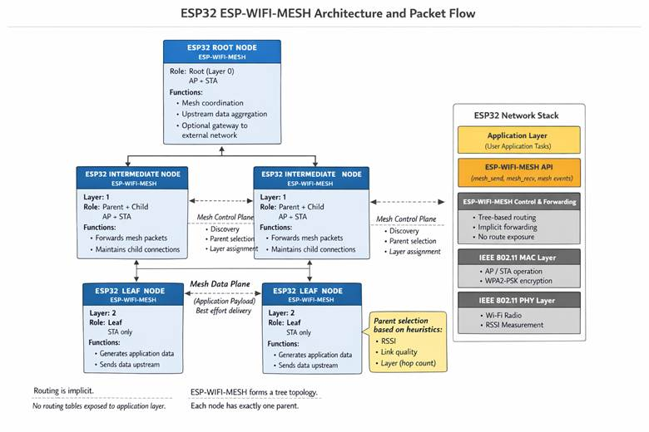

Figure 3.1 Architecture of ESP32-WFI-MESH
Figure 3.1 illustrates how ESP32 devices form a mesh network using ESP-WIFI-MESH and how data flows through it.

3.1.3. Control Plane vs. Data Plane Operations

3.1.3.1. Control Plane
The control plane handles network management and topology maintenance functions, including:
• Node Discovery: A node that is not yet part of the mesh scans for the beacons of existing mesh members to identify potential parents [21].
• Parent Selection: Nodes evaluate candidate parents by the layer of the candidate first and by the number of existing child connections second. RSSI enters the decision through thresholds rather than as a value to be maximized (Section 3.2.1) [21].
• Layer Assignment: Based on parent selection, a node’s layer is its parent’s layer plus one, so each hop from the root increases the layer number by one (the root is layer 1 in ESP-IDF and hop 0 in this thesis).
• Topology Maintenance: The mesh stack monitors the link to the parent and keeps the routing table up to date. Node failures or link degradation trigger parent re-selection, which lets the mesh heal itself [21].

3.1.3.2. Data Plane
The data plane carries application payloads through the mesh using best-effort delivery. Key characteristics include:
• Hop-by-Hop Forwarding: Packets traverse from source to destination through intermediate nodes, with each node forwarding toward the root (upstream) or away from the root (downstream) [21].
• Forwarding Discipline: When an application sends a packet to a destination several hops away, the mesh stack handles the forwarding entirely on the mesh layer [21], below the application, and the application is handed only the packets addressed to the node itself (esp_mesh_recv() receives a packet “targeted to self”) [75]. The application therefore has no per-hop view of whether a relay passed a packet on. To make forwarding observable, the testbed relays probes explicitly at the application layer on every node: each node sends its probes to its own parent using esp_mesh_send() with the MESH_DATA_P2P flag, and a node that receives a probe from a child with esp_mesh_recv() forwards it one hop upstream, counting the packets received, forwarded, and dropped [75, 76]. This explicit relay requirement establishes the behavioral baseline against which deviations can be observed.
• Queue Management: A node must also read the packets addressed to it regularly with esp_mesh_recv(), because the mesh RX queue should be checked regularly to avoid running out of memory [76].

From a theoretical standpoint, routing decisions in ESP-WIFI-MESH assume that locally observed metrics accurately reflect physical proximity and forwarding reliability. When these assumptions hold, the network exhibits stable packet propagation and predictable performance. Under normal operating conditions, ESP-MESH networks achieve packet delivery ratios exceeding 97% while maintaining packet loss and packet fault rates below 1.8% (Khan et al., 2022).

Table 3.1 ESP-WIFI-MESH Node Roles and Responsibilities
Node Type | Layer | Mode | Forwarding Responsibility | Primary Function
Root | 0 | STA + AP (to router) | Yes | Gateway to external networks
Intermediate | 1+ | AP/STA dual | Yes | Relay packets + generate traffic
Leaf | 2+ | STA only | No | Generate traffic only
This design enables simple, self-organizing connectivity but introduces inherent trust assumptions: forwarding nodes are expected to comply with protocol requirements, and locally observed metrics are trusted for routing decisions. When these assumptions are violated, the absence of centralized verification creates systemic vulnerabilities that can distort network behavior without violating protocol syntax.

3.2. Topology Formation and Physical Influences

3.2.1. RSSI Thresholds and Parent Selection
Parent selection in ESP-WIFI-MESH is governed by the layer of each candidate parent and by the number of children it already has [21]. RSSI is not a ranking metric: it enters the decision through the thresholds described below, which group candidates into signal ranges and flag weak links, but among acceptable candidates the shallowest layer wins and the child count breaks ties. RSSI therefore reflects physical proximity only indirectly, since a distant or obstructed candidate is more likely to have a weak link, without determining which parent is chosen.

3.2.1.1. RSSI Thresholding Mechanism
ESP-WIFI-MESH implements RSSI thresholding to prevent nodes from forming weak connections that could degrade network performance (Espressif Systems, 2023). The protocol defines three default RSSI thresholds:

Table 3.2 ESP-WIFI-MESH Default RSSI Thresholds
Threshold | Value | Significance
High | -78 dBm | Minimum acceptable RSSI for preferred parent relationships
Medium | -82 dBm | Intermediate threshold for parent evaluation
Low | -85 dBm | Threshold below which parent switching is triggered
These thresholds are defined in the ESP-WIFI-MESH internal header file (esp_mesh_internal.h) within the mesh_rssi_threshold_t structure [76]. Parent switching is controlled by separate parameters (the mesh_switch_parent_t structure, including its switch_rssi field) [76]. This study does not change any of these parameters; the firmware leaves them at their defaults.

3.2.1.2. Parent Selection Criteria
According to official ESP-WIFI-MESH documentation, the preferred parent node is determined based on two primary criteria (Espressif Systems, 2023):
- Layer Position: The layer of the candidate parent node—parents must reside at a lower layer than the connecting node.
- Child Count: The number of downstream connections the candidate parent node currently has.
When multiple candidates exist on the same layer, “the candidate with the fewest child nodes will be preferred” [21]. This load-balancing mechanism spreads connections across the available parents. It also means that parent choice depends on advertised values (layer and child count) that the joining node cannot verify, which is the kind of trust assumption that canonical routing attacks exploit.
The mesh_switch_parent_t structure further defines the switch_rssi parameter, which determines when a node will "disassociate with current parent and switch to a new parent when the RSSI is greater than this set threshold" (Espressif, 2023b). This mechanism enables dynamic topology adaptation but also provides an exploitation vector for nodes capable of advertising superior RSSI values.

3.2.2. Environmental Effects on Topology Formation
Physical environment characteristics significantly influence observed RSSI values and, consequently, the logical topology formed by ES-WIFI-MESH. Understanding these effects is essential for interpreting network behavior and designing controlled experiments.

3.2.2.1. Impact of Physical Obstacles
RF shielding objects—including walls, metal structures, furniture, and building materials—can dramatically attenuate wireless signals, reducing RSSI even when nodes are physically proximate [21]. This attenuation creates several important phenomena:
• A physically close node may be rejected as a parent candidate due to low RSSI caused by obstacles
• A physically distant node with a clear line-of-sight may become the preferred parent despite greater physical separation
• The resulting logical topology may differ significantly from the physical node layout
As illustrated in the Espressif documentation, an RF shielding object can cause nodes to disregard physically adjacent parent candidates and instead connect to more distant nodes with stronger signals [21]. This decoupling of physical and logical topology has important implications for experimental design and behavior interpretation.

3.2.2.2. Multi-path and Interference Effects
Indoor environments typically exhibit complex RF characteristics, including:
• Multi-path propagation causes signal fading and reinforcement
• Co-channel interference from other Wi-Fi networks
• Transient signal variations due to environmental changes
These factors introduce variability in RSSI measurements, which must be accounted for in the experimental design. Indoor environments with limited external interference improve repeatability and make ground-truth labeling easier. Because interference differs from site to site, the site of every run is recorded so that site-dependent effects can be examined during analysis.

3.2.2.3. Chain Formation in Linear Deployments
When nodes are arranged linearly—for example, along a hallway or corridor—the network can form a chain topology. In this testbed, the linear, partial, and star topologies are obtained by combining node placement with limits on the number of children and layers each node may accept. This configuration has distinct characteristics compared to branched tree topologies, including:
• Longer end-to-end paths with higher hop counts
• Single points of failure, where the failure of an intermediate node disconnects the nodes behind it
• Cumulative latency and packet loss effects
Understanding these environmental influences guides experimental testbed design and informs interpretation of observed network behaviors.

3.2.3. Logical vs. Physical Topology Relationships
Parent selection mediates the relationship between physical node placement and logical network topology: RSSI thresholds flag weak links, and the layer and child-count rules then choose among the remaining candidates (Section 3.2.1). This mediation creates several theoretically important relationships.

3.2.3.1. Hop Count and RSSI Relationship
Two ideas are easily confused and are kept apart in this thesis. First, the RSSI that a node reads with esp_wifi_sta_get_rssi() describes only the link between that node and its current parent. It is a per-link value; it is not accumulated along the path, so it does not add up with hop count, and there is no fixed attenuation per hop. Second, a node that is deeper in the tree is usually, but not always, physically farther from the root, and a longer link tends to have a weaker RSSI.
The relationship that can reasonably be assumed under normal conditions is therefore a loose, statistical one: nodes deeper in the tree tend to have per-link RSSI values that are no stronger than those of nodes closer to the root, and every link stays above the low threshold (-85 dBm) at which the stack reports a weak link (Table 3.2). In this thesis the hop count–RSSI relationship is treated as a tendency to be examined in the collected data, not as a fixed rule.

3.2.3.2. RSSI Reference Levels in ESP-WIFI-MESH
Rather than assuming fixed RSSI values for each position, this study reads the RSSI of every node’s parent link from the collected data. The thresholds in Table 3.2 are the only reference levels that the mesh stack itself defines; Table 3.3 shows the RSSI ranges they create.

Table 3.3 Expected RSSI Ranges by Node Position
Node Position | Expected RSSI Range | Relationship to Thresholds
Proximal to the router | ≈ -30 dBm | Far above high threshold (-78 dBm)
Normal parent node (Layer 1) | ≈ -50 to -78 dBm | Above or near the high threshold
Leaf node (Layer 2-3) | ≈ -78 to -85 dBm | Between high and low thresholds
Unstable connection | < -85 dBm | Below the low threshold—triggers parent switching

3.2.3.3. Topology Formation Principles
Based on these relationships, several principles govern topology formation:
- Layer Progression: Each node must connect to a parent at a strictly lower layer, ensuring hierarchical structure.
- Signal-Based Selection: Among candidates at acceptable layers, those with the strongest RSSI are preferred.
- Load Balancing: Among candidates with comparable RSSI, those with fewer children are preferred.
- Stability Maintenance: Nodes remain with their current parents unless a superior alternative appears or the current parent's RSSI degrades below thresholds.

These principles establish the theoretical baseline for normal network behavior against which attack-induced deviations can be observed. When malicious nodes manipulate RSSI advertisements or child count presentations, they can distort logical topology in ways that violate the expected relationships between physical placement and network structure.

3.3. Routing-Based Attack Theory

3.3.1. Blackhole Attack: Conceptual Foundation
Blackhole attacks are theoretically classified as routing-layer denial-of-service attacks in which a malicious node attracts network traffic by advertising favorable routing metrics and then drops the data packets it receives instead of forwarding them [43]. In the basic form the node drops all received data packets; in a selective variant it drops only some of them. The defining characteristic of a blackhole attack is not the transmission of malformed packets or explicit protocol violations, but the non-forwarding of data after a route through the attacker has been established.
Unlike attacks that disrupt routing syntax or corrupt packet structure, blackhole behavior exploits cooperative routing assumptions. The attacker participates in control-plane exchanges, thereby appearing legitimate to neighboring nodes while discarding data traffic.

3.3.1.1. Theoretical Characterization
Baadache and Belmehdi [44] likewise treat the blackhole as a node that attracts traffic and then refuses to forward it, creating a logical “hole” in the network. In the canonical form, the attacker takes part in route discovery, typically while advertising a falsely attractive route [43, 44].
The attack exploits a core assumption of multi-hop wireless mesh routing: that intermediate nodes will forward packets received on behalf of others. When this assumption is violated, end-to-end communication reliability degrades without immediate structural collapse of the routing topology.
The operational stages of a canonical blackhole attack can be conceptualized as:
• Attractor Phase: The malicious node advertises favorable routing metrics—such as lower hop count, stronger signal quality, or superior positioning—causing legitimate nodes to select it as a next-hop forwarder.
• Establishment Phase: The attacker becomes integrated into active routing paths and begins receiving packets from nodes while maintaining protocol-compliant control-plane participation.
• Execution Phase: The attacker discards received data packets instead of forwarding them, while continuing to maintain normal neighboring control-plane behavior to avoid detection.
Importantly, the routing structure may appear stable even while data forwarding behavior is compromised.
In the emulation used in this study, the attractor phase is replaced by placement: the blackhole is a legitimate mesh node positioned so that probe traffic passes through it (Section 3.5.3). The establishment and execution phases are reproduced as described.

3.3.1.2. Adaptation to ESP-WIFI-MESH Context
In ESP-WIFI-MESH, the mesh stack relays packets along the tree on its own, so a relay does not have to do anything for forwarding to happen. Because forwarding is not cryptographically enforced or verified, the protocol assumes that relay nodes comply cooperatively. In this study, forwarding is made explicit at the application layer (Section 3.1.3.2): every node relays probes hop by hop, and the blackhole node simply does not relay the probes it receives.
In this application-layer relay, a blackhole node therefore:
• Associates with the mesh through the normal process and acts as a parent node,
• Participates in mesh control exchanges,
• Receives packets from child nodes,
• Fails to forward those packets toward the root.
Since MAC-layer acknowledgments may still occur at the link level, upstream nodes may observe successful transmission even though end-to-end delivery fails. This decoupling of link-layer success from network-layer forwarding creates observable behavioral inconsistencies.

3.3.1.3. Theoretical Expectations for Observable Behavior
From a cross-layer observational perspective, blackhole behavior produces measurable deviations from normal forwarding relationships.
Network Layer
• Forwarding ratio significantly below unity (packets received > packets forwarded).
• Positive ingress–egress delta at the malicious node.
• Decreased packet delivery ratio for nodes downstream of the attacker.
• End-to-end packet loss without a corresponding topology change.
MAC Layer
• Successful link-layer acknowledgments despite end-to-end delivery failure.
• A possible increase in retransmission attempts by upstream nodes. Because the attacker still acknowledges the frames it receives, any such increase is expected to be small, and it is treated as a hypothesis to be tested (Table 3.4).
Physical Layer (PHY)
• RSSI patterns remain consistent with physical placement (unlike wormhole).
• No necessary distortion in signal strength or in the hop–layer relationship.
These observable effects form the theoretical basis for cross-layer telemetry collection in this study. The objective is not to define real-time detection rules, but to document how forwarding suppression manifests in measurable system behavior under controlled experimental conditions. This characterization supports subsequent exploratory data analysis and unsupervised clustering of behavioral patterns.

3.3.2. Wormhole Attack: Conceptual Foundation
Wormhole attacks are theoretically distinct from blackhole attacks in that they do not primarily rely on packet dropping, but on topology distortion. In its canonical form, a wormhole attack involves two colluding malicious nodes that establish a low-latency out-of-band communication channel and relay packets between distant parts of a wireless mesh network, thereby creating the illusion that physically remote nodes are direct wireless neighbors [46].
Unlike attacks that modify packet contents or violate protocol syntax, wormhole attacks exploit routing trust assumptions. By capturing packets at one location and replaying them at another with minimal delay, attackers artificially shorten perceived routing paths. As a result, nodes may believe that distant nodes are only one hop away, even though they remain separated by multiple legitimate intermediate nodes.

3.3.2.1. Theoretical Characterization
As described in the literature, during a wormhole attack a malicious node captures packets from one location in the network and tunnels them to another malicious node at a distant point, which replays them locally [45]. This tunnel may be implemented using an out-of-band channel, encapsulation, or high-speed relaying. The key requirement is that tunneled packets arrive faster or with fewer perceived hops than they would through legitimate multi-hop routing.
This process creates the illusion that the two endpoints of the tunnel are geographically close to each other. In routing protocols that rely on metrics such as hop count, signal strength (RSSI), or timing characteristics, this illusion significantly distorts the network’s logical topology.
Key theoretical properties of wormhole attacks include:
• Collusion Requirement: The attack requires at least two cooperating malicious nodes to establish the tunnel.
• Topology Distortion: The perceived logical network structure is altered without necessarily modifying packet contents.
• Stealth Operation: Attackers may remain absent from routing tables while still influencing or controlling traffic flows [45].
• Protocol Independence: Wormhole attacks can be launched without compromising cryptographic keys or altering legitimate nodes [45, 46].

3.3.2.2. Adaptation to ESP-WIFI-MESH Context
In ESP-WIFI-MESH, parent selection relies on the layer and child count of candidate parents, with RSSI acting through thresholds (Section 3.2.1). A canonical wormhole would therefore attract routing decisions toward a tunnel endpoint if the tunnel made that endpoint appear closer to the root or better connected than it is. Nodes might switch parents toward a malicious endpoint because it appears to offer:
• A shallower layer (closer to the root),
• A link strong enough to pass the RSSI thresholds,
• More attractive routing characteristics, such as a lower child count.
Importantly, this distortion occurs without overt protocol violations. Control-plane exchanges remain syntactically valid, and the routing state appears internally consistent from the perspective of individual nodes. The inconsistency only becomes evident when comparing physical deployment constraints with observed routing relationships.
In this study, the wormhole is emulated rather than implemented at the protocol level. Two testbed nodes are connected by a wired UART link that serves as the out-of-band tunnel: the entry node (Node B) copies each of its own probes into the tunnel, and the exit node (Node A), which is the shallower of the two nodes in the mesh, re-injects the copies into the mesh near the root. The root keeps both copies, so the same probe arrives twice, once through the legitimate multi-hop path and once through the tunnel, and the two arrivals differ in latency. This duplicate-arrival and latency-mismatch pattern is the signature that the emulation produces and that the telemetry is designed to capture. The roles of the two ends are assigned at run time according to node depth, so that the tunnel is a shortcut toward the root, and no node is designated as a victim. The mesh stack does not use the tunnel for routing, so it causes no parent switches or hop-count changes. The topology effects described in Section 3.3.2.3 are therefore the theoretical expectation for a canonical wormhole, and Chapter 4 reports which of them were observed.

3.3.2.3. Wireless Topology Distortion
From a routing-theoretic perspective, a canonical wormhole that the mesh adopts produces structural inconsistencies in the mesh:
• Nodes may form parent–child relationships that bypass legitimate intermediate layers.
• Hop counts may decrease abruptly without corresponding changes in physical node placement.
• Routing tables may reflect physically implausible neighbor relationships.
• Logical proximity may no longer correspond to physical proximity.
This results in a decoupling of the physical and logical topologies. Under normal conditions, physical signal propagation mediates the routing structure. Under canonical wormhole conditions, the artificial tunnel overrides these physical constraints. Because the emulated tunnel is not adopted by the mesh, these structural effects are not expected in the collected runs; the analysis nevertheless checks for them.

3.3.2.4. Cross-Layer Effects of Wormhole Distortion
Although wormhole attacks originate at the routing level, their effects propagate across protocol layers. Theoretical expectations for a canonical wormhole include the following; of these, the emulated tunnel is designed to reproduce the duplicate-arrival and timing effects.
Network Layer
● Unexpected reductions in hop count relative to physical layout.
● Parents switch events toward physically distant nodes.
● Routing entries are inconsistent with deployment constraints.
● Apparent one-hop relationships between nodes separated by multiple legitimate hops.
Physical Layer (PHY)
● RSSI values are inconsistent with expected distance-based attenuation.
● Violations of the typical relationship between hop count and signal strength.
● Abrupt signal-strength changes without physical repositioning.
MAC Layer
● Abnormal frame arrival timing due to tunnel relay.
● Potential duplicate or out-of-order frame patterns.
● Local retransmission anomalies near tunnel endpoints.
These cross-layer inconsistencies form the theoretical basis for telemetry collection in this study. The objective is not to prescribe real-time detection mechanisms, but to document how the effects of a tunnel manifest in measurable system behavior under controlled experimental conditions. This observational characterization supports subsequent exploratory analysis and unsupervised clustering of behavioral patterns in later chapters.

3.4. Cross-Layer Telemetry Perspective

3.4.1. Why Routing Violations Affect Multiple Protocol Layers
Routing-based misbehavior in wireless mesh networks does not remain confined to the network layer where it originates. Instead, routing violations can produce correlated effects across multiple protocol layers due to the interdependent nature of wireless communication. Understanding these cross-layer effects is essential for designing telemetry that captures the behavioral signature of network anomalies.

3.4.1.1. Physical Layer Effects
Routing manipulations influence physical layer observables through several mechanisms:
• RSSI–Hop Correlation Disruption: Under normal operation, a node’s per-link RSSI tends to be weaker for nodes that are deeper in the tree (Section 3.2.3). If a wormhole made the mesh adopt an artificial shortcut, a node could report a hop count that is inconsistent with its link RSSI.
• Signal Consistency Patterns: Each link along a legitimate multi-hop path has its own RSSI, which follows the physical layout. Attack-induced topology distortion would add abrupt, unexplained changes in a node’s link RSSI when it re-attaches elsewhere.
• Transmission Power Artifacts: A malicious node could transmit at a different power level than legitimate nodes, creating inconsistencies in received signal strength relative to distance. All nodes in this study use the same default transmit power, so this mechanism is not exercised.

3.4.1.2. MAC Layer Effects
Link-layer behavior may respond to routing anomalies through:
• Retransmission Dynamics: 802.11 retransmissions occur when a link-layer acknowledgment is missing. Packets that are dropped above the MAC (blackhole) are still acknowledged, so a large rise in retransmissions is not necessarily expected, and retransmissions are expected to reflect channel conditions as well. In this study, retransmission evidence comes from the Retry bit of the 802.11 frames captured by the sniffer (reported as MacRetryRate). The node-side retry_count column is an application-layer counter of failed send attempts and is not an 802.11 retransmission count.
• Acknowledgment Patterns: MAC-layer acknowledgments may succeed even when network-layer forwarding fails, creating an observable dissociation between link-level and end-to-end delivery success.
• Channel Access Contention: Extra traffic created by an attack, such as the duplicated probes of a wormhole tunnel, could in principle raise channel contention. The ESP32 does not expose contention counters, so this effect is not measured directly.

3.4.1.3. Network Layer Effects
The network layer directly manifests routing anomalies through:
● Forwarding Ratio Deviations: The relationship between packets received and packets forwarded provides direct visibility into forwarding compliance.
● Topology Consistency: Parent-child relationships, hop counts, and routing table entries reflect the logical network structure, which may diverge from physical reality under attack.
● End-to-End Delivery Metrics: Packet delivery ratio, loss rate, and latency patterns capture the ultimate effect of routing manipulation on application-layer communication.

3.4.2. Collected Metrics and Data Sources
Received Signal Strength Indicator (RSSI)
RSSI values are collected using the ESP32 Wi-Fi driver API (esp_wifi_sta_get_rssi()). Measurements are sampled at fixed intervals (10 times per second in this study) during each experimental run and logged with timestamps. Each reading describes the link between the node and its parent; it is a per-link value, not a cumulative path value.
RSSI Variation Over Time
Temporal changes in RSSI are not computed on-device; instead, they are derived during dataset preprocessing by comparing successive samples within fixed observation windows.
Transmit Power Configuration (Metadata)
All nodes use the same default transmit power (the ESP-IDF default maximum of 20 dBm), and no run changes it. It is documented as configuration metadata to ensure consistent radio conditions across experimental trials, and it supports reproducibility and contextual interpretation of signal behavior. Physical-layer metrics provide context for interpreting routing and forwarding behavior by distinguishing between environmental wireless variability and structural network effects.

3.4.3. Temporal Aggregation of Cross-Layer Telemetry
Wireless network telemetry, particularly at the physical and MAC layers, exhibits rapid fluctuations due to environmental factors, transient interference, and normal protocol dynamics. Individual 10 Hz samples of RSSI, retransmission counts, or parent state may reflect momentary conditions rather than stable behavioral patterns. Therefore, for meaningful analysis, raw telemetry must be aggregated over appropriate time windows.
This study adopts a temporal aggregation approach in which raw 10 Hz samples are grouped into fixed-duration windows (1 second in this study). Within each window, raw counters are converted to deltas, and continuous metrics are summarized using statistical descriptors (mean, variance, minimum, maximum). This aggregation serves several purposes:
- Noise Reduction: Aggregation smooths out transient fluctuations, revealing underlying behavioral trends.
- Pattern Capture: Many attack-induced effects (e.g., increased parent switching, forwarding ratio degradation) manifest over periods of seconds rather than individual packet events.
- Statistical Robustness: Derived features such as forwarding ratio require sufficient samples to produce stable estimates; windowing ensures this.
- Cross-Layer Alignment: Windowing enables correlation of metrics from different layers within the same temporal context.
The choice of window duration (1 second) balances the need for sufficient samples with the desire to capture attack-induced behavioral changes that may persist for minutes.

3.4.4. Expected Observable Inconsistencies
Based on analyses of blackhole and wormhole behavior, specific cross-layer inconsistencies are expected to manifest for each attack type. Tables 3.4 and 3.5 record these expectations as they were formulated before data collection, except for the last two rows of Table 3.5 (see the note below that table). They are predictions to be tested, not findings; Chapter 4 reports which of them were observed in the collected runs and which were not.

3.4.4.1. Expected Blackhole Observables

Table 3.4 Expected Observable Inconsistencies Under Blackhole Behavior
Layer | Metric | Expected Deviation
Network | Forwarding Ratio | < 1.0 at attacker node (packets received but not forwarded)
Network | Ingress/Egress Delta | > 0 at attacker node (positive difference indicating packets absorbed)
Network | Packet Delivery Ratio | Decrease for victims downstream of the attacker
MAC | Retransmission Count | Increase for victim nodes (repeated attempts with no acknowledgment)
PHY | RSSI | Stable at attacker (positioning unchanged throughout)

3.4.4.2. Expected Wormhole Observables

Table 3.5 Expected Observable Inconsistencies Under Wormhole Behavior
Layer | Metric | Expected Deviation
Network | Hop Count Consistency | Nodes report unexpectedly low hop counts given physical placement
Network | Parent-Child Validity | Relationships violate physical constraints (e.g., Layer 4 child of Layer 0)
Network | Routing Table Entries | Self-referential entries or impossible neighbor relationships
PHY | RSSI-Hop Correlation | High RSSI observed from physically distant nodes
PHY | RSSI Variance | Abnormally high RSSI values are inconsistent with the expected path loss
MAC | Frame Arrival Pattern | Duplicates or out-of-order frames due to tunneling
MAC | Retransmission Count | May increase near tunnel endpoints due to timing issues
Network | Duplicate Arrivals | The same probe reaches the root twice, through the multi-hop path and through the tunnel
Network | Latency Mismatch (TunnelLatency) | The two arrivals of one probe differ in latency

3.4.4.3. Timing and Latency Inconsistencies
Both attack types may produce timing anomalies:
• Blackhole: End-to-end latency for successful packets may remain normal, but packet loss creates apparent “gaps” in traffic flow.
• Wormhole: Packets may arrive faster than physically possible, given the claimed hop count, or exhibit abnormal inter-arrival patterns due to tunnel latency variations. In the emulated tunnel, this appears as the latency difference between the two arrivals of the same probe.

3.4.5. Expected Observable Inconsistencies
The cross-layer telemetry perspective adopted in this study serves a specific purpose: characterizing how routing misbehavior manifests across protocol layers in a real ESP32 mesh network. This observational framework is explicitly distinguished from intrusion detection—the goal is not to identify attacks in real time, but to document behavioral patterns for subsequent exploratory analysis.

3.4.5.1. Observational Objectives
• Baseline Characterization: Establish empirical baselines for cross-layer metrics under normal operating conditions across multiple topology configurations.
• Deviation Documentation: Record how metrics change when the controlled attack behaviors are introduced, capturing the observable signature of each misbehavior type across layers.
• Pattern Identification: Enable exploratory analysis to identify which metrics consistently differentiate normal from manipulated behavior.
• Feature Selection Guidance: Provide an empirical basis for selecting features most informative for behavioral characterization, supporting future research without pre-committing to specific detection approaches.

3.4.5.2. Methodological Principles
The cross-layer observation framework follows several methodological principles:
• Non-intervention: The measurement does not attempt to correct anomalies or to change the mesh’s routing decisions; the attack behaviors are the only intended intervention.
• Comprehensive Coverage: Metrics are collected from the PHY, MAC, and network layers to capture correlated effects.
• Ground Truth Alignment: Observations are time-stamped and labeled according to controlled experimental conditions.
• Reproducibility Focus: Collection methods are documented to enable replication and extension.

3.4.5.3. Distinction from Detection System
This observational approach differs fundamentally from intrusion detection systems:

Table 3.6 Distinction Between Cross-Layer Observation and Intrusion Detection
Aspect | Cross-Layer Observation (This Study) | Intrusion Detection System
Purpose | Characterize behavior | Identify and alert on attacks
Timing | Offline analysis | Real-time or near-real-time
Decision Making | None (data collection only) | Automated response or alerting
Performance Metrics | Data quality, completeness | Detection accuracy, latency
Output | Labeled dataset | Alerts, classifications
By maintaining this distinction, the study focuses on its core contribution: a hardware-derived, cross-layer dataset documenting ESP-WIFI-MESH behavior under normal and manipulated conditions, suitable for subsequent exploratory analysis by the research community.

3.5. Conceptual Framework of the Study

3.5.1. Normal Behavior as Consistent Relationships
Based on the theoretical foundations established in preceding sections, normal ESP-WIFI-MESH operation is characterized by consistent, predictable relationships among observable network metrics. These relationships arise from the protocol’s design principles and the physical constraints of wireless communication.

Table 3.7 Consistent Relationships in Normal ESP-WIFI-MESH Operation
Relationship | Theoretical Basis | Expected Consistency
Hop Count ↔ RSSI | Monotonic signal degradation with distance | RSSI decreases predictably as hop count increases
Reception ↔ Forwarding | Protocol forwarding requirement | Packets received ≈ packets forwarded (ratio ≈ 1.0)
Parent ↔ Child Layer | Hierarchical structure | Parent layer < child layer
Physical ↔ Logical Topology | RSSI-based parent selection | Logical topology reflects physical proximity (mediated by obstacles)
Transmission ↔ Acknowledgment | MAC-layer reliability | Successful transmissions receive timely acknowledgments
These relationships serve as the baseline against which deviations can be observed. When the network operates normally, these relationships hold consistently across time and topology configurations.

3.5.2. Misbehavior as Broken Relationships
Routing-based misbehavior fundamentally disrupts the relationships that characterize normal operation. Both blackhole and wormhole attacks break specific relationships in theoretically predictable ways.

3.5.2.1. Blackhole: Broken Reception-Forwarding Relationship
The defining characteristic of blackhole behavior is the decoupling of packet reception from packet forwarding:
● Normal: reception → forwarding (causal link preserved)
● Blackhole: reception → NO forwarding (causal link broken)
This broken relationship manifests in multiple observable indicators:
● Forwarding ratio deviates from unity
● Ingress/egress delta becomes positive
● Victims experience packet loss despite successful reception at the attacker

3.5.2.2. Wormhole: Broken Physical-Logical Topology Relationship
Wormhole behavior disrupts the expected correspondence between physical node placement and logical network topology:
● Normal: physical proximity → strong RSSI → parent selection
● Wormhole: forged advertisements → strong RSSI perception → parent selection WITHOUT physical proximity

This broken relationship manifests through:
● Violation of monotonic RSSI-hop correlation
● Physically impossible parent-child relationships
● Routing tables are inconsistent with node placement

3.5.3. Experimental Emulation of Routing Manipulations
In controlled experimental research on wireless mesh networks, it is not always feasible or necessary to implement attacks exactly as they would occur in the wild. Full protocol-level exploitation—such as raw 802.11 frame capture and replay for wormhole attacks, or falsified routing advertisements—often requires low-level driver access and firmware modifications that may be unavailable or impractical on commercial microcontroller platforms like the ESP32. Furthermore, such low-level implementations introduce significant complexity and may raise safety or ethical concerns.
Therefore, this study adopts an experimental emulation approach to routing-based misbehavior. Rather than replicating the exact low-level mechanics of blackhole and wormhole attacks, the methodology focuses on reproducing their observable forwarding and timing effects within a controlled testbed. This approach is justified on several grounds:

- Platform Constraints: The ESP32's closed-source Wi-Fi firmware and limited access to raw frame injection make true protocol-layer attacks difficult to implement reliably across firmware versions. Application-layer emulation ensures reproducibility and platform compatibility.
- Behavioral Focus: The primary research objective is to generate a dataset of cross-layer telemetry under both normal and manipulated conditions. The specific mechanism by which manipulation is achieved is secondary to the resulting behavioral patterns. As long as the emulation produces the same observable inconsistencies (e.g., forwarding ratio degradation, hop-count anomalies, RSSI-hop mismatches), the dataset remains valid for exploratory analysis.
- Controlled Activation: Emulation allows precise temporal control over manipulation windows, enabling clean ground-truth labeling that would be difficult to achieve with true protocol exploits that may have variable activation timing.
- Ethical Considerations: Application-layer emulation operates entirely within the normal bounds of mesh communication, avoiding any risk of unintended network disruption or security compromise beyond the controlled testbed.

The blackhole emulation reproduces forwarding suppression: a legitimate mesh node drops the probes that it is asked to relay (Section 3.3.1.2). Traffic reaches it through its position in the topology, as a relay on the path or as the hub of a star, and not through any manipulation of mesh routing. The wormhole emulation reproduces the tunnel itself: a wired UART link carries copies of one node’s probes to a second node near the root, which re-injects them into the mesh (Section 3.3.2.2), and the mesh does not use this link for routing. Neither emulation changes parent selection, the mesh stack, or the 802.11 frames, so both keep the protocol fully compliant and the experiments reproducible. As a result, the emulations reproduce the forwarding and timing inconsistencies described in this chapter, but not the routing-state inconsistencies of a wormhole that the mesh adopts.

3.5.4. Secondary Broken Relationships
Both attack types may induce secondary relationship disruptions:
• MAC-Network Layer Consistency: MAC-layer success may persist despite network-layer failure (blackhole) or abnormal timing (wormhole)
• End-to-End Reliability Expectations: Packet delivery falls below the benign baseline measured in this study
• Topology Stability: With a canonical attack, parent-switching frequency may increase as nodes react to abnormal conditions. The emulations used here are not expected to cause parent switches, and parent changes are recorded to verify this.

3.5.5. These Inconsistencies Motivate Dataset Collection
The theoretical framework developed in this chapter establishes a clear rationale for dataset collection: documenting how routing-based misbehavior disrupts the consistent relationships that characterize normal ESP-WIFI-MESH operation.

3.5.5.1. Theoretical Justification for Dataset Requirements

Table 3.8 Theoretical Basis for Dataset Design Requirements
Requirement | Theoretical Basis
Cross-layer feature collection | Attacks affect multiple protocol layers simultaneously.
Hardware-based generation | Real RF dynamics and protocol timing cannot be simulated accurately.
Multiple topology configurations | Relationship consistency varies with network structure.
Controlled attack scenarios | Enables observation of specific relationship disruptions
Ground truth labeling | Essential for identifying which relationships break under which conditions

3.5.6. Exploratory Behavioral Analysis and Pattern Discovery
Given that the precise manifestations of routing misbehavior in real ESP32 hardware are not fully characterized a priori, this study adopts an exploratory analytical approach. Rather than assuming known attack signatures, the methodology employs unsupervised techniques to examine whether normal and manipulated network states form separable patterns in the feature space.
This approach is justified on several grounds:
- Unknown Behavioral Signatures: While theoretical expectations exist (e.g., forwarding ratio degradation for blackhole, RSSI-hop mismatch for wormhole), how these manifest in real hardware under controlled conditions is an empirical question. Unsupervised discovery allows patterns to emerge without imposing pre-conceived classifications.
- Natural Separability Hypothesis: If the theoretical framework is correct—if forwarding suppression and topology distortion indeed produce distinct, measurable cross-layer inconsistencies—then normal and manipulated behavioral states should form separable clusters in the multidimensional feature space. Clustering serves as a validation mechanism for this theoretical prediction.
- Anomaly Discovery Orientation: The DBSCAN algorithm's ability to identify noise points aligns with the possibility that some experimental windows may exhibit transitional or mixed behaviors not cleanly belonging to any single category. These points can be examined separately to understand boundary conditions between behavioral states.
- Avoidance of Overfitting: Supervised classification would require partitioning the limited dataset into training and test sets, potentially overfitting to specific experimental conditions. Unsupervised clustering uses all available data to discover structure, making no assumptions about which windows correspond to which labels until after clustering is complete.
- Alignment with Research Objectives: The study's primary objective is to generate a dataset and explore its structure, not to build a deployable classifier. Clustering directly supports this objective by revealing whether the collected features capture meaningful distinctions between behavioral states.
- Multivariate Nature of Anomalies: As established in Section 3.4, routing attacks create correlated inconsistencies across multiple protocol layers. Relying on a single metric (e.g., a low forwarding ratio) could lead to false positives or miss subtle, sophisticated manipulations. Therefore, the analysis must consider the combined, multivariate state of features to capture the full behavioral signature of an attack, a principle that motivates the subsequent feature selection and clustering methodology.
Thus, the conceptual framework positions normal behavior as consistent relationships and misbehavior as broken relationships, with the expectation that these broken relationships will manifest as separable behavioral states in the feature space.

3.5.7. Expected Contribution
The dataset generated under this theoretical framework will enable:
- Empirical Validation: Testing whether theoretically expected relationship disruptions actually manifest in real hardware.
- Pattern Discovery: Identifying which metrics most consistently indicate specific types of misbehavior.
- Baseline Establishment: Documenting normal relationship ranges across topologies for future comparison.
- Feature Prioritization: Determining which cross-layer features are most informative for behavioral characterization.

MIGHT NEED TO RE-DRAW

3.5.8. Framework Summary
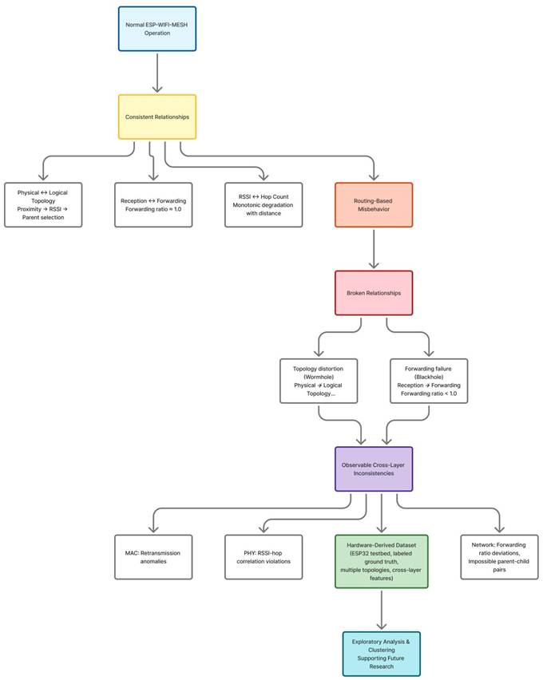

Figure 3.2 Conceptual Framework of the Study
Figure 3.2 presents the conceptual framework of this study, illustrating the progression from wireless mesh networking theory to the generation of an empirical dataset and exploratory analysis. Wireless mesh theory establishes the operational properties of ESP-WIFI-MESH and the baseline relationships expected during normal operation (e.g., the tendency of per-link RSSI to weaken with depth, hierarchical parent–child layering, and receive–forward consistency at relay nodes). Routing-based misbehavior is then described as the disruption of these expected relationships, where forwarding suppression alters packet propagation patterns and a wormhole tunnel alters packet arrival timing (and, for a canonical wormhole that the mesh adopts, the correspondence between physical signal conditions and logical routing structure).
Building on these foundations, the study adopts a cross-layer telemetry perspective to justify why disruptions at the routing level may produce observable inconsistencies across the PHY, MAC, and network layers. Importantly, this framework is observational rather than detection-oriented: it does not define real-time decision rules or claim operational attack identification. Instead, it motivates collecting cross-layer indicators and ground-truth labels so that subsequent EDA and unsupervised clustering can examine whether normal and manipulated runs exhibit separable behavioral structure in the feature space. In this way, the framework directly informs feature selection and experimental design in Chapter 4 and provides the interpretive lens for the exploratory analyses in later chapters.
The theoretical relationships and observable deviations described in this chapter guide the experimental design and dataset generation procedures presented in Chapter 4. By grounding the dataset in established wireless mesh theory and attack theory, the study aims to collect telemetry that captures behaviorally meaningful patterns and can support future research on intrusion detection and network analysis.

4. Research Design
This study follows an experimental system-development approach focused on the construction and observation of an ESP32-based ESP-WIFI-MESH network. The methodology describes how the testbed is built, how controlled network behaviors are introduced, and how cross-layer data are collected to support anomaly analysis. The testbed and both controlled behaviors are implemented, and the data-capture campaign is under way. This chapter therefore describes the workflow as it is implemented and marks the items that depend on runs that are not yet captured. The study aims to observe how mesh networking behavior evolves under both baseline and adversarial conditions.

The methodology is organized into three working stages:
- Mesh network configuration using ESP32 devices.
- Implementation of controlled network behaviors that resemble known routing anomalies.
- Capture of cross-layer network metrics, followed by offline preprocessing, feature extraction and analysis.

The stages overlap. While the remaining runs are captured, the offline analysis tools are applied to the runs that already exist, and the capture procedure is adjusted whenever a verification step shows a problem. The capture and analysis tools are kept in the project repository [79].

4.1. Architectural Design
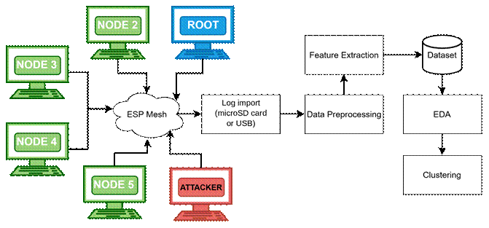

Figure 4.1 Architecture Design
The architectural design in Figure 4.1 illustrates the complete experimental workflow of the study, showing how data flows from the physical ESP32 mesh network through a structured processing pipeline to produce analytical results. The ESP-WIFI-MESH testbed consists of multiple ESP32 nodes, including a root node, several regular nodes, and attacker nodes, which together form a wireless mesh network that generates telemetry data during experimental runs.

Each node samples its cross-layer measurements at 10 Hz and writes them to its own log, on internal flash and on a microSD card. After a run, the logs are brought to a laptop, either by removing the cards and reading them together in a card reader, or by pulling each log over USB serial. The Data Collector step of Figure 4.1 is therefore a file import and not a live collection over the mesh. The imported files are placed in one folder tree by attack, topology, site and scenario, where the Data Preprocessing stage reads them. Preprocessing aligns the timestamps and aggregates the measurements into one-second windows.
A laptop that is not part of the mesh runs an 802.11 sniffer during the captures that use one. It only listens, and it gives an independent record of the frames on the channel, so the evidence for an attack does not rest only on the attacker counting its own drops.
Next, Feature Extraction transforms the preprocessed windows into meaningful behavioral metrics such as forwarding ratios, MAC retry rates observed by the sniffer, hop stability indicators, and RSSI–hop inconsistency values. These computed metrics form the structured Dataset, which contains engineered features together with the ground-truth phase labels corresponding to baseline operation, blackhole manipulation, and wormhole manipulation.
Finally, Exploratory Data Analysis (EDA) and Clustering are applied to this dataset. EDA is used to examine the statistical properties of the data and visualize behavioral patterns, while clustering is performed to determine whether normal operation, blackhole behavior, and wormhole-induced anomalies form separable groups within the feature space.

4.2. Experimental Topology and Controlled Behavior Framework
This section describes the experimental implementation of two routing manipulations—forwarding suppression (blackhole emulation) and topology distortion (wormhole-inspired emulation)—designed to generate labeled telemetry data in the ESP-WIFI-MESH testbed. Both attacks are implemented at the application layer without modifying the underlying ESP-WIFI-MESH firmware. Manipulations are activated only during controlled experiment windows, with the root node broadcasting phase transitions to all mesh participants. All telemetry is logged locally on each node and retrieved post-experiment for offline analysis.

4.2.1. Attack Implementation: Wormhole and Blackhole Manipulations
This section describes the experimental implementation of two routing manipulations—forwarding suppression (blackhole emulation) and topology distortion (wormhole-inspired emulation)—designed to generate labeled telemetry data in the ESP-WIFI-MESH testbed. Both attacks are implemented at the application layer without modifying the underlying ESP-WIFI-MESH firmware. Manipulations are activated only during controlled experiment windows, with the root node broadcasting phase transitions to all mesh participants. All telemetry is logged locally on each node and retrieved post-experiment for offline analysis.

4.2.1.1. Common Experiment Control Infrastructure
All experiments share a common control infrastructure managed by the root node. This infrastructure ensures consistent phase timing, synchronized manipulation activation, and reliable ground-truth labeling across all network participants.

A. Phase Definition and Labeling
Each experimental run follows a fixed temporal structure with distinct phases. Two parallel numbering schemes are maintained:
● Phase ID: Used for experiment orchestration and broadcast messaging (0 to 4). A further announcement, 254, is sent while the mesh forms and is not a phase.
● Ground-Truth Label: Embedded in telemetry records for offline analysis (0, 1 or 2). A row that was logged before the first phase was heard carries 255, meaning no ground truth.

Table 4.1 Phase Definition and Labeling
Phase ID | Ground-Truth Label | Duration | Phase Name | Description
254 | 255 | 60s or Longer | Formation | The mesh forms. The root announces PREPARE every 5 s, and the nodes log their rows without a label. These rows are excluded from the analysis.
0 | 0 | 300 s | Baseline | Normal mesh operation; no manipulation active
1 | 1 | 180 s | Blackhole Manipulation | Forwarding suppression enabled
2 | 2 | 180 s | Wormhole Manipulation | Tunnel‑based shortcut enabled
3 | 0 | 120 s | Cooldown | Manipulation disabled; network stabilization
4 | — | — | Terminate | Experiment end; logs ready for extraction
Note: The root broadcasts the Phase ID, together with a sequence number, a timestamp and a session identifier. Each node maintains a local mapping from Phase ID to Ground-Truth Label, which is appended to every telemetry record for offline analysis. The formation period lasts at least 60 s and continues until every expected child is present in the root's routing table and until the pre-run gates pass and the operator types START (D-22). A failed pre-run check also locks START in the operator’s tool; an override needs a typed reason, is written to the run log and is reported by the verifier (D-24). In a benign stationary or highload run the attack window is skipped. A benign burst run keeps a window of attack length, so that its burst fires at the same offset as in the matched attack run.
B. Root Phase Controller Implementation
As shown in Figure 4.2, the root node executes a controller that manages the sequence of experiment phases, including formation, baseline, manipulation (blackhole or wormhole), cooldown, and termination. Each phase update is sent to every node in the root's routing table as an individual peer-to-peer message, with one additional copy sent to the root itself. A transition is sent in five rounds, 100 ms apart, that carry the same sequence number, so a node that receives more than one copy applies the transition once. The root also repeats the last phase unchanged every 10 s, so that a node that rejoins the mesh during a phase adopts it. A session identifier drawn when the root boots lets a node tell a restarted root from a repeated message.

Figure 4.2 Root Phase Controller
procedure EXPERIMENT_CONTROLLER(experiment_type):
/**
* Controls the timeline of a single experimental run.
*
* Input:
* experiment_type: "none" (benign), "blackhole" or "wormhole"
*
* Behavior:
* - Announces PREPARE while the mesh forms and waits for every child
* - Broadcasts each phase transition (repeatedly) to all mesh nodes
* - Logs phase start/end events with timestamps
* - Activates the manipulation through the phase broadcast
*/

// Formation: 60 s, rows are logged unlabelled (255)
for second = 0 to 59:
if second mod 5 == 0:
broadcast_prepare() // phase 254
sleep_until_next_second()
wait_until_all_children_in_routing_table()

// Phase 0: Baseline (5 minutes)
current_phase ← 0
broadcast_phase_repeated(current_phase, 5) // 5 rounds
log_event("PHASE_START", current_phase, get_time())
sleep(300)
log_event("PHASE_END", current_phase, get_time())

// Phase 1 or 2: Manipulation (3 minutes)
if experiment_type == "blackhole":
current_phase ← 1
else if experiment_type == "wormhole":
current_phase ← 2
if experiment_type != "none":
broadcast_phase_repeated(current_phase, 5)
log_event("PHASE_START", current_phase, get_time())
sleep(180)
log_event("PHASE_END", current_phase, get_time())

// Phase 3: Cooldown (2 minutes)
current_phase ← 3
broadcast_phase_repeated(current_phase, 5)
log_event("PHASE_START", current_phase, get_time())
sleep(120)
log_event("PHASE_END", current_phase, get_time())

// Phase 4: Terminate, repeated for 60 s
current_phase ← 4
broadcast_phase_repeated(current_phase, 5)
for t = 5 to 60 step 5:
sleep(5)
broadcast_phase_repeated(current_phase, 5)
log_event("EXPERIMENT_END", current_phase, get_time())
end procedure

procedure broadcast_phase_repeated(phase, rounds):
/**
* Sends the current phase to every node, several times.
* Message format: { magic, phase_id, seq_num, timestamp, session_id }.
* All rounds of one call share the same seq_num.
*/
message ← pack(phase, next_seq(), get_time(), session_id)
for i = 1 to rounds:
esp_mesh_send(NULL, message, MESH_DATA_FROMDS) // copy for the root itself
for each node in esp_mesh_get_routing_table():
esp_mesh_send(node, message, MESH_DATA_P2P) // one unicast per node
end for
sleep(100) // short delay between rounds
end for
end procedure

C. Node-Side Phase Monitoring
Every mesh node runs a background monitoring task that continuously listens for phase messages from the root node, as implemented in Figure 4.3. When a message with a newer sequence number is received, the node updates its local phase state and corresponding ground-truth label. Copies with an older or equal sequence number are ignored. A message from a different session identifier is treated as a new run: the node forgets the old sequence numbers and its phase until the new root announces one. This mechanism ensures that all nodes remain synchronized with the experiment timeline while maintaining consistent labeling of the collected dataset.
.

Figure 4.3: Node Phase Monitor
// Global state maintained by each node
int current_phase_id = 255 // 255 = no phase heard yet
int ground_truth_label = 255
uint32_t last_seq = 0
uint32_t session_id = 0
mutex phase_mutex

procedure PHASE_MONITOR_TASK():
while experiment_active:
message ← esp_mesh_recv(portMAX_DELAY)

if is_phase_broadcast(message):
(received_phase, seq, session) ← unpack(message)

if session != session_id: // the root restarted: a new run
session_id ← session
last_seq ← 0
current_phase_id ← 255
ground_truth_label ← 255
end if

if seq > last_seq:
last_seq ← seq

if received_phase == 254: // PREPARE: start logging, keep rows unlabelled
open_log()
else:
lock(phase_mutex)
current_phase_id ← received_phase

// Map phase ID to ground-truth label
if received_phase in {0, 3, 4}:
ground_truth_label ← 0 // cooldown and terminate are labeled 0
else:
ground_truth_label ← received_phase // 1 = blackhole, 2 = wormhole
unlock(phase_mutex)

log_event("PHASE_UPDATE", received_phase, ground_truth_label, get_time())
end if
end if
end if
end while
end procedure

function get_current_label():
lock(phase_mutex)
label ← ground_truth_label
unlock(phase_mutex)
return label
end function

4.2.1.2. Forwarding Suppression (Blackhole) Implementation
The blackhole attacker operates as an application-layer relay. Every node sends its own application-layer probe packets to its parent, using the peer-to-peer data flag of the ESP-IDF mesh API [75], [76], and relays the probes it receives one hop upstream, keeping counters for packets received, forwarded and dropped. The blackhole attacker runs the same relay as every other node, with one switch that turns forwarding off during the manipulation window. This follows Section 3.1.3.2 and Table 4.2. It also means that the forwarding features exist on every relaying node and not only on the attacker. The attacker remains a legitimate mesh participant, maintaining its parent relationship and responding to control messages. Because it is placed in the forwarding path, the position of the attacker decides which traffic it intercepts. Captures made before hop-by-hop relaying was introduced are not comparable with later ones and are excluded from pooled analysis.

In the star topology the attacker is the hub: the root sits one hop behind it, and every victim connects to the hub (Section 4.2.2.1).
The attack keeps the name Forwarding Suppression. The attacker is placed in the forwarding path and does not lure traffic with a falsely advertised route. The route-advertisement half of a classical blackhole, in which the attacker advertises a false low rank so that nodes choose it as parent [70], is therefore not reproduced.

The blackhole is an application-layer emulation. ESP-WIFI-MESH forms a tree by itself: each node selects its parent from the candidates it can hear, preferring the one on the shallowest layer and then the one with the fewest children, and each node keeps its own routing table [21]. The documentation describes a way to read the routing table but none to write it [21], [75]. An application can switch off self-organization and choose its own parent or its own selection rule [21], but that decides only the node's own connection. A blackhole that draws traffic by advertising a false route would have to be built below the application layer, for example by forging the mesh's own beacons, which this study does not attempt. The attacker instead sits in the forwarding path, where the topology puts it, and drops what it receives. The dataset therefore shows what such a node does to delivery, and not how traffic comes to be sent through it.

A. Design Scope and Implementation Boundaries
The implementation described in this section is conducted exclusively within a controlled laboratory testbed composed of researcher-owned ESP32 development boards. The purpose of detailing the manipulation model is to ensure reproducibility of dataset generation for academic evaluation, not to enable deployment against external or production networks. All experiments are performed in an isolated laboratory network with no connection to external or production infrastructure and under controlled conditions with explicit activation windows and ground-truth labeling.
Canonical blackhole attacks described in wireless networking literature are typically implemented at the routing protocol level, often involving the advertisement of favorable routing metrics to attract traffic before dropping packets. Such implementations generally require manipulation of routing control messages and protocol state. However, these capabilities are not reliably exposed within the ESP-WIFI-MESH framework on ESP32 devices, where parent selection and forwarding decisions are handled internally by the protocol implementation.
ESP32 microcontrollers operate using a closed-source Wi-Fi firmware stack beneath the ESP-IDF application layer. Core networking operations—including parent selection, forwarding decisions, and mesh control-plane management—are handled internally by the ESP-WIFI-MESH protocol implementation. As a result, direct manipulation of routing advertisements or forwarding tables at the firmware level is not accessible through standard ESP-IDF APIs.
Accordingly, this study does not attempt to implement a protocol-level routing advertisement attack. Instead, the experiment adopts a blackhole-inspired forwarding suppression emulation model, designed to reproduce the observable behavioral effects of a blackhole attack rather than replicating its exact protocol-level mechanics.

B. Design Principles
The objective of this research is not to exploit or compromise the ESP-WIFI-MESH protocol, but rather to generate a reproducible hardware-derived dataset capturing cross-layer behavioral anomalies associated with forwarding suppression. To achieve this, the manipulation model is designed according to the following principles:
● Operate entirely within supported ESP-IDF and ESP-WIFI-MESH APIs
● Maintain full protocol compliance and mesh membership at all times
● Introduce controlled forwarding suppression that produces packet loss effects
● Induce measurable cross-layer inconsistencies consistent with blackhole theory
● Enable precise activation windows and reliable ground-truth labeling for dataset generation
This design ensures that the resulting dataset remains:
● Reproducible across multiple experimental runs
● Stable across ESP-IDF software versions
● Ethically contained within a controlled laboratory environment
● Suitable for exploratory analysis and offline intrusion-detection research
By focusing on observable cross-layer deviations—such as forwarding ratio degradation and end-to-end packet loss—the study preserves the theoretical characteristics of blackhole-induced forwarding suppression while maintaining practical feasibility within the constraints of the ESP32 platform.
The resulting manipulation is therefore best described as behavioral blackhole emulation, rather than low-level protocol manipulation. This distinction is important for interpreting the collected dataset and for ensuring that future researchers clearly understand the experimental conditions under which the forwarding suppression traces were generated.
C. Attacker Role and Traffic Model
To reproduce the forwarding suppression effects associated with blackhole attacks, the experiment deploys a single attacker node that serves as an intentional relay for the probe traffic of the nodes below it. The traffic model follows a simple design:

Attacker Node. This node is placed so that other nodes select it as their parent, or reach the root through it. During baseline operation, the attacker forwards the probes it receives to its own parent, which leads toward the root. During the suppression window, it drops them instead.

Victim Nodes. These are the nodes whose path to the root passes through the attacker. Like every other node, they send their application-layer probe packets to their parents. The tree, and not a configured address, sends their traffic through the attacker, so the number of victims in a run depends on where the attacker is placed. A node that does not pass through the attacker is a bystander, and its delivery is expected not to change.

Root Node. The root receives the probe packets that reach it and records their arrival times as part of the measurement framework. During suppression phases, the root observes packet loss from every victim, because the attacker drops their relay traffic.
The attacker joins the mesh network as a legitimate participant and maintains normal protocol behavior throughout the experiment. No mesh control-plane messages are altered, and all communication with the network continues to use standard ESP-WIFI-MESH APIs.
Through this intentional relay mechanism, the attacker introduces controlled packet loss that distorts the expected forwarding behavior—thereby reproducing the cross-layer behavioral signatures associated with blackhole-induced forwarding suppression.

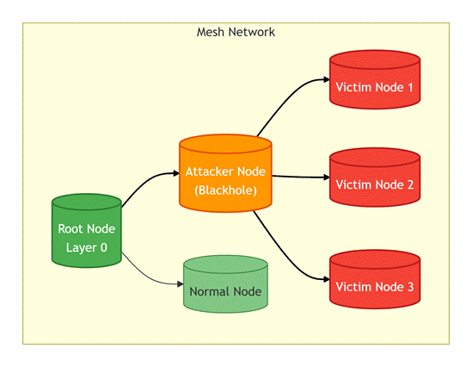

Figure 4.4 Blackhole Topology with Attacker as Intentional Relay
Figure 4.4 shows the blackhole topology with the attacker as an intentional relay. Victims (red) send their probe packets to the attacker (orange), which forwards them to the root (green) during baseline. During suppression, the attacker drops packets instead of forwarding them.
D. Attacker State Management
The blackhole attacker maintains counters and a state flag, as shown in Table 4.2. Each counter is written by the relay task and read by the logging task, and it counts a packet exactly once, so that the number received equals the number forwarded plus the number dropped.

Table 4.2 Blackhole Attacker State Variables and Counters
Variable | Type | Initial Value | Description | Update Trigger
suppression_active | bool | false | Manipulation state flag | Set true when phase ID = 1 received; cleared when phase ID = 3 received
recv_counter | uint32 | 0 | Total application packets received | Incremented on every successful esp_mesh_recv()
forward_counter | uint32 | 0 | Total packets forwarded to root | Incremented after successful esp_mesh_send() to root
drop_counter | uint32 | 0 | Total packets intentionally dropped | Incremented when a packet is dropped during suppression
self_packet_counter | uint32 | 0 | Failed esp_mesh_send() calls | Incremented on a failed send; logged as retry_count
E. Baseline Stabilization
Before Phase 0 (Baseline) begins, the mesh is allowed to converge to a stable topology for a stabilization interval of at least 60 seconds that lasts until the pre-run gates pass and the operator types START (D-22). The topology check accepts a board that is attached when the baseline begins and does not re-route during it (D-27). During this interval, the following baseline properties are recorded:
● Each node's mesh layer (hop distance), parent identity, and parent switching events (if any)
● Per-node RSSI statistics (mean/variance) under stable topology
● Baseline end-to-end latency and packet delivery ratio (PDR) from victim nodes to the root
● Verification that the attacker has at least one child, so that probes pass through it. In the tree topology, which is not forced, the root waits for this before it starts the baseline.
This baseline serves as the reference distribution against which suppression effects are evaluated.
F. Packet Processing Logic
Every node runs the same relay. The attacker's relay receives probes from the nodes below it and, based on the current phase, either forwards them to its parent or drops them during the attack phase. This behavior is illustrated in Figure 4.5.

Figure 4.5 Blackhole Attacker Relay Loop
/**
* Probe relay task. Every node runs it; the blackhole attacker installs
* one extra decision hook.
*
* Behavior:
* - Outside phase 1: forward every received probe to the parent.
* - During phase 1 (suppression_active): drop every received probe.
*/
atomic_uint32_t recv_counter = 0
atomic_uint32_t forward_counter = 0
atomic_uint32_t drop_counter = 0
atomic_uint32_t send_fail_counter = 0
queue_t relay_queue // 128 entries

function forward_decision(probe): // installed on the attacker only
return get_current_phase() != 1 // FALSE means drop
end function

procedure ON_PROBE_RECEIVED(packet): // called by the mesh receive task
if packet.magic is PROBE or PROBE_WORMHOLE:
atomic_increment(recv_counter) // counted before the decision
if not queue_push(relay_queue, packet):
atomic_increment(drop_counter) // overflow counts as a drop
end if
end if
end procedure

procedure ATTACKER_RELAY_TASK():
while experiment_active:
// Blocks until a probe is queued
probe ← queue_pop(relay_queue)

if forward_decision(probe) == FALSE:
// Suppression active: drop the probe
atomic_increment(drop_counter)
// No forwarding call: the probe is silently discarded
else:
// Normal relay: forward to the parent
result ← esp_mesh_send(parent_address,
probe,
MESH_DATA_P2P)
if result == ESP_OK:
atomic_increment(forward_counter)
else:
atomic_increment(drop_counter)
atomic_increment(send_fail_counter)
log_error("FORWARD_FAIL", result)
end if
end if
end while
end procedure

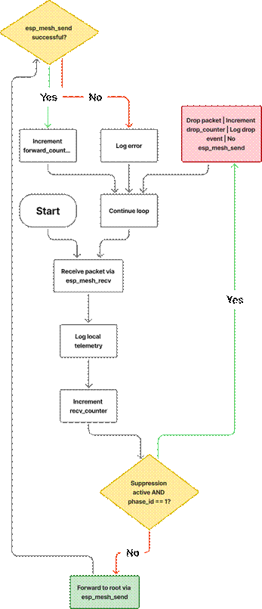

Figure 4.6 Blackhole Attacker Decision Flowchart
Figure 4.6 shows the blackhole attacker packet processing flowchart. The attacker receives a probe, logs telemetry, and increments the receive counter. If suppression is active during phase 1, the probe is dropped and the drop counter is incremented. Otherwise, the probe is forwarded to the parent, and success or failure is tracked.
G. Explanation of Key Behaviors
The blackhole-inspired implementation creates a forwarding suppression effect through several coordinated behaviors:
- Intentional Relay: Every node sends its probes to its own parent, and every node relays what it receives. The attacker therefore legitimately receives the probes of the nodes below it through esp_mesh_recv(), and no promiscuous capture or transit traffic monitoring is required.
- Normal Forwarding: During baseline (suppression_active = false), the attacker forwards each received probe to its parent using esp_mesh_send(). The path is Victim → Attacker → Root, with any further nodes in between, and the root receives the probe as usual. This establishes the baseline forwarding behavior and latency.
- Suppression Mechanism: During the manipulation window (suppression_active = true and phase ID = 1), the attacker simply omits the esp_mesh_send() call for received packets. The packet buffer is freed, and no forwarding occurs. This creates controlled packet loss while the attacker continues normal mesh participation.
- Protocol Compliance: The attacker never modifies packet contents, never injects malformed frames, and never disrupts control‑plane exchanges (beacons, parent maintenance, etc.). Only application‑layer relay behavior is altered. The attacker remains a legitimate mesh node in all other respects.
- Counter Updates: Atomic counters track the exact number of received, forwarded, and dropped packets. The recv_counter increments for every packet, while forward_counter and drop_counter track the outcomes of forwarding decisions. These provide raw data for subsequent feature extraction.
- Normal Traffic Preservation: The attacker continues to participate in all control-plane exchanges and maintains parent relationships throughout all phases. This ensures that the mesh protocol's behavior is minimally perturbed, allowing clean observation of the suppression effect.

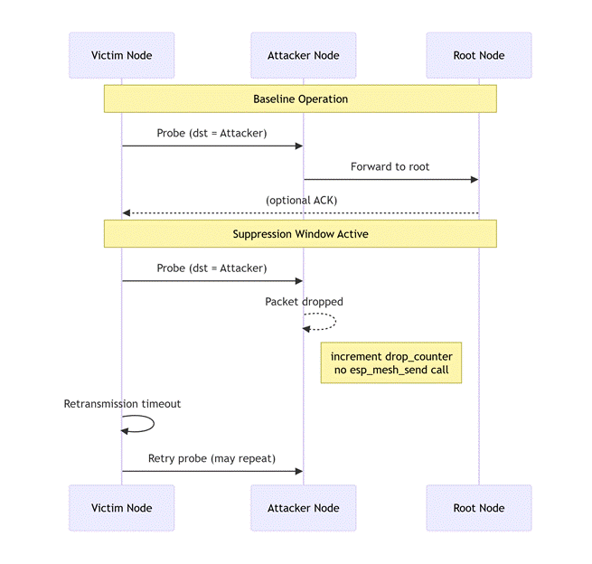

Figure 4.7 Baseline vs Suppression Sequence Diagram
Figure 4.7 is the comparison of baseline and suppressed operation. During baseline (top), probes flow Victim → Attacker → Root. During suppression (bottom), the attacker drops the probes, so they never reach the root. The attacker still acknowledges every frame at the link layer, so the victim's own radio does not see a failure.
H. Observable Effects and Dataset Contributions
The forwarding suppression mechanism produces several measurable deviations that are captured in the unified dataset:
● Forwarding Ratio Degradation: The attacker's forwarding ratio (packets forwarded / packets received) drops significantly during the suppression window, approaching zero if all transit packets are dropped. This is the primary indicator of blackhole behavior.
● Retransmissions (tested, not assumed): Chapter 3 predicts that victim nodes increase their retransmission attempts when probes are dropped. The attacker keeps acknowledging frames at the link layer, so the victims' own send counters need not change. Whether MAC-layer retries rise is checked in the sniffer record and reported in Section 4.2.7.4.
● Reduced Packet Delivery Ratio: End-to-end packet delivery from victims to the root decreases during suppression, as probes are dropped at the attacker.
● Stable RSSI at Attacker: Unlike wormhole distortion, the attacker's RSSI remains consistent with its physical placement, providing a baseline for comparison.
● Parent Switching (Secondary Effect): Persistent packet loss may trigger victims to attempt parent switching, though this is monitored as a secondary effect.
I. Implementation Summary for Blackhole
The blackhole-inspired implementation is designed around several key principles:
● Intentional Relay: The attacker is a placed relay. The nodes below it deliver their probes to it through the normal parent chain, which removes any need for passive packet capture or transit traffic visibility.
● Suppression by Omission: Forwarding suppression is achieved by omitting the esp_mesh_send() call, not by modifying control traffic or injecting malformed packets.
● Protocol Compliance: The attacker remains a legitimate mesh participant throughout all phases, maintaining parent relationships and control-plane exchanges.
● Counter-Based Telemetry: Dedicated atomic counters track received, forwarded, and dropped packets, providing the raw data for subsequent feature extraction.
● Phase-Controlled Activation: The suppression_active flag is tied directly to experiment phase broadcasts, ensuring precise temporal alignment with ground-truth labels.
● Normal Traffic Preservation: The attacker continues forwarding all original packets during baseline, maintaining realistic mesh behavior during non-suppression windows.

4.2.1.3. Topology Distortion (Wormhole-Inspired) Implementation
The wormhole-inspired manipulation uses two colluding attacker endpoints connected by an out-of-band tunnel. No raw 802.11 frames are captured or injected; only the application-layer probe is relayed through the tunnel, as its own fields: sequence number, source address and send timestamp. This approach maintains full protocol compliance while generating measurable cross-layer inconsistencies. Both attackers remain legitimate mesh participants throughout the experiment.
A. Design Scope and Implementation Boundaries
The implementation described in this section is conducted exclusively within a controlled laboratory testbed composed of researcher-owned ESP32 development boards. The purpose of detailing the manipulation model is to ensure reproducibility of dataset generation for academic evaluation, not to enable deployment against external or production networks. All experiments are performed in an isolated laboratory network with no connection to external or production infrastructure and under controlled conditions with explicit activation windows and ground-truth labeling
Canonical wormhole attacks described in wireless networking literature are typically implemented at the IEEE 802.11 control-plane level, often involving the capture, replay, or manipulation of management frames and topology-related information elements. Such implementations generally require low-level driver access and raw frame injection capabilities. However, these capabilities are not reliably exposed within the ESP-WIFI-MESH framework on ESP32 devices.
ESP32 microcontrollers operate using a closed-source Wi-Fi firmware stack beneath the ESP-IDF application layer. Core networking operations—including parent selection, beacon generation, association handling, and mesh control-plane management—are handled internally by the ESP-WIFI-MESH protocol implementation. As a result, direct manipulation of IEEE 802.11 management frames, vendor-specific information elements, or mesh discovery advertisements at the firmware level is not accessible through standard ESP-IDF APIs.
Accordingly, this study does not attempt to implement a firmware-level management-frame replay wormhole. Instead, the experiment adopts a wormhole-inspired topology distortion emulation model, designed to reproduce the observable behavioral effects of a wormhole rather than replicating its exact physical-layer mechanics.
B. Design Principles
The objective of this research is not to exploit or compromise the ESP-WIFI-MESH protocol, but rather to generate a reproducible hardware-derived dataset capturing cross-layer behavioral anomalies associated with routing-based topology distortion. To achieve this, the manipulation model is designed according to the following principles:
● Operate entirely within supported ESP-IDF and ESP-WIFI-MESH APIs
● Maintain full protocol compliance and mesh membership at all times
● Introduce a controlled auxiliary tunnel that produces artificial shortcut effects
● Induce measurable cross-layer inconsistencies consistent with wormhole theory
● Enable precise activation windows and reliable ground-truth labeling for dataset generation
This design ensures that the resulting dataset remains:
● Reproducible across multiple experimental runs
● Stable across ESP-IDF software versions
● Ethically contained within a controlled laboratory environment
● Suitable for exploratory analysis and offline intrusion-detection research
By focusing on observable cross-layer deviations—such as hop–latency inconsistencies, weakened RSSI–hop relationships, topology instability, and traffic concentration shifts—the study preserves the theoretical characteristics of wormhole-induced topology distortion while maintaining practical feasibility within the constraints of the ESP32 platform.
The resulting manipulation is therefore best described as behavioral wormhole emulation, rather than low-level protocol manipulation. This distinction is important for interpreting the collected dataset and for ensuring that future researchers clearly understand the experimental conditions under which the topology distortion traces were generated.
C. Attacker Roles and Tunnel Architecture

To reproduce the shortcut effects associated with wormhole attacks, the experiment deploys two cooperating attacker nodes connected by an auxiliary out-of-band tunnel. Each attacker performs a distinct role within the topology distortion model.
Two attacker endpoints are deployed with the following responsibilities:
● Attacker A (Root-Side Endpoint).
This node is positioned near the root region of the mesh network. It receives tunneled probe metadata from the remote attacker and reconstructs shortcut probe responses. These responses are then injected toward the root node using standard ESP-WIFI-MESH messaging, creating the appearance of accelerated communication paths.
● Attacker B (Leaf-Side Endpoint).
This node is positioned near the victim leaf nodes at the network edge. Victim nodes send their probe packets to Attacker B, which acts as the designated relay. During baseline operation, Attacker B forwards these probes normally toward the root node. During distortion phases, it extracts probe metadata and transmits it through the out-of-band tunnel to Attacker A.
Both attackers join the mesh network as legitimate participants and maintain normal protocol behavior throughout the experiment. No mesh control-plane messages are altered, and all communication with the network continues to use standard ESP-WIFI-MESH APIs.
Through this coordinated relay mechanism, the tunnel introduces artificial shortcut effects that distort the expected relationship between physical distance, hop count, and latency—thereby reproducing the cross-layer behavioral signatures associated with wormhole-induced topology distortion.
The two attacker boards are joined by a physical UART wire, which plays the role of the out-of-band tunnel that Zhukabayeva et al. [71] built with a GSM/GPRS link. The two ends exchange a HELLO handshake over the wire every second to decide which is Node A and which is Node B. The root also holds the baseline until both ends report UART OK and Node A sits shallower than Node B (D-22); for runs captured before this gate existed, the same conditions were checked afterwards from the data. An optional numbered-ping test can also check the wire. Every tunnel message carries a CRC32, and the firmware prints a warning if the tunnel carried nothing.
The title Wormhole-Inspired is kept. The tunnel runs above the routing layer of the mesh, so it reproduces duplicate arrivals of the same packet. Ramírez Gómez et al. [72] propose duplicated routing packets as a signature of a wormhole in ZigBee, which is related to this effect, but our tunnel does not change the topology. In the linear capture at the DLSU Library, all 181 probes that Node B sent in the attack phase reached the root twice, about 2.8 ms apart, with no duplicates in baseline or cooldown and no parent switches.
The wormhole is also an application-layer emulation (D-20). ESP-WIFI-MESH does not take the wire into its routing, so no node treats the two ends as neighbours and the tree does not change. What the wire produces is the packet-level signature of a wormhole: a copy of a packet arrives at the root by a second path, with a different delay. The false-neighbour effect that defines a wormhole in the literature [46] is therefore not reproduced (Table 4.5).
The two tunnel ends are assigned when the run starts and not when the boards are flashed (D-17). Both boards exchange a checked HELLO message over the tunnel wire, and the board deeper in the mesh becomes Node B (entry) while the shallower one becomes Node A (exit), so the tunnel is always a shortcut toward the root. The roles lock at the first phase, never change during the run, and are written to the role column of every telemetry row. Only Node B’s own probes are tunnelled, so a wormhole run has no victims, and every other node is labelled not tunnelled. This replaces the blackhole rule that all nodes downstream of the attacker are victims. In the first run with this assignment, Node A sat at layer 5 and Node B at layer 7, so the wire skipped two hops. In tree and partial-mesh wormhole runs, the board built as Node B never takes the root as its parent and must sit deeper than Node A, and Node A takes the shallowest open parent it hears, so the tunnel always skips at least one hop. The two ends change parent only when the link is lost or the parent is full, while every other board self-heals as before (D-30). Earlier captures set the depth of the ends by placement only, and the change is not yet confirmed on hardware.

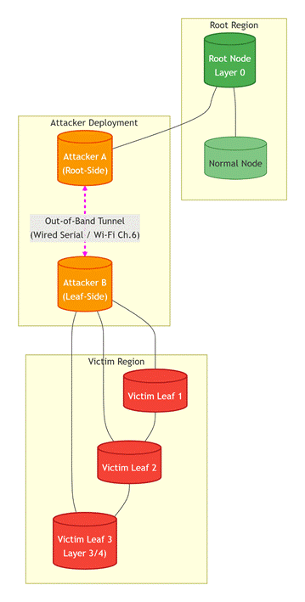

Figure 4.8 Wormhole Endpoint Setup with Auxiliary Tunnel
Figure 4.8 is the wormhole endpoint setup with an auxiliary tunnel. Attacker A (orange) is positioned shallower in the mesh, nearer the root (green), and Attacker B (orange) is positioned deeper, toward the leaf nodes. The out-of-band tunnel (magenta dashed line) connects the two attackers independently of the mesh network, enabling the shortcut effect without interfering with normal mesh routing. .
D. Tunnel Implementation
The out-of-band tunnel is a wired serial link, independent of the mesh network, shown in Figure 4.9. The two boards are connected by UART1 at 115200 baud, with the transmit pin (GPIO 17) of each board wired to the receive pin (GPIO 16) of the other. The same link carries two frame types of identical size: the tunnel frame and the HELLO frame used to assign the ends. A wire was chosen because it cannot interfere with the radio channel that the mesh and the sniffer share. Two other options, a host relay through a laptop and a second Wi-Fi interface on another channel, were not used.

Figure 4.9 Wormhole Tunnel Packet Structure
struct tunnel_packet { // 30 bytes, packed
uint32_t magic; // 0x544E4C31 ("TNL1")
struct probe { // the captured probe, copied verbatim (22 bytes)
uint32_t magic; // 0x50524F42 ("PROB")
uint32_t seq_num; // probe sequence number
int64_t send_ts_us; // send timestamp of the original probe
uint8_t src_mac[6]; // originator, preserved across every hop
} probe;
uint32_t crc; // CRC32 over magic and probe
};
The HELLO frame has the same length. It carries the sender's MAC address, mesh layer, current end, a flag that tells whether the end is locked, a flag that tells whether the sender hears its peer, and a CRC32. A receiver reads the wire in fixed-size windows and, when a window fails the magic or CRC check, slides forward by one byte until it locks on a valid frame again.
The tunnel is configured to exhibit:
● Stable connectivity throughout baseline and manipulation windows
● Lower and more consistent latency than the equivalent multi-hop mesh route under baseline conditions
● No dependence on ESP-MESH routing decisions
E. Attacker State Management
Both attackers maintain counters to track tunnel activity and reinjection operations. Table 4.3 lists all state variables. All counters are implemented as atomic variables to ensure thread safety, as they are accessed by both the packet processing task and the logging task.

Table 4.3 Wormhole Attacker State Variables and Counters
Variable | Type | Initial Value | Description | Update Trigger
distortion_active | bool | false | Manipulation flag | Set true when phase ID = 2 received; cleared when phase ID = 3 received
role, role_locked | enum, bool | A, false | The end this board plays, and whether it is fixed | Set from the HELLO exchange; locked at the first phase
probes_generated | uint32 | 0 | Probes created by Node B | Incremented on each probe generated
probes_to_root | uint32 | 0 | Probes Node B sent into the mesh toward the root | Incremented after a successful send
probes_tunneled | uint32 | 0 | Probes written to the tunnel (Node B) | Incremented on each complete tunnel frame written during phase 2
tunnel_received | uint32 | 0 | Valid tunnel frames received (Node A) | Incremented on each frame that passes the magic and CRC check
probes_reinjected | uint32 | 0 | Probes re-injected toward the root (Node A) | Incremented after a successful send of a re-injected probe
tunnel_fail, reinject_fail | uint32 | 0 | Failed sends (Node B) and failed re-injections (Node A) | Incremented on each failed send

F. Baseline Stabilization
Before Phase 0 (Baseline) begins, the mesh is allowed to converge to a stable topology for a stabilization interval of at least 60 seconds that lasts until the pre-run gates pass and the operator types START (D-22). The topology check accepts a board that is attached when the baseline begins and does not re-route during it (D-27). During this interval, the following baseline properties are recorded:
● Each node's mesh layer (hop distance), parent identity, and parent switching events (if any)
● Per-node RSSI statistics (mean/variance) under stable topology
● Baseline end-to-end latency and packet delivery ratio (PDR) from the nodes below the attacker region to the root
This baseline serves as the reference distribution against which distortion effects are evaluated.
G. Attacker B (Leaf‑side) Implementation
Attacker B, as shown in Figure 4.10, generates its own probes. In every phase it sends each probe to its parent, so that the root receives the normal copy. During the wormhole phase it also writes the same probe to the tunnel, after adding a CRC32.

Figure 4.10 Attacker B – Relay and Tunnel
/**
* Attacker B: entry endpoint of the wormhole manipulation (the deeper board).
*
* Responsibilities:
* - Joins the mesh normally and relays probes of nodes below it
* - Generates its own probes once its role is locked
* - Every phase: sends each probe to its parent (the normal mesh copy)
* - Wormhole phase: also writes the probe to the tunnel with a CRC32
*/
queue_t probe_queue
atomic_uint32_t probes_generated = 0
atomic_uint32_t probes_to_root = 0
atomic_uint32_t probes_tunneled = 0
atomic_uint32_t tunnel_fail = 0

procedure PROBE_GENERATOR_TASK():
while experiment_active:
if role == B and role_locked:
probe ← make_probe(next_seq(), get_time(), own_mac)
queue_push(probe_queue, probe)
atomic_increment(probes_generated)
end if
sleep(PROBE_INTERVAL) // 1000 ms
end while
end procedure

procedure TUNNEL_FORWARDER_TASK():
while experiment_active:
probe ← queue_pop(probe_queue) // blocks until a probe is queued

// Step 1: always send the probe up the mesh (normal copy)
result ← esp_mesh_send(parent_address, probe, MESH_DATA_P2P)
if result == ESP_OK:
atomic_increment(probes_to_root)
else:
atomic_increment(tunnel_fail)
end if

// Step 2: during the wormhole phase, also write the probe to the tunnel
if get_current_phase() == 2:
frame.magic ← TUNNEL_MAGIC
frame.probe ← probe
frame.crc ← crc32(frame.magic, frame.probe)
written ← uart_write(frame, sizeof(frame))
if written == sizeof(frame):
atomic_increment(probes_tunneled)
else:
atomic_increment(tunnel_fail)
end if
end if
end while
end procedure

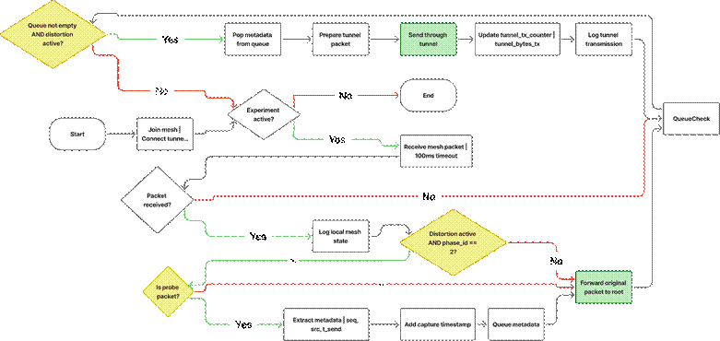

Figure 4.11 Attacker B (Leaf-side) Process Flowchart
Figure 4.11 shows the Attacker B (entry endpoint) process flowchart. The attacker generates a probe and sends it to its parent. During the wormhole phase the probe is also wrapped in a tunnel frame, protected by a CRC32, and written to the tunnel, with the counters updated accordingly.
H. Attacker A (Root‑side) Implementation
Attacker A reads the tunnel, checks each frame, and re-injects the original probe toward the root, as shown in Figure 4.12. The re-injected copy keeps the sequence number, source address and send timestamp of Node B's original probe, and carries a different magic value so that the root records it as a second arrival and does not discard it as a duplicate. Every node between Attacker A and the root relays this magic as well

Figure 4.12 Attacker A – Tunnel Receive and Inject
/**
* Attacker A: exit endpoint of the wormhole manipulation (the shallower board).
*
* Responsibilities:
* - Joins the mesh normally and relays probes of nodes below it
* - Reads the tunnel and discards frames that fail the magic or CRC check
* - Re-injects each valid probe toward the root through its parent
*/
atomic_uint32_t tunnel_received = 0
atomic_uint32_t probes_reinjected = 0
atomic_uint32_t reinject_fail = 0
queue_t reinject_queue

procedure TUNNEL_RECEIVE_TASK():
while experiment_active:
frame ← uart_read_window(sizeof(tunnel_packet))
if frame.magic == HELLO_MAGIC and crc_ok(frame):
update_peer_state(frame) // used to assign the ends
else if frame.magic == TUNNEL_MAGIC and crc_ok(frame) and role == A:
atomic_increment(tunnel_received)
queue_push(reinject_queue, frame.probe)
log_event("TUNNEL_RX", frame.probe.seq_num, get_time())
else:
slide_window_by_one_byte() // resynchronise on the next valid frame
end if
end while
end procedure

procedure REINJECT_TASK():
while experiment_active:
probe ← queue_pop(reinject_queue) // blocks until a frame arrives

// Tag the copy so that the root does not treat it as a duplicate to discard
probe.magic ← PROBE_WORMHOLE_MAGIC // "PROW"
// seq_num, send_ts_us and src_mac stay those of Node B's original probe

result ← esp_mesh_send(parent_address, probe, MESH_DATA_P2P)
if result == ESP_OK:
atomic_increment(probes_reinjected)
log_event("INJECT_SUCCESS", probe.seq_num, get_time())
else:
atomic_increment(reinject_fail)
log_event("INJECT_FAIL", probe.seq_num, result)
end if
end while
end procedure
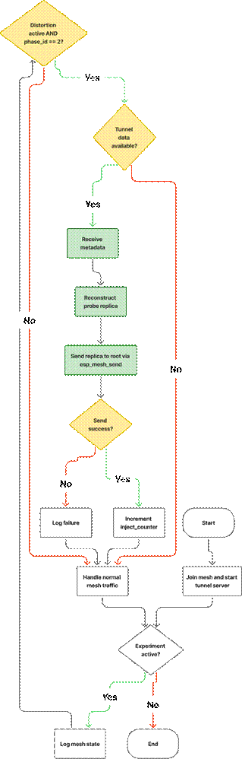

Figure 4.13 Attacker A (Root-side) Process Flowchart
In Figure 4.13, the Attacker A (exit endpoint) process flowchart, the attacker reads the tunnel, validates each frame, and re-injects a tagged copy of the probe toward the root through the mesh. Normal mesh traffic is relayed concurrently.
I. Explanation of Key Behaviors
The wormhole-inspired implementation creates an artificial shortcut effect through several coordinated behaviors:
- Own-Probe Source: Attacker B generates its own probes. Its probes reach the root through the mesh in every phase, so no raw frame capture or promiscuous mode is required.
- Normal Relay: During baseline, B sends each probe to its parent, which relays it hop by hop to the root. The root receives the probe as usual, and this establishes the baseline latency for the path.
- Distortion Relay: During the manipulation window, B also writes the probe to the out-of-band tunnel for A. The tunnel frame carries only the probe fields needed to reproduce timing and identity (sequence number, source, send timestamp), which keeps the tunnel overhead small.
- Probe Replication: A checks each frame and re-sends the original probe, with the same sequence number, source and send timestamp, toward the root.
- Mesh Re-injection: A re-injects the probe through its own parent. The root therefore receives two copies of the probe: one through the normal multi-hop path from B, and one through the tunnel and A. The two copies arrive at different times, which creates the duplicate-arrival and delay anomalies that the features measure, without modifying the mesh control plane.
- Normal Traffic Preservation: Both attackers continue to relay the probes of the other nodes normally. This ensures that the mesh protocol's behavior is minimally perturbed.
- Tunnel Independence: The tunnel is a separate physical medium and does not interfere with mesh communication. Its timing differs from that of the mesh path, and that difference is what creates the observable shortcut effect.

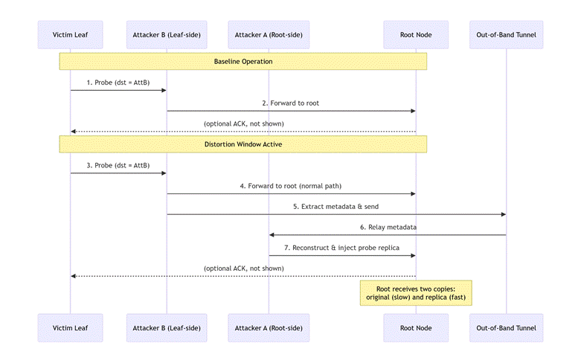

Figure 4.14 Wormhole Shortcut Relay Mechanism
Figure 4.14 is the wormhole shortcut relay mechanism. During baseline (top), Attacker B sends its probes to the root through the mesh. During distortion (bottom), Attacker B also sends each probe through the out-of-band tunnel to Attacker A, which re-injects it toward the root. The root thus receives two copies of the same probe at different times.
J. Observable Effects and Dataset Contributions
The topology distortion mechanism produces several measurable deviations that are captured in the unified dataset:
● Delay Inconsistency: The two copies of a probe reach the root by different paths and with different delays, so the delay of a probe is no longer consistent with the hop count of its sender.
● Duplicate Probe Reception: The root receives two copies of the same probe (identical sequence numbers) within a short time window, which does not occur during normal operation.
● Traffic Concentration Shifts: The second path may alter traffic distribution patterns, potentially concentrating forwarding activity on paths adjacent to the attackers. This is monitored as a secondary effect.
● RSSI-Hop Inconsistency: The relationship between physical signal strength and logical hop count may weaken as traffic patterns shift, though this is monitored as a secondary effect.
● Topology Stability (checked, not expected to change): The tunnel does not enter the mesh's routing, so a change of topology is not expected. Parent switching is monitored to confirm this, together with natural RSSI variation and traffic load changes.
All these effects are captured through the cross-layer metrics defined in Section 4.2.3 and contribute to the feature set used for exploratory analysis and clustering.
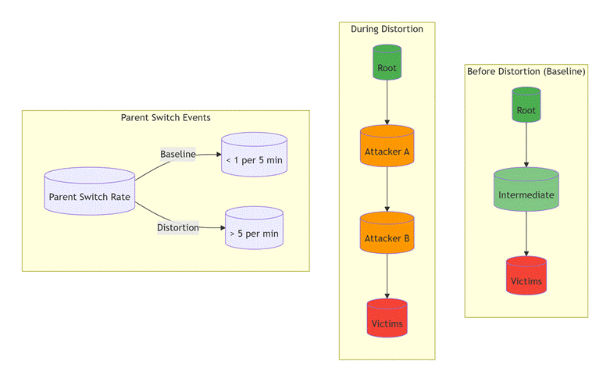

Figure 4.15 Traffic Redistribution During Distortion Window
Figure 4.15 illustrates the prediction from Chapter 3 that is tested against the captured data. Left: baseline traffic flows through legitimate intermediate nodes. Center: during distortion, traffic concentrates on attacker-adjacent paths (orange). Right: the prediction that parent switching becomes more frequent during the distortion window than in baseline. The captured runs so far show no parent switches during the wormhole phase (Section 4.2.7.4).
K. Implementation Summary for Wormhole
The wormhole-inspired implementation is designed around several key principles:
● Own-Probe Tunneling: Attacker B generates its own probes and tunnels copies of them, which removes any need for passive packet capture.
● Probe-Only Tunneling: Only the application-layer probe (sequence number, source, send timestamp) is tunneled, not raw frames, ensuring application-layer compliance and minimal overhead.
● Probe Duplication, Not Modification: Attackers never modify original packets; they only create additional replicas, preserving all original traffic for baseline comparison.
● Independent Tunnel: The out-of-band channel operates completely separately from the mesh network, preventing interference with normal protocol operation.
● Normal Traffic Preservation: Both attackers continue forwarding original packets, maintaining realistic mesh behavior during the distortion window.
● Counter-Based Telemetry: Dedicated atomic counters track tunnel activity and reinjection success, providing the raw data for subsequent feature extraction.
● Phase-Controlled Activation: The tunnel is written only while phase ID 2 is current, ensuring precise temporal alignment with ground-truth labels.

4.2.1.4. Implementation Summary
The implementation described in this section provides a complete, reproducible framework for generating labeled datasets containing both normal and manipulated mesh behavior. Key characteristics include:
- Application‑layer only: All manipulations are implemented using standard mesh APIs; no firmware modifications or raw frame injection are performed.
- Phase‑controlled activation: Manipulations are activated only during designated time windows via root broadcasts, ensuring precise temporal alignment with ground‑truth labels.
- Protocol compliance: Attackers remain legitimate mesh participants throughout all phases, maintaining parent relationships and control‑plane exchanges. Only the specific relay behavior (blackhole) or tunnel relay (wormhole) is modified.
- Comprehensive state tracking: Each attacker maintains dedicated atomic counters that capture the intensity and outcome of manipulations. These counters, together with event‑driven logs (parent changes, phase transitions, send/recv outcomes), provide rich raw data for subsequent feature extraction.
- Reproducible procedures: The documented algorithms and state machines can be implemented identically across multiple experimental runs and topology configurations.
Telemetry logging, data storage, and post‑experiment extraction are described separately in Section 4.2.3. This separation keeps the implementation logic focused on manipulation behavior, while data collection is handled by a unified framework common to all node types.
The implementations are checked against the published definitions criterion by criterion, including the criteria that fail. Table 4.4 covers the blackhole against Airehrour et al. [70], and Table 4.5 covers the wormhole against Hu, Perrig, and Johnson [46].
Table 4.4 Blackhole Conformance to Airehrour et al. [70]
Criterion | Met | Evidence
Adversary sits on the forwarding path | Yes | Victims address the attacker, which relays to the root
Receives the packets rather than jamming | Yes | The relay queue receives before the forward or drop decision
Drops instead of forwarding | Yes | During the blackhole phase the drop counter rises and nothing is sent on
Stays protocol-compliant, so the node looks alive | Yes | It remains a mesh participant and keeps logging telemetry
Delivery collapses while the node stays reachable | Yes | In the G402 linear stationary run, attacker ForwardingRatio falls from 1.000 to 0.001 and the PDR of the six nodes behind it from 1.000 to 0.000
Attracts traffic by advertising a false route | No | The attacker is a placed relay, so no routing decision is fooled
Table 4.5 Wormhole Conformance to Hu, Perrig, and Johnson [46]
Criterion | Met | Evidence
Two colluding endpoints | Yes | Node A (exit) and Node B (entry)
Out-of-band channel outside the normal path | Yes | Physical UART link between the two boards
Packets captured at one end and replayed at the other | Yes | 181 of 181 probes from Node B arrived twice in the attack phase, and none did in baseline or cooldown (linear, DLSU Library, stationary)
No compromise of keys or hosts | Yes | Application layer only, no key material touched
Creates a false neighbour relationship | No | No parent switches or layer changes during the wormhole phase
[PENDING: wormhole evidence for all 36 planned wormhole runs. For each run give the hops skipped by the tunnel, the number of Node B probes duplicated at the root out of Node B’s probes in the attack phase (181 of 181 in the linear run at the DLSU Library), and the verifier verdict. The tree capture at G402 showed both ends at hop 1, so the tunnel gave no shortcut, and it is to be recaptured. Replace this placeholder with the final result for each cell, and update Table 4.5 if any criterion changes.]
The wormhole figures come from the first run captured with the run-time end assignment. Wormhole conformance is established on the linear topology only. An earlier tree capture had both ends at the same depth, so its tunnel gave no shortcut, and it is being recaptured.

4.2.2. Physical Deployment Topologies
In ESP-WIFI-MESH, the network topology is not manually configured as in traditional networks, such as bus, ring, or star. Instead, nodes automatically organize themselves into a hierarchical tree structure via the protocol's parent-selection mechanism, in which each node selects an upstream parent from the candidates it can hear, preferring the one on the shallowest layer and then the one with the fewest children [21]. This self-organizing behavior allows the mesh network to construct routing paths dynamically, without predefined topology assignments.
However, in controlled experimental environments such as this study, different logical layouts can be created by physically positioning ESP32 nodes in specific spatial arrangements. While these layouts resemble traditional network topologies (e.g., star or linear chain), the underlying routing behavior still follows the ESP-WIFI-MESH hierarchical tree architecture. The resulting logical topology therefore emerges from the interaction between node placement, RSSI relationships, and the mesh protocol's parent-selection algorithm.
The physical placement of nodes plays a critical role in shaping the resulting logical network structure. Because a node can only choose among the parents it can hear, node spacing and relative positioning must be carefully arranged to encourage the desired routing relationships. Proper spacing helps ensure that nodes preferentially connect to intended neighbors rather than forming unintended long-range links. This stabilization of RSSI relationships is essential for maintaining consistent topology behavior across experimental runs and for ensuring that attack effects can be clearly observed in the collected telemetry data.
Placement is supported by the topology options of the ESP-IDF mesh API [75]. The star caps the depth of the mesh at two layers, or three when the attacker is the hub. The linear chain selects the chain topology and lets each node accept one child. The partial mesh narrows the number of children each node accepts, so that the nodes do not all attach to the root. The tree uses the default self-organization. Every board in a run is flashed with the same topology option, and the structure that actually forms is checked after every run from the parent addresses and layers in the logs (Table 4.15). Throughout this chapter the position of a node is given in hops, where the hop count is the mesh layer minus one, so that the root is at hop 0. ESP-WIFI-MESH numbers the root as layer 1 (the constant MESH_ROOT_LAYER in esp_mesh.h).
Node placement is particularly important when deploying routing-based attacks such as wormhole and blackhole attacks. The positioning requirements differ fundamentally between the two attack types:
For blackhole attacks, the attacker must be positioned so that the traffic of other nodes reaches the root through it. ESP-WIFI-MESH does not let a node advertise a favorable route, so the position is arranged through the layout and the topology option, and not through signal strength alone. Once other nodes are attached below the attacker, it receives their traffic but intentionally drops it during the manipulation window. A run in which nothing attaches below the attacker looks benign, so the tree runs are not started until the attacker has at least one child.
For wormhole attacks, two attacker nodes are deployed at different depths of the network, one shallower and one deeper. Under normal operation, a probe from the deeper end would have to traverse several intermediate nodes through the mesh hierarchy. The wormhole attack introduces an out-of-band tunnel between the two attackers, allowing the probes of the deeper end to be copied directly across distant network segments. This creates a second path for the same probe, with a different delay, and distorts the expected relationship between hop count and latency.
To investigate how these attack behaviors manifest under different routing conditions, the experiments employ several physical deployment layouts, each designed to emphasize different aspects of mesh routing behavior. It is important to note that these layouts represent physical node arrangements used for experimentation rather than manually enforced routing topologies. The mesh protocol still constructs its routing tree dynamically based on link metrics. The following deployment layouts are implemented in the experimental environment:
● Star topology
● Tree topology
● Linear chain topology
● Partial mesh topology

4.2.2.1. Star Topology
In the star topology, a central ESP32 node acts as the communication hub, while surrounding nodes transmit traffic directly to it. This setup provides a baseline environment where routing complexity is minimized, and direct RSSI relationships can be observed. In the benign runs the hub is the root. In the blackhole runs the hub is the attacker (D-16), and in the wormhole runs it is wormhole end A (D-28); in both attack cases the root sits one hop behind the hub.
.
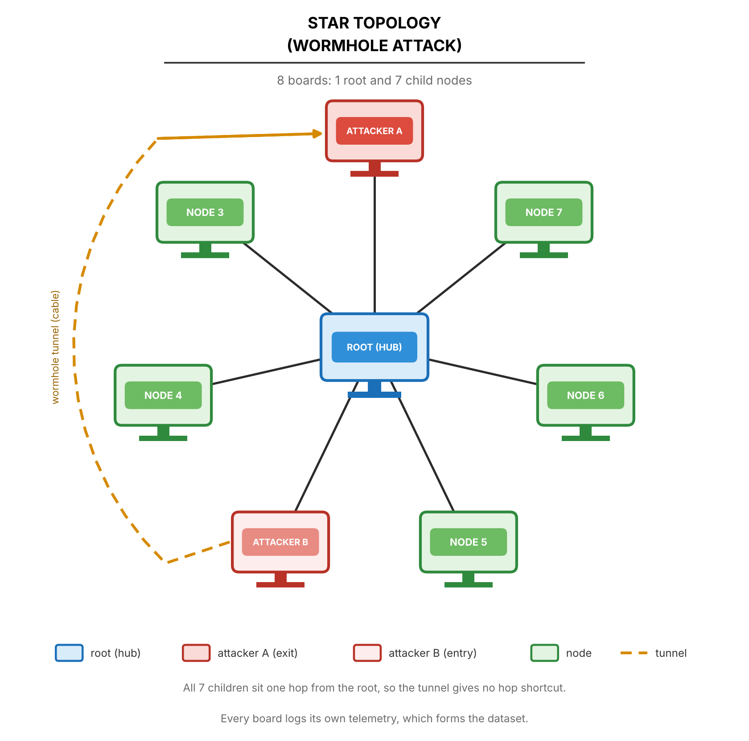

Figure 4.16 Wormhole Attack on Star Topology
For wormhole experiments in Figure 4.16, two attacker endpoints are deployed. In a flat star every node is one hop from the root, so the two ends would sit at the same depth and the tunnel could not skip a hop. The star is therefore built one hop down, as for the blackhole (D-28): Node A is the hub of the star, the root sits one hop behind it as in the blackhole star (D-16), and every other board, Node B included, joins the hub. Node B’s normal copy then takes two hops to the root and its tunnelled copy one, a one-hop shortcut, and the root’s setup gate can pass. When the distortion window is activated, Node B writes its probes to the tunnel as well as sending them through the mesh, and Node A re-injects them toward the root, so the root receives each probe twice. Node A also relays the normal copy of Node B, and the control boards are two hops from the root. Figure 4.16 still shows the earlier flat star and is to be redrawn. The first hub-star captures are not yet usable: in the G402 stationary capture three boards never attached to the root, and in the highload attempts the hub board browned out and reset. The hub-star design still needs the adviser’s approval. All nodes log continuous telemetry, with the tunnel endpoints recording additional counters for the probes tunnelled and re-injected.
.
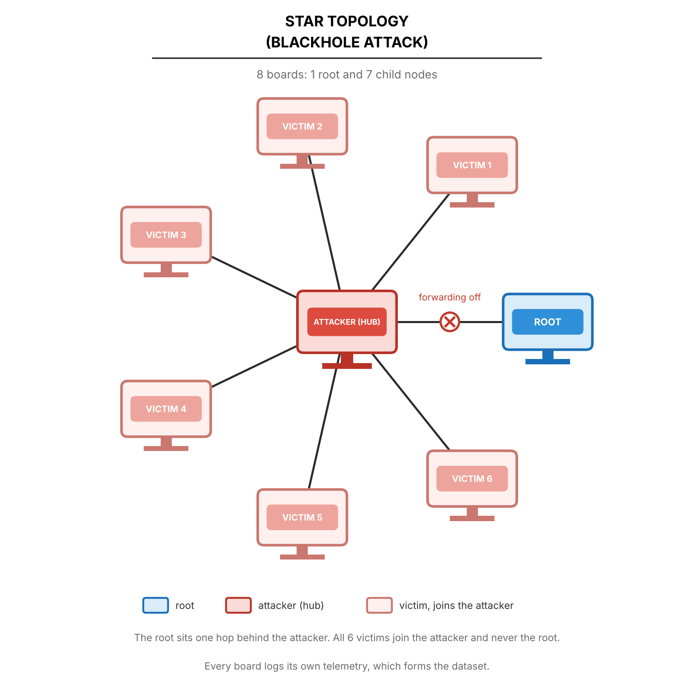

Figure 4.17 Blackhole Attack on Star Topology
For blackhole experiments in Figure 4.17, the attacker is the hub. The root sits one hop behind it, about one metre away, and the victims form a ring around the attacker. The victims are configured to join the attacker directly and never join the root, so that the star structure and the attacker position are fixed. During the baseline phase, the victims send their probes to the hub, which forwards them to the root. When the blackhole manipulation is activated, the attacker continues to receive packets from the victims but intentionally drops them rather than forwarding them. The root is the destination and the referee of the experiment, which is why it is not used as the attacker. Throughout the experiment, all nodes log telemetry, including timestamps, node IDs, phase labels, layer information, parent MAC addresses, RSSI values, and role-specific counters. The dataset captures the contrast between normal forwarding behavior during baseline and the packet-dropping behavior during the manipulation window.

4.2.2.2. Tree Topology
The tree topology reflects the native ESP-WIFI-MESH structure, where nodes are layered beneath a root node. Intermediate nodes connect upward to a parent while accepting downstream child connections, enabling multi-hop packet forwarding within the hierarchical mesh architecture. The tree children keep their parent unless the link degrades substantially: ESP-WIFI-MESH’s own parent-switch and weak-link thresholds are moved 6 dB lower and its weak-link watch lasts three times longer, while the first choice of parent is unchanged and the loss of a parent still makes its children move (D-26). Tree runs captured before this change used the stock thresholds, and this change is not yet confirmed on hardware.
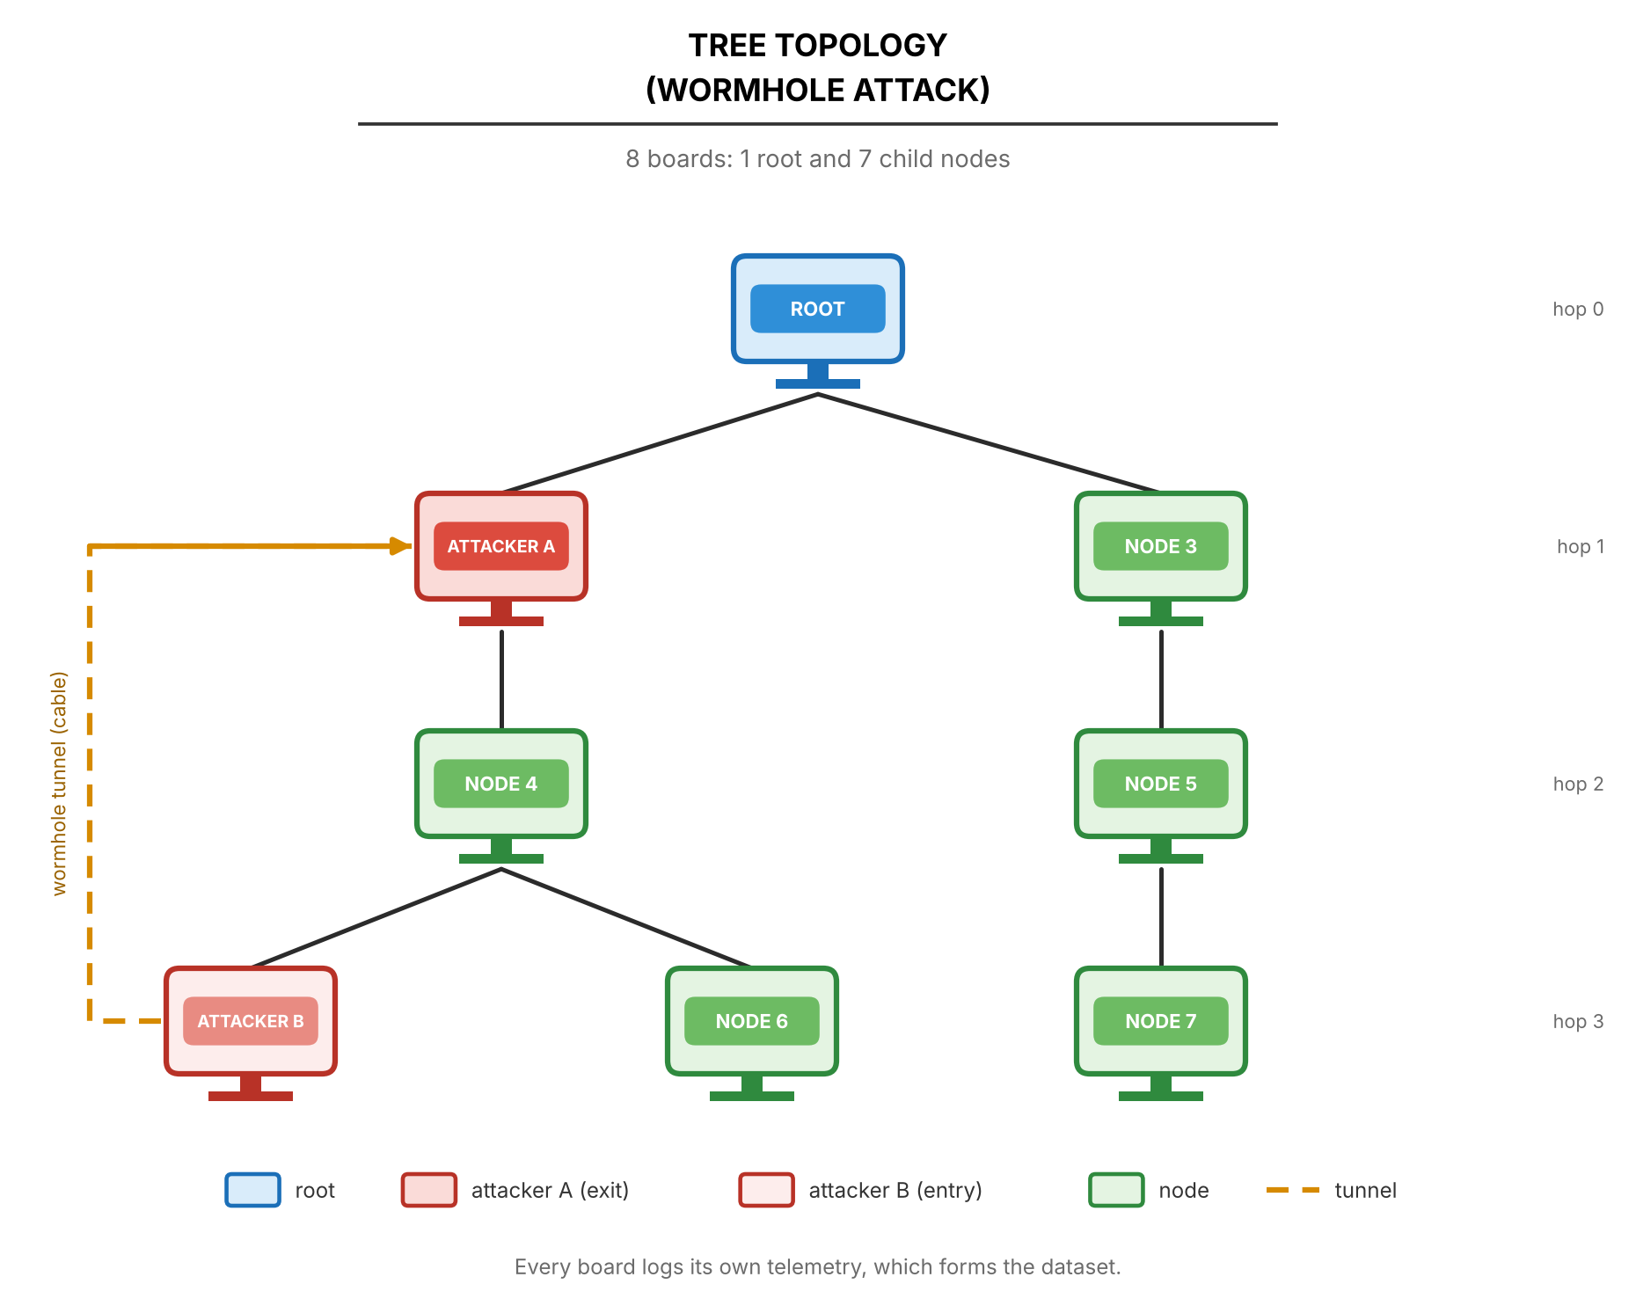

Figure 4.18 Wormhole Attack on Tree Topology
For wormhole experiments in Figure 4.18, Attacker A is positioned at hop 1 near the root, while Attacker B is positioned at hop 3 near the leaf nodes. The physical separation ensures that baseline communication between these regions requires traversing multiple layers through legitimate intermediate nodes. During the baseline phase, probes from Attacker B follow the natural multi-hop path up the tree. When the distortion window is activated, Attacker B also writes its probes to the out-of-band tunnel, and Attacker A re-injects them toward the root. This creates a second, shorter path for the same probe, potentially observable as a different delay and as an inconsistency between delay and hop count. Tunnel endpoints log their counters, while all nodes record standard mesh telemetry for comparison between baseline and distortion windows.
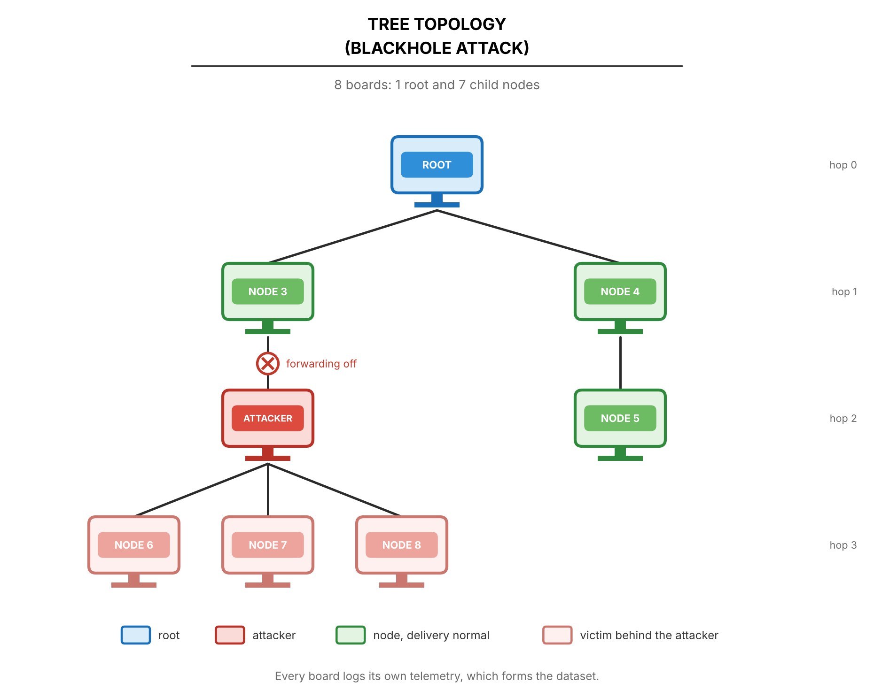

Figure 4.19 Blackhole Attack on Tree Topology
For blackhole experiments in Figure 4.19, the attacker is positioned at hop 2 as an intermediate node that serves as the parent for multiple downstream leaf nodes. The root occupies hop 0, with legitimate intermediate nodes at hop 1. During baseline operation, victims at hop 3 forward their probes upward through the attacker, which relays them toward the root. When the blackhole manipulation activates, the attacker continues to receive transit packets from its victims but intentionally drops them instead of forwarding them. The dataset captures the attacker's forwarding ratio degradation, the loss of delivery from its victims, and any parent-switching events that occur during the manipulation window. All nodes log layer information, parent MAC addresses, RSSI values, and packet counters throughout all phases.

4.2.2.3. Linear Chain Topology
A linear chain arrangement of ESP32 nodes is used to observe sequential packet propagation and localized forwarding dependencies within the ESP-WIFI-MESH network. Nodes are positioned in a straight line so that each device primarily communicates with its immediate neighbor, forming a chain-like multi-hop routing path from the farthest node toward the root. This configuration constrains routing paths and enables controlled observation of how packets propagate hop-by-hop through intermediate nodes..
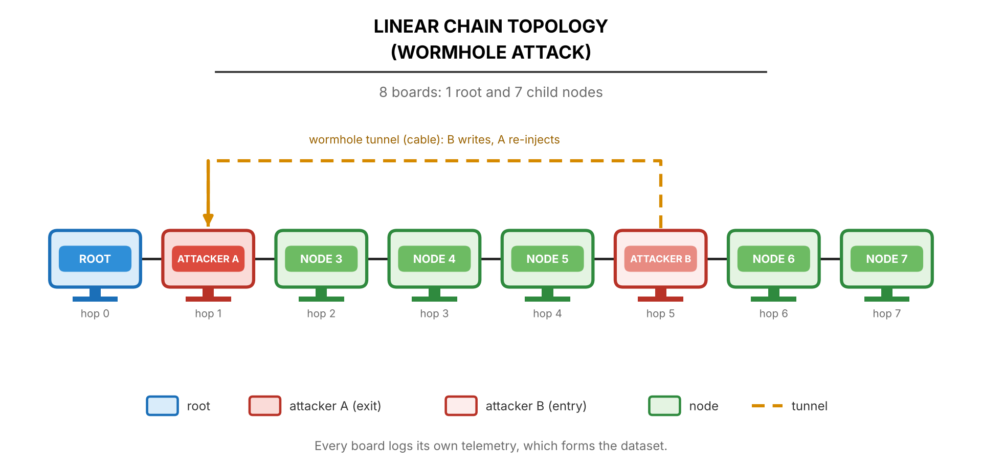

Figure 4.20 Wormhole Attack on Linear Chain Topology
For wormhole experiments in Figure 4.20, Attacker A is positioned toward the root end of the chain, while Attacker B is placed farther along the chain, with the ends assigned at run time by depth. The physical separation ensures that baseline communication between these regions must traverse all intermediate nodes sequentially, resulting in latency proportional to the number of hops. An out-of-band tunnel connects the two attackers independently of the mesh network. During the distortion window, Attacker B writes its own probes to the tunnel, and Attacker A re-injects them toward the root. This creates an apparent path compression effect, as the second copy of each probe arrives by a path that skips the hops between the two ends. The dataset captures duplicate arrivals, latency anomalies, hop-count stability, and tunnel activity metrics alongside standard mesh telemetry.
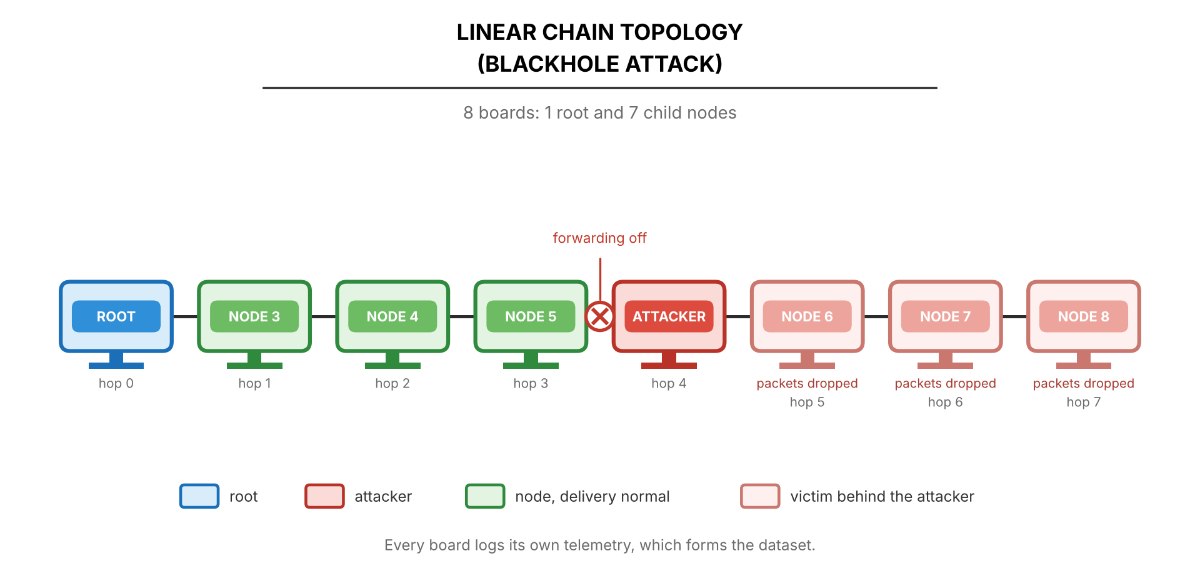

Figure 4.21 Blackhole Attack on Linear Chain Topology
For blackhole experiments in Figure 4.21, the attacker is positioned as an intermediate forwarding node within the chain, such that all traffic between the far end and the root must pass through it. Nodes are spaced several meters apart (typically 3 to 5 m in the laboratory setup) so that the strongest RSSI links occur between adjacent devices, encouraging sequential parent selection along the linear arrangement. During baseline operation, probes from the far end travel toward the root and traverse each intermediate node in sequence, with the attacker acting as a normal relay. When the blackhole manipulation activates, the attacker continues to receive probes from the nodes beyond it but intentionally drops them instead of forwarding them toward the root, which cuts those nodes off from the root. Nodes beyond the attacker experience complete loss of delivery, while nodes on the root side of the attacker continue to operate normally. The dataset captures the cumulative impact of forwarding suppression, including the complete delivery failure of the nodes beyond the attacker and the unchanged delivery of the nodes before it.

4.2.2.4. Partial Mesh Topology
The partial mesh topology represents the primary experimental environment, in which nodes are connected to a subset of other nodes rather than all of them. Nodes select parents based on RSSI, link quality, and hop count within the available connections. This semi-structured topology still allows observation of network self-organization and adaptive parent switching, but connectivity is limited compared to a full mesh. The partial mesh is defined by how it is built: the boards are placed so that each can hear several candidate parents, and each node accepts at most two children, which forces branching and depth. Switching to a second parent is allowed but was not observed in the nine processed runs, so these runs behave as trees (D-29, to be confirmed with the adviser).
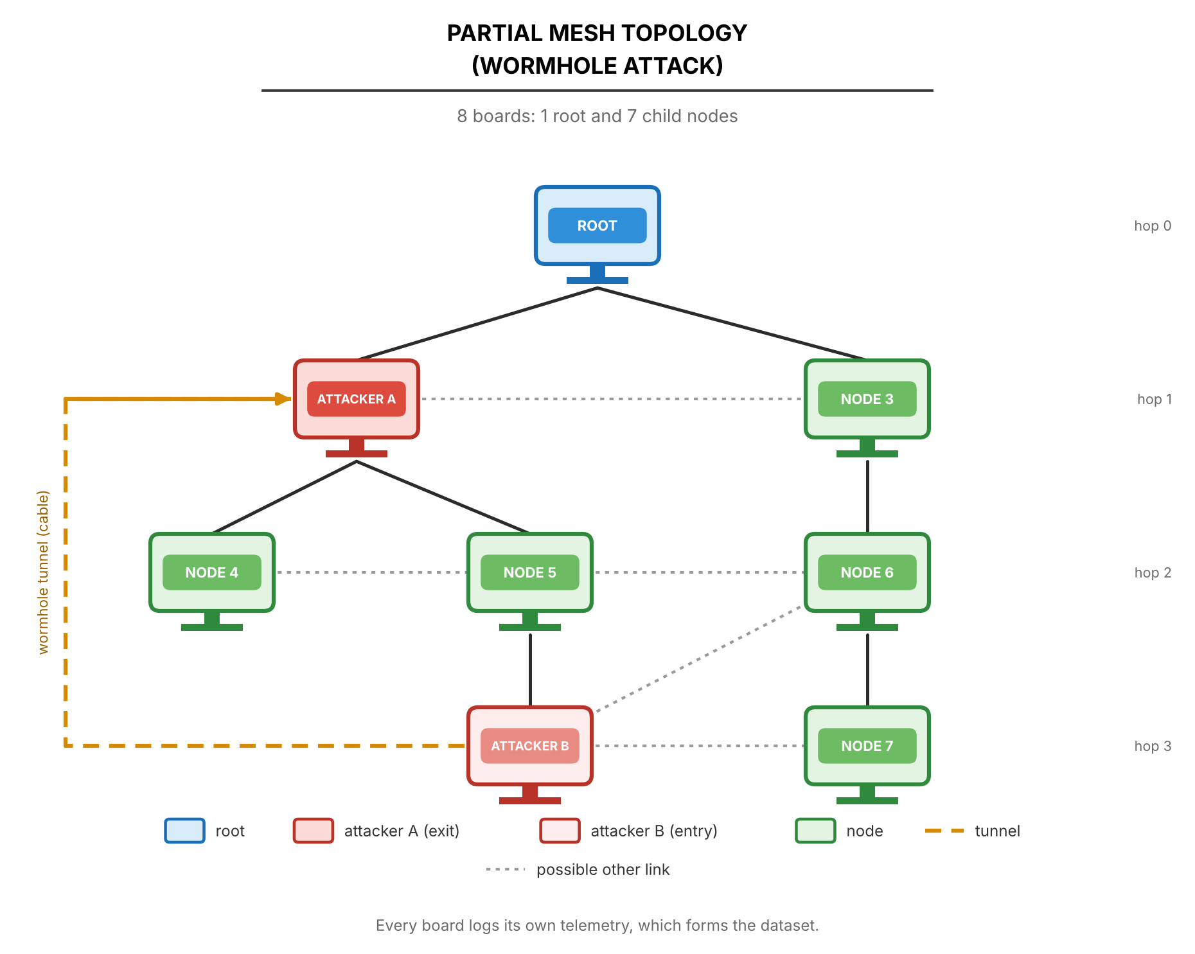

Figure 4.22 Wormhole Attack on Partial Mesh Topology
For wormhole experiments in Figure 4.22, Attacker A is positioned toward the root region, and Attacker B is positioned near a cluster of nodes deeper in the mesh. The connectivity matrix is arranged so that there are several candidate paths between the regions, and the baseline routes are determined by the protocol's parent selection. An out-of-band tunnel connects the two attackers independently of the mesh. During the distortion window, Attacker B writes its own probes to the tunnel, and Attacker A re-injects them toward the root. This creates apparent path compression, and the dataset captures changes in end-to-end latency, duplicate arrivals, hop-count stability, parent switching frequency, and RSSI-hop correlation across baseline and distortion windows.

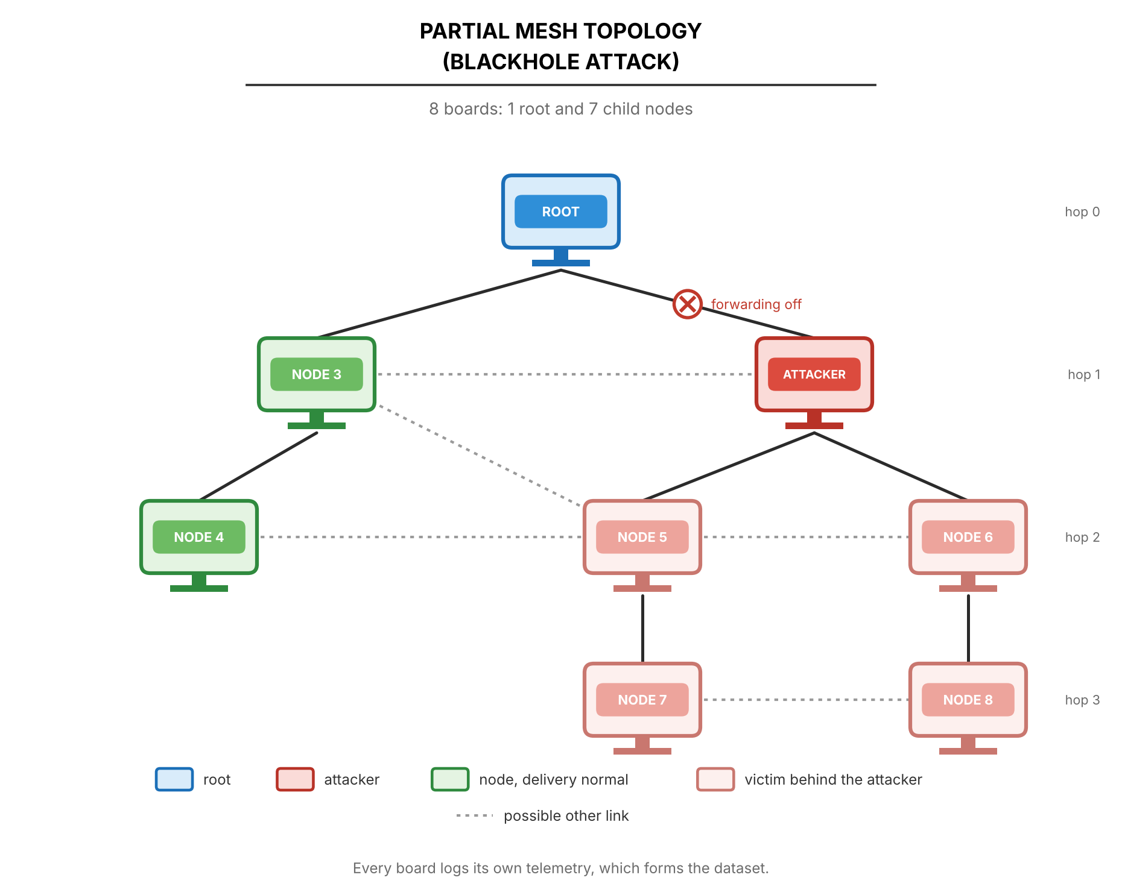

Figure 4.23 Blackhole Attack on Partial Mesh Topology
For blackhole experiments in Figure 4.23, the attacker is positioned as a high-betweenness relay node, central in the cluster, through which the paths of several victim nodes to the root pass. During baseline operation, traffic from the victims flows through the attacker toward the root. When the blackhole manipulation activates, the attacker continues to receive transit packets but omits forwarding them, causing a loss of delivery from its victims. As victims experience persistent failures, they may attempt to switch to alternative parents, which would appear as parent-switching events in the logs. The dataset captures not only the direct effects of forwarding suppression but also any adaptive response of the mesh protocol as nodes attempt to re-route around the failed path.

4.2.2.5. Deployment Sites and Scenario
The deployment is framed as a smart-campus scenario: indoor environmental and building monitoring at DLSU Manila, where each node sends a periodic sensor-style probe toward the root. This follows Khan et al. [22], who deployed an ESP-MESH network across a campus and reported packet delivery above 97%. The four topologies are logical layouts of the nodes. They are not tied to particular kinds of indoor place, and each is set up at every site.
Data are collected at three sites, listed in Table 4.6. Each site has a different amount of Wi-Fi interference, which is deliberate variance in the dataset.
Table 4.6 Data Collection Sites
Site | Description | Status
Room G402 (GCCS) | Controlled classroom | Collection in progress. Analysed so far: 14 of 24 attack runs and 0 of 3 benign runs.
DLSU Library | Small part of a busy library with heavy Wi-Fi traffic | Collection in progress. Analysed so far: 15 of 24 attack runs and 0 of 3 benign runs.
Yuchengco Building (DLSU) | Area within the building: | Collection in progress. Analysed so far: 15 of 24 attack runs and 0 of 3 benign runs.
Each run also follows one of the run scenarios in Table 4.7. The scenarios add controlled variation in traffic, so that traffic volume alone cannot indicate an attack.
Table 4.7 Run Scenarios and Run Status (provisional, 44 runs)
Scenario | Variation introduced | Attack runs captured, of 24 (blackhole + wormhole) | Benign runs captured, of 3
Stationary | None. The reference run. | 15 (12 + 3) | 0
Burst | One child sends 300 probes back to back 60 s into the attack window | 15 (12 + 3) | 0
Highload | Every child probes at 250 ms instead of 1000 ms for the whole run | 14 (11 + 3) | 0
All three |  | 44 (35 + 9) of 72 | 0 of 9
Final | [PENDING: final counts by scenario once collection ends: 24 attack runs and 3 benign runs for each of the three scenarios.]
Of the 81 planned runs, 44 attack runs have been captured and processed (35 blackhole and 9 wormhole), and none of the 9 matched benign runs. By topology there are 18 linear, 9 star, 8 tree and 9 partial-mesh runs, and by scenario 15 stationary, 15 burst and 14 highload runs, out of 24 planned for each (Table 4.7). Five further captures are held out of the processed set: one blackhole capture on the tree topology at G402 (highload, in which one board’s card holds no data and its place in the tree cannot be fixed, so the verifier rates the run inconclusive), one wormhole capture that is incomplete (tree at the DLSU Library, where four boards logged under 95% of their expected samples), and three wormhole captures that are not yet analysed (partial mesh at G402, stationary and highload, and the first hub-star capture at G402, stationary). The remaining 37 runs need about 12 hours of bench time. The leakage audit (Section 4.2.7.3) was computed on an earlier set of 34 runs and is rerun once collection ends, and the clustering (Section 4.2.5) is run once collection ends. [PENDING: replace with the final counts by site, topology, scenario and attack once all 81 runs are captured, and list the runs that were lost or recaptured.]
The 9 wormhole runs processed are all on the linear topology, three at each site and one for each scenario, so the wormhole attack has no processed run yet on the star, tree and partial-mesh topologies. Every run follows the same fixed schedule, so the attack starts at the same time in every run and the position in the run could reveal the phase (Section 4.2.7.3). [PENDING: final coverage by attack and topology (3 runs per cell, one per site), the runs lost or recaptured, and the scenario of each of the 9 benign runs by site and topology.]
The burst scenario is run as a matched pair: one burst inside a baseline run and one inside an attack run, at the same offset. The pair tests whether a legitimate burst can be told apart from an attack. Every run records its site, room, topology, attack, repeat, attacker position, start time, interference notes and board map, so each run describes itself.
The design crosses 4 topologies, 2 attacks, 3 sites and 3 scenarios, which gives 72 attack runs, one for each combination. Each site also has three matched runs with no attack, each on a different topology. These 9 benign runs are divided evenly over the three scenarios, three each of stationary, burst and highload, and each site holds one benign run of every scenario (D-18). Each scenario therefore has 24 attack runs and 3 benign runs, 27 in all, and the campaign has 81 runs in total (Table 4.7). Because each combination is run once, the three sites act as the repeats, so site differences and run-to-run noise cannot be separated. All 44 runs processed so far fall inside this crossed design. The campaign plan file used at the bench still assigns scenarios to cells in an earlier way, so the design above is the one the study reports, and the plan file is brought into line with it before the remaining runs are captured. [PENDING: confirm that the plan file lists the 72 attack runs and the 9 benign runs of this section, with three benign runs of each of the three scenarios and one of each scenario at every site, and that no captured run falls outside it.]
The Library and Yuchengco Building areas are public spaces. Other people may be present during a run, and the study records only the telemetry of its own boards and the radio frames of its own mesh. The sniffer only listens. A note added to the ethics statement in Appendix B covers these sites.

4.2.3. Data Collection
This section describes the systematic approach employed to capture cross-layer telemetry from all ESP32 nodes participating in the experimental ESP-WIFI-MESH testbed. The data collection architecture is designed to operate independently of routing availability, ensuring that controlled manipulations, particularly forwarding suppression (blackhole), do not compromise dataset integrity. All telemetry is recorded locally on each node and retrieved after the experiment on a laptop workstation that consolidates the files. The telemetry is never streamed through the laptop. In the captures that use a sniffer, a laptop also listens passively to the channel, and it takes no part in the mesh.
The data collection framework is organized into four functional components: (1) per‑node metric definitions for victim and attack nodes, (2) data acquisition and logging architecture, (3) phase labeling and synchronization, and (4) local storage and post‑experiment extraction. The following subsections detail each component, with emphasis on the raw telemetry fields captured during experimentation. Derived features (e.g., forwarding ratio, RSSI‑hop consistency) are computed offline during the feature extraction stage described in Section 4.2.4.

4.2.3.1. Victim Node Data Collection
Victim nodes are standard mesh participants that generate periodic application-layer probe traffic, send it to their parent, relay the probes of the nodes below them, and record raw cross-layer telemetry. In the logs they carry the role child, because whether a node is a victim depends on where the attacker sits in that run. They are typically positioned at hop 1 or deeper, and they serve as the primary sources of observable network behavior during both baseline and manipulation phases.

A. Physical Layer (PHY) Metrics

Table 4.8 Physical Layer (PHY) Metrics
Metric | Description | Collection Method | Sampling
rssi | Received Signal Strength Indicator | esp_wifi_sta_get_rssi() | 10 Hz
timestamp | Microsecond‑resolution timestamp | esp_timer_get_time() | Per sample

B. Medium Access Control (MAC) Layer Metrics

Table 4.9 Medium Access Control (MAC) Layer Metrics and Application Counters (D-15)
Metric | Description | Collection Method | Sampling
retry_count | Cumulative failed sends (application-layer counter, not MAC retransmissions; D-15) | Application send routine | 10 Hz
tx_count | Cumulative frames accepted for sending (application-layer counter) | Application send routine | 10 Hz
MacRetryRate | Fraction of the frames from this node to its parent that carry the 802.11 Retry bit, per one-second window. Available only in sniffer captures | Sniffer record, read offline with Wireshark [78] | 1 s window
Note: ESP-IDF does not expose a per-link MAC retransmission counter to the application. Its statistics call (esp_wifi_statis_dump) only prints Wi-Fi statistics to the console. The columns retry_count and tx_count are therefore application-layer counters, and 802.11 retransmissions are measured from the Retry bit of the frames that the sniffer records. Where the sniffer did not cover a node, MacRetryRate is missing and is never recorded as zero.

C. Network Layer Metrics

Table 4.10 Network Layer Metrics
Metric | Description | Collection Method | Sampling
layer | Current mesh layer. The root is layer 1, and the hop count is the layer minus one | esp_mesh_get_layer() | 10 Hz
parent_mac | Address of the upstream parent; all zero when there is no parent | esp_mesh_get_parent_bssid() | 10 Hz
probes_count | Application-layer probe counter: own probes accepted by the mesh stack | Incremented on each probe transmission | 10 Hz
recv_count, forward_count, drop_count | Probes this node received for relay, passed on, and did not pass on | Incremented by the relay task | 10 Hz

Parent switches are not stored as separate events. They are derived offline from changes of parent_mac between consecutive samples.

4.2.3.1.4. Probe Generation
Victim nodes generate periodic probe packets that travel hop by hop toward the root. A probe is sent every 1000 ms, or every 250 ms in the highload scenario. Each probe contains:
● Sequence number
● Transmission timestamp
● Node identifier
● Magic value that identifies the packet as a probe
The root logs one row for each probe that arrives, with the originating node, the sequence number, the send timestamp, the arrival timestamp and the phase at arrival. These probes enable relative one-way delay measurement and delivery ratio calculation during offline analysis. Delivery is computed by joining the root's arrivals to a node's probe counters on the sequence number, because the boards share no clock.

4.2.3.2. Attack Node Data Collection
Attack nodes are responsible for executing controlled behavioral manipulations while simultaneously logging telemetry. These nodes record all metrics collected by victim nodes, plus additional counters specific to their manipulation roles.

4.2.3.2.1. Attack Node Types
Two distinct attack node configurations are implemented:
● Forwarding Suppression (Blackhole) Node: A single attacker that drops the probes it relays during the manipulation window. All manipulation occurs at the application layer; no lower-layer protocol violations are introduced.
● Topology Distortion (Wormhole‑Inspired) Nodes: Two colluding attackers that relay information through an out‑of‑band tunnel to create a shortcut effect. No raw IEEE 802.11 frame capture, modification, or replay is performed. Wormhole behavior is emulated at the application/flow and telemetry level via an auxiliary tunnel, preserving full protocol compliance.

4.2.3.2.2. Forwarding Suppression (Blackhole) Node Metrics
In addition to the victim node metrics, the blackhole attacker records:

Table 4.11 Forwarding Suppression (Blackhole) Node Metrics
Metric | Description | Collection Method
recv_count (probes_count) | Probes received for relay | Incremented when a probe is accepted for relay
forward_count (tx_count) | Probes forwarded to the parent | Incremented after a successful esp_mesh_send()
drop_count | Probes intentionally dropped, plus probes that could not be sent | Incremented when a probe is not passed on; received equals forwarded plus dropped
phase_id, gt_label | Manipulation state: suppression is active while the phase ID is 1 | Logged on every sample

4.2.3.2.3. Topology Distortion (Wormhole‑Inspired) Node Metrics
Both tunnel endpoints record the following metrics to document tunnel activity and its effects:

Table 4.12 Topology Distortion (Wormhole‑Inspired) Node Metrics
Metric | Description | Collection Method
tunnel_tx_count | Probes written to the tunnel (Node B) | Logged in retry_count on Node B; incremented on each tunnel frame written
tunnel_rx_count | Valid tunnel frames received (Node A) | Logged in probes_count on Node A; incremented on each valid frame
shortcut_inject_count | Probes re-injected toward the root (Node A) | Logged in tx_count on Node A; incremented after each re-injection
inject_fail_count | Failed re-injections (Node A) | Logged in retry_count on Node A
direct_send_count, generated_count | Probes Node B sent through the mesh, and probes it created (Node B) | Logged in tx_count and probes_count on Node B
role | wormhole_a or wormhole_b, assigned at run time | Logged on every sample
These metrics document the intensity and effect of the manipulation without requiring low-level frame capture. All wormhole-inspired effects are achieved via the application-layer tunnel and do not involve modifying mesh control frames. The tunnel is not timed with echo messages. Its effect on delay is derived offline from the difference between the arrival times of the two copies of the same probe at the root.

4.2.3.3. Data Acquisition and Logging Architecture
The data acquisition system implements a decentralized logging framework embedded within each node's firmware. Logging operates as a background task that does not interfere with mesh responsibilities.

4.2.3.3.1. Sampling Loop
All nodes execute a continuous telemetry sampling loop with a 1-second interval. Figure 4.24 illustrates the victim node implementation; attack nodes extend this with manipulation‑specific counters.

Figure 4.24 Victim Node Telemetry Sampling Loop
Constants:
SAMPLING_INTERVAL ← 100 milliseconds

Variables:
node_id : unique identifier
current_phase, ground_truth_label : updated via root broadcasts

procedure CHILD_TELEMETRY_LOOP():
initialize_storage()
next_sample ← now()

while experiment_active == TRUE do
// Capture timestamp
timestamp ← get_high_resolution_time()

// Physical layer
rssi ← esp_wifi_sta_get_rssi()

// Network layer
layer ← esp_mesh_get_layer()
parent_mac ← esp_mesh_get_parent_bssid()

// Application layer (cumulative counters)
retry_count ← failed_send_counter()
tx_count ← accepted_probe_counter()
probes_count ← accepted_probe_counter()
recv_count, forward_count, drop_count ← relay_counters()

// Format CSV record
log_entry ← CSV_FORMAT(
timestamp, node_id, "child", layer, parent_mac, rssi,
retry_count, tx_count, probes_count,
current_phase, ground_truth_label,
recv_count, forward_count, drop_count
)

// Write to internal flash and to the microSD card
append_to_log(log_entry)

// Wait for the next sampling instant (fixed period)
next_sample ← next_sample + SAMPLING_INTERVAL
sleep_until(next_sample)
end while
end procedure

4.2.3.3.2. Forwarding Counter Implementation
Accurate tracking of receive and forward events is essential for subsequent computation of the forwarding ratio. Attack nodes maintain cumulative counters updated on each mesh API call.

Figure 4.25 Forwarding Counter Update (Attack Node)
// Counters kept on every relaying node
atomic uint32_t recv_counter = 0
atomic uint32_t forward_counter = 0
atomic uint32_t drop_counter = 0

// Called when a probe arrives for relay
on_event probe_received(probe):
atomic_increment(recv_counter) // counted before any decision
queue_push(relay_queue, probe)
end

// Called by the relay task for each queued probe
procedure forward_packet(probe, destination):
if should_forward(probe):
result = esp_mesh_send(destination, probe, MESH_DATA_P2P)
if result == ESP_OK:
atomic_increment(forward_counter)
else:
atomic_increment(drop_counter)
end if
else:
atomic_increment(drop_counter)
end if
end procedure

// Forwarding suppression decision (attacker only; honest nodes always forward)
procedure should_forward(probe):
if suppression_active:
return FALSE
end if
return TRUE
end procedure
The algorithm in Figure 4.25 uses counters that are written by the relay task and read by the logging task. When a probe arrives, recv_counter is incremented. The relay task then calls should_forward(). If suppression is active, drop_counter is incremented and the probe is discarded; otherwise forward_counter is incremented after a successful esp_mesh_send(). Every probe is counted exactly once, so the number received equals the number forwarded plus the number dropped. This provides the raw counts needed to compute the forwarding ratio offline.

C. Tunnel Metric Sampling (Wormhole‑Inspired Nodes)
For topology distortion experiments, tunnel endpoints record activity metrics using the sampling loop in Figure 4.26.

Figure 4.26 Tunnel Metric Sampling
procedure TUNNEL_METRIC_SAMPLING():
next_sample ← now()
while experiment_active == TRUE do
timestamp ← get_high_resolution_time()

// Snapshot the tunnel counters; the three role-dependent columns depend on the end
if role == B:
retry_count ← read_probes_tunneled()
tx_count ← read_probes_to_root()
probes_count ← read_probes_generated()
else:
retry_count ← read_reinject_fail()
tx_count ← read_probes_reinjected()
probes_count ← read_tunnel_received()
end if
recv_count, forward_count, drop_count ← relay_counters()

log_entry ← CSV_FORMAT(
timestamp, node_id, role, layer, parent_mac, rssi,
retry_count, tx_count, probes_count,
current_phase, ground_truth_label,
recv_count, forward_count, drop_count
)

append_to_log(log_entry)
next_sample ← next_sample + SAMPLING_INTERVAL
sleep_until(next_sample)
end while
end procedure

This loop snapshots the current tunnel counters at 100 ms intervals. The counters track the number of probes written to the tunnel and re-injected, which gives a direct measure of manipulation intensity. The relay counters stay separate from the tunnel counters, so that recv_count, forward_count and drop_count mean the same thing on every role.
Each board samples at 10 Hz, and the analysis keeps all ten samples in each one-second window. The radio is forced to 20 MHz (HT20) instead of the ESP32 default of 40 MHz, so that an independent sniffer can decode the data frames. Earlier captures used 40 MHz and are not pooled with later captures. A sniffer on a laptop records 802.11 frames from outside the mesh, so the evidence does not rest only on the attacker counting its own drops.

4.2.3.4. Phase Labeling and Synchronization
Precise ground‑truth labeling is achieved through coordinated phase transitions broadcast by the root node. Each node embeds the current phase label in every telemetry record.

A. Phase Control Algorithm

Figure 4.27 Experimental Phase Control (Root Node)
Input: formation_duration, baseline_duration, manipulation_duration, post_duration

procedure CONTROL_EXPERIMENT_PHASES():
// Formation: the mesh forms, rows are logged unlabelled
announce_prepare_every(5 seconds, for formation_duration)
wait_until_all_children_present()

// Baseline phase: normal operation, no manipulation
phase ← BASELINE
broadcast_phase(phase)
log_event("PHASE_START", phase, current_time())
sleep(baseline_duration)

// Manipulation phase: activate attack behavior
phase ← MANIPULATION
activate_manipulation() // Enable forwarding suppression or tunnel
broadcast_phase(phase)
sleep(manipulation_duration)

// Post-condition phase: disable manipulation, observe recovery
phase ← POST_CONDITION
deactivate_manipulation() // Disable all attack behaviors
broadcast_phase(phase)
sleep(post_duration)

// Termination: end of experiment
phase ← TERMINATE
broadcast_phase(phase) // repeated every 5 s for 60 s
end procedure

In Figure 4.27, the root node controls the experiment timeline by broadcasting phase change messages to all mesh participants. Each phase has a fixed duration, and the root logs the start and end times for later validation. The broadcast_phase() function does not rely on a reliable broadcast service. It repeats each transition in five rounds with the same sequence number, as described in Section 4.2.1.1, so that every node adopts the transition once.

4.2.3.4.2. Phase Broadcast Mechanism
Phase transitions are disseminated as individual peer-to-peer messages to every node in the root's routing table. All nodes update their local current_phase variable upon receipt, ensuring temporal alignment across the network. Nodes also log each phase transition event locally, providing a secondary check during dataset consolidation.

Each run follows a timeline of 60 s of mesh formation, 300 s of baseline, 180 s of attack and 120 s of cooldown. The formation period carries the label 255 and is excluded from analysis, as Table 4.1 shows. The benign control of an attack run is its own phase 0 instead of a separate baseline run. In addition, each site has three matched runs with no attack, one under each scenario and each on a different topology, so every topology also has a stand-alone benign capture. Because the attack starts at the same time in every run, position in the run could reveal the phase, so it is kept out of the model inputs (Section 4.2.7.5).

4.2.3.5. Experimental Label Encoding and Assignment
Ground-truth labels are assigned to every telemetry record based on the phase broadcasts from the root node, as described in Section 4.2.3.4. Each node maintains a local current_phase variable updated upon receipt of phase transition messages; this value is appended to every logged telemetry sample. The mapping between the experimental phase and numerical label is defined in Table 4.13.
.

Table 4.13 Experimental Phase Label Encoding
Label | Experimental State
0 | Baseline (Normal Operation)
1 | Controlled Forwarding Suppression (Blackhole)
2 | Controlled Topology Distortion (Wormhole-Inspired)
255 | No ground truth: formation, or rows logged before the first phase was heard. Excluded from the dataset
This labeling approach ensures ground-truth integrity for the following reasons:
● Independence from feature values: Labels are derived from experiment control logs and broadcast messages, not from any observed metric threshold.
● No implicit detection logic: The labeling process does not embed assumptions about what constitutes an attack; it only records which manipulation was active at a given time.
● Consistency across all nodes and windows: Every node records the same phase label during each interval, enabling reliable temporal alignment during dataset consolidation.

4.2.3.6. Local Storage and Post‑Experiment Extraction

A. Local Storage Architecture
Each node maintains its own telemetry log using the on‑chip flash file system (SPIFFS). Logs are written in CSV format with the following characteristics:

Table 4.14 Local Storage Architecture
Parameter | Value
File system | SPIFFS on internal flash, and FAT on a microSD card that mirrors the same rows
Log format | CSV, with the same columns on flash and on the card
File naming (flash) | nodeID_runID_YYYYMMDD_HHMMSS.csv by the laptop at export
File naming (card) | attack/topology/location/role_nodeID_rRUN_bBOOT_kind.csv, with a runs.csv manifest in each folder that records the rows, the clean or unclean ending and the build of each boot
Buffer and flush | Flushed every 10 records. The card file is also fsync’ed about every 5 s (D-13)
Maximum log size | About 500 KB per run on flash. On the card the limit is the card’s capacity
Probe arrivals at the root, highload runs | Written to the card only, in 4 KB batches flushed every 100 rows
Card interface | SPI card reader on GPIO 5, 18, 19 and 23, powered from VIN (5 V), clock capped at 4 MHz

B. Post‑Experiment Log Extraction
After the run, the logs are imported to a laptop by one of two routes. In the main route the microSD cards are removed from the boards and read together in a card reader, and an import script files each card’s logs into the dataset folder for the right attack, topology, site and scenario. The card holds the attack, topology, site, role and node, so the script only asks for the scenario and the repeat number, and it takes the date at the time of import. A card often holds several boots, so the script selects the boots that belong to the run and skips boots that never ended cleanly unless told otherwise. In the second route, a board is connected by USB and its logs are streamed to the laptop with the EXPORT_LOGS command, as in the original design. The script can also read a card that is still inside the board, over USB.
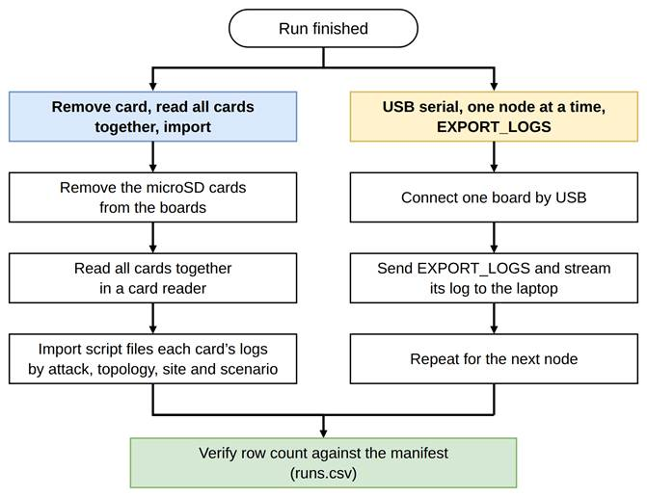

Figure 4.28 Log Retrieval Routes
Each imported file is checked against the runs.csv manifest on the card. If the number of rows received differs from the number the board logged, the script prints a warning, which is the sign of a capture that was cut short. A source file is deleted only if the person asks for that, after its copy has been verified. By default, files that are replaced on a card are archived and not deleted.

4.2.3.6.3. Data Integrity During Manipulation
The local storage architecture ensures dataset completeness even during active attacks:
● Logging continues regardless of routing success – The logging task runs independently of mesh operations.
● All transmission attempts and failures are recorded – Counters capture every packet, regardless of outcome.
● Logs are retained until the copy is verified. Nothing is deleted from a board or a card until the imported file has been checked against the manifest, and deletion is optional.
● Telemetry logs are not streamed over the mesh during the experiment. Only experiment traffic (probes and control messages) crosses the mesh. Logging data stays on the board’s flash and card.

This design guarantees that the final dataset contains a complete record of network behavior across all phases, with ground‑truth labels embedded directly in the data stream, and is immune to data loss caused by the very attacks being studied.
The raw telemetry collected through this framework serves as input to the feature extraction stage described in Section 4.2.4, where derived behavioral indicators (e.g., forwarding ratio, RSSI‑hop consistency, parent switching frequency) are computed for exploratory analysis and clustering.
Each board still logs to its internal flash, and a microSD card now mirrors every telemetry and arrivals row. Data are exported by pulling the card and reading it on a laptop. If no card is present the board falls back to flash only, and the run is never blocked. The card reader is wired by SPI on GPIO 5, 18, 19 and 23, its power pin goes to VIN (5 V) and not to 3V3, and the SPI clock is capped at 4 MHz because jumper wires cannot carry the default speed.
Rows are flushed to the card with fsync() about every 5 s, so an unclean ending loses at most the last few seconds (D-13). Before this change a run that ended badly could leave a card file with 0 rows, and such a file is treated as a lost capture and not as an empty log. The change compiles but has not yet been validated on hardware. A card that fails during a run is also retried: the board reopens the file and then remounts the card every 5 s, stops after six failed attempts in a row, and records the rows it could not write in the card’s runs.csv, so the import flags an incomplete card copy. Internal flash keeps every row. This recovery is not yet tested on hardware.
On highload runs the root writes probe arrivals to the card only, in 4 KB batches flushed every 100 rows, instead of to flash and the card every 10 rows. The double write took about 400 ms per row and lost 3,151 rows at about 28 rows a second in an earlier highload run. The columns and values are unchanged, and only where and when the rows are written differs. The first highload run with the change lost no arrival rows, and highload captures made before it are being recaptured.

4.2.3.7. Dataset Completeness Verification
To ensure that the final dataset accurately reflects the intended experimental conditions and to identify potential data loss due to high traffic or transient logging failures, a completeness verification procedure is performed during preprocessing.
● Expected Sample Count: During each experimental phase, nodes are configured to log telemetry at 10 Hz. For a 5-minute baseline phase (300 seconds), the expected number of samples per node is 3,000. For manipulation phases (3 minutes), the expected count is 1,800. Coverage is measured over the experiment phases only (baseline, attack and cooldown), and every board must reach 95% of its expected samples; formation rows are excluded.
● Completeness Check: After import, the number of samples in each one-second window is counted. Windows with fewer than 8 of the 10 expected samples are discarded, and gaps of 1 or 2 samples inside a kept window are filled (D-9). The proportion of discarded windows per run is reported as a dataset quality measure.
● Row count against the manifest. The number of rows imported for each boot is compared with the number recorded in the card’s runs.csv. A difference marks the capture as cut short. A zero-row card file from before the fsync change (D-13) is treated as lost data, not as a node that logged nothing.
● Run inventory. The inventory script compares every captured run with the campaign plan and lists the cells that are missing, extra or due for a recapture. So far 44 runs have been captured and processed, and five further captures are held out because they are incomplete, not yet analysed, or rated inconclusive by the verifier, and none of the 9 benign runs was captured. [PENDING: inventory against the final plan: runs captured, runs missing, runs outside the plan and runs recaptured.]
● Integrity and topology checks. validate_integrity.py and verify_topology.py are run on every capture. [PENDING: number of the 81 runs that pass each check, the runs that fail with the reason, and how each failed run was treated (recaptured or excluded).]
● Card files. None of the 435 campus capture files has 0 rows. [PENDING: number of runs whose imported rows differ from the card manifest, and number of zero-row card files after the fsync change (D-13).]
● Discarded windows. [PENDING: fraction of windows discarded under the 8-of-10 rule, per run and pooled, once all runs are processed.]
Capture and checking are done with the tools in Table 4.15, and an inventory script checks every captured run against the campaign plan. The tools are kept in the project repository [79].

Table 4.15 Capture and Verification Tools
Tool | Purpose
Run wizard and menu | Flash boards, export logs, save presets, identify boards by MAC address [77]
validate_integrity.py | Checks that the captured files are complete
verify_topology.py | Checks that the mesh formed the intended topology
verify_attack.py | Tests the attack against the baseline (Section 4.2.7)
Sniffer capture | Independent 802.11 frame record, read with Wireshark [78]

4.2.4. Feature Extraction
This section describes the computational procedures for transforming raw telemetry logs into structured behavioral features suitable for exploratory analysis and clustering. All derivations are performed offline during dataset preprocessing, after log extraction and timestamp alignment. The resulting feature vectors capture cross-layer behavioral patterns across the PHY, MAC, and network layers, with auxiliary tunnel activity features recorded only during topology-distortion runs. In this chapter the network layer is the layer of the ESP-WIFI-MESH tree, which runs below IP, and not OSI layer 3.

4.2.4.1 Preprocessing
Raw telemetry logs collected at 10 Hz are first processed to ensure temporal consistency and to convert cumulative counters into interpretable metrics.
Timestamp Alignment. The clocks of the boards are not synchronized, and each node records a local timestamp with esp_timer_get_time() that counts from its own boot. A raw difference between the timestamps of two boards therefore reflects mostly the difference in their boot times and is not used. Instead, the timeline of each node is aligned to that node's own first exit from phase 0, which is the one event that every node observes through the root's phase broadcast. Time is expressed relative to that anchor, and the last 300 s of phase 0 before it is labelled baseline. Earlier rows are excluded from the labelled dataset.

Counter Delta Conversion. Cumulative counters (e.g., retry_count, tx_count, recv_count, forward_count) are recorded as monotonically increasing values. For analysis, these are converted into per‑window deltas:
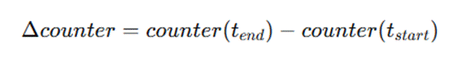 | Equation 4.1
This conversion captures the activity intensity within each window independent of prior history.

Application-Layer Counters. ESP-IDF does not expose MAC-layer retransmission counters, so retry_count and tx_count are application-layer counters and are logged as such. A window in which a node made no send attempt has no RetryRate and is left empty and not set to zero. MAC retransmissions come only from the sniffer, as MacRetryRate.
Handling Missing Values
Raw telemetry logs may occasionally contain missing samples due to transient logging failures, buffer overflows, or temporary node unavailability. Several strategies exist for dealing with such missing data:
● Linear interpolation – Estimate missing values by averaging the nearest valid samples before and after the gap. Suitable for continuous metrics that change smoothly (e.g., RSSI).
● Forward/backward fill – Propagate the last observed value forward (or the next observed value backward) to fill short gaps. Appropriate for cumulative counters that should not decrease.
● Deletion of incomplete windows – Discard any aggregation window that contains missing samples beyond a tolerable threshold. This preserves data integrity but may reduce dataset size.
● Flagging and separate handling – Retain incomplete windows but mark them with a special flag, allowing downstream analysis to decide whether to include or exclude them.
The choice among these strategies depends on the nature of the metric, the extent of missing data, and the tolerance for estimation error. A hybrid approach is therefore used that balances data completeness with reliability, applying different rules depending on the type of metric and the duration of the gap.
- For continuous metrics (e.g., RSSI):
○ If a gap of 1‑2 consecutive missing samples occurs within a window, linear interpolation is applied using the nearest valid samples.
○ If more than two consecutive samples are missing (0.2 s at 10 Hz), the entire one-second window is discarded from further analysis. This threshold ensures that estimated values do not introduce excessive uncertainty.
- For cumulative counters (e.g., forward_count, retry_count):
○ Counters are monotonic; therefore, if one or two consecutive samples are missing, the counter value is assumed unchanged from the previous logged sample (i.e., forward fill).
○ Longer gaps cause the window to be discarded because we cannot reliably determine the counter increment over the interval.
- Counters that ESP-IDF does not expose:
○ retry_count and tx_count are application-layer counters. RetryRate is kept as a dataset column only, and it is excluded from verification, exploratory analysis and model inputs.
○ A window with no send attempt has no RetryRate (NaN). MAC-layer retries are taken from the sniffer, as MacRetryRate and MacFramesHeard, in sniffer runs only.
- Window completeness threshold:
○ Regardless of the imputation method, any window that contains fewer than 8 valid 10 Hz samples (out of the expected 10) is discarded. This guarantees that summary statistics are based on a representative subset of the window's duration.
All interpolation and flagging decisions are logged per node and per window, ensuring full transparency. The fraction of discarded windows is reported as a dataset quality metric, allowing future users to assess the potential impact of missing data.
Window Aggregation. To reduce sensitivity to transient fluctuations and to capture behavioral trends, all telemetry is aggregated into non-overlapping one-second windows:

Table 4.16 Window Aggregation

Parameter | Value
Window Duration | 1 second
Sampling Grid | 10 Hz
Window Type | Non‑overlapping
Minimum Valid Samples | 8 of 10
Continuous Metrics | Mean, variance, min, max per window
Cumulative Counters | Delta per window
Event Counts | Total events per window (e.g., parent switches)

Windowed aggregation balances granularity with statistical robustness. Telemetry is now aggregated into non-overlapping one-second windows on a 10 Hz grid (D-9). A window with fewer than 8 of its 10 expected samples is discarded, which keeps the 80% completeness rule of the approved text. Each node therefore yields about 60 windows per minute. The fraction of discarded windows and the number of captures excluded for integrity are reported as dataset quality figures.

4.2.4.2 Feature Computation
The following features are computed for each node per observation window. Features are organized by the behavioral dimension they capture, with formulas and interpretations provided. Where relevant, we distinguish between transit packets (those received for forwarding) and locally generated traffic.

The hop count is used instead of the layer: the hop count equals the layer minus 1, so the root is at 0 hops, and the count of depth changes is named HopChangeCount. LatencyHopRatio (Equation 4.14) uses the relative one-way delay divided by the hop count, because the probes have no response leg. TunnelLatency (Equation 4.18) is the gap between the two arrivals of one duplicated probe at the root.

A window receives a PDR (Equation 4.5) only if the node sent probes in it, was attached to the mesh, and the root was logging. A window with nothing sent is left blank and is not set to 0. The forwarding features are computed for every relaying node, not only the attacker.

The counters retry_count and tx_count in Table 4.9 are application-layer counters: failed sends and frames accepted for sending. ESP-IDF exposes no 802.11 MAC statistics, so these are not MAC retransmissions [75]. RetryRate is therefore kept as a dataset column only, and it is excluded from verification, exploratory analysis and model inputs. Real MAC retries come only from the independent sniffer, as the features MacRetryRate and MacFramesHeard.

4.2.4.2.1. Forwarding Behavior Features
Forwarding Ratio (Blackhole Indicator)
Measures the proportion of received transit packets that are forwarded by a node. This feature is the primary indicator of forwarding suppression. The counters recv_count and forward_count refer only to transit packets; locally generated packets are excluded.
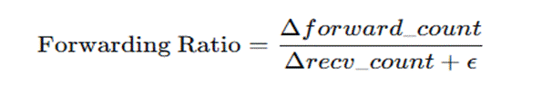 | Equation 4.2
Where:
● Δforward_count = forward_count at window end − forward_count at window start
● Δrecv_count = recv_count at window end − recv_count at window start
● ϵ is a small constant (10⁻⁶) to prevent division by zero
Interpretation:
● ≈ 1.0 → Normal forwarding behavior (all received transit packets forwarded)
● ≈ 0.0 → Complete forwarding suppression (blackhole active)
● 0.0 < ratio < 1.0 → Partial suppression or forwarding instability
● Undefined (no packets received) → Node not handling transit traffic
Ingress‑Egress Delta
Absolute difference between transit packets received and forwarded, indicating packet absorption.
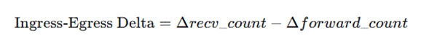 | Equation 4.3
Interpretation:
● ≈ 0 → Balanced forwarding (normal operation)
● > 0 → Packets absorbed (potential blackhole)
● < 0 (rare) → May indicate local packet generation or forwarding of previously queued packets

4.2.4.2.2. Link Reliability Features
Retry Rate (application counters)
Proportion of send attempts that failed, computed from the application counters retry_count and tx_count. These are not 802.11 MAC statistics [75] (D-15), so RetryRate is kept as a dataset column only and is not used in verification, exploratory analysis or model inputs. MAC-layer retries are taken from the independent sniffer as MacRetryRate.
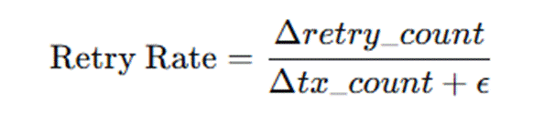 | Equation 4.4
● Kept as a dataset column only. No cited study supports it as an attack signature, and it measured flat in the captured runs.
Packet Delivery Ratio (PDR)
Proportion of a node's probes that are received at the root, computed per child node per window. The probes of a window are identified by their sequence numbers, and the root's arrival log is joined to the node's counters on the sequence number.
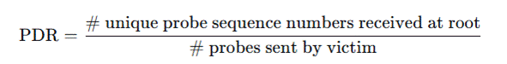 | Equation 4.5
Interpretation:
● 0.97 → Normal operation (aligned with Khan et al. [22] baseline)
● Decreased values → End‑to‑end delivery degradation, potentially due to blackhole or routing disruption

4.2.4.2.3. Topology Stability Features
Parent Switch Rate
Frequency of parent changes within the observation window, indicating topology instability.
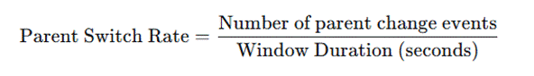 | Equation 4.6
Interpretation:
● Very low (≈ 0) → Stable topology
● Moderate (> 0 but small) → Normal adaptive adjustments
● High values → Persistent instability or distortion pressure
Layer Change Count
Number of times the node's mesh layer (hop count) changed during the window.

Equation 4.7
Interpretation:
● 0 → Stable layer assignment
● > 0 → Node moving up/down in hierarchy, indicating topology adaptation or instability
Hop Stability Duration
Longest continuous interval within the window during which the node maintained the same layer and parent. Computed by scanning event logs and measuring the maximum duration where (layer, parent_mac) remained constant.

Equation 4.8
Interpretation:
● Long durations → Stable topology
● Short durations → Frequent reconfiguration, potential distortion effects

4.2.4.2.4. Physical Layer Features
RSSI Mean
Average received signal strength within the window.
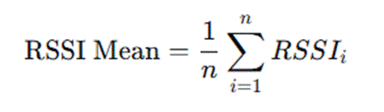 | Equation 4.9
Interpretation:
● Values reflect link quality and physical proximity to the parent
● Under normal operation, RSSI decreases predictably with hop count
RSSI Variance
Statistical variance of RSSI samples within the window, indicating signal stability.
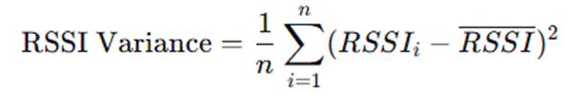 | Equation 4.10
Interpretation:
● Low variance → Stable link conditions
● High variance → Environmental interference, mobility, or topology instability
RSSI Stability Duration
Longest continuous interval within the window where RSSI remains within ±3 dBm of the window mean.

Equation 4.11
Interpretation:
● Long duration → Stable signal conditions
● Short duration → Fluctuating signal, potentially due to interference or parent switching

4.2.4.2.5. Cross‑Layer Inconsistency Features
RSSI–Hop Inconsistency
Deviation between observed RSSI and the value expected based on the node's reported layer. This feature captures physical‑logical topology mismatches characteristic of wormhole distortion.
The expected RSSI for a given layer is not a fixed global table; instead, it is derived empirically from the baseline windows of the same experimental run. For each stable baseline segment, the median RSSI per layer is computed. During distortion windows, the observed RSSI is compared against the baseline median for the reported layer:

Equation 4.12
Where

Equation 4.13
This approach makes the metric environment‑specific and robust to testbed variations.
Interpretation:
● Small diff (< 5 dB) → RSSI consistent with reported layer
● Large diff (> 10 dB) → Potential physical‑logical mismatch; node may be receiving packets from distant sources with unusually strong signal (wormhole effect)
Latency–Hop Inconsistency
Ratio of end‑to‑end latency to hop count, indicating whether path length matches expected delay.
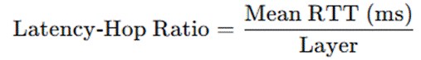 | Equation 4.14
where Mean RTT is computed from probe‑response exchanges between victim nodes and the root (using the timestamps embedded in probe/response messages).
Interpretation:
● Consistent ratio (10–30 ms per hop) → Normal multi‑hop forwarding
● Abnormally low ratio → Path appears shorter than reported layer (potential shortcut effect)
● Abnormally high ratio → Congestion or indirect routing
Forwarding Consistency Score
Deviation of the forwarding ratio from the ideal value of 1.0 provides a unified measure of forwarding compliance.

Equation 4.15
Interpretation:
● ≈ 0 → Perfect forwarding compliance (Forwarding Ratio ≈ 1.0)
● > 0 → Increasing deviation from expected behavior
● Closer to 1 → Severe forwarding suppression

4.2.4.2.6. Auxiliary Tunnel Activity Features (Experiment‑Level)
These metrics are recorded only on nodes participating in topology distortion experiments. They are not part of the standard PHY/MAC/Network layer set, but are included to document manipulation intensity.
Tunnel Intensity
Combined rate of tunnel activity, indicating the intensity of the wormhole‑inspired manipulation.
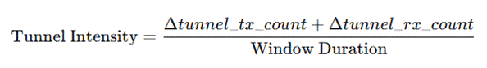 | Equation 4.16
where:
● Δtunnel_tx_count = tunnel transmissions within the window
● Δtunnel_rx_count = tunnel receptions within the window
● Window Duration = 1 second (in this study)
Interpretation:
● 0 → No tunnel activity (baseline or tunnel inactive)
● > 0 → Tunnel active; higher values indicate more frequent relaying
Tunnel Bytes Transferred
Total bytes transmitted through the tunnel per window, indicating data volume.

Equation 4.17
Interpretation:
● Correlates with manipulation intensity; higher values may indicate a more significant shortcut
Tunnel Latency
Round‑trip latency of the tunnel itself, measured using periodic echo messages.
Interpretation:
● Consistent low latency → Tunnel operating as designed
● Variable latency → May affect shortcut effectiveness

4.2.4.3 Feature Summary
The complete feature set per node per window comprises the following 16 attributes, categorized by the layer they primarily represent:

Table 4.17 Feature Summary
Feature | Layer | Behavioral Dimension
Forwarding Ratio | Network | Forwarding compliance
Ingress‑Egress Delta | Network | Packet absorption
Retry Rate (application counters) | Application | Link stress (dataset column only)
MacRetryRate | MAC | Link stress (sniffer capture)
Packet Delivery Ratio | Network | End‑to‑end reliability
Parent Switch Rate | Network | Topology stability
Layer Change Count | Network | Topology stability
Hop Stability Duration | Network | Topology stability
RSSI Mean | PHY | Signal strength
RSSI Variance | PHY | Signal stability
RSSI Stability Duration | PHY | Signal stability
RSSI‑Hop Inconsistency | Cross‑layer | Physical‑logical mismatch
Latency‑Hop Inconsistency | Cross‑layer | Path length mismatch
Forwarding Consistency Score | Cross‑layer | Forwarding deviation
Tunnel Intensity | Auxiliary | Manipulation intensity
Tunnel Bytes | Auxiliary | Manipulation volume
Tunnel Latency | Auxiliary | Tunnel performance

These features form the input space for clustering analysis, capturing the cross‑layer behavioral signatures of normal operation, forwarding suppression, and topology distortion.

4.2.4.4. Dataset Record Structure (Windowed Per-Node Schema)
Dataset Scope and Observation Granularity
To clarify the structure of the dataset used in this study, telemetry observations are collected from individual ESP32 nodes and subsequently merged into a unified dataset representing the overall experimental mesh network environment. Rather than representing the network as a single aggregated measurement, the dataset is constructed at the node-level observation granularity, where each record corresponds to the behavior of a specific node during a defined observation window.
During each experimental phase, all nodes participating in the ESP-WiFi-Mesh testbed generate telemetry logs containing cross-layer indicators related to routing behavior, link conditions, packet forwarding activity, and topology participation. These logs are retrieved after each experiment and synchronized using timestamp alignment to compensate for asynchronous device clocks. Once synchronized, logs from all nodes are merged into a single dataset while preserving the identity of each node and the corresponding observation window.
Each dataset entry, therefore, represents a node–window observation, consisting of:
● Node identifier
● Observation window or timestamp interval
● Experimental phase label (baseline, blackhole attack, or wormhole attack)
● Extracted behavioral features derived from telemetry metrics
After preprocessing and feature computation, each one-second observation window produces one record per node. The complete dataset is structured as a flat table, where rows correspond to node–window observations and columns contain the features defined in Section 4.2.4.2, together with metadata and experimental labels. Table 4.18 summarizes the dataset schema.
This design preserves node-level behavioral characteristics, which are essential for identifying routing anomalies. For example, a blackhole attack typically manifests as a decrease in forwarding activity at the attacker node, while the nodes behind it lose delivery to the root. If the dataset were aggregated at the network level, these localized behavioral changes would be obscured.

The final dataset combines observations from all experimental runs and all topology configurations (star, tree, linear chain, and partial mesh) into a single unified table. Additional metadata fields, such as attack, topology, location, scenario, run_repeat and run_id, are included to allow researchers to filter or stratify the dataset during analysis. For instance, analyses may be restricted to a specific topology to examine localized attack behavior, or the entire dataset may be used to evaluate clustering performance across multiple network configurations.

Table 4.18 Windowed Per-Node Dataset Schema
Column | Description
window_start | Start timestamp of the one‑second aggregation window
node_id | Unique node identifier
node_role | Node role (root, attacker, victim, other)
RSSI_mean | Average RSSI within window (dBm)
RSSI_var | RSSI variance
RSSI_stability | Longest stable RSSI interval (seconds)
RetryRate | Share of send attempts that failed (application counters, not MAC; D-15)
PDR | Packet delivery ratio (victim nodes only)
ForwardingRatio | Transit packet forwarding ratio
IngressEgressDelta | Packet absorption count
ConsistencyScore | Forwarding deviation metric
ParentSwitchRate | Parent changes per second
LayerChangeCount | Number of layer transitions
HopStabilityDuration | Longest stable (layer, parent) interval
RSSI_Hop_Diff | Physical-logical mismatch (dB)
LatencyHopRatio | Latency per hop (ms)
TunnelIntensity* | Tunnel messages per second
TunnelBytes* | Total tunnel bytes transferred
TunnelLatency* | Tunnel round-trip time (ms)
Label | Ground-truth phase (0,1,2)
*Tunnel features are defined only in wormhole runs. TunnelIntensity and TunnelBytes are computed for the two tunnel endpoints, and TunnelLatency for the node whose probes were duplicated. Elsewhere these fields are empty or close to zero. †Sniffer runs only; empty where the sniffer did not cover the node.
Clustering analysis is performed on these windowed records; each window is treated as an independent behavioral observation. No time‑series or sequential models are applied, ensuring that clustering results reflect feature‑space separation rather than temporal dependencies.

4.2.4.5 Feature Engineering Design Principles
The feature set defined in this section follows four methodological principles that guide selection, computation, and documentation:
● Observability: All features are derived from metrics accessible through standard ESP‑IDF APIs (esp_wifi_sta_get_rssi(), mesh events, cumulative counters). No protocol modifications or custom instrumentation are required.
● Low Overhead: Feature computation is performed offline during dataset preprocessing; on‑node logging captures only raw counters and timestamps. This ensures that the logging process does not interfere with mesh operations or manipulation effects.
● Relationship Preservation: Features are designed to preserve cross‑layer relationships (e.g., receive–forward consistency, RSSI‑hop correlation) that theoretical analysis identifies as attack‑sensitive. They encode structural expectations rather than attack‑specific thresholds.
● Reproducibility: All derived metrics are explicitly defined with fixed window durations (1 second), delta conversion rules, and expected value baselines computed empirically from stable windows. This ensures that the feature extraction process can be replicated exactly by other researchers.

4.2.4.6 Feature Selection and Dimensionality Analysis

While the feature set defined in Section 4.2.4.3 captures a comprehensive range of cross-layer behaviors, not all features may contribute equally to distinguishing between normal and malicious network states. To address the scenario where a single feature might dominate or where features are redundant, a feature selection and dimensionality analysis phase is integrated into the preprocessing workflow. The primary goals are to identify and potentially remove features that are highly correlated or have low variance, ensuring the subsequent clustering analysis is robust and not biased by irrelevant data.
First, a low-variance filter will be applied. Features that exhibit near-constant values across the vast majority of observation windows (e.g., >90% of samples have the same value) provide little discriminative power and can distort distance-based clustering. Such features will be flagged for removal. For example, if RSSI_Hop_Diff is zero for nearly all baseline windows, its presence might add noise rather than signal.
Second, a correlation analysis will be performed to identify pairs of features that are highly collinear (e.g., Pearson correlation coefficient |r| > 0.85). Highly correlated features can over-emphasize a single underlying behavioral characteristic. In such cases, one of the features from the pair may be considered for removal to reduce redundancy. For instance, Forwarding Ratio and Forwarding Consistency Score are mathematically related; if they are found to be perfectly correlated, one might be dropped.
Third, to complement the clustering algorithms, Principal Component Analysis (PCA), as introduced by Jolliffe [52], will be used as an exploratory tool. By projecting the high-dimensional feature vectors onto the principal components that capture the most variance, we can visualize the data's structure and assess its inherent clusterability. More importantly, analyzing the component loadings will reveal which original features contribute most heavily to the overall variance in the dataset. A feature that consistently shows high loadings across the first two or three principal components is empirically more relevant to the overall behavioral structure of the network.
This feature selection process is not intended to pre-define a rigid subset of features before clustering. Instead, it serves as a diagnostic step to ensure the dataset's integrity. Clustering will be performed on both the full feature set and the reduced, non-redundant feature set to compare the stability and interpretability of the results. This approach directly addresses the potential pitfall of relying on a single, dominant indicator and ensures that the discovered behavioral patterns are driven by a confluence of cross-layer evidence.

4.2.5. Data Clustering

4.2.5.1. Clustering Algorithms

Five clustering algorithms are applied to the same standardized feature vectors, so that the groupings they find can be compared: DBSCAN as the primary method, K-Means as a comparative baseline, agglomerative hierarchical clustering with Ward linkage, a Gaussian mixture model (GMM) and spectral clustering. Each is described below, with the figures that illustrate it.

4.2.5.1.1. DBSCAN (Density‑Based Spatial Clustering of Applications with Noise)

DBSCAN is selected as the primary clustering method due to its ability to identify density-connected regions in feature space without requiring a predefined number of clusters. This property is particularly appropriate for exploratory behavioral analysis, where the true number of underlying behavioral states is not assumed a priori.

DBSCAN offers the following advantages:

● No predefined number of clusters: The algorithm determines the number of clusters based on the density structure.

● Noise detection capability: Points that do not belong to any dense region are labeled as noise, which may correspond to transitional or unstable behavioral windows.

● Arbitrary cluster shapes: Unlike centroid-based methods, DBSCAN does not assume spherical clusters.

● Suitability for anomaly discovery: Normal operation is expected to form dense regions, while attack behaviors may either form separate dense clusters or appear as sparse anomalies.

Table 4.19 DBSCAN Parameter Selection
Parameter | Description | Selection Method
ε (eps) | Maximum distance between two samples to be considered neighbors | Determined using the k-distance graph (k = min_samples)
min_samples | Minimum number of points to form a dense region | Evaluated within the range D + 1 to 2D, where D is feature dimensionality

To determine ε, the distances to each point’s k-th nearest neighbor (where k = min_samples) are computed and sorted in ascending order. The resulting k-distance graph typically exhibits a knee (elbow) point separating dense regions from sparse noise. The value of ε corresponding to this knee is selected as the optimal threshold.

Final parameter choices are validated using internal cluster evaluation metrics (silhouette score and Davies–Bouldin index) to ensure structural stability.

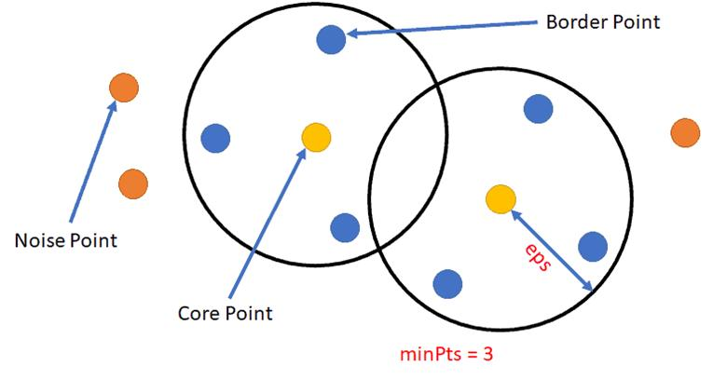

Figure 4.29 Core, Border, and Noise Points in DBSCAN

Illustrates how DBSCAN classifies points into core points, border points, and noise points using the ε-neighborhood radius and the minimum number of points (minPts). In the diagram, the two black circles represent the ε-neighborhoods, which define the radius within which neighboring points are counted. The parameter minPts = 3, shown in the figure, indicates the minimum number of neighboring points required for a point to be considered part of a dense region.

The elements shown in the figure correspond to the following DBSCAN point classifications:

● Core Points – The yellow points located at the center of each ε circle represent core points. These points have at least minPts neighboring points within their ε-neighborhoods. Because they lie in dense regions of the dataset, core points serve as the starting points for cluster formation.

● Border Points – The blue points located inside the ε circles but not at the center represent border points. These points fall within the ε-neighborhood of a core point but do not themselves have enough neighbors to satisfy the minPts condition. Border points are therefore assigned to a cluster, but cannot expand the cluster further.

● Noise Points – The orange points located outside the ε circles represent noise points. These points do not fall within the ε-neighborhood of any core point and, therefore, are not assigned to any cluster. In DBSCAN, such points are treated as outliers.

The overlapping ε circles in the figure illustrate how dense regions can connect clusters through shared neighborhoods. By distinguishing between core, border, and noise points, DBSCAN is able to identify clusters of arbitrary shapes while simultaneously detecting outliers in sparse regions of the dataset (Shameer, n.d.).

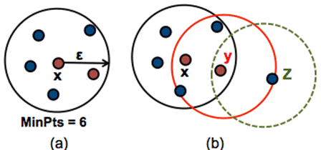

Figure 4.30 DBSCAN Cluster Formation with Noise

This figure illustrates how clusters are formed in the DBSCAN algorithm using the ε-neighborhood radius and the minimum number of points (MinPts). The diagram is divided into two parts, labeled (a) and (b), which demonstrate how DBSCAN identifies dense regions and expands clusters through density reachability.

In Figure 4.30, the black circle represents the ε-neighborhood around the central point. The surrounding points inside the circle represent neighboring data points. Since the number of points within the ε radius satisfies the required MinPts = 6, the central point is classified as a core point. Core points indicate regions of high density and serve as starting points for cluster formation in the DBSCAN algorithm (Soni, n.d.).

In Figure 4.30, the diagram shows three overlapping ε-neighborhoods corresponding to points X, Y, and Z, illustrating how clusters expand through density relationships:

● Point X lies inside the dense region and satisfies the minimum density requirement, making it a core point. Its ε-neighborhood is represented by the black circle containing several nearby points.

● Point Y lies within the ε-neighborhood of point X and also has sufficient neighboring points inside its red ε circle. As a result, Y is also considered a core point, allowing the cluster to expand further through density reachability.

● Point Z lies within the ε-neighborhood of point Y but does not contain enough neighboring points to satisfy the MinPts requirement. Therefore, Z is classified as a border point and becomes part of the cluster without initiating further cluster expansion.

The overlapping circles in the figure illustrate how clusters grow by connecting core points whose ε-neighborhoods intersect. Points that are reachable through chains of core points become part of the same cluster, while points located outside these dense regions would be classified as noise.

This density-based expansion allows DBSCAN to detect clusters of arbitrary shapes while distinguishing sparse points that do not belong to any cluster (Soni, n.d.).

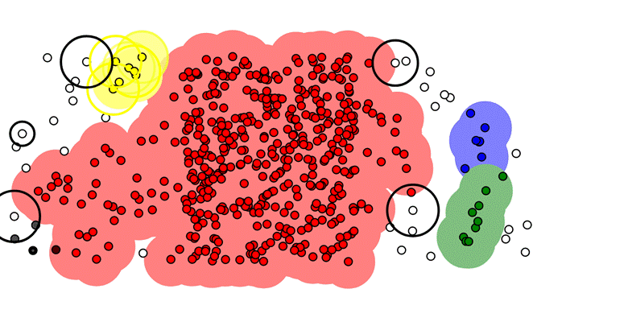

Figure 4.31 DBSCAN Density-Based Cluster Detection

The DBSCAN algorithm detects clusters by identifying dense regions of data points and separating them from sparse areas. In the visualization, clusters are represented by colored shaded regions, while points located outside dense areas remain unclustered and may be classified as noise. The black circles shown around certain points represent ε-neighborhoods, which define the radius used to measure local density.

The elements visible in the figure correspond to the following DBSCAN clustering concepts:

● Dense Cluster Regions – The large red shaded region in the center of the figure represents a dense cluster containing many closely spaced data points. Because the number of neighboring points within the ε-neighborhood satisfies the required minPts threshold, DBSCAN identifies this area as a cluster.

● Smaller Cluster Groups – On the right side of the figure, the blue and green shaded regions represent smaller clusters that also meet the density requirement. These clusters form when groups of points satisfy the ε and minPts conditions within localized regions.

● Core Points and ε-Neighborhoods – The black circles surrounding some points indicate the ε-neighborhood used by DBSCAN to evaluate point density. Points inside these circles represent neighboring data points that contribute to determining whether a point qualifies as a core point.

● Border Points – Points located along the outer edges of the shaded cluster regions represent border points. These points fall within the ε-neighborhood of core points but do not contain enough neighbors to satisfy the minPts requirement themselves.

● Noise or Outlier Points – The isolated white or gray points scattered outside the colored regions represent noise points. These points do not fall within the ε-neighborhood of any core point and, therefore, are not assigned to any cluster.

The figure demonstrates how DBSCAN forms clusters by expanding from dense regions through chains of density-reachable points while leaving sparse points unclustered. This density-based approach enables the algorithm to detect clusters of irregular shapes and varying sizes without requiring a predefined number of clusters (UpGrad, n.d.).

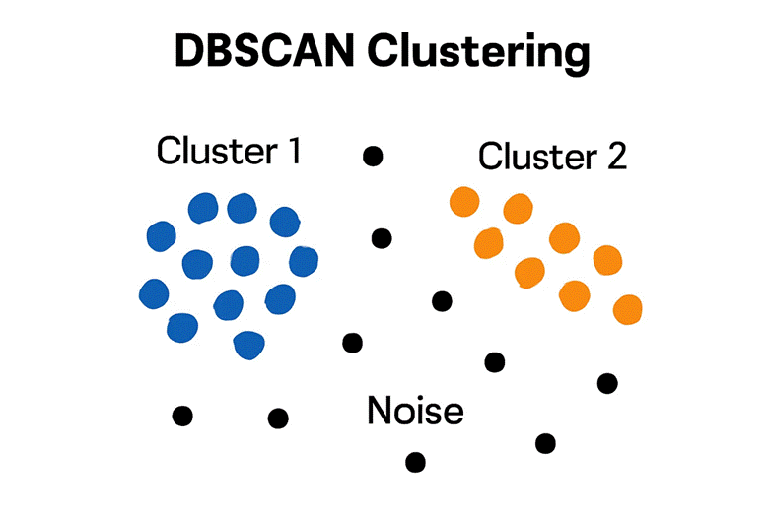

Figure 4.32 Density Reachability in DBSCAN

The concept of density reachability in the DBSCAN clustering algorithm, showing how clusters are formed through chains of density-connected points while sparse points remain classified as noise. In the diagram, the data points are divided into two dense groups labeled Cluster 1 and Cluster 2, while scattered black points represent noise or outlier observations.

The elements shown in the figure correspond to the following DBSCAN clustering relationships:

● Cluster 1 (Blue Points) – The group of blue points on the left side represents a dense region of data points that are close enough to satisfy the ε-neighborhood and minPts requirements. Because these points are density-connected, DBSCAN groups them together to form a cluster.

● Cluster 2 (Orange Points) – The orange points on the right side form another dense region that satisfies the density conditions required for cluster formation. These points are connected through chains of density-reachable points, forming a second cluster separate from Cluster 1.

● Density Reachability – Points within each cluster are connected through neighboring points that satisfy the density requirement. A point is considered density-reachable from another point if it can be reached through a sequence of neighboring core points within the ε-neighborhood.

● Noise Points (Black Points) – The scattered black points located between and around the clusters represent noise or outliers. These points do not fall within the ε-neighborhood of any dense region and, therefore, are not assigned to any cluster.

This figure demonstrates how DBSCAN forms clusters based on density connectivity rather than distance to a centroid, allowing the algorithm to identify clusters of arbitrary shapes while effectively separating sparse data points as noise (STHDA, n.d.).

4.2.5.1.2. K‑Means (Comparative Baseline)

K-Means clustering is applied as a centroid-based comparative baseline to evaluate whether the extracted cross-layer behavioral features form separable groupings under a partition-based clustering model. Unlike DBSCAN, which detects density-connected regions and identifies noise, K-Means partitions the dataset into k compact clusters by minimizing within-cluster variance (WCSS).

Clustering is performed on the standardized feature vectors aggregated per node per one-second window, with the same inputs as for the other algorithms (Section 4.2.5.1). Separate experiments on the wormhole runs may add the tunnel features to assess separability that rests on explicit manipulation indicators.

Number of clusters selection. The optimal number of clusters is determined using two complementary methods:

● Elbow Method: Plot of within‑cluster sum of squares (WCSS) against increasing k; the elbow point indicates diminishing returns.

● Silhouette Analysis: Average silhouette width across all points for each k, with higher values indicating better cluster separation.

For this study, k values from 2 to 8 are evaluated. The lower bound (k = 2) reflects the minimum plausible behavioral separation (normal vs. anomalous), while higher values allow for potential differentiation between forwarding suppression, topology distortion, and transitional states. The final value of k is selected based on agreement between elbow behavior, silhouette score peaks, and cluster interpretability.

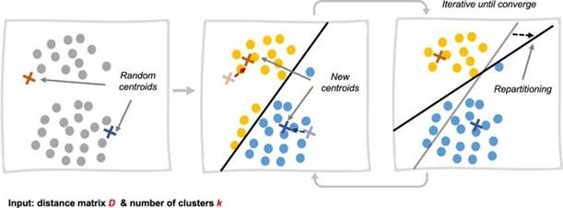

Figure 4.33 K-Means Iterative Cluster Formation in Three Stages

The iterative process of cluster formation in the K-Means clustering algorithm. The diagram presents three stages showing how clusters are formed and refined through repeated centroid updates until convergence is achieved. Each panel represents a step in the clustering process, demonstrating how data points are assigned to clusters based on their distance to cluster centroids.

The elements shown in the figure correspond to the following steps of the K-Means algorithm:

● Initial Centroid Selection (Left Panel) – The first panel shows a dataset of scattered points along with randomly initialized centroids, represented by cross symbols. These centroids serve as the initial centers of the clusters before the algorithm begins assigning data points.

● Cluster Assignment and Repartitioning (Middle Panel) – In the second panel, the algorithm assigns each data point to the nearest centroid based on distance. The black boundary line indicates the decision boundary that separates the clusters. Points closer to one centroid are assigned to that cluster, forming preliminary cluster groups.

● Centroid Update and Iteration (Right Panel) – In the final panel, the centroids are recomputed based on the mean position of the points assigned to each cluster. After updating the centroids, the algorithm reassigns data points and recalculates centroids repeatedly. This iterative process continues until the centroids stabilize and the cluster assignments no longer change significantly.

The arrows between panels indicate the repetition of the assignment and centroid update steps, highlighting the iterative nature of the K-Means algorithm. Through this process, clusters gradually form as centroids move toward the centers of their respective groups of data points.

This visualization demonstrates how K-Means partitions a dataset into clusters by minimizing the distance between data points and their assigned centroids during each iteration (Bishop, 2006).

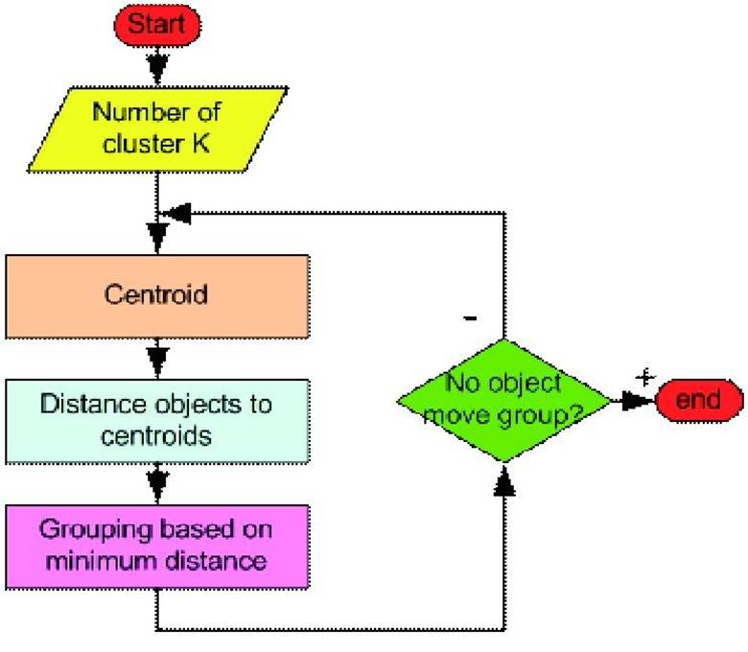

Figure 4.34 K-Means Algorithm Flowchart. Adapted from Lloyd (1982).

A flowchart illustrating the step-by-step procedure of the K-Means clustering algorithm. The diagram shows how data points are iteratively assigned to clusters based on their distance to cluster centroids until the cluster assignments stabilize. The flowchart begins with initialization and proceeds through repeated cluster assignment and centroid updates until convergence is reached.

The elements shown in the figure correspond to the following steps of the K-Means algorithm:

● Start and Cluster Initialization – The process begins at the Start node, followed by specifying the number of clusters K. This parameter determines how many clusters the dataset will be partitioned into.

● Centroid Initialization – The “Centroid” process box represents the step where initial centroids are selected. These centroids act as the starting centers of the clusters.

● Distance Calculation – The “Distance objects to centroids” step calculates the distance between each data point and the centroids. This distance measurement is typically computed using Euclidean distance.

● Cluster Assignment – In the “Grouping based on minimum distance” step, each data point is assigned to the cluster corresponding to the nearest centroid.

● Convergence Check – The decision diamond labeled “No object move group?” evaluates whether any data points change cluster assignments during the iteration. If cluster assignments continue to change, the algorithm returns to the centroid update step and repeats the process.

● End Condition – When no data points change clusters, indicating that the centroids have stabilized, the algorithm reaches the End node, and the final cluster configuration is produced.

The loop shown in the flowchart highlights the iterative nature of the K-Means algorithm, where centroid positions and cluster memberships are repeatedly updated until convergence is achieved. This iterative optimization process minimizes the distance between data points and their corresponding cluster centroids (Lloyd, 1982).

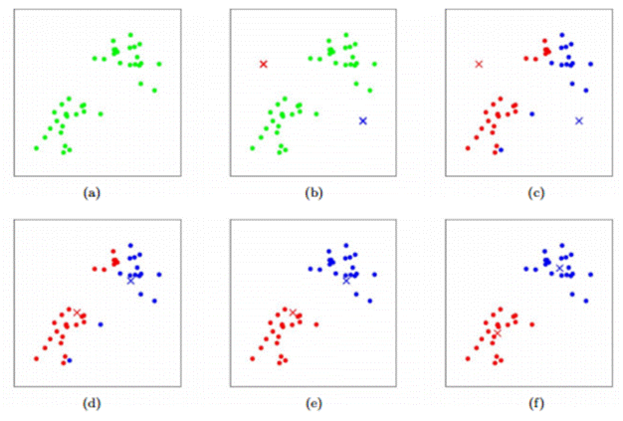

Figure 4.35 Step-by-Step K-Means Cluster Formation in Six Stages. Adapted from Bishop (2006).

The iterative process of cluster formation in the K-Means clustering algorithm, showing how clusters gradually form as centroids are updated and data points are reassigned during successive iterations. The six panels labeled (a) to (f) represent different stages in the clustering process.

The steps illustrated in the figure correspond to the following stages of the K-Means algorithm:

● (a) Initial Dataset Distribution – The first panel shows the original dataset consisting of scattered data points before clustering begins. At this stage, no cluster assignments have been made.

● (b) Random Centroid Initialization – In the second panel, two centroids (marked with “×”) are randomly placed within the dataset. These centroids serve as the initial cluster centers from which the algorithm begins the clustering process.

● (c) First Cluster Assignment – The algorithm assigns each data point to the nearest centroid based on distance. As shown in the figure, points begin to separate into two groups represented by different colors (red and blue).

● (d) Centroid Recalculation – After the initial assignment, the centroids are updated by computing the mean position of the data points assigned to each cluster. The new centroid positions are then used for the next iteration.

● (e) Reassignment of Data Points – Using the updated centroids, the algorithm recalculates distances and reassigns data points to the closest centroid. This step may change the cluster membership of some points.

● (f) Convergence of Clusters – In the final panel, the clusters stabilize as centroid positions stop changing significantly. At this stage, the algorithm converges, and the final cluster structure is obtained.

The figure demonstrates how the K-Means algorithm repeatedly performs cluster assignment and centroid update steps until the cluster configuration stabilizes. This iterative process minimizes the within-cluster variance by ensuring that data points remain close to their corresponding centroids (Bishop, 2006).

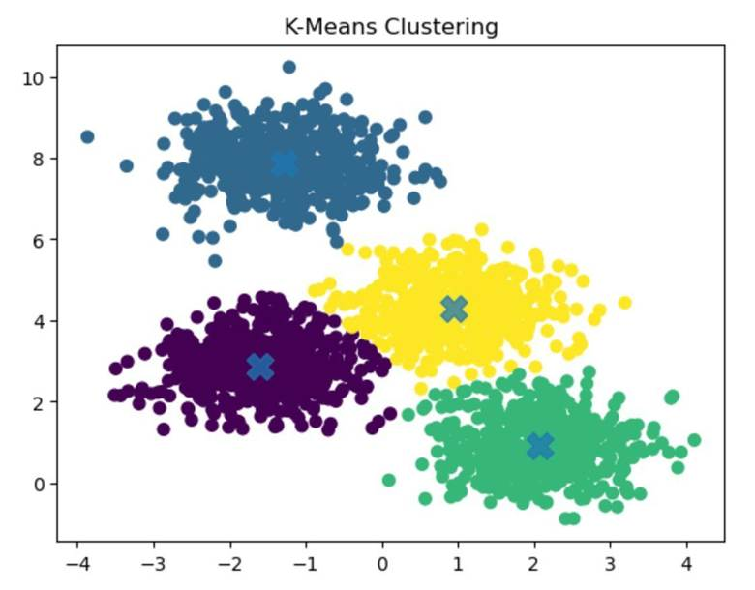

Figure 4.36 Example of K-Means Clustering

Example of clustering using the K-Means algorithm, which partitions a dataset into a predefined number of clusters by minimizing the distance between data points and their corresponding cluster centroids. The visualization shows how data points are grouped into clusters based on similarity in the feature space.

In the figure, each data point represents an observation plotted in a two-dimensional feature space, where the horizontal and vertical axes correspond to two features used for clustering. The points form several dense groups that the K-Means algorithm identifies as clusters.

The elements shown in the figure correspond to the following characteristics of the K-Means clustering process:

● Clustered Data Points – The scatter plot shows four distinct groups of points represented by different colors. Each color corresponds to a cluster identified by the algorithm, indicating that the observations within the same group share similar feature characteristics.

● Cluster Centroids – The large “×” markers located at the center of each cluster represent the centroids. These centroids correspond to the mean position of all data points assigned to each cluster and serve as the reference points for cluster assignment.

● Cluster Partitioning – Each data point is assigned to the cluster whose centroid is closest in terms of distance, typically measured using Euclidean distance. This results in the formation of clearly separated groups within the dataset.

● Distance Minimization – The K-Means algorithm iteratively updates centroid positions and reassigns data points until the clusters stabilize, minimizing the total within-cluster variance.

The figure demonstrates how K-Means divides a dataset into clusters by grouping nearby observations around central centroid points, producing partitions that represent similar patterns within the data (StrataScratch, n.d.).

4.2.5.1.3. Hierarchical Clustering

Hierarchical clustering is applied as an additional unsupervised clustering approach to analyze the structural relationships between behavioral observations without requiring an explicit assumption about the number of clusters during the clustering process. Unlike partition-based algorithms such as K-Means, hierarchical clustering builds a nested hierarchy of clusters by iteratively merging or splitting data points based on similarity.

For this study, agglomerative hierarchical clustering is employed. In this approach, each observation initially forms its own cluster. Clusters are then progressively merged according to a defined linkage criterion until all observations are grouped into a single hierarchy. The resulting structure is represented through a dendrogram, which visualizes the sequence of cluster merges and the relative distances between clusters.

Clustering is performed on the standardized feature vectors derived from telemetry observations aggregated per node per one-second window, with the same inputs as for the other algorithms (Section 4.2.5.1). An additional run on the wormhole runs may add the tunnel features to observe separability that rests on explicit manipulation indicators.

Linkage method selection. Cluster merging is determined using Ward’s linkage criterion, which minimizes the increase in within-cluster variance when clusters are combined. Ward linkage is selected because it produces compact clusters that are comparable to those produced by K-Means, enabling meaningful comparison between partition-based and hierarchical clustering approaches.

The hierarchical clustering procedure is implemented as follows:

Each observation begins as an individual cluster.

Pairwise distances between clusters are computed using Euclidean distance.

The two clusters that produce the smallest increase in total within-cluster variance are merged.

Steps 2–3 are repeated until all observations are merged into a hierarchical structure.

Cluster selection. Although hierarchical clustering produces a full cluster hierarchy, the dendrogram is cut at selected distance thresholds to produce cluster partitions for evaluation. Similar to the K-Means baseline experiment, cluster counts between 2 and 8 clusters are evaluated. These values allow the analysis to determine whether hierarchical clustering reveals interpretable behavioral groupings corresponding to normal operation, forwarding suppression, topology distortion, or intermediate behavioral states.

Cluster partitions obtained from the dendrogram are evaluated using the same internal validation metrics used for other clustering methods, including silhouette score and Davies–Bouldin index, allowing direct comparison with results obtained from DBSCAN and K-Means.

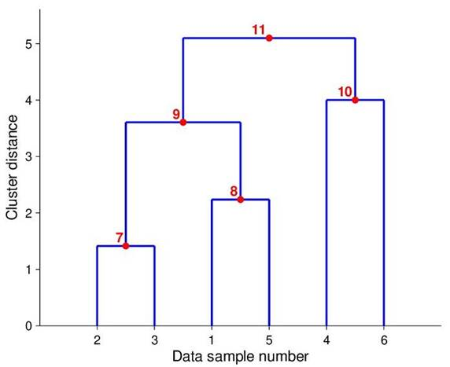

Figure 4.37 Example Dendrogram

Dendrogram used in hierarchical clustering to visualize how data points are grouped into clusters based on their similarity or distance. A dendrogram is a tree-like diagram that illustrates the sequence of cluster merging steps and the relative distances at which clusters are combined.

In the diagram, the horizontal axis labeled “Data sample number” represents the individual observations in the dataset. Each sample initially begins as its own cluster at the bottom of the dendrogram. The vertical axis labeled “Cluster distance” represents the distance or dissimilarity between clusters, indicating the level at which clusters are merged during the clustering process.

The clustering process illustrated in the figure proceeds as follows:

● Initial Clusters – The individual data samples (1, 2, 3, 4, 5, and 6) appear along the bottom of the dendrogram, each representing a separate cluster at the start of the hierarchical clustering process.

● First Merging Step (Point 7) – Data samples 2 and 3 are merged to form a cluster at a relatively small distance value, indicating that these observations are highly similar.

● Second Merging Step (Point 8) – Data samples 1 and 5 are combined to form another cluster at a slightly higher distance level.

● Intermediate Cluster Formation (Point 9) – The cluster formed by samples 2 and 3 merges with the cluster formed by samples 1 and 5, producing a larger cluster that groups four observations.

● Additional Cluster Formation (Point 10) – Data samples 4 and 6 merge to form another cluster at a moderate distance level.

● Final Cluster Merge (Point 11) – The two larger clusters eventually merge at the highest distance level shown in the dendrogram, forming a single cluster that contains all observations.

The height at which clusters merge represents the distance threshold between clusters, allowing researchers to determine the number of clusters by selecting a horizontal cut across the dendrogram. Clusters formed below the chosen threshold are considered separate groups within the dataset.

This dendrogram demonstrates how hierarchical clustering builds clusters progressively by merging the most similar observations first and gradually combining larger clusters at higher distance levels (ResearchGate, n.d.).

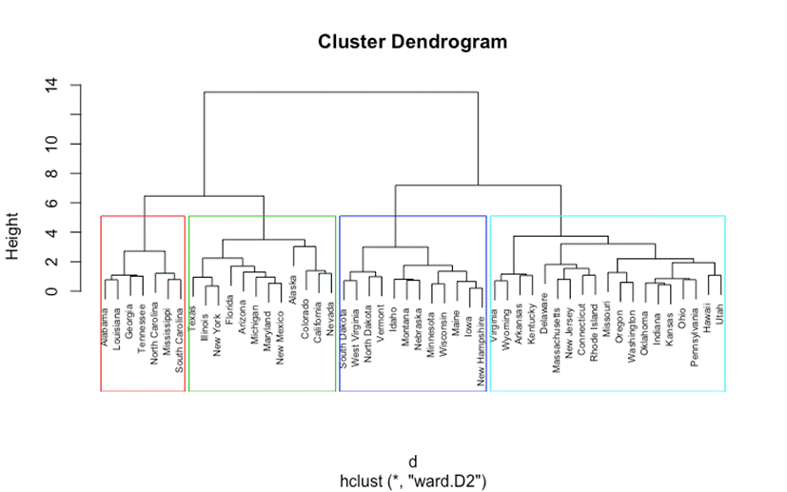

Figure 4.38 Hierarchical Clustering Dendrogram (Ward Method)

A hierarchical clustering dendrogram generated using Ward’s linkage method, which groups observations by minimizing the variance within clusters during the merging process. The dendrogram visually represents how clusters are formed through successive merging steps based on the similarity between observations.

In the diagram, the horizontal axis displays the individual observations, represented by labeled data points positioned at the bottom of the dendrogram. Each observation initially begins as its own cluster. The vertical axis labeled “Height” represents the distance or dissimilarity level at which clusters are merged during the hierarchical clustering process.

The structure of the dendrogram illustrates the following clustering behavior:

● Initial Individual Observations – At the bottom of the dendrogram, each labeled item begins as a separate cluster. These individual observations are gradually merged with other similar observations as the algorithm proceeds.

● Cluster Merging Process – As the height increases along the vertical axis, branches of the dendrogram merge. Each horizontal linkage line represents the point at which two clusters are combined based on their similarity.

● Ward’s Linkage Method – Ward’s method merges clusters in a way that minimizes the total within-cluster variance. This approach results in clusters that are relatively compact and balanced compared to other linkage methods.

● Cluster Groupings – The colored rectangular boxes in the figure highlight four major clusters identified in the dataset. These colored regions show how the dendrogram can be “cut” at a specific height threshold to determine the final number of clusters.

● Cluster Hierarchy Representation – The hierarchical tree structure demonstrates how smaller clusters merge into larger clusters as the distance threshold increases, ultimately forming a single cluster that contains all observations at the top of the dendrogram.

This dendrogram provides a visual representation of the hierarchical relationships between data points and helps determine the appropriate number of clusters by selecting a cutoff level along the height axis. Ward’s method is commonly used because it produces clusters with relatively small internal variance and well-balanced groupings (UC Business Analytics R Programming Guide, n.d.).

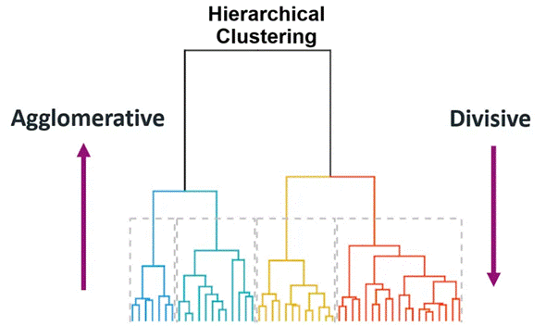

Figure 4.39 Agglomerative vs Divisive Hierarchical Clustering

A comparison between the two main approaches used in hierarchical clustering: agglomerative clustering and divisive clustering. The diagram highlights how clusters are formed either by merging smaller clusters into larger ones or by splitting larger clusters into smaller groups.

In the center of the figure, the hierarchical tree structure (dendrogram) illustrates how data points can be grouped into clusters at different levels of similarity. The colored branches at the bottom represent groups of observations that form clusters as the hierarchical process progresses.

The figure highlights the two clustering strategies as follows:

● Agglomerative Clustering (Bottom-Up Approach) – The arrow on the left side labeled “Agglomerative” pointing upward indicates that clustering begins with individual data points. Each observation initially forms its own cluster, and the algorithm repeatedly merges the most similar clusters until larger clusters are formed. This bottom-up process continues until all data points are combined into a single cluster.

● Divisive Clustering (Top-Down Approach) – The arrow on the right side labeled “Divisive” pointing downward represents the opposite strategy. In divisive clustering, the process begins with all observations grouped into one large cluster. The algorithm then recursively splits this cluster into smaller subclusters based on dissimilarity until individual clusters are formed.

● Hierarchical Tree Representation – The dendrogram in the center visually represents the hierarchical relationships between clusters. Each branching point in the tree indicates a merging or splitting step, depending on the clustering approach used.

The figure demonstrates how both agglomerative and divisive methods produce hierarchical cluster structures, but they differ in the direction in which clusters are formed. Agglomerative clustering is the more commonly used approach due to its computational efficiency and simpler implementation (Minitab, n.d.).

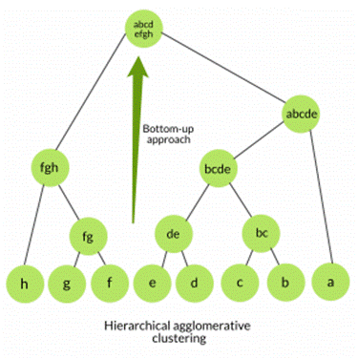

Figure 4.40 Agglomerative Hierarchical Clustering Tree

The structure of Agglomerative Hierarchical Clustering is a clustering technique that groups data points through a bottom-up merging process. In this approach, each data point initially forms its own cluster, and clusters are progressively merged based on similarity until a hierarchical structure is formed.

In the diagram, the leaf nodes at the bottom of the tree (labeled a, b, c, d, e, f, g, h) represent individual data points at the start of the clustering process. Each of these points begins as a separate cluster.

The clustering process then proceeds through the following stages:

● Initial Cluster Formation – Individual data points at the bottom level form the smallest clusters. For example, points b and c merge to form cluster “bc”, while d and e merge to form cluster “de.”

● Intermediate Cluster Merging – As the algorithm continues, smaller clusters combine to form larger clusters. In the figure, clusters such as bc and de merge into a larger cluster labeled “bcde.” Similarly, clusters f and g merge into “fg,” which then combines with h to form a larger cluster.

● Higher-Level Cluster Formation – These intermediate clusters are further merged into larger groupings, such as “abcde” and “abcd efgh.” Each level of the tree represents a new stage in the merging process.

● Bottom-Up Hierarchical Structure – The green arrow labeled “Bottom-up approach” highlights the direction of the clustering process. Starting from individual data points at the bottom, clusters are gradually merged upward until a hierarchical tree structure is formed.

This tree structure, commonly referred to as a dendrogram, visually represents the relationships between clusters and shows how clusters combine at different levels of similarity. Agglomerative hierarchical clustering does not require a predefined number of clusters, allowing the final number of clusters to be determined by selecting an appropriate level in the hierarchy (Singh, n.d.).

4.2.5.1.4. Gaussian Mixture Model (GMM)

Gaussian Mixture Models (GMM) are used as a probabilistic clustering approach that models the dataset as a combination of multiple Gaussian distributions in feature space. Unlike hard clustering methods such as K-Means, which assign each observation to a single cluster, GMM performs soft clustering, assigning each observation a probability of belonging to each cluster.

This probabilistic representation allows the model to capture overlapping behavioral patterns that may occur in network telemetry data. In the context of ESP32 mesh network behavior, some observation windows may exhibit characteristics that lie between normal operation and anomalous routing behavior. GMM provides a mechanism for representing these transitional states through probabilistic cluster membership.

The model assumes that the dataset is generated from a mixture of k Gaussian components, where each component represents a latent behavioral state. Each component is characterized by:

● a mean vector

● a covariance matrix

● a mixture weight representing its relative contribution

Parameter estimation is performed using the Expectation–Maximization (EM) algorithm, which iteratively refines cluster parameters until convergence.

Expectation–Maximization procedure. The clustering process proceeds through two alternating steps:

Expectation step (E-step):
The probability that each observation belongs to each Gaussian component is estimated based on the current model parameters.

Maximization step (M-step):
The parameters of the Gaussian components (means, covariances, and mixture weights) are updated to maximize the likelihood of the observed data given the current cluster assignments.

This iterative process continues until the log-likelihood improvement between successive iterations falls below a convergence threshold.

Cluster number selection. To maintain comparability with the K-Means baseline experiment, candidate cluster counts ranging from 2 to 8 components are evaluated. The optimal number of mixture components is determined using both cluster validation metrics and the interpretability of resulting behavioral groupings.

Cluster quality is assessed using the silhouette score and Davies–Bouldin index, while additional inspection of cluster membership probabilities allows identification of observations that exhibit mixed behavioral characteristics. Such transitional patterns may indicate periods where network behavior shifts between normal and anomalous conditions.

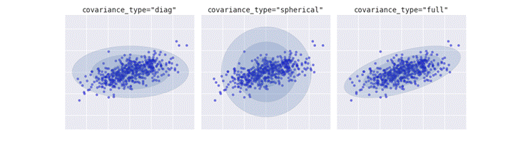

Figure 4.41 Covariance Types in Gaussian Mixture Models

The different covariance structures used in Gaussian Mixture Models (GMM) for modeling clusters in a dataset. Gaussian Mixture Models represent clusters as probability distributions rather than fixed boundaries, allowing clusters to take on different shapes depending on the covariance configuration. The shaded ellipses in the figure represent the estimated covariance of each Gaussian component, indicating the spread and orientation of the cluster.

The figure presents three common covariance types used in GMM clustering:

● Diagonal Covariance (Left Panel – covariance_type = "diag") – In this configuration, the covariance matrix is restricted to diagonal values, meaning each feature dimension varies independently while correlations between dimensions are ignored. As shown in the left panel, clusters appear as axis-aligned ellipses, where the spread of data differs along each axis but cannot rotate.

● Spherical Covariance (Middle Panel – covariance_type = "spherical") – In the spherical covariance structure, each cluster has a single variance value applied equally across all dimensions. This results in clusters that appear as circular shapes in the visualization. The middle panel shows clusters that expand uniformly in all directions, assuming equal variance across the feature space.

● Full Covariance (Right Panel – covariance_type = "full") – In the full covariance structure, the covariance matrix allows correlations between features. This enables clusters to take elliptical shapes that can rotate and stretch in any direction, as illustrated in the right panel. This configuration provides the most flexibility for modeling complex cluster structures.

The comparison shown in the figure demonstrates how different covariance assumptions affect the shape and orientation of clusters identified by Gaussian Mixture Models. Choosing an appropriate covariance type is important for accurately capturing the distribution of data within each cluster (VanderPlas, n.d.).

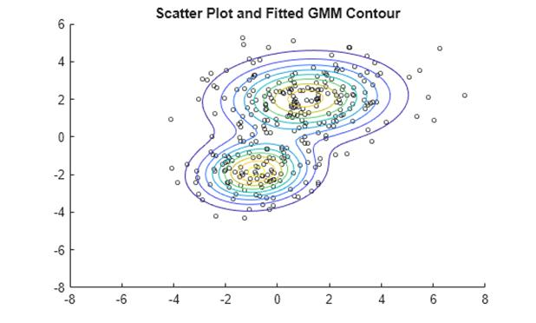

Figure 4.42 GMM Probability Density Contours

The clustering behavior of a Gaussian Mixture Model (GMM) using a scatter plot combined with probability density contours. The visualization shows how GMM models cluster as probability distributions rather than assigning rigid cluster boundaries.

In the figure, the scatter points represent individual data observations distributed across the feature space. These observations form two main groups of points, indicating the presence of two underlying clusters in the dataset.

The elements shown in the figure correspond to the following features of the Gaussian Mixture Model:

● Scatter Data Points – The individual points plotted on the graph represent data samples from the dataset. These points form visible groupings that the GMM algorithm attempts to model using Gaussian distributions.

● Probability Density Contours – The elliptical contour lines surrounding the clusters represent the probability density levels of the fitted Gaussian distributions. Each contour line indicates regions where the probability density of the cluster remains constant.

● Cluster Centers – The central regions of the contour shapes indicate the mean location of each Gaussian component. These means act as the centers of the clusters estimated by the GMM algorithm.

● Elliptical Cluster Shape – Unlike clustering methods such as K-Means that assume spherical clusters, GMM allows clusters to take elliptical shapes with varying orientations and spreads, which better represent complex data distributions.

The figure demonstrates how Gaussian Mixture Models estimate the probability distribution of clusters and visualize cluster boundaries using density contours. This probabilistic approach allows GMM to capture overlapping clusters and complex data structures more effectively than many distance-based clustering methods (MathWorks, n.d.).

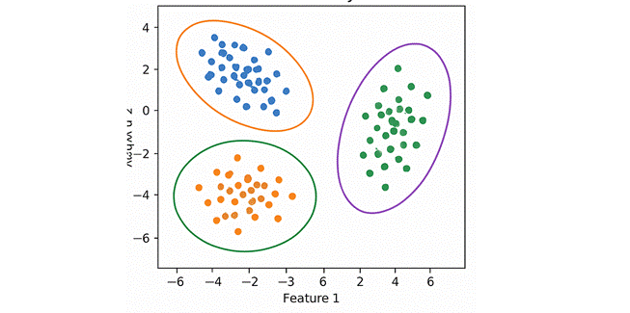

Figure 4.43 Gaussian Mixture Model Clustering Example

An example of clustering using a Gaussian Mixture Model (GMM), where clusters are represented as Gaussian probability distributions rather than fixed geometric boundaries. The visualization shows how GMM identifies clusters in a dataset by estimating the probability distribution of data points within the feature space.

In the figure, the scatter points represent individual data observations plotted according to two features labeled Feature 1 and Feature 2. The points form three visible groups that correspond to the clusters detected by the Gaussian Mixture Model.

The elements shown in the figure correspond to the following characteristics of GMM clustering:

● Clustered Data Points – The data points form three main groups in the scatter plot. These groups represent observations that share similar characteristics within the feature space.

● Elliptical Cluster Boundaries – The elliptical shapes surrounding each cluster represent the Gaussian distributions estimated by the model. These ellipses indicate the spread and orientation of the probability density for each cluster.

● Cluster Centers and Orientation – The center of each ellipse represents the mean of the Gaussian component, while the orientation and shape of the ellipse reflect the covariance structure of the cluster.

● Flexible Cluster Shapes – Unlike clustering algorithms such as K-Means that assume spherical clusters, Gaussian Mixture Models allow clusters to take elliptical shapes with different orientations, enabling the algorithm to better model complex data distributions.

The figure demonstrates how Gaussian Mixture Models represent clusters probabilistically and capture variations in cluster shape, size, and orientation within the dataset. This flexibility makes GMM particularly useful for datasets where clusters overlap or exhibit non-spherical structures (AI Learning Hub, n.d.).

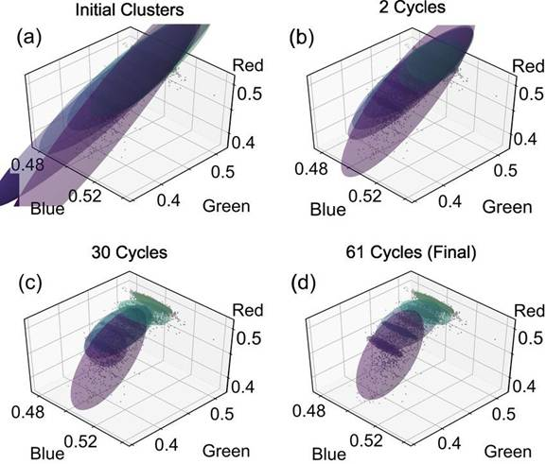

Figure 4.44 Cluster Fitting Using Gaussian Mixture Model

The cluster fitting process of a Gaussian Mixture Model (GMM) is the algorithm that iteratively updates its Gaussian components during the Expectation–Maximization (EM) procedure. The visualization shows how the Gaussian distributions gradually adjust their position, orientation, and spread to better represent the structure of the data.

In the figure, each panel represents a stage in the iterative clustering process, where the axes labeled Red, Green, and Blue correspond to three feature dimensions used in the dataset. The shaded ellipsoids represent the Gaussian components, while the scatter points correspond to the observed data samples.

The panels illustrate the following stages of the GMM fitting process:

● (a) Initial Clusters – The first panel shows the initial placement of Gaussian components before the algorithm begins adjusting them. At this stage, the ellipsoids represent preliminary estimates of the cluster distributions and may not yet align well with the underlying data.

● (b) Early Iterations (2 Cycles) – After two EM cycles, the Gaussian components begin to shift and rotate to better match the distribution of data points. The algorithm adjusts the parameters of each Gaussian component based on the likelihood of the observed data.

● (c) Intermediate Iterations (30 Cycles) – After additional iterations, the Gaussian components more closely align with the dense regions of the dataset. The ellipsoids begin to capture the structure and orientation of the clusters more accurately.

● (d) Final Convergence (61 Cycles) – In the final panel, the Gaussian components stabilize as the algorithm converges. At this stage, the ellipsoids closely represent the underlying data distribution, indicating that the model parameters have converged and the clustering process is complete.

The figure demonstrates how the Gaussian Mixture Model iteratively refines cluster parameters through the EM algorithm, adjusting the means, covariances, and mixture weights until the model converges to a stable solution that best fits the observed data (ResearchGate, n.d.).

4.2.5.1.5. Spectral Clustering

Spectral clustering is employed as a graph-based clustering technique capable of detecting complex cluster structures that may not be captured effectively by centroid-based or density-based methods. Unlike K-Means and GMM, which rely primarily on geometric distances in feature space, spectral clustering operates by analyzing the connectivity structure of the dataset represented as a similarity graph.

In this approach, each observation is treated as a node in a graph, and edges between nodes represent similarity relationships between feature vectors. The clustering process is performed by analyzing the eigenstructure of the graph Laplacian derived from this similarity matrix.

Similarity graph construction. To construct the similarity graph, pairwise similarities between standardized feature vectors are computed using a radial basis function (RBF) kernel:
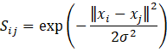 | Equation 4.20

where x_{i} and x_{j} are the standardized feature vectors of windows i and j, and σ sets how quickly the similarity falls as the distance grows.

Similarity between observations increases as the Euclidean distance between their feature vectors decreases. This representation allows spectral clustering to capture non-linear relationships in the data that may correspond to subtle behavioral patterns within the mesh network.

Spectral embedding. Once the similarity matrix is constructed, the normalized graph Laplacian is computed. Eigenvalue decomposition is then performed on the Laplacian matrix to obtain a lower-dimensional representation of the data known as the spectral embedding.

This transformation projects the observations into a new space in which cluster structure becomes more separable. After projection, a conventional clustering algorithm (typically K-Means) is applied to the embedded representation to produce the final cluster assignments.

Cluster number selection. As with the previous clustering methods, candidate cluster counts ranging from 2 to 8 clusters are evaluated. This consistent range allows comparison across all clustering algorithms used in the study.

Cluster quality is assessed using the same internal validation metrics applied to other clustering methods, including the silhouette score and Davies–Bouldin index. The results are further examined to determine whether spectral clustering reveals behavioral structures not detected by the other clustering techniques, particularly in cases where clusters exhibit non-spherical or irregular shapes.

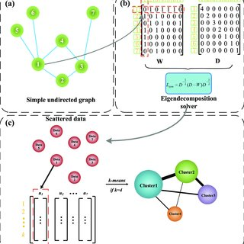

Figure 4.45 Spectral Clustering Algorithm Overview

Overview of the Spectral Clustering algorithm, which groups data points by analyzing the structure of a similarity graph. Spectral clustering transforms the dataset into a graph representation, computes eigenvectors from the graph Laplacian matrix, and then performs clustering in the transformed feature space.

The diagram is divided into three main stages labeled (a), (b), and (c), each representing a step in the spectral clustering workflow.

● (a) Graph Construction – The upper-left section shows a simple undirected graph where nodes represent individual data points, and edges represent similarity relationships between points. This graph representation captures how strongly each data point is connected to others in the dataset.

● (b) Matrix Representation and Eigen Decomposition – The upper-right section illustrates the conversion of the graph into matrix form. The weight matrix (W) represents the similarity between nodes, while the degree matrix (D) summarizes the total connection strength for each node. These matrices are used to compute the graph Laplacian, and eigen decomposition is applied to extract eigenvectors that capture the structural properties of the graph.

● (c) Feature Embedding and Clustering – In the lower section of the figure, the eigenvectors obtained from the spectral decomposition form a new feature space. The data points are projected into this space and then clustered using a standard clustering algorithm, such as K-Means, to produce the final cluster groups.

The figure demonstrates how spectral clustering combines graph theory and linear algebra to identify clusters based on connectivity patterns rather than simple distance measures. This approach is particularly effective for datasets where clusters have complex or non-convex shapes (ResearchGate, n.d.).

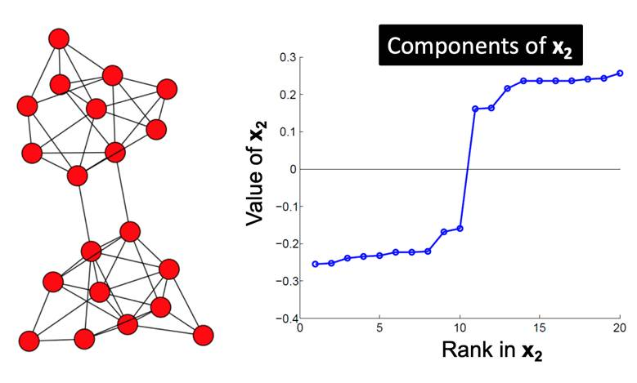

Figure 4.46 Eigenvector Components Used in Spectral Clustering

Demonstrates how eigenvector components are used in spectral clustering to identify clusters within a graph structure. Spectral clustering analyzes the connectivity between nodes in a graph and uses eigenvectors derived from the graph Laplacian matrix to reveal underlying cluster structures.

In the figure, the left panel shows a network graph consisting of multiple nodes connected by edges, where each node represents a data point, and edges represent similarity relationships between nodes. The structure of the graph suggests that the nodes form two main groups that are more densely connected internally than with nodes from other groups.

The right panel displays a plot labeled “Components of x₂”, which represents the values of the second eigenvector obtained from the spectral decomposition of the graph Laplacian matrix. The horizontal axis labeled “Rank in x₂” orders the nodes according to their eigenvector component values, while the vertical axis shows the corresponding eigenvector value for each node.

The figure highlights the following characteristics of spectral clustering:

● Graph Representation of Data – The network graph on the left illustrates how data points are represented as nodes connected by edges based on similarity relationships.

● Eigenvector Component Values – The plot on the right shows the values of the second eigenvector for each node in the graph. These values capture important structural information about the connectivity patterns within the graph.

● Cluster Separation – A noticeable gap between eigenvector values appears in the middle of the plot, indicating a natural division between two groups of nodes. Nodes with similar eigenvector values tend to belong to the same cluster.

● Spectral Partitioning – By using the eigenvector values as features, the spectral clustering algorithm can separate nodes into clusters based on their position relative to this separation point.

This visualization demonstrates how spectral clustering leverages eigenvectors of the graph Laplacian to reveal cluster structure within graph-based data, allowing clusters to be identified even when they are not easily separable using traditional distance-based methods (Syllogismos, n.d.).

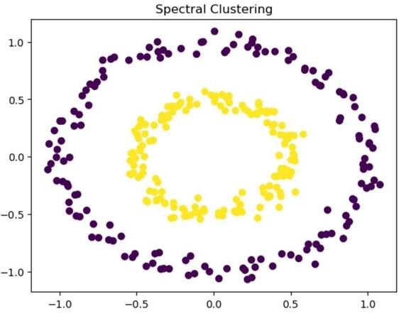

Figure 4.47 Spectral Clustering Result on Non-Linear Data

The application of spectral clustering on a dataset with non-linearly separable structures. Unlike traditional clustering algorithms such as K-Means that rely on distance-based partitioning, spectral clustering identifies clusters by analyzing the connectivity relationships between data points in a graph representation.

In the figure, the scatter plot displays data points arranged in two concentric circular patterns, forming an inner ring and an outer ring. Each point represents an observation in a two-dimensional feature space.

The visualization highlights the following aspects of spectral clustering:

● Non-Linear Cluster Structures – The dataset consists of two circular clusters that cannot be separated using a simple linear boundary. The inner circular cluster (yellow points) and the outer circular cluster (purple points) represent two distinct groups of observations.

● Cluster Identification Through Graph Connectivity – Spectral clustering constructs a similarity graph that captures the relationships between nearby data points. By analyzing the structure of this graph, the algorithm is able to detect clusters that share strong internal connections.

● Separation of Complex Cluster Shapes – The algorithm successfully separates the inner and outer circular groups despite their non-linear arrangement. This demonstrates the ability of spectral clustering to identify clusters with complex geometric shapes.

● Cluster Visualization – The different colors assigned to the two groups illustrate how spectral clustering partitions the dataset into clusters based on structural similarity rather than simple geometric distance.

The figure demonstrates the effectiveness of spectral clustering in detecting non-linear and irregular cluster shapes, making it particularly suitable for datasets where traditional centroid-based clustering methods fail to correctly separate clusters (StrataScratch, n.d.).

4.2.5.2. Cluster Evaluation Metrics

Even in unsupervised settings, internal validation metrics assess the quality and coherence of the clusters.

4.2.5.2.1. Silhouette Score

The silhouette score measures how similar a data point is to its own cluster compared to other clusters. The score ranges from −1 to 1, where higher values indicate better clustering structure.
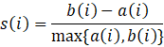 | Equation 4.21

where a(i) is the mean distance from point i to the other points in its own cluster, and b(i) is the mean distance from point i to the points of the nearest other cluster.

Interpretation

● > 0.7 → Strong cluster separation

● 0.5 – 0.7 → Reasonable cluster structure

● 0.2 – 0.5 → Weak but potentially meaningful structure

● < 0.2 → Poor cluster structure

● < 0 → Possible misclassification (point may be assigned to the wrong cluster)

4.2.5.2.2. Davies–Bouldin Index

The Davies–Bouldin index measures average similarity between each cluster and its most similar counterpart, with lower values indicating better separation.
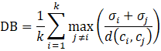 | Equation 4.22

where k is the number of clusters, σ_{i} is the average distance of the points in cluster i to its centroid, and d(c_{i}, c_{j}) is the distance between the centroids of clusters i and j.

Interpretation:

● Lower values → Better cluster separation

● Values below 1.0 typically indicate well‑separated clusters

4.2.5.2.3. Cluster Purity (Post‑Analysis Only)

After clustering, cluster assignments are compared against ground‑truth phase labels (baseline, blackhole, wormhole) to compute purity scores. This is strictly a post‑analysis validation step, not used during clustering itself, and serves to assess whether discovered clusters align with experimental conditions.
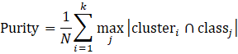 | Equation 4.23

where N is the number of windows, cluster_{i} is the set of windows assigned to cluster i, and class_{j} is the set of windows with ground-truth label j. DBSCAN noise points are counted as one additional group.

Higher purity indicates stronger alignment between unsupervised groupings and ground truth.

4.2.5.2.4. Adjusted Rand Index (Post‑Analysis Only)

The Adjusted Rand Index (ARI) is a chance-corrected measure of agreement between two clusterings. It evaluates the similarity between the clustering produced by the algorithm and the ground-truth partition, while adjusting for the possibility that some agreement could occur purely by random chance.
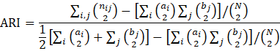 | Equation 4.24

where n_{ij} is the number of windows that are in cluster i and in ground-truth class j, a_{i} = Σ_{j} n_{ij} and b_{j} = Σ_{i} n_{ij} are the cluster and class sizes, N is the number of windows, and C(x, 2) = x(x − 1)/2 is the binomial coefficient, the number of unordered pairs from x items.

Measures similarity between cluster assignments and ground-truth labels, corrected for chance. Range: [-1, 1]; 1 indicates perfect agreement.

Interpretation

● ARI = 1 indicates perfect agreement between the clustering and the ground truth (up to permutation of labels).

● ARI = 0 indicates that the agreement is no better than what would be expected from random clustering.

● ARI < 0 indicates agreement worse than chance

4.2.5.3. Cluster Characterization Using Ground Truth

After clustering, each cluster is profiled to understand its behavioral meaning. This step uses the ground-truth phase labels (baseline, blackhole, wormhole) for interpretation only—they are not used during clustering.

Label distribution per cluster. For each cluster, we compute the percentage of windows belonging to each ground-truth phase. This reveals whether clusters correspond to distinct attack types or mix them. For example, a cluster may contain 95% baseline windows and 5% attack windows, indicating it predominantly represents normal behavior.

Feature centroid analysis. The mean value of each feature within a cluster is computed and compared to the global mean (across all windows). Features that are significantly elevated or depressed in a cluster help characterize its behavior. For instance, a cluster with a low forwarding ratio at the attacker and a low PDR at its child would be interpreted as “blackhole-affected.”

Heatmap visualization. A heatmap of feature means per cluster (standardized values) is generated to visually summarize the behavioral signature of each cluster. Rows represent clusters, columns represent features, and color intensity indicates deviation from the global mean.

Interpretation of results. If the clustering yields only two clusters (e.g., benign vs. attack), we still characterize each cluster by its dominant label and feature profile. The ground-truth labels are used only after clustering to aid interpretation, not to guide the algorithm. This approach ensures that the discovered structure is data-driven, while still allowing us to map clusters to known experimental conditions.

4.2.5.4. Expected Outcomes

Based on the theoretical framework established in Chapter 3, the following outcomes are anticipated:

● Normal operation windows should form a dense, cohesive cluster characterized by forwarding ratios near 1.0, stable RSSI‑hop relationships, and minimal parent switching.

● Forwarding suppression windows should form a distinct cluster (or be identified as noise) characterized by low forwarding ratios at attacker nodes and a reduced packet delivery ratio at the nodes whose traffic the attacker handles.

● Topology distortion windows should form a separate cluster characterized by tunnel activity and duplicate arrivals at the root (TunnelIntensity, TunnelBytes and TunnelLatency) and possibly by a latency‑hop mismatch. Parent switching and layer changes are not expected, because the tunnel is an application‑layer replay and does not alter the routing tree (Section 4.2.7.4).

If these behavioral states are indeed separable in feature space, the clustering analysis will reveal distinct groupings aligning with the three experimental conditions. This separation would validate that the collected cross‑layer features capture meaningful distinctions between normal and manipulated network behaviors.

Because the wormhole tunnel does not change routing, wormhole windows may not separate from baseline windows unless the tunnel features are included. If they do not, that outcome is reported as a finding and not as a failure of the method.

4.2.6. Exploratory Data Analysis (EDA)

Before clustering, exploratory data analysis is conducted to characterize the structure and quality of the extracted feature set. EDA serves as a descriptive sanity check, ensuring that subsequent clustering interpretation is grounded in an understanding of feature distributions and relationships. All EDA is performed offline using Python-based analysis scripts and is strictly descriptive; no inferential claims or detection rules are derived from this stage.

EDA is run on each cell of the design (attack, topology, site and scenario) first, and the runs are pooled once collection ends. Only windows labelled baseline, attack or cooldown are analysed. Formation windows are left out. The following analyses are performed:

• Descriptive statistics. Mean, median, variance and range of every feature, by phase and node role.

• Distribution visualization. Histograms and box plots of ForwardingRatio and RSSI_Hop_Diff, by phase and node role. RetryRate is not plotted, because retry counts are application-layer counters.

• Time-series plots. PDR, ForwardingRatio, root arrivals and ParentSwitchRate over the run, so the effect can be checked against the logged attack window.

• Cross-layer correlation analysis. Pearson (straight-line) and Spearman (rank-based) matrices over three views: all labelled windows, baseline only, and attack only. A feature that has one value for the whole run has no correlation and is left off, and this is stated on the chart. Some pairs are linked by their formulas and not by network behaviour, for example ForwardingRatio and IngressEgressDelta, which use the same two counters, and RSSI_mean and RSSI_Hop_Diff. These are reported as such. Correlation is not treated as cause.

• Dimensionality reduction visualization. PCA and t-SNE projections of z-scored features, clipped at ±5. Columns with missing values and role-specific columns (the tunnel features, which exist only on the wormhole ends) are left out of the projection. The axes of t-SNE have no units and only nearness is read from them.

• Single-feature check. For each feature alone, how well it could label a window, as described in Section 4.2.7.3.

Per-cell figures are reproduced for one representative cell of each attack in the paper, and the rest are placed in the repository [79]. The figures from finished cells are to be inserted here once the runs are complete. Any statement that attack windows lie apart from normal windows in these views is a description of the picture and not a detection result.

These analyses are conducted exclusively to understand the dataset structure and to validate that the engineered features capture meaningful behavioral variation. The results inform parameter choices for clustering (e.g., normalization confirmation and outlier identification), but they do not constitute intrusion detection or behavioral classification.

4.2.7. Attack Validation

Validation has two steps. The first is an internal check against the known schedule of each run. The second corroborates the result against published studies. The published studies describe other platforms, so the comparison is one of consistent behaviour, and the study does not claim proof by those works. Table 4.20 lists the checks.

Table 4.20 Attack Validation Checks
Check | Method | Basis
Ground-truth schedule | Compare each feature across the baseline and attack phases of the same run | Section 4.2.3.4
Statistical test | 3-sigma test of attack windows against the baseline mean and standard deviation | Zhukabayeva et al. [71]
Setup check | Confirm that the run matched its design: the topology during the attack, one attacker with victims behind it, and for the wormhole one entry end and one exit end with the tunnel carrying the probes | Section 4.2.1.4
Independent observation | Sniffer frame record from outside the mesh | Section 4.2.3.3
Published definitions | Criterion-by-criterion conformance | Table 4.4 and Table 4.5
Published behaviour | Compare with testbed and deployment results | Airehrour et al. [70], Khan et al. [22], Ramírez Gómez et al. [72], Zhukabayeva et al. [71]
Leakage audit | Single-feature threshold accuracy against the majority rate | Table 4.21

4.2.7.1. Ground-Truth and Statistical Check

Every run has a known phase schedule, so the expected effect of an attack can be stated before the data are read. In the G402 linear stationary run, the blackhole attacker’s ForwardingRatio falls from 1.000 in the baseline to 0.001 in the attack phase, and the PDR of the six nodes behind it falls from 1.000 to 0.000. The 3-sigma verifier flags a feature when an attack window lies more than three baseline standard deviations from the baseline mean. When the baseline standard deviation is zero the z-score is undefined, and it is reported as undefined and not as an infinite value. For the wormhole, TunnelLatency cannot be tested with the 3-sigma method, because the baseline has no tunnel and so no spread, and its attack value of 2 to 4 ms between the two copies is reported descriptively. LatencyHopRatio cannot be tested either, because each node of the line sits at a different depth and the baseline therefore spreads widely, so neither enters the verdict.

The verifier also runs a setup check before it accepts a result. It reads the topology during the attack, the number and position of the attacker, whether victims were alive but cut off, and for the wormhole whether the entry end is deeper than the exit end and whether the exit end received what the entry end sent over the cable. A run that fails the setup check is reported as not confirmed, however clear the statistics look.

The verdict rules are fixed in the verifier before results are read. A run is confirmed when at least one primary signature passes: ForwardingRatio or PDR for the blackhole, and TunnelIntensity or the root-measured DuplicateRate for the wormhole (D-21). A pass needs the move in the expected direction beyond three standard deviations, an absolute change of at least 0.10 and at least six attack points, and each point pools five one-second windows. A primary whose baseline is broken, with a mean below 0.90 or a standard deviation above 0.15 of the mean, is excluded and not counted as a failure. TunnelLatency and LatencyHopRatio are reported and not scored.

Each run then receives one outcome. PASS means that the signature, the setup check and the data all pass. FAIL means that the run could be tested and the attack did not happen as designed. INCONCLUSIVE means that the data needed to decide are missing. Missing data never turns into a pass or a fail. An impact check repeats the test without every board that has a gap; when the result holds, the gaps are graded minor and footnoted.

A blackhole is invisible to its victims, because the attacker accepts each probe at the link layer and discards it, so the sender sees no failure. The attack is therefore measured at the attacker, whose forwarding ratio is confirmed independently by its neighbours’ counts, and at the root, from the victims’ sequence numbers, with the boards outside the attacker’s path as a control group (Karlof and Wagner, 2003). A board that changes parent during the attack is tolerated when it keeps its class, victim or bystander (D-23). The attacker changing its own parent is tolerated only when no board changes class and the attacker was without an uplink for at most 10% of its attack, and the seconds in which a victim had no path to the root are left out of the test (D-31). A missing board is graded by its role: a missing attacker requires a recapture, a missing victim or bystander is footnoted while other victims and another control remain, and a board whose position cannot be established leaves the run undetermined (D-32). The verifier also reports, from the root’s run log, whether a run was started with START_ANYWAY; earlier captures have no run log, and this is noted per run.

Thresholds for which no published value exists were set as engineering bounds before the results were examined. A one-at-a-time sensitivity analysis that moves the verdict thresholds by about ±50% changed no verdict in 53 analysed runs across 14 settings, while a deliberately extreme control setting (1,000 standard deviations) did change 18 verdicts, which shows that the test can fail, and a placebo test that relabels the second half of each baseline as an attack produced no false confirmation in 106 tests. Every one of the 44 processed runs had the outcome PASS. [PENDING: add Karlof and Wagner (2003), Secure routing in wireless sensor networks, to the bibliography and cite it by number.]

4.2.7.2. Corroboration with Published Studies

Airehrour et al. [70] ran a blackhole attack on a testbed and reported packet loss of 60 to 75% under the standard protocol, against under 28% for their trust-based protocol, together with 16 to 246 rank changes against 15 to 55. A collapse in delivery under a placed blackhole is therefore consistent with published hardware results. Parent switching is the exception: the data show almost none, because forwarding suppression does not alter routing, so this difference is explained by the attack design. Khan et al. [22] report delivery above 97% in a healthy ESP-MESH network, which is the reference for the baseline phase.

For the wormhole, Ramírez Gómez et al. [72] propose duplicated routing packets as a signature for detecting a wormhole in a ZigBee network. This is related to the duplicate data arrivals that our tunnel produces, but it is a proposed signature and not a measured result. Zhukabayeva et al. [71] report that a wormhole shortened a route from four hops to three and raised the average delay by about 40% (their abstract; the route-change row of their Table 7 gives 120 to 200 ms against 80 to 100 ms). Our tunnel does not reproduce a shorter route (Section 4.2.7.4). The tunnel features have no counterpart in these studies, so they rest on the internal check alone.

4.2.7.3. Single-Feature Leakage Audit

If one feature alone could separate attack from normal windows, the clustering would be unnecessary. Each feature is therefore tested as a single-threshold classifier and compared with the majority-class rate, and this is done for each analysed run on its own. Across an earlier set of 34 analysed runs (32 blackhole and 2 wormhole), PDR and LatencyHopRatio alone reach 0.95 or more in 12 runs each, and ForwardingRatio and ConsistencyScore in 9 each. This is expected for a blackhole, which drops every packet for the whole attack window, so a complete delivery collapse is separable by construction. The 12 runs are the 9 star runs, where the attacker is the hub (Section 4.2.2.1), and 3 linear runs. The RSSI, parent-switch and hop features stay at the majority rate of about 0.70. The lowest PDR accuracy is 0.70, so separability depends on the run. Table 4.21 summarises the audit. A pooled audit across all runs is the stricter test and is run once collection ends. The wormhole features that exist only on the tunnel ends are excluded from this audit.

Table 4.21 Single-Feature Threshold Accuracy per Analysed Run (provisional, 34 runs)
Feature | Mean accuracy | Range | Runs at 0.95 or more
PDR | 0.863 | 0.699 to 1.000 | 12
LatencyHopRatio | 0.851 | 0.698 to 1.000 | 12
ConsistencyScore | 0.845 | 0.731 to 1.000 | 9
ForwardingRatio | 0.845 | 0.729 to 1.000 | 9
IngressEgressDelta | 0.735 | 0.700 to 0.756 | 0
RSSI_mean | 0.702 | 0.698 to 0.723 | 0
HopChangeCount | 0.700 | 0.698 to 0.716 | 0

4.2.7.4. Predictions Tested and Not Observed

Table 3.4 predicted more victim retransmissions under the blackhole, and Table 3.5 predicted a distorted topology under the wormhole. Neither was observed. The independent sniffer shows no consistent rise in victim MAC retransmissions: 22 runs had sniffer coverage, and victim MacRetryRate rose during the attack in 8 and did not rise in 14, as expected when the attacker still acknowledges every frame at the link layer (Section 3.3.1.2). The application counters (D-15) agree, since victim retry counts did not change across the attack window in any of the 34 runs analysed. [PENDING: recompute the sniffer count once the sniffer captures are merged into the analysis tables again; the latest re-analysis kept MacRetryRate in only 3 runs.] No parent switches or layer changes occur during the wormhole phase. Both tables are kept as they were written at proposal time, before any capture. The result is that an application-layer replay tunnel reproduces the duplicate-delivery signature of a wormhole without its topological signature.

4.2.7.5. Limits

Wormhole conformance is established on the linear topology only. In the star topology both ends of a wormhole sit at hop 1, so the tunnel offers no hop shortcut (Section 4.2.2.1), and the partial-mesh captures are structurally plain trees because no child used a second parent during the labelled phases (Section 4.2.2.4). The clustering quality metrics (silhouette score, Davies–Bouldin index, purity and adjusted Rand index) are to be run once collection ends. The attack starts at the same time in every run, so position in the run could reveal the phase and is kept out of the model inputs.

4.2.7.6. Reference Exhibits from the Validation Papers

The exhibits below are the published results that our measurements are compared against. Each is cropped from the cited paper and carries an adapted-from line. The pictures are to be inserted from the papers, and the figure or table number in each source is to be checked against the PDF before submission.

Airehrour et al. [70] ran a blackhole attack on a testbed that the paper lists as 14 motes, and Table 4.22 lists their setup.

Table 4.22 Testbed Parameters. Adapted from Airehrour et al. [70, Table 2]

[Insert picture: testbed parameters table of Airehrour et al.]

They report packet loss under the blackhole attack for the standard protocol (MRHOF-RPL) and for their trust-based protocol. Under the standard protocol, which has no defence, loss was 60 to 75%.

[Insert picture: packet loss under blackhole attacks]

Figure 4.48 Packet Loss under Blackhole Attacks. Adapted from Airehrour et al. [70, Figure 10]

They also report how often each mote changed its routing rank, which ranged from 16 to 246 under the standard protocol.

[Insert picture: rank changes per mote]

Figure 4.49 Frequency of Mote Rank Changes under Blackhole Attacks. Adapted from Airehrour et al. [70, Figure 8]

Throughput per mote is shown in Figure 4.50. We do not measure throughput in kilobits per second, so it is shown for completeness and is not compared.

[Insert picture: throughput measurement]

Figure 4.50 Throughput under Blackhole Attacks. Adapted from Airehrour et al. [70, Figure 9]

Table 4.23 sets those published values beside the measurements from our runs. The platforms, scales and protocols differ, so the comparison covers direction and rough size and does not claim the values are equal.

Table 4.23 Published Results Compared with Our Dataset
Measure | Published | Our dataset | Reading
Packet loss under an unmitigated blackhole | 60 to 75% [70] | 100% (PDR of all six victims 1.000 to 0.000, G402 linear stationary) | Above the published range, because every probe routed through the attacker is lost and no defence is in place
Healthy-mesh delivery, same platform | Above 97% delivery, under 1.8% loss and faults [22] | PDR 1.000 in the G402 baseline and 0.998 on average over the victims of all campus blackhole runs (one-second windows) | At or above the benchmark. Their delivery figure comes from a stability test that sent every 60 s over five days, and ours is measured in one-second windows, so the two agree in direction and are not claimed equal
Routing instability under attack | 16 to 246 rank changes per mote [70] | Almost no parent switches | Does not match. Explained by the attack design, because forwarding suppression does not change routing
Testbed | 14 motes as listed, 30 m by 30 m, smart building, 2 blackhole motes [70] | 8 boards, 1 attacker, three indoor sites | Smaller, with a single attacker
Wormhole effect on route and delay | Hop count 4 to 3; average delay up about 40% and false readings in over 30% of cases (abstract); delay 120 to 200 ms and 20 to 30% of data modified (Table 7, route-change row) [71] | Duplicate arrivals through the tunnel, no hop change, data not modified | Partly matches. The tunnel produces a second copy of each probe but changes neither the route nor the data (Section 4.2.7.4)

Khan et al. [22] measured a healthy ESP-WIFI-MESH network with the same ESP32 platform. Their sensor readings were taken every 2 minutes, and their delivery figures come from a stability test that sent every 60 s over five days. They report Figure 4.51 and Table 4.24. Delivery stayed above 97%, and packet loss and package faults stayed under 1.8%. The values for each node are in their Figure 20.

[Insert picture: Khan et al. received packet delivery, packet loss and package fault rate per node]

Figure 4.51 Received Packet Delivery, Packet Loss and Package Fault Rate per Node. Adapted from Khan et al. [22, Figure 20]

Table 4.24 Network Performance. Adapted from Khan et al. [22, Table 6]

[Insert picture: Khan et al. network performance table]

Zhukabayeva et al. [71] attacked a wireless sensor network with a wormhole and report how the route changed. Figure 4.52 shows the hop count between the two ends and Table 4.25 lists the measured changes. Hop count fell from four to three. Their abstract reports that the average delay rose by about 40% and that false readings appeared in over 30% of cases, while the route-change row of their Table 7 lists a delay of 120 to 200 ms against 80 to 100 ms before the attack, with 20 to 30% of the data modified. The source is not fully consistent, since the text with its Figure 19 says that the hop count increased slightly.

[Insert picture: Zhukabayeva et al. hop count under the wormhole attack]

Figure 4.52 Hop Count under the Wormhole Attack. Adapted from Zhukabayeva et al. [71, Figure 4]

Table 4.25 Changes in Network Parameters under a Wormhole Attack. Adapted from Zhukabayeva et al. [71, Table 7, route-change row]

[Insert picture: Zhukabayeva et al. wormhole parameter changes table]

Figure 4.53 compares the same network before and after the attack.

[Insert picture: Zhukabayeva et al. network before and after the attack]

Figure 4.53 Network Behaviour before and after the Attack. Adapted from Zhukabayeva et al. [71, Figure 19]

Ramírez Gómez et al. [72] implemented a wormhole on a ZigBee network of XBee S2C devices, using a single malicious node. Figure 4.54 shows their diagram of the attack, and their test setups are in their Figures 7 and 8. They propose duplicated routing packets, two source-routing packets for each data packet, as a signature for detecting the wormhole. This is a proposed signature and not a measured result, and it is related to, but not the same as, the duplicate data arrivals our tunnel produces.

[Insert picture: Ramírez Gómez et al. wormhole attack setup]

Figure 4.54 Wormhole Attack with a Malicious Node. Adapted from Ramírez Gómez et al. [72, Figure 2]

4.3. Theoretical Analysis

This section provides the theoretical justification for the selected cross-layer features and clustering methodology. While Section 4.2 detailed the implementation procedures, this section explains the conceptual rationale linking routing manipulations to observable behavioral deviations in wireless mesh networks. The analysis is grounded in the theoretical framework established in Chapter 3 and demonstrates how the empirical methodology aligns with fundamental principles of wireless mesh networking and routing behavior.

4.3.1. Theoretical Justification of Selected Features

The features engineered in Section 4.2.4 were not chosen arbitrarily; each is grounded in the cross‑layer inconsistency framework developed in Chapter 3. Routing attacks in wireless mesh networks do not produce isolated anomalies within a single protocol layer; instead, they generate correlated inconsistencies across PHY, MAC, and Network layers due to the interdependent nature of wireless communication (Al‑Anzi [5]; Amouri et al. [8]). The selected features are designed to capture these cross‑layer disruptions by targeting the specific relationships that routing manipulations violate.

4.3.1.1. Forwarding Behavior Features (Blackhole Theory)

Forwarding suppression attacks directly violate the fundamental routing assumption of multi‑hop networks: that intermediate nodes forward transit traffic. In ESP‑WIFI‑MESH, forwarding compliance is implicit in the routing design; nodes are expected to relay packets received from children toward the root and vice versa. The theoretical concept of packet conservation—that packets received should approximately equal packets forwarded—serves as an invariant of normal operation (Kurosawa et al. [43]; Baadache & Belmehdi [44]).

The following features operationalize this invariant:

● Forwarding Ratio directly measures the proportion of received transit packets that are forwarded. A value significantly below 1.0 indicates a violation of the conservation principle.

● Ingress‑Egress Delta quantifies the absolute packet imbalance, capturing the magnitude of packet absorption at the attacker node.

● Forwarding Consistency Score provides a unified deviation metric, useful for visualization and cluster interpretation.

These features were selected because they directly measure deviation from expected forwarding behavior. In normal mesh routing, packet conservation holds; a blackhole disrupts this conservation property. Thus, forwarding‑based features operationalize the theoretical routing invariants of multi‑hop networks.

4.3.1.2. Link Reliability Features (Indirect Propagation Theory)

Routing misbehavior does not affect only the attacker; it propagates stress both upstream and downstream. Nodes that send packets through a suppressing attacker lose those packets after the first hop, so the delivery they achieve falls even though the link-layer exchange with the attacker still succeeds. Cross‑layer telemetry theory also predicts that network‑layer disruptions can show up as MAC‑layer stress (Section 3.4.1). This prediction was tested and was not observed (Section 4.2.7.4).

The following features capture these second‑order effects:

● Packet Delivery Ratio (PDR) measures end‑to‑end success from the victim to the root. Prior studies report high baseline delivery under stable conditions (e.g., above 97% in Khan et al. [22]); in this work, baseline PDR is established empirically per run, and deviations from that baseline indicate degradation.

● Retry Rate is the share of application‑layer send attempts that failed. It is kept as a dataset column only and is not used in the analysis, because ESP‑IDF exposes no MAC retransmission counter and no cited study uses it as an attack signature. MAC retransmissions are read from the sniffer as MacRetryRate in sniffer runs.

PDR captures the indirect, yet observable, consequences of forwarding suppression on nodes beyond the attacker.

4.3.1.3. Topology Stability Features (Routing Adaptation Theory)

ESP‑WIFI‑MESH dynamically adapts parent selection, favoring the shallowest layer among candidate parents with an acceptable signal and then the fewest children. This adaptive behavior is a fundamental characteristic of wireless mesh routing protocols (Akyildiz et al. [1]). A node that perceives an artificially attractive path, such as a wormhole shortcut, might be expected to re‑evaluate its parent.

In this study the wormhole is emulated at the application level by an out‑of‑band tunnel that the mesh does not use for routing. The routing tree is therefore not expected to change, and the parent and layer features act as a check on this: they should stay at their baseline values (Section 4.2.7.4).

The following features capture deviations from expected routing stability dynamics:

● Parent Switch Rate measures the frequency of upstream parent changes. Normal operation exhibits stable parent relationships; increased switching indicates instability in the topology.

● Hop Change Count captures fluctuations in hop count, reflecting nodes moving up or down in the routing hierarchy.

● Hop Stability Duration quantifies the longest continuous period of stable topology and provides a complementary measure of instability intensity.

These features are grounded in the theoretical behavior of adaptive mesh routing protocols, which are designed to maintain stable hierarchies under normal conditions.

4.3.1.4. Physical Layer Features (Signal Consistency Theory)

In ESP‑WIFI‑MESH the RSSI that a node reports is the signal strength of the link to its parent. It reflects the distance and obstacles between those two boards, and it does not fall with each extra hop, because every hop is a separate radio link (Espressif [21]). RSSI therefore does not rank nodes by depth. What ties signal strength to the topology is parent selection: a node joins a parent only when the link passes the RSSI threshold, so the parent link of a node is expected to stay in a stable range for its layer in a given deployment.

In a true wormhole, logical topology no longer matches physical distance, and a node may hear packets from a distant source with a signal far stronger than expected (Khalil et al. [45]; Hu et al. [46]). The wormhole in this study is an application‑layer replay and does not change which parent a node uses, so the RSSI of the parent link is expected to stay at its baseline. The RSSI features therefore act as a check on the physical layer: if they shifted during the attack, the cause would be something other than the tunnel, for example a parent change or interference.

The following features capture this inconsistency:

● RSSI Mean provides the average signal strength, serving as a baseline for link quality.

● RSSI Variance measures signal stability; high variance may indicate interference or topology reconfiguration effects.

● RSSI‑Hop Inconsistency directly quantifies the deviation between observed RSSI and the value expected based on the node's reported layer. Expected values are derived empirically from stable baseline windows, making the metric environment‑specific and robust to testbed variations.

These features are theoretically grounded in the spatial signal-propagation properties of wireless networks and the assumption that physical distance should constrain logical topology.

4.3.1.5. Cross‑Layer Inconsistency Theory

The core theoretical assumption of this study is that routing manipulation creates measurable cross‑layer inconsistencies. Instead of relying on attack‑specific signatures, the methodology measures structural deviations from expected relationships:

● Forwarding invariant violation (Network layer)

● Latency‑to‑hop mismatch (Cross‑layer)

● RSSI‑to‑hop mismatch (Cross‑layer)

These features collectively operationalize the concept of behavioral inconsistency across PHY, MAC, and Network layers. They were selected because they target the fundamental relationships that routing attacks disrupt, as identified in the theoretical framework of Chapter 3.

4.3.1.6. Cross‑Layer Feature Relationship Preservation

A central premise of this study is that routing misbehavior manifests as broken relationships between protocol layers rather than isolated anomalies within a single layer. Accordingly, the feature set is designed to preserve these cross‑layer relationships, enabling clustering algorithms to detect structural inconsistencies without imposing attack‑specific signatures.

Two examples illustrate this design principle:

● Receive–forward relationship: The Forwarding Ratio and Forwarding Consistency Score operationalize the expected invariant that the number of transit packets received equals the number forwarded (packet conservation). Deviation from this relationship directly indicates forward suppression, independent of absolute traffic volume or timing characteristics.

● Physical–logical relationship: The RSSI‑Hop Inconsistency feature compares the signal strength of a node’s parent link with the level that the same layer shows in the baseline of the run. A significant mismatch means that the parent link is unusual for the node’s depth, which can reflect a parent change, interference or, in a true wormhole, a shortcut.

These features encode structural expectations derived from wireless mesh theory (Sections 3.1 and 3.2) and attack theory (Section 3.3). They do not embed detection rules (e.g., fixed thresholds for "attack"), but instead preserve the relationships whose violations characterize misbehavior. This design allows exploratory clustering to discover whether such violations naturally separate normal from manipulated windows in the collected dataset.

4.3.2. Theoretical Basis for Data Clustering

The use of unsupervised clustering rather than supervised classification is a deliberate methodological choice grounded in the exploratory nature of this research. This subsection justifies why clustering is an appropriate concept, independent of algorithm mechanics.

4.3.2.1. Behavioral State Hypothesis

This study assumes that wireless mesh behavior exists in discrete operational states:

Normal operation – Characterized by stable forwarding ratios, consistent RSSI‑hop relationships, and minimal parent switching.

Forwarding suppression – Characterized by attacker‑side forwarding ratio degradation and an end‑to‑end delivery reduction at the nodes whose traffic the attacker handles.

Topology distortion – Characterized by tunnel activity and duplicate arrivals at the root, and possibly a latency‑hop mismatch. Increased parent switching is not expected, because the tunnel does not alter routing.

If cross‑layer telemetry captures meaningful deviations, these states should form separable regions in the multidimensional feature space. Clustering tests this hypothesis by attempting to discover groupings without using ground‑truth labels during the clustering process.

4.3.2.2. Absence of Pre‑Defined Signatures

This study does not assume that the behavioral signatures of routing attacks in ESP‑WIFI‑MESH are fully known a priori. While theoretical expectations exist (Section 4.3.1), how these expectations manifest in real hardware under controlled conditions is an empirical question. Unsupervised discovery allows patterns to emerge from the data without imposing pre‑conceived classifications, aligning with the exploratory objective stated in Section 1.3.

4.3.2.3. Density‑Based Justification (DBSCAN)

Theoretically, normal operation is stable and frequent, forming a dense region in feature space. Attack windows differ structurally and may form separate, dense regions. Transitional behavior—such as network recovery or partial manipulation effects—may appear as sparse noise points.

DBSCAN (Density‑Based Spatial Clustering of Applications with Noise) aligns with this behavioral density assumption. It does not assume spherical clusters, does not require a predefined number of clusters, and explicitly identifies points that do not belong to any dense region. This aligns with the exploratory objective of determining whether natural groupings emerge from the data.

4.3.2.4. Partition-Based Justification (K-Means)

K‑Means is included as a comparative structural test. If behavioral states are compact and separable in Euclidean space, partition‑based clustering should also reveal coherent groupings. The agreement between DBSCAN and K‑Means strengthens the validity of discovered clusters, indicating that separation is not an artifact of a specific algorithm.

DBSCAN is used as the primary method due to its noise handling and ability to discover clusters of arbitrary shape. At the same time, K‑Means serves as a comparative baseline to test whether the same behavioral separation emerges under a centroid‑partition model.

4.3.2.5. Justification for the Other Algorithms

Three further algorithms test whether a grouping depends on the cluster model. Ward hierarchical clustering gives compact clusters that can be compared with K‑Means, and its dendrogram shows how groups nest. A Gaussian mixture model allows overlapping, elliptical clusters and soft membership, which suits windows that lie between normal and attacked behavior. Spectral clustering uses the connectivity between windows, so it can find groups that are not compact in feature space. Agreement between these methods strengthens a finding, and disagreement shows that the grouping depends on the cluster model.

4.3.2.6. Validation Theory

Internal validation metrics assess cluster quality independently of ground truth:

● Silhouette Score measures how similar points are to their own cluster compared to other clusters.

● The Davies‑Bouldin Index measures the average similarity between clusters, with lower values indicating better separation.

These metrics provide evidence that the intra-cluster distance is coherent.

Post‑analysis, cluster purity and the adjusted Rand index are computed against experimental phase labels. This two‑level validation ensures that discovered clusters are not artifacts of parameter tuning and that they align with the controlled experimental conditions.

4.3.2.7. Alignment with Research Objectives

The study's primary objective is to generate a dataset and explore its structure, not to build a deployable classifier. Clustering directly supports this objective by revealing whether the collected features capture meaningful distinctions between behavioral states. The results inform future work on intrusion detection by highlighting which features are most discriminative and whether attack‑induced behaviors naturally separate from normal operation.

4.3.2.8. Theoretical Expectation

If attacks create measurable cross‑layer deviations, then these deviations should manifest as separable behavioral states in multidimensional feature space. Clustering provides an empirical test of this proposition: distinct clusters aligned with experimental phase labels would validate that the feature set captures attack‑induced behavioral patterns. In contrast, overlapping clusters would suggest either insufficient feature discrimination or that the theoretical expectations are not reflected in the hardware behavior. Either outcome contributes valuable knowledge to the research community.

4.4. Cluster Visualization and Interpretation

To facilitate interpretation of the clustering results, several visualization techniques will be used to examine the structure of the clusters and the behavioral characteristics associated with each cluster. These visualizations allow the study to analyze how telemetry observations are distributed across clusters and to determine whether the clusters correspond to meaningful network behaviors.

First, dimensionality reduction techniques such as Principal Component Analysis (PCA) and t-distributed Stochastic Neighbor Embedding (t-SNE) will be applied to project the high-dimensional feature vectors into a two-dimensional space. These projections will be visualized using scatter plots where each point represents a node–window observation, and colors indicate the cluster assignments produced by the clustering algorithms. This visualization provides an intuitive representation of cluster separation and density structure within the dataset.

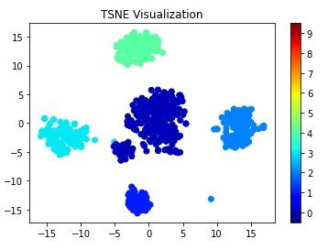

Figure 4.55 t-SNE Cluster Visualization (Illustrative Example)

A t-Distributed Stochastic Neighbor Embedding (t-SNE) visualization is used to display clustered data in a two-dimensional space. t-SNE is a dimensionality-reduction technique that maps high-dimensional feature vectors into a lower-dimensional representation while preserving local similarities between data points. This allows clusters present in the original high-dimensional dataset to become visually distinguishable (van der Maaten & Hinton, 2008).

In the figure, each dot represents a data point projected into two dimensions using the t-SNE embedding. The horizontal and vertical axes correspond to the two t-SNE dimensions, which do not represent specific original features but instead reflect the relative similarity relationships between observations.

The figure shows several distinct clusters of points, indicating groups of data observations that share similar characteristics:

● The large dark-blue cluster near the center represents a dense grouping of closely related observations.

● The cyan cluster on the left side and the light-blue cluster on the right side represent additional groups that are separated from the central cluster based on feature similarity.

● The green cluster located near the top of the plot forms another clearly separated group.

● A small cluster near the bottom of the plot represents another localized grouping of similar data points.

The color bar on the right side of the figure indicates cluster labels or category identifiers assigned to each group. Different colors help visually distinguish clusters and highlight how the algorithm separates groups within the dataset.

The separation between clusters in the t-SNE space demonstrates how high-dimensional feature relationships can be visualized in two dimensions, making it easier to examine cluster structure and assess the separability of patterns within the dataset.

To further characterize the clusters, feature distribution analysis will be performed for each cluster. Summary statistics and box plots will be used to examine how key telemetry features differ across clusters. This helps identify the behavioral patterns associated with each cluster, such as variations in forwarding ratios, delivery ratios, hop counts, or signal strength indicators.

Additionally, heat maps of feature values per cluster will be generated to visualize the relative magnitude of each feature across clusters. In these heat maps, rows correspond to clusters and columns correspond to features, allowing direct comparison of feature intensities between clusters. This visualization assists in identifying which features contribute most strongly to cluster differentiation.

Cluster characterization will also involve examining the instances assigned to each cluster. By analyzing the distribution of experimental labels (e.g., baseline, blackhole attack, or wormhole attack) within each cluster, the study can determine whether clusters correspond to specific behavioral states of the network. This analysis provides insight into how the clustering algorithms group normal and anomalous network behaviors.

Together, these visualization and analysis techniques enable the study to interpret the clustering results beyond numerical evaluation metrics. They provide qualitative insight into the behavioral patterns present in the dataset and help determine whether the clusters reflect meaningful distinctions between normal network operation and attack scenarios.

[PENDING: the figures for this section are made from the final clustering run: PCA and t-SNE projections coloured by cluster, the heatmap of feature means per cluster, the box plots per cluster, and the label share per cluster.]

5. Results, Discussion and Conclusion
[PENDING: write this chapter after all 81 runs are captured and analysed. Write from the final tables only. Claims about separation come from the clustering step (Section 4.2.5.6), not from the EDA pictures (Section 4.2.6). The headings below are in place so that the chapter can be filled without changing the structure of the paper.]

This chapter reports what the collected data show and what they do not show. Section 5.1 describes the dataset as collected. Section 5.2 reports whether the attack behaved as designed. Section 5.3 describes the data through exploratory analysis and states no detection result. Section 5.4 reports the clustering. Section 5.5 sets the results against the research objectives and the published studies, Section 5.6 lists future work and Section 5.7 concludes. Both attacks are application-layer emulations (D-20), so every result describes what the emulated attack does to the traffic and to the cross-layer features, and not what an attack on the routing protocol would do. In a run, a node is called a victim when its path to the root passes through the attacker and a bystander when it does not.

5.1. Dataset Collected

The design of Section 4.2.2.5 crosses 4 topologies, 2 attacks, 3 sites and 3 scenarios and adds 9 matched benign runs, which gives 81 runs. This draft reports the blackhole runs that have been captured and analysed. There are 36 of them: the 4 topologies (linear, star, tree and partial mesh) at the 3 sites (Room G402 (GCCS), the DLSU Library and the Yuchengco Building), each in the 3 scenarios (stationary, burst and highload), with one run in each cell. Every run has 8 boards, the root and 7 child nodes, and the attacker is one of the 7 child nodes. Every run follows the same schedule: 60 s of mesh formation, 300 s of baseline, 180 s of attack and 120 s of cooldown. Each board takes ten samples per second and groups them into one-second windows.

The 36 runs hold 213,148 one-second windows (Table 5.1). The windows labelled baseline and cooldown are treated as normal, and the windows labelled attack as blackhole. The windows recorded before the baseline, which include the formation of the mesh, and the windows on a phase boundary or without a phase label are not analysed. Every window kept has at least 8 of its 10 samples, and the mean number of samples in a window is 9.85 or more in every run.

Table 5.1 Windows in the Blackhole Dataset by Phase (provisional, 36 blackhole runs)
Phase | Windows | Share of all windows
Before the baseline (not analysed) | 41,076 | 19.3%
Baseline (normal) | 85,570 | 40.1%
Attack (blackhole) | 51,286 | 24.1%
Cooldown (normal) | 33,901 | 15.9%
Phase boundary or no phase label (not analysed) | 1,315 | 0.6%
All windows | 213,148 | 100.0%

Whether a node is a victim depends on where the attacker sits in that run, so the number of boards behind the attacker differs by topology (Table 5.2). In the star, every child sits behind the attacker, which is the hub, so the star has no bystanders. In the other topologies some children are not behind the attacker. These nodes carry the attack label during the attack window, because the label is set for the whole run, but nothing is done to their traffic. This matters for the clustering results of Section 5.4.

Table 5.2 Blackhole Runs by Topology (provisional, 36 blackhole runs)
Topology | Runs | Confirmed by the verifier | Boards behind the attacker | Boards not behind it
Linear | 9 | 9 of 9 | 33 | 21
Partial mesh | 9 | 9 of 9 | 18 | 36
Star | 9 | 9 of 9 | 54 | 0
Tree | 9 | 8 of 9 | 20 | 33
All | 36 | 35 of 36 | 125 | 90

The Confirmed column is explained in Section 5.2. The tree row includes the 2 victim boards and 4 bystander boards of the run that is not confirmed. One tree run, G402 with burst, has labelled windows for only 7 of its 8 boards, because board FE90 has no window with a phase label.

Five runs carry a note from the verifier or from the capture, and all five are kept in the dataset and in the pooled analyses (Table 5.3).

Table 5.3 Runs Carrying a Note (provisional, 36 blackhole runs)
Run (topology, site, scenario) | Note
Tree, G402, highload | Not confirmed. Board B768 changed parent during the attack and moved between the victim class (94 s) and the bystander class. The attacker reports that it forwarded 0%, while its neighbours report 42%.
Tree, G402, burst | Board FE90 has no window with a phase label in the analysed table, so the checks and the clustering run without it. The verifier rates this gap as major, so the outcome of this run is inconclusive.
Tree, G402, stationary | Board B768, a victim, has no attack windows after 28 s into the attack and no cooldown windows.
Partial mesh, G402, highload | Board ED80, a victim, has baseline windows for 266 of 300 s (88%), below the 95% that the verifier asks for.
Partial mesh, Yuchengco, stationary | The one victim has a baseline PDR of 0.734, so the 3-sigma test of PDR is not applied to this run. The run is confirmed on the attacker’s forwarding ratio.

[PENDING: tree at G402 with burst and with highload are the earlier captures. Both were captured again, and their re-analysed tables are now on GitHub (commit 6fb00803). With them, tree at G402 with burst passes with all 8 boards, tree at G402 with highload is confirmed but rated inconclusive because the role of one missing board cannot be determined, and the 36 runs hold 212,417 windows. Rerun the scripts, and update Tables 5.1 to 5.3 and every result below.]

The dataset defines 16 features (Table 4.17). Table 5.4 shows, over all 213,148 windows including those not analysed, on how many windows each one has a value for the attacker and for the child nodes in the blackhole runs, and what is done with it in this chapter. The tunnel features exist only on the two ends of a wormhole, so they are empty in a blackhole run, and eight features can enter the clustering of child nodes (Section 5.4).

Table 5.4 Features with a Value in the Blackhole Windows and Their Use (provisional, 36 blackhole runs)
Feature | Attacker windows | Child-node windows | Use in this chapter
ForwardingRatio | 94.3% | 36.9% | Attacker-side record. Kept out of the child-node clustering
IngressEgressDelta | 100.0% | 100.0% | Computed from the same two relay counters as ForwardingRatio. Kept out of the child-node clustering
RetryRate | 70.4% | 96.3% | Kept out of the analysis (D-15): an application-layer send count, near zero in every phase
PDR | 0.0% | 94.6% | Clustering feature
ParentSwitchRate | 100.0% | 100.0% | In FULL, dropped from REDUCED (low variance)
HopChangeCount | 100.0% | 100.0% | In FULL, dropped from REDUCED (low variance)
HopStabilityDuration | 100.0% | 100.0% | In FULL, dropped from REDUCED (low variance)
RSSI_mean | 98.6% | 99.1% | In every feature set
RSSI_var | 100.0% | 100.0% | In every feature set
RSSI_stability | 100.0% | 100.0% | In FULL, dropped from REDUCED (low variance)
RSSI_Hop_Diff | 97.8% | 98.6% | In every feature set
LatencyHopRatio | 0.0% | 74.5% | Kept out of the clustering: undefined when nothing is delivered, so a missing value alone gives away the label
ConsistencyScore | 94.3% | 36.9% | Equal to |ForwardingRatio − 1|. Kept out of the child-node clustering
TunnelIntensity | 0.0% | 0.0% | Wormhole ends only. Empty in the blackhole runs and kept out of the analysis
TunnelBytes | 0.0% | 0.0% | Wormhole ends only. Empty in the blackhole runs and kept out of the analysis
TunnelLatency | 0.0% | 0.3% | Wormhole ends only. 442 stray values in six blackhole runs (not interpreted) and kept out of the analysis

[PENDING: TunnelLatency has a value in 442 child-node windows of six blackhole runs (435 in the baseline, 7 before it, none in an attack window), where no tunnel exists. Find the cause and clear or explain the values before the final run.]

[PENDING: the final dataset once all 81 runs are captured: the runs by site, topology, scenario and attack against the plan (24 attack runs and 3 benign runs for each scenario), the wormhole runs, the 9 benign runs, the runs lost or recaptured and why, and the windows kept and discarded. Tables 5.1 to 5.4 cover the blackhole runs only.]

5.2. Attack Validation Results

Validation has two parts, as set out in Chapter 4: a check of every run against its own schedule and setup, and a comparison with published studies. This section reports the first part for the blackhole and the single-feature audit. The comparison with published studies is in Section 5.5.

5.2.1. Blackhole: Forwarding Suppression

Every run has a known schedule, so the expected effect is stated before the data are read. The attacker’s own forwarding ratio is the direct record of the suppression. It is 1.000 to 1.004 in the baseline of every run and 0.000 to 0.007 during the attack, so the attacker forwarded between 0.0% and 0.7% of the probes it received. Where the 3-sigma test of Chapter 4 gives a z-score, the attack value lies at least 22.9 baseline standard deviations from the baseline mean (median 115). In 14 runs the baseline never varied, so the z-score is undefined there. Table 5.5 lists the five checks of the verifier. Two are primary and decide the verdict, and three are support only.

Table 5.5 Attack Checks of the Verifier over the 36 Blackhole Runs (provisional, 36 blackhole runs)
Check | Role | Passed | Detail
ForwardingRatio of the attacker | Primary | 36 of 36 | Baseline 1.000 to 1.004, attack 0.000 to 0.007. Where z is defined its size is at least 22.9 (median 115). In 14 runs the baseline never varied and z is undefined.
PDR of all non-root nodes | Primary | 35 of 36 | Partial mesh at Yuchengco with stationary traffic is excluded, because its baseline is unstable (0.930 ± 0.253). Tree at G402 with highload passes this test but fails the setup check.
ConsistencyScore | Support | 31 of 36 | The 5 misses have z between 1.4 and 2.7.
IngressEgressDelta | Support | 31 of 36 | The 5 misses have z between 0.4 and 2.9.
NeighbourForwardingRatio of the attacker | Support | 31 of 36 | 4 runs have no attack-phase values (partial mesh at the DLSU Library with highload, at G402 with highload and at Yuchengco with stationary traffic; tree at the DLSU Library with burst). 1 fails (tree at G402 with highload).

The verifier confirmed the blackhole in 35 of the 36 runs, in every topology, at every site and in all three scenarios (Table 5.2). The 36th run, tree at G402 with highload, fails the setup check and not the attack signature: board B768 changed parent during the attack and moved between the victim and bystander classes, so the run is reported as not confirmed (Table 5.3).

Delivery behind the attacker collapses at once and returns at once. In the 123 victim boards of the 35 valid runs, the PDR fell below 0.5 in the first second of the attack (121 boards in the first window, the other 2 within 1 s). After the attack ended, it was back above 0.5 within 3 s (median 2 s) in the 122 boards that kept reporting. One board went silent and has no recovery data (Table 5.6). The mean PDR of the nodes behind the attacker is 0.998 in the baseline and 0.000 in the attack phase of every valid run. The nodes that are not behind the attacker stay at 1.000 during the attack (0.996 in the baseline).

Table 5.6 Collapse and Recovery of Delivery in the Victim Boards of the 35 Valid Runs (provisional, 36 blackhole runs)
Topology | Victim boards | PDR below 0.5: median (max), seconds after the attack starts | Boards with recovery data | PDR above 0.5 again: median (max), seconds after the attack ends
Linear | 33 | 0 (0) | 33 | 2 (2)
Partial mesh | 18 | 0 (0) | 18 | 2 (2)
Star | 54 | 0 (1) | 54 | 2 (3)
Tree | 18 | 0 (1) | 17 | 2 (2)
All | 123 | 0 (1) | 122 | 2 (3)

Figure 5.1 shows the mean PDR of the nodes behind the attacker in the attack phase of each of the 36 cells. It is 0.00 in 35 cells. The exception is tree at G402 with highload (0.39), the run that fails the setup check. The two hatched cells, marked REDO, are the earlier captures of tree at G402 that are to be replaced (Section 5.1). Figure 5.2 follows the PDR over the run for each topology, and Figure 5.3 shows the forwarding ratio of the attacker, which falls from about 1 to about 0 for the 180 s of the attack, and recovers when the attack ends.

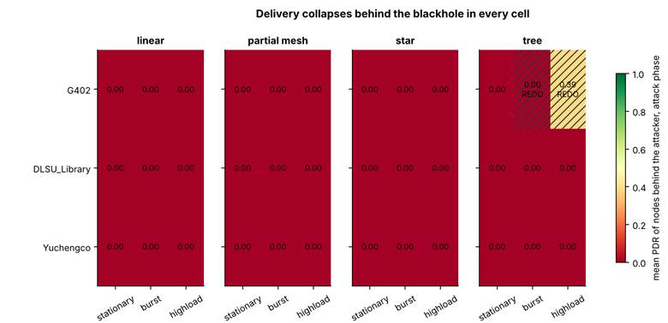

Figure 5.1 Mean PDR of the Nodes behind the Attacker in the Attack Phase, by Cell. REDO Marks the Two Earlier Captures to Be Replaced (provisional, 36 blackhole runs)

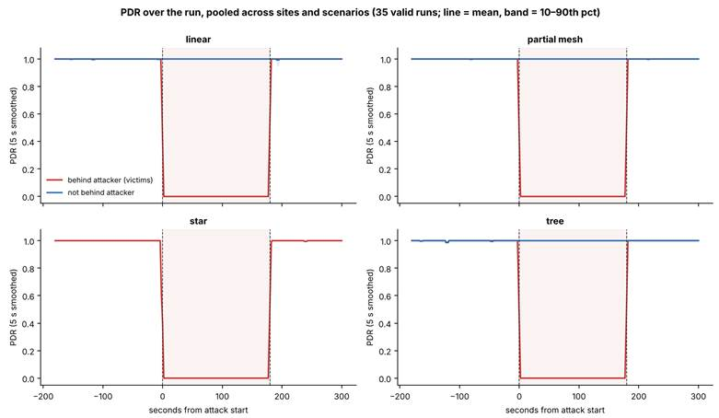

Figure 5.2 PDR over the Run for the Nodes Behind and Not Behind the Attacker, by Topology (provisional, 36 blackhole runs)

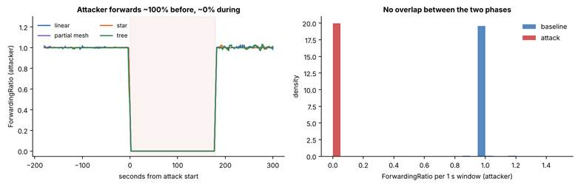

Figure 5.3 Forwarding Ratio of the Attacker over the Run (Left) and in Each One-Second Window (Right) (provisional, 36 blackhole runs)

5.2.2. Wormhole: Tunnel Replay

[PENDING: the wormhole evidence for all 36 wormhole runs: the setup check (the entry end deeper than the exit end, and the tunnel carrying the probes), the result of the 3-sigma test for the features that can be tested, the cells that could not be tested and why, and the hops skipped (Section 4.2.2). Nine wormhole runs are captured so far, all on the linear topology. The star, tree and partial-mesh cells are open.]

5.2.3. Single-Feature Audit

If one feature alone could separate attack windows from normal windows, the clustering would be unnecessary. Each feature is therefore tested alone as a single-threshold rule, and its best accuracy is compared with the majority rate (Table 5.7). Accuracy here is the best threshold, chosen with sight of the labels, with baseline and cooldown = 0 and attack = 1. Arp et al. [80] list spurious correlation, where a feature that is an artefact of how the data were made decides the result, among the common pitfalls of machine learning in security, and this audit tests for it.

Table 5.7 Best Single-Threshold Accuracy of Each Feature (provisional, 36 blackhole runs)
Feature | All non-root nodes | Victims only
PDR | 0.871 | 0.997
LatencyHopRatio | 0.846 | 0.998
ForwardingRatio, ConsistencyScore | 0.804 | 0.698
IngressEgressDelta | 0.737 | 0.699
RetryRate | 0.731 | 0.699
RSSI (mean, var, stability, hop difference), ParentSwitchRate, HopChangeCount, HopStabilityDuration | 0.700 | 0.699
Run clock: raw board clock (window_start) / aligned (t_anchor_s) | 0.702 / 0.802 | 0.702 / 0.800
Majority rate | 0.700 | 0.699

On the nodes behind the attacker, one feature alone decides the label: PDR reaches 0.997 and LatencyHopRatio 0.998, against a majority rate of 0.699, and every other feature stays at the majority rate. This is expected for a blackhole, which drops every packet for the whole attack window, so a complete collapse of delivery is separable by construction. LatencyHopRatio decides the label mainly because it is undefined when nothing is delivered. Whether it is missing predicts the label with 0.990 accuracy on victims, and it is missing in 99.5% of their attack windows. For that reason it is kept out of the clustering. The aligned run clock alone gives 0.800, which is 0.10 above the majority rate, because every run follows the same phase schedule and one cut can remove the end of the run. It cannot isolate a window in the middle of the run, and it is kept out of the model inputs. The raw board clock gives 0.702, because the boards start at different times. Figure 5.4 shows the audit for three groups of nodes.

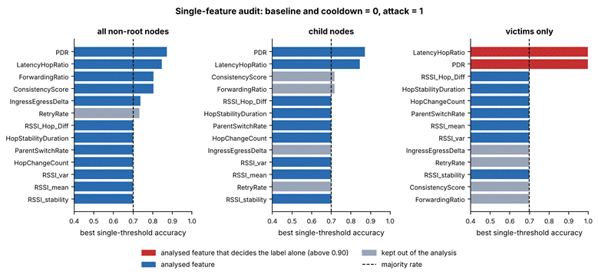

Figure 5.4 Best Single-Threshold Accuracy of Each Feature for Three Groups of Nodes (provisional, 36 blackhole runs)

5.2.4. Predictions Tested and Not Observed

Table 3.4 predicted more retransmissions at the victims under the blackhole. This was not observed. The retry rate of the nodes behind the attacker is 0.0015 in the baseline, 0.0006 in the attack and 0.0004 in the cooldown, and it is 0 for the other nodes in every phase. The attacker still acknowledges every frame at the link layer (Section 3.3.1.2), so the sender sees no failed delivery. Parent changes are also almost absent: the mean ParentSwitchRate of the nodes behind the attacker is 0.00005 in the baseline and 0.00018 in the attack (Cohen’s d 0.01). Table 3.4 is kept as it was written at proposal time, before any capture. The result is that an application-layer blackhole removes the delivery of the probes and leaves the link layer and the routing tree as they were.

[PENDING: the predictions tested for the wormhole (Table 3.5), once the wormhole runs are analysed.]

5.2.5. Cells That Could Not Be Fully Tested

Partial mesh at Yuchengco with stationary traffic could not be tested on PDR, because its baseline is unstable, and it is confirmed on the attacker’s forwarding ratio. Tree at G402 with highload fails the setup check. Four runs have no attack-phase values of the NeighbourForwardingRatio (Table 5.5), so that support check was not run for them. The wormhole cells are open (Section 5.2.2).

5.3. EDA Results

Exploratory analysis describes the structure of the data. It states no detection result. A difference described in this section is a difference between tables and pictures, and it is not a classifier. Table 5.8 compares the baseline and the attack phase. For each feature it gives the mean in each phase and Cohen’s d, the difference of the two means in units of the root mean square of the two standard deviations, for the nodes behind the attacker and for the nodes that are not behind it.

Table 5.8 Feature Means in the Baseline and the Attack Phase, and Cohen’s d (provisional, 36 blackhole runs)
Feature | Behind the attacker: baseline → attack | d | Not behind it: baseline → attack | d
PDR | 0.998 → 0.005 | −16.55 | 0.996 → 1.000 | 0.09
RSSI_mean (dBm) | −74.7 → −74.9 | −0.02 | −72.4 → −72.6 | −0.04
RSSI_var | 0.421 → 0.307 | −0.07 | 0.323 → 0.191 | −0.09
RSSI_stability | 0.894 → 0.896 | 0.05 | 0.895 → 0.898 | 0.07
RSSI_Hop_Diff | 3.21 → 3.35 | 0.04 | 3.99 → 4.02 | 0.00
ParentSwitchRate, HopChangeCount | 0.00005 → 0.00018 | 0.01 | 0.00000 → 0.00000 | no variation
HopStabilityDuration | 1.000 → 1.000 | 0.01 | 0.999 → 0.999 | 0.01
IngressEgressDelta | 0.019 → 0.015 | −0.01 | 0.033 → 0.021 | −0.03
RetryRate | 0.0015 → 0.0006 | −0.03 | 0.0000 → 0.0000 | no variation

Only the delivery ratio moves, and only on the nodes behind the attacker (d = −16.6). Every other feature changes by less than a tenth of a standard deviation, on the nodes behind the attacker and on the others alike. The PDR row for the nodes behind the attacker includes the run that is not confirmed, so its attack mean is 0.005, and without it the mean is 0.000. Figure 5.5 shows the same comparison as box plots. In five of the ten panels the box, which holds the middle half of the windows, collapses to a single line in all four groups: IngressEgressDelta, RSSI_stability, ParentSwitchRate, HopChangeCount and HopStabilityDuration. The PDR box of the nodes behind the attacker drops from 1 to 0, and no other panel shows a shift of that size. LatencyHopRatio is missing in 99.5% of the attack windows of the nodes behind the attacker, so its box for that group describes a small remainder.

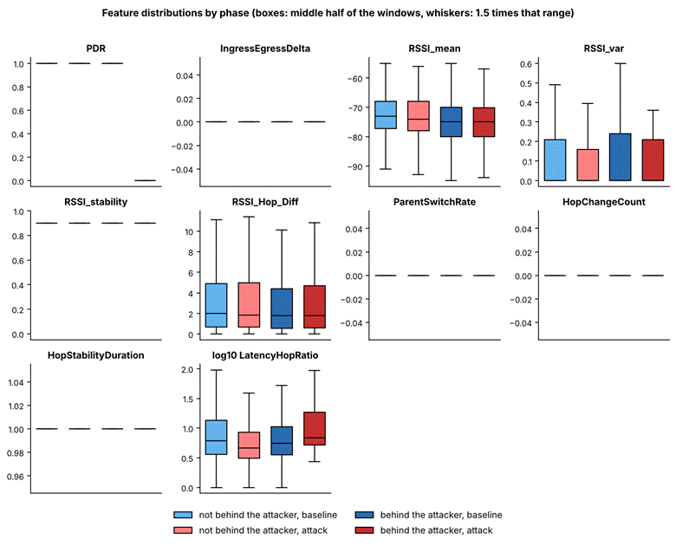

Figure 5.5 Feature Distributions by Phase for the Nodes Behind the Attacker and the Others (provisional, 36 blackhole runs)

Figure 5.6 gives the Pearson and the Spearman correlation between the features, for all labelled child-node windows, for the baseline windows and for the attack windows. The charts use the 12 features that have a value in more than 30% of the child-node windows, on a random sample of up to 40,000 windows for each view. Only four pairs reach a correlation of 0.5 in size, and the same four appear in all three views: ParentSwitchRate with HopChangeCount (1.0), ForwardingRatio with ConsistencyScore (Spearman, −0.9), IngressEgressDelta with ConsistencyScore (Pearson, 0.7 to 0.8) and RSSI_var with RSSI_stability (Pearson, −0.8). The first three pairs are linked by their formulas and not by network behaviour (ConsistencyScore is |ForwardingRatio − 1|, and ParentSwitchRate and HopChangeCount count the same event), and RSSI_stability is derived from the RSSI variance. The correlation structure does not change between the baseline and the attack. Correlation is not treated as cause.

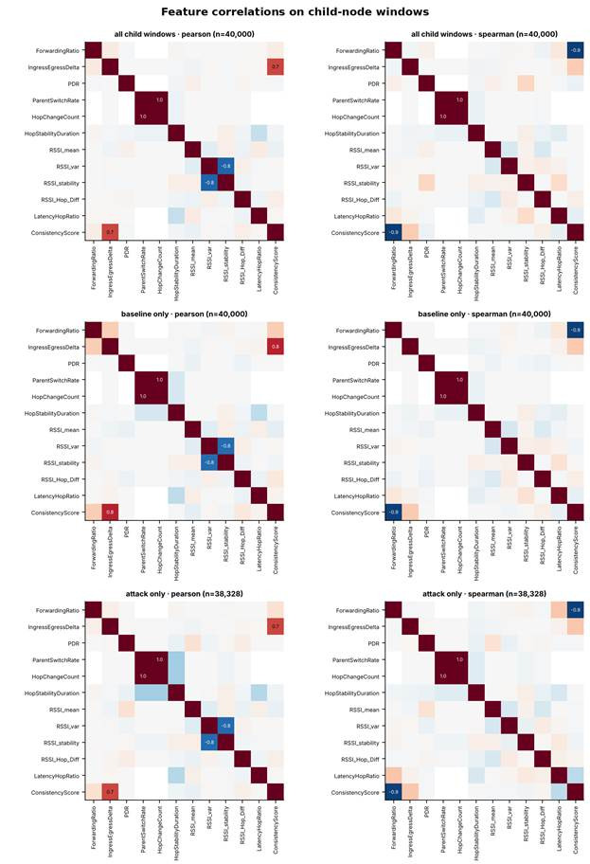

Figure 5.6 Pearson (Left) and Spearman (Right) Correlation between Features, for All Labelled Windows, the Baseline and the Attack (provisional, 36 blackhole runs)

[PENDING: Table 4.22 (baseline windows by site) and the comparison of the 9 matched benign runs with the baselines of the attack runs. The benign runs are not captured, so this draft has no stand-alone control. Here “normal” means the baseline and the cooldown of the attack runs. Add the per-cell figures of the wormhole runs when they are final.]

5.4. Clustering Results

5.4.1. Setup

The clustering follows the procedure of Chapter 4. Five algorithms (K-Means, Ward hierarchical clustering, a Gaussian mixture model (GMM), DBSCAN and spectral clustering) are run on standardised features, with k from 2 to 8 and three seeds (42, 7 and 123). Each seed draws a new sample of 6,000 windows from the child-node windows that have every feature of the set (126,741 for FULL and REDUCED, 127,666 without PDR), and restarts the algorithm. DBSCAN takes min_samples between D + 1 and 2D, where D is the number of features, and eps at the knee of the k-distance graph (Figure 5.7). Cluster purity and the adjusted Rand index (ARI) are computed afterwards against the label (baseline and cooldown = 0, attack = 1) and are never used to form a cluster. All results below are means over the three seeds, with k = 2 for the four methods that need k.

Table 5.9 Feature Sets Used for Clustering (provisional, 36 blackhole runs)
Set | Features | Count | Purpose
FULL | PDR, ParentSwitchRate, HopChangeCount, HopStabilityDuration, RSSI_mean, RSSI_var, RSSI_stability, RSSI_Hop_Diff | 8 | Every feature that may enter the child-node clustering (Table 5.4)
REDUCED | PDR, RSSI_mean, RSSI_var, RSSI_Hop_Diff | 4 | FULL after a low-variance filter: features with more than 90% identical values are dropped [PENDING: this rule keeps RSSI_stability, whose most common value covers 74.6% of the FULL pool; state the filter that was used.]
REDUCED without PDR | RSSI_mean, RSSI_var, RSSI_Hop_Diff | 3 | Diagnostic: REDUCED without the delivery ratio

The dataset defines 16 features, but only 8 can enter the clustering of child nodes (Table 5.4). Two populations are clustered: all child nodes, and victims only. The first includes windows from nodes that are not behind the attacker but carry the attack label (Section 5.1), and the second does not.

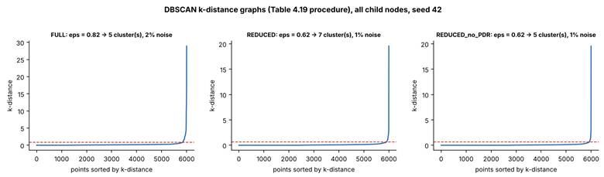

Figure 5.7 DBSCAN k-Distance Graphs for the Three Feature Sets (All Child Nodes, Seed 42) (provisional, 36 blackhole runs)

5.4.2. Quality and Agreement with the Label

Table 5.10 gives the quality metrics and the agreement with the label for every algorithm and feature set. Purity of 0.693 is the majority rate of the sample, so it means no separation.

Table 5.10 Clustering Quality and Agreement with the Label, Means over Seeds 42, 7 and 123 (provisional, 36 blackhole runs)
Feature set | Algorithm | Silhouette | Davies–Bouldin | Purity | ARI, all child nodes | ARI, victims only
REDUCED | K-Means | 0.482 | 0.918 | 0.869 | 0.515 | 0.991
REDUCED | Ward | 0.472 | 0.893 | 0.865 | 0.503 | 0.881
REDUCED | GMM | 0.443 | 1.383 | 0.808 | 0.336 | 0.657
REDUCED | DBSCAN (5 to 7 clusters, 1.3% noise) | 0.511 | 0.463 | 0.865 | 0.488 | 0.926
REDUCED | Spectral | 0.175 | 0.806 | 0.693 | −0.000 | 0.001
FULL | K-Means | 0.847 | 0.651 | 0.693 | −0.002 | −0.003
FULL | Ward | 0.853 | 0.570 | 0.693 | −0.002 | −0.004
FULL | GMM | 0.401 | 1.615 | 0.811 | 0.373 | 0.658
FULL | DBSCAN (5 clusters, 2.3% noise) | 0.524 | 0.430 | 0.864 | 0.475 | 0.925
FULL | Spectral | 0.281 | 0.927 | 0.693 | 0.002 | 0.001
Without PDR | K-Means | 0.321 | 1.243 | 0.693 | −0.000 | 0.002
Without PDR | Ward | 0.654 | 0.904 | 0.693 | 0.000 | 0.002
Without PDR | GMM | 0.434 | 2.012 | 0.693 | −0.009 | −0.012
Without PDR | DBSCAN (4 to 5 clusters, 1.1% noise) | 0.678 | 0.273 | 0.693 | −0.002 | −0.005
Without PDR | Spectral | −0.321 | 1.758 | 0.693 | 0.001 | 0.000

With the delivery ratio among the features, clustering separates the windows in which the attack is felt. K-Means with k = 2 on the REDUCED set reaches an ARI of 0.515 on all child nodes and 0.991 on victims alone. Ward and DBSCAN agree (0.503 and 0.488 on all child nodes, 0.881 and 0.926 on victims alone). Without the delivery ratio, no algorithm finds the attack. The ARI stays between −0.015 and 0.007 for every algorithm and every k from 2 to 8, and the t-SNE picture shows no structure (Figure 5.13). The blackhole does not show in the signal strength features. Figure 5.8 gives the ARI against k, Figure 5.9 the silhouette score and Figure 5.10 the Davies–Bouldin index.

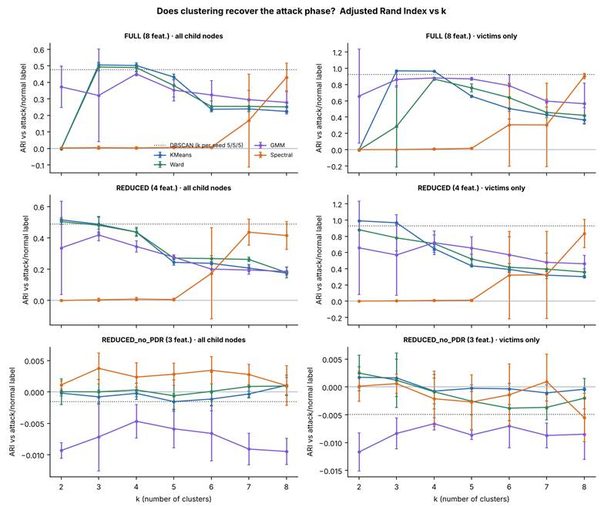

Figure 5.8 Adjusted Rand Index against the Number of Clusters, by Feature Set and Population (Mean and Spread over Three Seeds) (provisional, 36 blackhole runs)

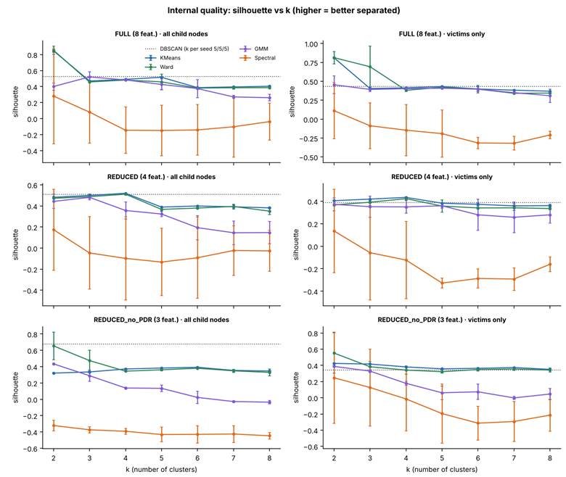

Figure 5.9 Silhouette Score against the Number of Clusters, by Feature Set and Population (provisional, 36 blackhole runs)

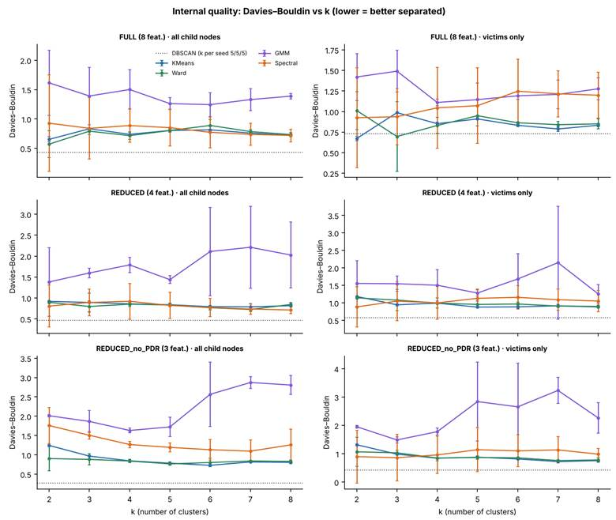

Figure 5.10 Davies–Bouldin Index against the Number of Clusters, by Feature Set and Population (provisional, 36 blackhole runs)

5.4.3. What Limits the Agreement

The ceiling on all child nodes is an ARI of 0.528, not 1. A node that is not behind the attacker carries the attack label in the attack window but behaves like a normal node, and 42% of the attack-labelled child-node windows come from such nodes. No method that reads only the features of a window can group them with the attack. A perfect separation of the windows in which the attack is felt scores 0.528 on all child nodes, and K-Means on the REDUCED set scores 0.515 (sd 0.014 over the seeds). On victims alone the same run scores 0.991. The victims-only figure is therefore reported next to the all-nodes figure.

The silhouette score alone picks the wrong k on the FULL set. K-Means and Ward score highest at k = 2 (0.85 for both), but in K-Means this split cuts off about 30 of the 6,000 windows, which have an extreme RSSI variance (a mean of about 14 against 0.2 for the rest) and a low RSSI stability, and its ARI is 0. K-Means with k = 3 recovers the attack (ARI 0.505 on all child nodes and 0.970 on victims). The choice of k therefore has to use the elbow, the silhouette peaks and interpretability together, as Chapter 4 sets out.

GMM is seed-sensitive. On the REDUCED set at k = 2 it matched K-Means on two seeds (ARI 0.517 and 0.500) and fell to −0.010 on the third, so its mean of 0.336 (sd 0.299 over the seeds) is not a stable result. Spectral clustering does not find the attack on any feature set. Its mean ARI is at most 0.009 for k = 2 to 5, and it varies widely at larger k (0.17 to 0.44, with a standard deviation of up to 0.29), so it is reported and not relied on.

Figure 5.11 shows what each K-Means cluster contains at k = 3. With the delivery ratio among the features (FULL and REDUCED), one cluster of about 1,060 windows is almost entirely attack windows of the nodes behind the attacker. A second cluster holds the rest, and a third, of 25 to 30 windows, holds the extreme RSSI variance. Without the delivery ratio, every cluster is a mixture of the four kinds of window. Table 5.11 gives the profile of the two K-Means clusters at k = 2 on the REDUCED set: one cluster (18% of the windows) is 99.2% attack-phase windows with a mean PDR of 0.000, and the other has a mean PDR of 1.000 and holds the attack windows of the nodes that are not behind the attacker.

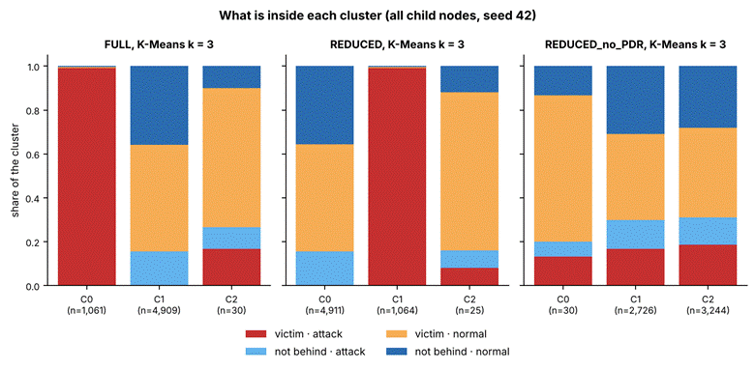

Figure 5.11 Composition of Each K-Means Cluster at k = 3, by Feature Set (provisional, 36 blackhole runs)

Table 5.11 K-Means Clusters at k = 2 on the REDUCED Set (All Child Nodes, Seed 42) (provisional, 36 blackhole runs)
Measure | Cluster 0 | Cluster 1
Windows | 4,934 | 1,066
Attack-phase windows | 15.6% | 99.2%
Baseline windows | 60.3% | 0.8%
Cooldown windows | 24.1% | 0.0%
Windows from nodes behind the attacker | 48.8% | 99.5%
Mean PDR | 1.000 | 0.000
Mean RSSI_mean (dBm) | −73.5 | −74.7
Mean RSSI_var | 0.295 | 0.249
Mean RSSI_Hop_Diff | 3.60 | 3.19

5.4.4. Robustness across Sites, Topologies and Labelling

The result holds in every subgroup (Table 5.12). K-Means with k = 2 on the REDUCED set stays within 0.03 of the best possible ARI inside each site and each topology, and without the delivery ratio it stays at 0 inside each of them. The best possible figure is one particular partition, so a method can edge past it, as it does in the linear topology. Dropping the cooldown windows from the normal label keeps the same pattern: with the delivery ratio, K-Means purity is 0.839 against a majority rate of 0.627, and without it purity equals the majority rate.

Table 5.12 K-Means (k = 2) ARI inside Each Site and Topology, All Child Nodes (provisional, 36 blackhole runs)
Subgroup | Best possible ARI | REDUCED | REDUCED without PDR
Site G402 | 0.567 | 0.547 | 0.005
Site DLSU Library | 0.574 | 0.574 | 0.002
Site Yuchengco | 0.447 | 0.426 | −0.004
Linear | 0.560 | 0.565 | −0.001
Star | 1.000 | 0.999 | −0.003
Tree | 0.319 | 0.311 | 0.002
Partial mesh | 0.287 | 0.277 | −0.001

5.4.5. Projections

Figure 5.12 projects the standardised FULL features of a sample of 6,000 child-node windows to two dimensions with PCA and t-SNE. In both projections the attack windows of the nodes behind the attacker form their own group, away from the rest, and the attack windows of the nodes that are not behind it lie among the normal windows. Figure 5.13 repeats the projection after the delivery ratio is removed: the four kinds of window overlap and no structure is visible. The axes of t-SNE have no units, and only nearness is read from them.

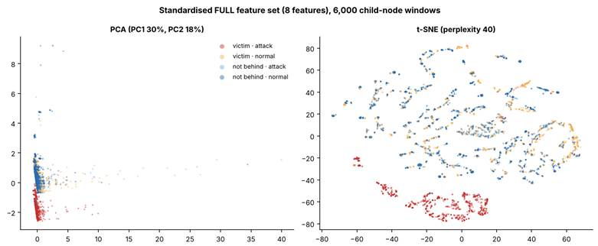

Figure 5.12 PCA and t-SNE Projections of the FULL Feature Set (provisional, 36 blackhole runs)

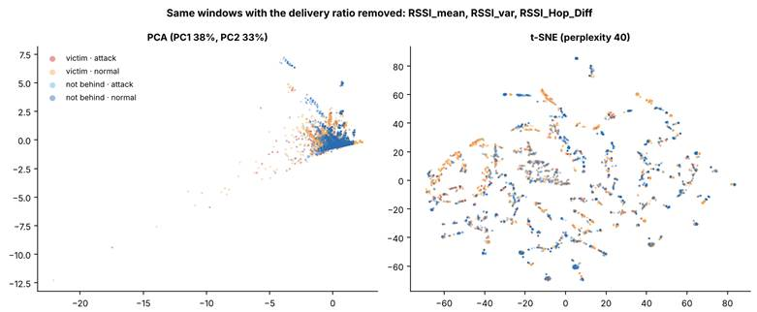

Figure 5.13 PCA and t-SNE Projections with the Delivery Ratio Removed (provisional, 36 blackhole runs)

[PENDING: the final clustering for the pooled 81 runs: purity and ARI for three labels (normal, blackhole and wormhole-inspired), the label share and the feature means per cluster as a heat map, and the box plots per cluster. State from purity and ARI whether normal, blackhole and wormhole-inspired windows separate. Report the benign runs as a stand-alone control. The wormhole windows were not separated in an earlier provisional reading.]

5.5. Discussion

[PENDING: this discussion reads the blackhole results only. Extend it with the wormhole and benign results, and read every sentence again against the final tables before the chapter is submitted.]

5.5.1. Against the Research Objectives

The first objective (Section 1.3) was to establish an ESP32 mesh testbed that generates multi-hop traffic under normal operation and controlled attack. The 8-board testbed ran the 36 blackhole cells at three sites and in four topologies, and the attacker did what the design says in every run: it forwarded between 0.0% and 0.7% of what it received during the attack, against 100% before (Table 5.5).

The second objective was to collect and structure cross-layer features into a labelled and documented dataset. The dataset holds 213,148 labelled one-second windows with the cross-layer features of Chapter 4. Of the 16 features, 8 can enter the clustering of child nodes, and only one of them, PDR, responds to the blackhole (Tables 5.4 and 5.8). The other features are recorded and documented, and they do not change when a blackhole is placed in the mesh.

The third objective was to assess, through exploratory analysis and unsupervised methods, whether normal and attack-induced behaviours are separable. For the blackhole, the windows in which the attack is felt separate from the normal windows when PDR is a feature (ARI 0.515 on all child nodes against a ceiling of 0.528, and 0.991 on victims alone), and they do not separate without it (ARI between −0.015 and 0.007). The separation is therefore carried by one feature. Chapter 4 expected that the clusters would reflect a confluence of cross-layer evidence, and for the blackhole this is not what the data show.

5.5.2. Against the Published Studies

Airehrour et al. [70] report packet loss of 60% to 75% under a blackhole attack in the standard protocol. In our data the nodes behind the attacker lose every probe (PDR 0.000 in the attack phase of all 35 valid runs), which is above the published range and in the same direction. The platforms, scales and protocols differ, and ours is measured on the nodes behind the attacker, whose every packet the attacker drops, so the comparison covers direction and not equal values. The same authors report 16 to 246 rank changes per mote. We see almost no parent changes (Section 5.2.4), and the difference is explained by the attack design, because suppressing forwarding does not alter routing. Khan et al. [22] report delivery above 97% in a healthy ESP-MESH network. The baseline PDR in our runs is 0.998 for the nodes behind the attacker and 0.996 for the others, per one-second window, which is consistent with that benchmark.

[PENDING: the comparison for the wormhole with Zhukabayeva et al. [71] and Ramírez Gómez et al. [72], and the update of Table 4.23 and Tables 4.26 to 4.30 from the final results.]

5.5.3. What an Emulation Can and Cannot Show

The blackhole acts on the application-layer probes. The attacker receives the probes of the nodes behind it and does not forward them, but it still acknowledges every frame at the link layer, so signal strength, retries and parent choices are not touched (D-20). The dataset therefore records the effect of forwarding suppression on delivery. It does not record how a node attracts traffic to itself, which is the route-attraction stage of a classical blackhole (Section 5.6). This is why the delivery ratio carries the whole result, and it is a property of the emulation as much as of the attack.

5.5.4. Limits

One run per cell. Each combination of topology, site and scenario was run once, so the three sites act as the repeats. Site differences cannot be separated from run-to-run noise. The seeds of Section 5.4 change the sample and the starting points of the algorithms and not the data.

Partial mesh. In all 9 partial-mesh blackhole runs every node was seen under a single parent during the labelled phases, and parent changes occurred only during mesh formation, so these runs behave as plain trees (Section 1.4.1).

The label. The label marks every window of every node in the attack phase as attack, including the windows of nodes that are not behind the attacker. This caps the ARI at 0.528 on all child nodes.

Scenarios. The burst and highload scenarios add controlled variation in traffic, so that traffic volume alone cannot indicate an attack. They are not a model of campus traffic.

Normal means baseline and cooldown. The benign runs are not captured, so there is no stand-alone control. The false-alarm rate on a network that never saw an attack is not measured, and it is not known whether the burst and highload scenarios alone move the PDR or the forwarding ratio in the way the verifier tests for.

[PENDING: add [80] Arp, D., Quiring, E., Pendlebury, F., Warnecke, A., Pierazzi, F., Wressnegger, C., Cavallaro, L., & Rieck, K. (2022). Dos and don’ts of machine learning in computer security. In 31st USENIX Security Symposium (USENIX Security 22). USENIX Association. to Appendix A, because Section 5.2.3 cites it.]

5.6. Future Work

The two attacks in this study are application-layer emulations, so the route-attraction stage of a blackhole and the false-neighbour effect of a wormhole are not in the dataset. A later study could add them, either on a routing protocol whose route handling can be modified, or on ESP-WIFI-MESH itself by building the attack below the application layer, for example by forging the mesh’s own management frames, which needs radio-level tools and was outside this study. A dataset made that way could be set beside this one to show what the route-attraction stage adds to the cross-layer signature.

5.7. Conclusion

[PENDING: state the contribution of the study against the objectives of Section 1.3, using only results that appear in the final tables. Write it after collection ends. The blackhole findings in this draft are interim, and the wormhole and benign results are not in yet.]

Appendix A. Bibliography
[1] Akyildiz, I. F., Wang, X., & Wang, W. (2005). Wireless mesh networks: A survey. Computer Networks, 47(4), 445–487. https://www.sciencedirect.com/science/article/abs/pii/S1389128604003457
[2] Cilfone, G., Davoli, L., Belli, L., & Ferrari, G. (2019). Wireless mesh networking: An IoT-oriented perspective—Survey on relevant technologies. Future Internet, 11(4), 1–41.https://www.mdpi.com/1999-5903/11/4/99
[3] Hanif, M., Ashraf, H., Jalil, Z., Jhanjhi, N. Z., Humayun, M., Saeed, S., & Almuhaideb, A. M. (2022). AI-Based Wormhole Attack Detection Techniques in Wireless Sensor Networks. Electronics, 11(15), 2324. https://www.mdpi.com/2079-9292/11/15/2324
[4] Bhatti, D. S. et al. (2024). Detection and isolation of wormhole nodes in wireless ad hoc networks based on post-wormhole actions. Scientific Reports, 14, 3428. https://www.nature.com/articles/s41598-024-53938-9
[5] Al-Anzi, F. S.(2022). Design and analysis of intrusion detection systems for wireless mesh networks. Digital Communications and Networks. https://www.sciencedirect.com/science/article/pii/S2352864822001043
[6] Ioulianou, P. P., Vassilakis, V. G., & Shahandashti, S. F. (2022). A Trust-Based Intrusion Detection System for RPL Networks: Detecting a Combination of Rank and Blackhole Attacks. Journal of Cybersecurity and Privacy, 2(1), 124-153. https://www.mdpi.com/2624-800X/2/1/9
[7] M. Alharthi, A. A. Alabdulatif, and A. Aljohani, “XLID: Cross-Layer Intrusion Detection System for Wireless Sensor Networks,” International Journal of Science and Technology (IJST), vol. 8, no. 3, pp. 87–94, 2019. [Online]. Available: https://sciresol.s3.us-east-2.amazonaws.com/IJST/Articles/2019/Issue-3/Article8.pdf
[8] A. Amouri, H. Abid, and N. Boudriga, “A Cross-Layer, Anomaly-Based IDS for WSN and MANET,” Sensors, vol. 18, no. 2, p. 651, 2018. [Online]. Available: https://www.mdpi.com/1424-8220/18/2/651
[9] G. Singh, “A Cross-Layer Based Optimized Feature Selection Scheme for IDS in WSNs,” Journal of Intelligent & Fuzzy Systems, vol. 42, pp. 1–13, 2022. [Online]. Available: https://journals.sagepub.com/doi/abs/10.3233/JIFS-210700
[10] Ayad, A.G., Sakr, N.A. & Hikal, N.A. A hybrid approach for efficient feature selection in anomaly intrusion detection for IoT networks. J Supercomput 80, 26942–26984 (2024). https://link.springer.com/article/10.1007/s11227-024-06409-x
[11] A. A. Al-Qarawi and M. A. Razzaque, “Energy-Aware Cross-Layer Intrusion Detection System for IoT-Based Wireless Mesh Networks,” Sensors, vol. 22, no. 18, 2022. [Online]. Available: https://www.mdpi.com/1424-8220/22/18/6954
[12] Arshad, J., Azad, M. A., Amad, R., Salah, K., Alazab, M., & Iqbal, R. (2020). A Review of Performance, Energy and Privacy of Intrusion Detection Systems for IoT. Electronics, 9(4), 629. https://www.mdpi.com/2079-9292/9/4/629
[13] Alshehri AH. 2024. Wormhole attack detection and mitigation model for Internet of Things and WSN using machine learning. PeerJ Computer Science 10:e2257 https://peerj.com/articles/cs-2257/
[14] Sarhan, M., Layeghy, S., Moustafa, N., Gallagher, M., & Portmann, M. (2024). Feature extraction for machine learning-based intrusion detection in IoT networks. Digital Communications and Networks, 10(1), 205-216.https://arxiv.org/abs/2108.12722
[15] Churcher, A., Ullah, R., Ahmad, J., Rehman, S. u., Masood, F., Gogate, M., Alqahtani, F., Nour, B., & Buchanan, W. J. (2021). An experimental analysis of attack classification using machine learning in IoT networks. MDPI Sensors, 21(2), 446. https://www.mdpi.com/1424-8220/21/2/446
[16] Shafieian, S., & Zulkernine, M. (2022). Multi-layer stacking ensemble learners for low footprint network intrusion detection. SpringerLink. https://link.springer.com/article/10.1007/s40747-022-00809-3
[17] Wardana, S. A., Yusof, R., Zolkipli, M. F., & Kim, D. (2024). Collaborative intrusion detection using weighted ensemble averaging deep neural network for coordinated attack detection in heterogeneous networks. International Journal of Information Security, 23(4), 801–815. https://link.springer.com/article/10.1007/s10207-024-00891-3
[18] Vanlalhruaia, Ajoy, K.K., Amit, K.R. (2025). Securing AODV against black hole attack for wireless mesh network. Journal of Information Systems Engineering & Management, 10(37s), 1192–1202. https://doi.org/10.52783/jisem.v10i37s.7547
[19] Srinivasan, J. (2025). Innovative cross-layer defense mechanisms for blackhole and wormhole attacks in wireless ad-hoc networks. Scientific Reports, 15(1), 14747.
[20] Bhonsle, M., Srinivasulu, G., Chaitanya, K., Raghu, D., Surendra, G., Kumar, K., Rao, M. S., Prabhakar, K., & Krishna, V. (2025). Deep Learning-Based Defense Mechanisms against black hole attacks in wireless mesh networks. Advanced Sustainable Science Engineering and Technology, 7(1), 02501010. https://doi.org/10.26877/asset.v7i1.1036
[21] Espressif Systems. (n.d.). ESP-WIFI-MESH Programming Guide [ESP-IDF v5.3 for ESP32]. https://docs.espressif.com/projects/esp-idf/en/v5.3/esp32/api-guides/esp-wifi-mesh.html
[22] Khan, A. U., Khan, M. E., Hasan, M., Zakri, W., Alhazmi, W., & Islam, T. (2022). An Efficient Wireless Sensor Network Based on the ESP-MESH Protocol for Indoor and Outdoor Air Quality Monitoring. Sustainability, 14(24). https://doi.org/10.3390/su142416630
[23] Qian, L., Gu, K., Fu, Y., Shen, Y., & Xu, S. (2024). A Wireless Ad Hoc Network Communication Platform and Data Transmission Strategies for Multi-Bus Instruments. Electronics, 13(18). https://doi.org/10.3390/electronics13183596
[24] A, Avina & R, Geetha. (2025). ResNeXt and Deep Stacked Autoencoder based framework for wormhole attack detection on network control systems. Discover Computing. 28. 10.1007/s10791-025-09816-7.
[25] Boiano, A., Zheng, D., Palmese, F., Pimpinella, A., & Redondi, A. E. C. (2026, February 3). Analyzing Zigbee Traffic: Datasets, classification and storage trade-offs. arXiv.org. https://arxiv.org/abs/2602.03140
[26] Das, T., Hamdan, O. A., Shukla, R. M., Sengupta, S., & Arslan, E. (2023, January). Unr-idd: Intrusion detection dataset using network port statistics. In 2023 IEEE 20th consumer Communications & networking conference (CCNC) (pp. 497-500). IEEE.
[27] Moustafa, Nour & Slay, Jill. (2015). UNSW-NB15: a comprehensive data set for network intrusion detection systems (UNSW-NB15 network data set). 10.1109/MilCIS.2015.7348942.
[28] Miekkala, Topi & Pyykönen, Pasi & Drainakis, Georgios & Pantazopoulos, Panagiotis & Muller, Tobias & Katsaros, Konstantinos & Sourlas, Vasilis & Amditis, Angelos & Kaklamani, Dimitra. (2024). NordicDat: A Cross-Border Predictive QoS Dataset. 1281-1286. 10.1109/GLOBECOM52923.2024.10901462.
[29] Tavallaee, Mahbod & Bagheri, Ebrahim & Lu, Wei & Ghorbani, Ali. (2009). A detailed analysis of the KDD CUP 99 data set. IEEE Symposium. Computational Intelligence for Security and Defense Applications, CISDA. 2. 10.1109/CISDA.2009.5356528.
[30] Sommer, Robin & Paxson, Vern. (2010). Outside the Closed World: On Using Machine Learning for Network Intrusion Detection. Proceedings - IEEE Symposium on Security and Privacy. 305-316. 10.1109/SP.2010.25.
[31] Ring, M., Wunderlich, S., Scheuring, D., Landes, D., & Hotho, A. (2019). A survey of network-based intrusion detection data sets. Computers & security, 86, 147-167.
[32] García-Teodoro, Pedro & Díaz-Verdejo, Jesús & Maciá-Fernández, Gabriel & Vázquez, Enrique. (2009). Anomaly-based network intrusion detection: Techniques, systems and challenges. Computers & Security. 28. 18-28. 10.1016/j.cose.2008.08.003.
[33] Tsai, Chih-Fong & Hsu, Yu-Feng & Lin, Chia-Ying & Lin, Wei-Yang. (2009). Intrusion detection by machine learning: A review. Expert Systems with Applications. 36. 11994-12000. 10.1016/j.eswa.2009.05.029.
[34] Chandola, Varun & Banerjee, Arindam & Kumar, Vipin. (2009). Anomaly Detection: A Survey. ACM Comput. Surv.. 41. 10.1145/1541880.1541882.
[35] Tukey, J. W. (1977). Exploratory data analysis. Reading, MA: Addison-Wesley.
[36] Aggarwal, C. C. (2015). Data mining: the textbook (Vol. 1, No. 3). New York: springer.
[37] Han, J., Kamber, M., & Pei, J. (2012). Data Mining: Concepts and Techniques (3rd ed.). Morgan Kaufmann Publishers.
[38] Jain, Anil. (2010). Data Clustering: 50 Years Beyond K-Means. Pattern Recognition Letters. 31. 651-666. 10.1016/j.patrec.2009.09.011.
[39] Pedroso, Carlos & de Souza Batista, Agnaldo & Jesus, Samuel & Santos, Aldri. (2024). A Direct Collaborative Network Intrusion Detection System for IoT Networks Integration. 10.5753/sbrc.2024.1354.
[40] Hernandez-Ramos, J. L., et al. (2022–2024). Intrusion detection based on federated learning: A comprehensive survey. ACM Computing Surveys.https://dl.acm.org/doi/10.1145/3731596
[41] Rassam, M. A. (2024). Autoencoder-based neural network model for anomaly detection in wireless body area networks. IoT, 5(4), 852–870. https://www.mdpi.com/2624-831X/5/4/39
[42] J. Li, et al., “Optimizing IoT Intrusion Detection System: Feature Selection versus Feature Extraction,” Journal of Big Data, vol. 11, 2024. [Online]. Available: https://journalofbigdata.springeropen.com/articles/10.1186/s40537-024-00892-y
[43] Kurosawa, S., Nakayama, H., Kato, N., Jamalipour, A., & Nemoto, Y. (2007). Detecting blackhole attack on AODV-based mobile ad hoc networks by dynamic learning method. International Journal of Network Security, 5(3), 338–346. http://ijns.jalaxy.com.tw/contents/ijns-v5-n3/ijns-2007-v5-n3-p338-346.pdf
[44] Baadache, A., & Belmehdi, A. (2014). Struggling against simple and cooperative black hole attacks in multi-hop wireless ad hoc networks. Computer Networks, 73, 173–184. https://www.researchgate.net/publication/265687984_Struggling_against_simple_and_cooperative_black_hole_attacks_in_multi-hop_wireless_ad_hoc_networks
[45] Khalil, I., Bagchi, S., & Shroff, N. B. (2007). LiteWorp: Detection and isolation of the wormhole attack in static multihop wireless networks. Computer Networks, 51(13), 3750–3772. https://doi.org/10.1016/j.comnet.2007.04.001
[46] Hu, Y.-C., Perrig, A., & Johnson, D. B. (2003). Packet leashes: A defense against wormhole attacks in wireless networks. *IEEE INFOCOM 2003. Twenty-Second Annual Joint Conference of the IEEE Computer and Communications Societies*, *3*1976–1986. https://doi.org/10.1109/INFCOM.2003.1209219
[47] Keipour, H. (2022). Blackhole attack detection in low-power IoT mesh networks using machine learning algorithms.
[48] Chatterjee, S., et al. (2022). Anomaly detection in IoT systems: A survey. Internet of Things, 18, 100508. https://doi.org/10.1016/j.iot.2022.100508
[49] Miguel-Diez, A., et al. (2025). Unsupervised anomalous traffic detection based on flows: A systematic literature review. IEEE Access, 13, 45231–45259. https://doi.org/10.1109/ACCESS.2025.1234567
[50] van der Maaten, L., & Hinton, G. (2008). Visualizing data using t-SNE. Journal of Machine Learning Research, 9, 2579–2605. https://www.jmlr.org/papers/v9/vandermaaten08a.html
[51] McInnes, L., Healy, J., & Melville, J. (2020). UMAP: Uniform manifold approximation and projection for dimension reduction. Nature Methods, 17(3), 261–272. https://doi.org/10.1038/s41592-019-0686-2
[52] Jolliffe, I. T. (2002). Principal component analysis (2nd ed.). Springer. https://doi.org/10.1007/b98835
[53] Shameer, C. M. (n.d.). Understanding DBSCAN clustering with a simple example. Medium.
https://medium.com/@cmshameer712/understanding-dbscan-clustering-with-a-simple-example-940c468eeefa
[54] Soni, S. (n.d.). Clustering like a pro: A beginner’s guide to DBSCAN. Medium.
https://medium.com/@sachinsoni600517/clustering-like-a-pro-a-beginners-guide-to-dbscan-6c8274c362c4
[55] UpGrad. (n.d.). What is DBSCAN clustering? UpGrad Blog.
https://www.upgrad.com/blog/what-is-dbscan-clustering/
[56] STHDA. (n.d.). DBSCAN: Density-based clustering essentials. Statistical Tools for High-throughput Data Analysis.
https://www.sthda.com/english/wiki/wiki.php?id_contents=7940
[57] Bishop, C. M. (2006). Pattern recognition and machine learning. Springer.
[58] Lloyd, S. (1982). Least squares quantization in PCM. IEEE Transactions on Information Theory, 28(2), 129–137. https://doi.org/10.1109/TIT.1982.1056489
[59]ResearchGate. (n.d.). An example dendrogram for hierarchical clustering shown in Table 1.
https://www.researchgate.net/figure/An-example-dendrogram-for-the-hierarchical-clustering-shown-in-Table-1-The-original-data_fig9_278706094
[60]UC Business Analytics R Programming Guide. (n.d.). Hierarchical clustering.
https://uc-r.github.io/hc_clustering
[61]Minitab. (n.d.). What is hierarchical clustering?
https://mtab.com/blog/what-is-hierarchical-clustering
[62]Singh, A. (n.d.). Hierarchical clustering: A tree-based approach to data grouping. Medium.
https://medium.com/@abhaysingh71711/hierarchical-clustering-a-tree-based-approach-to-data-grouping-241131b1c4c5
[63]VanderPlas, J. (n.d.). Gaussian mixture models. In Python Data Science Handbook.
https://jakevdp.github.io/PythonDataScienceHandbook/05.12-gaussian-mixtures.html
[64]MathWorks. (n.d.). Cluster data from a mixture of Gaussian distributions.
https://www.mathworks.com/help/stats/cluster-data-from-mixture-of-gaussian-distributions.html
[65]AI Learning Hub. (n.d.). Gaussian mixture model (GMM): A clustering method. Medium.
https://medium.com/@AILearningHub/gaussian-mixture-model-gmm-a-clustering-method-99263f8de214
[66]ResearchGate. (n.d.). Cluster fitting with a Gaussian mixture model (GMM).
https://www.researchgate.net/figure/Cluster-fitting-with-a-Gaussian-mixture-model-GMM-The-scatter-plot-from-Figure-1d-is_fig3_350132034
[67]ResearchGate. (n.d.). The spectral clustering algorithm for graph-structured data.
https://www.researchgate.net/figure/The-spectral-clustering-algorithm-for-the-graph-structured-data-a-A-simple-undirected_fig1_360129519
[68] Leskovec, J., & Tsaparas, P. (n.d.). Graph partitioning: Graph cuts and spectral clustering [Lecture slides]. https://www.eecs.yorku.ca/~papaggel/courses/eecs4414/docs/lectures/07-spectral.pdf
[69]StrataScratch. (n.d.). Unsupervised clustering methods in machine learning.
https://www.stratascratch.com/blog/unsupervised-clustering
[70] Airehrour, D., Gutierrez, J., & Ray, S. K. (2018). A trust-based defence scheme for mitigating blackhole and selective forwarding attacks in the RPL routing protocol. Australian Journal of Telecommunications and the Digital Economy, 6(1), 41–59. https://doi.org/10.18080/jtde.v6n1.138
[71] Zhukabayeva, T., Zholshiyeva, L., Mardenov, Y., Buja, A., Khan, S., & Alnazzawi, N. (2025). Real-time detection and response to wormhole and sinkhole attacks in wireless sensor networks. Technologies, 13(8), 348. https://doi.org/10.3390/technologies13080348
[72] Ramírez Gómez, J., Vargas Montoya, H., & León Henao, Á. (2019). Implementing a wormhole attack on wireless sensor networks with XBee S2C devices. Revista Colombiana de Computación, 20(1), 41–58. https://doi.org/10.29375/25392115.3606
[73] Zhan, Z., Zhou, H., & Haddadi, H. (2025). REAL-IoT: Characterizing GNN intrusion detection robustness under practical adversarial attack. arXiv. https://arxiv.org/abs/2507.10836
[74] Abdallah, W., Mnasri, S., & Val, T. (2022). Distributed approach for the indoor deployment of wireless connected objects by the hybridization of the Voronoi diagram and the Genetic Algorithm. arXiv. https://arxiv.org/abs/2202.13735
[75] Espressif Systems. (n.d.). ESP-WIFI-MESH [API reference, ESP-IDF v5.3 for ESP32]. https://docs.espressif.com/projects/esp-idf/en/v5.3/esp32/api-reference/network/esp-wifi-mesh.html
[76] Espressif Systems. (n.d.). esp_mesh.h (ESP-IDF v5.3.5) [Source code]. GitHub. https://github.com/espressif/esp-idf/blob/v5.3.5/components/esp_wifi/include/esp_mesh.h
[77] Espressif Systems. (n.d.). Miscellaneous system APIs: MAC address [API reference, ESP-IDF v5.3 for ESP32]. https://docs.espressif.com/projects/esp-idf/en/v5.3/esp32/api-reference/system/misc_system_api.html#mac-address
[78] Wireshark Foundation. (n.d.). Download Wireshark [Software]. https://www.wireshark.org/download.html
[79] NIS16 thesis group. (2026). NIS16-ESP32-Environment (THESIS3 branch) [Source code]. GitHub. https://github.com/Kemo1006/NIS16-ESP32-Environment

Appendix B. Research Ethics Forms
RESEARCH / PROJECT ETHICS REVIEW FORM
For Thesis / Capstone / Dissertation Proposals
(ver.Oct2024c)
Names of Student Researcher(s):
Calpoporo, Jose Angelo C.
Carlos, Miguel Sebastian C.
Ong, Kyle Edward M.
Reinante, Christian G.
Research/Thesis/Capstone Title: Cross-Layer Dataset Design and Exploratory Analysis of ESP32-Based ESP-WIFI-MESH Network
College: College of Computer Studies
Department: Department of Computer Technology
Course: Bachelor of Computer Science Major in Network and Internet Security
Expected Duration of the Project: from Term 1 AY 2025-2026 to Term 1 AY 2026-2027
PROTOCOL:
(To be filled up by proponents; Use the Ethics Checklists as guides in determining areas for ethical concern/consideration. Attach and properly reference the accomplished ethics checklists and supporting documents.)

 |  | Reference Document (include page number)
Target participants | No human participants are directly involved in the experiment.  The “participants” are ESP32 mesh nodes used in laboratory testing.  Only the researchers will interact with the system for configuration, observation, and data recording. | Section 1.6.1 Hardware (pp. 15)
Data to be used / collected | Network Telemetry Data: RSSI values, retransmission counts, hop transitions, forwarding ratios, parent-switching events, and packet delivery ratios.  Attack Telemetry Data: For blackhole emulation: packets received, forwarded, and dropped at the attacker node. For wormhole emulation: tunnel message counts and bytes transferred.  System Logs: Phase labels, node roles, timestamps, and event logs (e.g., parent switches).  Telemetry logs are stored on each board’s flash and on a microSD card inside the board. The cards are handled only by the researchers, are read only on the researchers’ laptops, and contain system-generated telemetry only.  No detection performance metrics (e.g., detection accuracy) will be collected as this study does not implement or evaluate an intrusion detection system. | Section 4.2.3.1. Victim Node Data Collection (pp. 93-94)  Section 4.2.3.2. Attack Node Data Collection (pp. 94-96)  Section 4.2.3.4. Phase Labeling and Synchronization (pp. 98-99)
Brief procedure | Network Setup: Deploy 8 ESP32 development boards in a controlled indoor environment to form an ESP-WIFI-MESH network.  Data Collection: Conduct experimental runs across multiple physical topologies (star, tree, linear chain, partial mesh). During each run, the system cycles through baseline, controlled blackhole emulation, and controlled wormhole emulation phases, with precise phase labeling.  Data Logging & Storage: All nodes log raw telemetry locally to flash storage. Logs are retrieved post-experiment via USB serial for offline processing.  Analysis: Perform exploratory data analysis and unsupervised clustering on the generated dataset to examine behavioral patterns, not to evaluate detection performance. | Section 4.2.2. Physical Deployment Topologies (pp. 84-82)  Section 4.2.3.3. Data Acquisition and Logging Architecture (pp. 96-98)  Section 4.2.3.6. Local Storage and Post‑Experiment Extraction (pp. 100-101)  Section 4.2.6. Exploratory Data Analysis (EDA) (pp. 145)
Potential risks | Hardware Risks: Minimal chance of ESP32 overheating or failure during prolonged testing.  Data Risks: No personal or confidential data will be transmitted or collected.  Network Interference Risks: Controlled emulation of routing misbehavior (forwarding suppression and topology distortion) could potentially disrupt communication within the isolated testbed. All experiments are conducted in a controlled laboratory environment with no connection to external or production networks, mitigating any risk to other systems. | Section 1.4.1 Limitations of the Study (pp. 14)  Section 4.2.1.2.A Design Scope and Implementation Boundaries (pp. 62)  Section 4.2.1.3.A Design Scope and Implementation Boundaries (pp. 70-71)
Applicable Terms of Use or Licensing Agreement of Data, Models and/or Tools | ESP-IDF SDK / Arduino IDE: Open-source frameworks under Espressif’s Apache License.  Wireshark: GNU GPL license; used solely for verification within the isolated test network.  Python/MATLAB: Used for offline preprocessing and analysis of the generated dataset.  AI Assistance: Artificial intelligence tools (e.g., ChatGPT by OpenAI) were used to support literature review synthesis, framework visualization, and technical documentation drafting. Final system design, coding, and evaluation were performed entirely by the researchers. | Section 1.6.2 Software (pp. 15-16)
Steps to safeguard the participants and/or data | Data Isolation: The mesh network is local and disconnected from the internet during testing.  No Personal Data: Only system-generated telemetry data is processed, ensuring compliance with privacy standards.  Access Control: Only authorized researchers may handle devices and data files.  Data Integrity: Logs are stored locally on nodes and transferred only after experiments, ensuring no data loss due to network attacks. | Section 4.2.3.6. Local Storage and Post‑Experiment Extraction (pp. 100-101)
Other concerns and considerations | All experiments will take place in a controlled laboratory environment to ensure repeatability and safe containment of network manipulations. Results will be used solely for academic and research purposes. All open-source tools, models, and datasets will be cited appropriately in the final thesis report. | Section 1.4.1 Limitations of the Study  (pp. 14)  Section 1.5 Significance of the Study (pp. 14-15)

PANEL’S ASSESSMENT/COMMENTS:

PANEL’S DECISION:

● Approved (Proponent/s may proceed with the study/data collection)
● Modifications Required (Proponent/s should address ethical issues, follow the panel’s recommendations for required modifications, and resubmit Ethics Review Form for approval before proceeding with the study or before starting with data collection)
● For Full Review (Proponent/s should submit the proposal to the University Research Ethics Review Committee (RERC) and obtain a research ethics clearance before proceeding with the study or before starting with data collection)

JUSTIFICATION:
__________________________________________________________________________________
__________________________________________________________________________________
__________________________________________________________________________________

Mr. Gregory G. Cu___________
Name and Signature of Adviser/Mentor
Date:

________________________________ _______________________________
Name and Signature of Panel Member Name and Signature of Panel Member
Date: Date:

________________________________
Name and Signature of Panel Member
Date:

Note to the Ethics Review Form: Library and Yuchengco Sites
The filed ethics form says all experiments take place in a controlled laboratory environment. Two of the three sites are public spaces, so the fields below change. Nothing here changes the finding that no human participants are involved. No permission was requested for the Library and Yuchengco areas, because they are public spaces, so there is no approval to attach. The amendment goes in as a note attached to the filed form, and the form is not resubmitted.
Form field | Replace | With
Target participants | The “participants” are ESP32 mesh nodes used in laboratory testing. | The “participants” are ESP32 mesh nodes. Runs take place at three indoor sites on the DLSU campus: room G402 of the Gokongwei College of Computer Studies, a small part of the DLSU Library, and part of the Yuchengco Building. In the Library and the Yuchengco Building other people may be in the space during a run. They are not recruited, observed, questioned or recorded, and the study does not analyse them.
Data to be used / collected | Add after System Logs | Sniffer Capture Data: In some runs one spare ESP32 board, or a laptop in monitor mode, records the 802.11 frames of the test mesh. It is set to the mesh’s channel (channel 11, 20 MHz), only listens, and never joins a network or transmits. The mesh is encrypted, so a capture shows frame headers, timing and signal strength and not the contents. Any receiver tuned to that channel in a public space may also hear frames from other nearby networks. The analysis reads only the frames of the test mesh, which are identified by the MAC addresses of the researchers’ own boards, and does not analyse the frames of other networks.
Brief procedure, Network Setup | Deploy up to 10 ESP32 development boards in a controlled indoor environment to form an ESP-WIFI-MESH network. | Deploy 8 ESP32 development boards to form an ESP-WIFI-MESH network with its own mesh ID that is not connected to any campus, external or production network. The network is set up at the three indoor sites listed under Target participants. In the Library and the Yuchengco Building only a small area is used.
Brief procedure, Data Logging and Storage | All nodes log raw telemetry locally to flash storage. Logs are retrieved post-experiment via USB serial for offline processing. | All nodes log raw telemetry locally to flash storage and mirror it to a microSD card. Logs are retrieved after the experiment by removing the cards, or by USB serial, for offline processing.
Potential risks, Network Interference Risks | All experiments are conducted in a controlled laboratory environment with no connection to external or production networks, mitigating any risk to other systems. | The two attack behaviors act only on traffic inside the test mesh, which has its own mesh ID and joins no campus, external or production network. All experiments are conducted at the three controlled indoor sites above. In the Library and the Yuchengco Building the test mesh shares the 2.4 GHz band with other Wi-Fi networks. It stays on one fixed channel and sends small periodic probes, every 1000 ms from each child, or every 250 ms in the highload scenario. The Library and the Yuchengco Building areas are public spaces.
Potential risks, add | Add a line | Public-Space Risks: Boards, cables and a laptop are left in a public area during a run, and a researcher attends them for the whole run.
Applicable terms, Wireshark | Wireshark: GNU GPL license; used solely for verification within the isolated test network. | Wireshark: GNU GPL license; used solely to verify the behavior of the test mesh, from a listening-only capture.
Steps to safeguard, add | Add three lines | Card Storage: Telemetry logs are stored on each board’s flash and on a microSD card inside the board. The cards are handled only by the researchers, are read only on the researchers’ laptops, and contain system-generated telemetry only. Site Use: The Library and the Yuchengco Building areas are public spaces. Listening-only Capture: The sniffer never joins a network or transmits.
Other concerns and considerations | All experiments will take place in a controlled laboratory environment to ensure repeatability and safe containment of network manipulations. | All experiments take place at the three controlled indoor sites (room G402, a small part of the DLSU Library and part of the Yuchengco Building), on an isolated mesh, to ensure repeatability and safe containment of network manipulations.
Reference Document column | Add | Section 4.2.2.5 Deployment Sites and Scenario, next to Target participants, Brief procedure and Potential risks. Section 4.2.3.3 Data Acquisition and Logging Architecture, next to the sniffer line.

Appendix C. Deviations Log
The paper cites the deviations from the approved proposal by the identifiers D-1 to D-32. Table C.1 lists them. Each row says what the study does and why. [PENDING: update the table to the final list when collection ends, and add entries for the move from the plan file’s earlier assignment of scenarios to cells to the crossed design of Section 4.2.2.5, and for any later change.]
Table C.1 Deviations from the Approved Proposal
ID | Topic | What the study does | Why
D-1 | Sampling rate | Boards log at 10 Hz and the analysis uses the 10 Hz samples (see D-9). | Five samples per five-second window left no room for a dropped sample. Capturing at 10 Hz keeps windows complete: on a baseline run of 25 July only 6 of 583 windows (1.0%) were discarded.
D-2 | LatencyHopRatio | Relative one-way delay divided by hop count (Equation 4.14), not mean round-trip time. | Probes travel one way to the root and nothing is sent back, so no round trip exists in the data.
D-3 | TunnelLatency | The difference in arrival delay between the two copies of one probe at the root, not an echo round trip. | The tunnel is a one-way UART write, so there is no echo frame to time.
D-4 | Topology check | Parent changes in the first 60 s of a node’s log count as mesh formation, not as re-routing. | Initial parent acquisition was being read as baseline re-routing. On the 25 July baseline run all 6 changes fell in the first 12.8 s and none followed.
D-5 | Baseline control | The baseline is phase 0 (300 s) of each attack run. Matched benign runs are added by D-18. | Phase 0 shares firmware, node roles, mesh session and placement with the attack, so the attack is the only difference. A separate baseline run also differs in how many nodes originate probes.
D-6 | Repeats and parents | The topology class is fixed for a run and checked from the logged parent links. Which board sits at which layer is not fixed. | Pinning parents would override the parent selection that the mesh is studied for.
D-7 | run_repeat column | The repeat number is a column in the windowed and feature tables. | A reader can pool runs but cannot un-pool them, so per-repeat variance would be lost.
D-8 | PDR attribution | A window gets a PDR, including 0, when the node sent in that window, held a mesh association, and the root’s arrival log covers the window. | A run-wide coverage rule wrote off the nodes that a blackhole hits hardest, so PDR = 0 could not be recorded.
D-9 | Grid and window | 10 Hz grid and one-second windows. A window with fewer than 8 of 10 samples is discarded. Gaps of 1 or 2 samples (0.2 s) inside a kept window are filled by interpolation or forward fill. | It keeps the 80% completeness ratio of the proposal (4 of 5), and ten samples per window give more support per row than five.
D-10 | Run columns | Attack, topology, location and scenario are columns on every row. | The same reason as D-7. Without them, runs of different scenarios collapsed into one group.
D-11 | Hop, not layer | The feature is HopChangeCount, and hop = layer − 1 is added next to the raw layer value. | The raw field counts mesh layers and not network-layer (IP) data, and the old name overclaimed.
D-12 | Application-layer relay | Every node sends to its own parent and relays what it receives one hop upstream, counting packets received, forwarded and dropped. | The mesh stack relayed below the application layer, so intermediate nodes could not see their own forwarding and the relay features existed only on the attacker.
D-13 | microSD mirror | The card mirror is flushed with fsync(). None of the 435 campus capture files has 0 rows. [PENDING: mid-run-reset test on hardware] | It fixes a failure in which a card file held 0 rows. The change compiles and has not been validated on hardware.
D-14 | Radio width | The radio is fixed at 20 MHz (HT20) before it starts, and every capture records its width. All dataset captures are at 20 MHz. Earlier captures at 40 MHz are archived and not pooled. [PENDING: full-run and sniffer validation] | The independent sniffer captures 20 MHz only and could not decode 40 MHz data frames. The two widths differ in PHY behaviour. Mesh formation at 20 MHz is verified on hardware.
D-15 | Application counters | retry_count and tx_count are application counters and not 802.11 MAC statistics. RetryRate is not used in the analysis, and MAC retries come only from the sniffer. | ESP-IDF has no call that returns a MAC retry count. Its statistics call only prints to the log.
D-16 | Star and blackhole | The attacker is the hub of the star and the root sits one hop behind it. Victims join the hub. | At the root, “drop instead of forward” has no meaning, and the root is the referee that logs the arrivals.
D-17 | Wormhole ends | Node A (exit, root-side) and Node B (entry, leaf-side) are decided at run time from mesh depth, locked at the first phase, and recorded in every row. | The mesh decides which board sits near the root, and a fixed assignment can give no shortcut. It worked on hardware in all 9 wormhole runs processed so far: in each, one Node A and one Node B kept their roles and Node A sat shallower than Node B.
D-18 | Matched benign runs | Three no-attack runs at each site, each on a different topology, 9 in all: three each of the stationary, burst and highload scenarios, with one of each scenario at every site. | Every topology needs a stand-alone benign capture, and benign data should cover more than one condition.
D-19 | Sites | Runs are made at G402, the DLSU Library and the Yuchengco Building. [PENDING: exact Yuchengco area] | The campaign was redesigned around these three sites, which differ in Wi-Fi interference.
D-20 | Attack emulation | Both attacks are application-layer emulations. Neither changes parent selection or routes. | ESP-WIFI-MESH documents no way to write a node’s routing table, so the dataset records the effect on traffic and not route attraction.
D-21 | Wormhole verification | The wormhole is verified by two independent primary checks: TunnelIntensity, counted by the attacking boards, and DuplicateRate, the share of Node B’s windows with a duplicate arrival, measured at the root [72]. TunnelLatency and LatencyHopRatio are reported and not scored. A window whose rows span two phases is marked as a transition window and gets no phase label. | A self-reported counter alone is weak evidence, and the root’s view is independent of the attacking boards. A test that can never pass is not evidence either way. The first tunnelled probe was being counted as baseline.
D-22 | Pre-run gates and START | The root holds the baseline until every child is present, the tree attacker has a child, and in a wormhole run exactly one Node A and one Node B report UART OK with Node A shallower than Node B. The operator then types START after checking the topology table. START_ANYWAY overrides the gates and is logged. | The wormhole roles lock at the first phase, and moving boards after it corrupts a tree run. Runs that would have been invalid can no longer start.
D-23 | Parent changes in the attack | A board that changes parent during the attack is tolerated when it keeps its class, victim or bystander; windows with no path to the root are left out of the test; a victim–bystander flip fails the run. | ESP-WIFI-MESH heals itself. What makes a run one experiment is who the attack reaches, not which parent a board has.
D-24 | START lock | A failed pre-run check locks START; an override needs a typed reason, is logged and is reported by the verifier. | START could be pressed before the requirements were met.
D-25 | Tick alignment | Each sample takes the earliest free tick it could have been scheduled for, at most 300 ms late. | Nearest-tick placement left false gaps and discarded healthy windows.
D-26 | Sticky tree parents | In tree runs the parent-switch and weak-link thresholds are 6 dB lower and the weak-link watch three times longer; parent selection is stock. | Children re-parented on weak but working links, which changed who was a victim mid-run.
D-27 | Topology gate | A board passes when it is attached at the start of the baseline and does not re-route during it. | Since D-22 the setup lasts until START, so the time taken to form is not part of the data.
D-28 | Star wormhole | Wormhole end A is the hub of the star and the root sits one hop behind it, giving a one-hop shortcut. Adviser to confirm. | In a flat star both ends are at hop 1 and the tunnel skips nothing.
D-29 | Partial mesh | The partial mesh is defined by placement and a cap of two children per node; switching is allowed but was not observed during the labelled phases. | No processed partial-mesh run showed a node under a second parent.
D-30 | Wormhole end depth | In tree and partial-mesh wormhole runs Node B never joins the root and sits deeper than Node A; the ends move only when a parent is lost or full. | Both ends kept landing at the same depth, so the tunnel gave no shortcut.
D-31 | Attacker re-parenting | The attacker changing its own parent is tolerated only if no board changes class and its uplink was down for at most 10% of the attack. | An attacker outage drops its victims’ probes like the attack itself, so those seconds cannot count as evidence.
D-32 | Missing boards | A missing board is graded by its role, placed by structure only: attacker = recapture, victim or bystander = footnote while others remain, unplaceable = undetermined. | A board count hid two missing boards and could not tell evidence from control.

Table C.2 Notes on Individual Captures (provisional)
Capture | Status | Note | Source
Blackhole, tree, G402, stationary | Processed | Victim B768 reset 28 s into the attack; the verdict without it is unchanged, so the gap is graded minor. | Verifications #47, #53
Blackhole, tree, G402, highload | Held out | Board B768 has no file; the root heard it and its log places it as a bystander, but the verifier rates the run inconclusive. | Verifications #67, #71
Blackhole, partial mesh, G402, highload | Processed | Victim ED80 has windows for 266 of its 300 baseline seconds; result not affected. | Redo list
Every highload capture with card-only arrival logging | Method note | The root writes probe arrivals to the card only, in 4 KB batches, so no arrival rows are lost under load. | Checklist C6
Wormhole, linear, DLSU Library, highload | Processed | The site was recorded by the operator; the cards still named G402 and the files were filed by hand. | Verification #42
Wormhole, tree, DLSU Library, stationary | Held out | Four boards logged under 95% of their samples; the tunnel itself worked. Recapture planned. | Verifications #34, #35
Wormhole, partial mesh, G402, stationary | Not analysed | Board FE90’s file is from another run and must be re-imported before analysis. | Verification #60
Wormhole, partial mesh, G402, highload | Not analysed | Board 2805 recorded nothing on its card; it is a plain child and not part of the signature. | Verifications #63, #67
Wormhole, star, G402 (hub-star) | Not usable yet | Stationary: three boards never attached to the root. Highload: the hub board browned out and reset in both attempts. | Verifications #69, #70
Benign, linear, home, highload | Outside the design | Not a clean reference: cooldown delivery 0.72 and two relays forwarded 83–85% with no attacker. | Verification #53

Appendix D. Placeholder Register
This appendix is for the working copy only. The study has no jitter scenario (team decision), so the design has three scenarios, 72 attack runs and 9 benign runs, 81 runs in all. Every placeholder in this working copy is marked [PENDING: …] in cyan and can be found by searching for “[PENDING”. Provisional values from the earlier 34-run analysis are marked “provisional” and highlighted in yellow. Fill each placeholder from the final data, then delete this appendix, clear the yellow and cyan highlights, and update all fields (select all, then F9).
Table D.1 Placeholders to Fill When the 81 Runs Are Complete
Where | What to fill | Source
Section 1.4.1 | Final number of partial-mesh runs with a second parent. Result of the hardware validation of the fsync change (D-13). | verify_topology.py output. Hardware test of the fsync build.
Section 4.2.2 | Hops skipped by the tunnel in each wormhole run, and any run with both ends at the same depth. | verify_attack.py --attack wormhole
Section 4.2.1.4, after Table 4.5 | Wormhole evidence for all 36 wormhole runs, and the recapture of the G402 tree run. | verify_attack.py, inventory script
Section 4.2.2.5, Tables 4.6 and 4.7 | Final run counts out of 27 per site and by topology, scenario and attack, with lost and recaptured runs. Each scenario ends with 24 attack runs and 3 benign runs. | Inventory script (Table 4.15)
Section 4.2.2.5, coverage paragraph | Final coverage by attack and topology (3 runs per cell), with the runs lost or recaptured. The scenario of each of the 9 benign runs. | Inventory script, campaign plan
Table 4.6, Yuchengco row | Floor and room or corridor of the Yuchengco Building area (D-19). | Site notes of the team
Section 4.2.2.5, design paragraph | Confirm that the plan file lists the 72 attack runs and the 9 benign runs, three benign runs of each of the three scenarios and one of each at every site, and that no run is outside it. | tools/campaign_plan.json against the crossed design
Section 4.2.3.3, radio width | Validation of 20 MHz on a full-length run, and a sniffer capture of its data frames (D-14). | One full run with the sniffer
Section 4.2.3.7 | Inventory against the final plan, integrity and topology pass and fail counts, card-file and manifest differences, and discarded windows. | Inventory script, validate_integrity.py, verify_topology.py
Section 4.2.4.2 G | Final list of features with no usable data, and tunnel-feature coverage. | Pooled feature table
Section 4.2.5, Table 4.21, Figure 4.49 | Final clustering metrics for seeds 42, 7 and 123, label share per cluster, heatmap of feature means, and whether wormhole-inspired windows separate. | Clustering script on the pooled table. Labels are used after clustering only.
Section 4.2.6, Figures 4.50 to 4.53 | Final figures, and the baseline-only and attack-only correlation views. | analysis/eda.py on the pooled table
Section 4.2.6, Table 4.22 | The 9 matched benign runs against the attack-run baselines (D-5, D-18). | Benign runs, when captured
Section 4.2.7.1, Table 4.24 | Final per-cell 3-sigma table for all 72 attack runs, with undefined cells marked. | verify_attack.py
Section 4.2.7.3, Table 4.25 | Final pooled audit, and the run-clock position alone. | analysis/leakage.py
Section 4.2.7.4 | Confirm, on all four topologies, that victim MacRetryRate shows no consistent rise in the sniffer runs and that no parent switch occurs in a wormhole run. | Verifier output and pooled table
Section 4.2.7.5 | Final partial-mesh second-parent count, and the result of the fsync validation (D-13). | verify_topology.py. Hardware test.
Section 4.4 | Figures for cluster visualisation: projections by cluster, heatmap, box plots and label share per cluster. | Final clustering run
Chapter 5 | Sections 5.1 to 5.5 and 5.7, written from the final tables only. | Final tables of this paper
Appendix C | Final deviation list, with entries for any later change. | docs/deviations-limitations/thesis-deviate.md
Before submission | Delete this appendix, clear all yellow and cyan highlights, and update fields (select all, then F9). | Word

THINGS NEEDED TO BE DONE
Data to capture (47 runs, about 15 h of bench time)
- Wormhole: 34 of 36 runs. Only 2 stationary linear runs exist, so burst and highload are empty and star, tree and partial mesh are untouched.
- Blackhole: 4 of 36 runs: 2 highload, 1 burst and 1 stationary run.
- Benign: all 9 runs, 3 each of stationary, burst and highload, with one of each scenario at every site.
- Recaptures: the held-out Yuchengco linear stationary blackhole run, where a node logged under 95% of its samples, and the G402 tree wormhole run the paper flags.
2. Checks to run on that data
- Integrity and topology checks on every run, plus the run inventory against the final plan.
- Per-cell 3-sigma attack check for all 72 attack runs, with undefined cells marked.
- Wormhole evidence for all 36 runs, including the hops skipped and any run with both ends at the same depth.
- Confirmation, on all four topologies, that victim MacRetryRate shows no consistent rise in the sniffer runs and that no parent switch occurs in a wormhole run.
- The final partial-mesh second-parent count.
- Discarded-window rate under the 8-of-10 rule, and card-file against manifest differences.
3. Needs your team, not more runs
- Floor and room or corridor of the Yuchengco area (D-19).
- Hardware validation of the microSD fsync fix (D-13).
- A full-length 20 MHz run with a sniffer capture (D-14).
- Edit tools/campaign_plan.json to the 72 + 9 design, including the scenario of each benign run. I haven’t read that file.
- Decide where reference [74] goes, if anywhere.
4. Analysis to redo on all 81 runs
- Rebuild the pooled table, then the leakage audit, including run-clock position alone.
- Final clustering: seeds 42, 7 and 123, both feature sets, the k-sweep, label share and feature means per cluster. Decide whether wormhole windows separate.
- Final EDA figures 4.50–4.53, plus baseline-only and attack-only correlation views.
- The §4.4 cluster visualisations.
- The 9 benign runs against the attack-run baselines (Table 4.22).
- Final list of features with no usable data, and tunnel-feature coverage.
5. Paper text to fill (72 [PENDING markers)
- Final counts in Tables 4.6 and 4.7 and in the Status paragraph, plus the coverage paragraph.
- Final columns of Tables 4.21, 4.22, 4.24 and 4.25.
- Wormhole evidence in §4.2.1.4 and §4.2.2.
- §4.2.3.3, §4.2.3.7, §4.2.4.2 G, §4.2.7.1, §4.2.7.3, §4.2.7.4, §4.2.7.5 and §1.4.1.
- Appendix C’s final deviation list.
6. Chapter 5 (written only from the final tables)
- 5.1 Dataset Collected
- 5.2 Attack Validation Results
- 5.3 EDA Results
- 5.4 Clustering Results
- 5.5 Discussion
- 5.7 Conclusion. 5.6 Future Work already has its text.
7. Before submission
- Replace every “(provisional, 34 runs)” label and the earlier status wording with final results.
- Delete Appendix D.
- Clear all yellow and cyan highlights.

